CodeG
Simple
-
Revision 1

Table of contents
Syntax 2
Reserverd keywords 2
Variable pool 3
Instructions 4
Address link 7
Special arguments 8
Comment 8
Exemple 9
Notepad++ 9

Syntax
Every file must be encoded in ASCII.
The code must be written line by line and each line must end with a line feed (LF). All characters between 0 and 31 as well as character 127 in the ASCII table will be ignored during compilation.
Multiple spaces are allowed between keywords, during compilation, extra spaces will be removed.

Each written word represents a type of keyword. There is 7 types of keywords :

Keyword type | Description
target | A [target] is a reserved keyword that identifies a physical peripheral or an operation. The only possibilities are «OP», «OPERATION», «P», «PERIPHERAL».
bus | A [bus] is a constant decimal number that represents the identifier of a bus.
value | A [value] can be a [variable], a hexadecimal number, a decimal number, a binary number or any available special arguments.
name | A [name] represents a word with a special definition like a label name or a macro.
instruction | An [instruction] represents a reserved keyword having a certain action on the code.
variable | A [variable] represents a memory location where your value is located. A [variable] is identified with the ‘$’ symbol.
string | A [string] is an argument to an instruction or an undefined/unknown keyword.

Reserverd keywords
“set” | “var” | “label” | “affect” | “function” | “do”
“if_not” | “else” | “end” | “choose” | “OP” | “P”
“write” | “if” | “brut” | “jump” | “call” | “restart”
“PERIPHERAL” | “OPERATION” | “tick” | “simple” | “long” | “repeat”
“_src” | “_bread1” | “_bread2” | “_result” | “_ram” | “_spi”
“_ext1” | “_ext2” | “pool” | “#” | “##”

Variable pool
A variable pool is a grouping of variables subject to certain rules/constraints.

Pool size :
You can change the pool size. You cannot insert more variables if the maximum pool size is reached.
If you specify a size of 0, the size will be dynamically allocated.

Pool address :
You can change the start address of a pool.
If no address is specified, the address will be allocated automatically.

The default pool :
A pool is automatically created by default by the compiler and cannot be configured.
The size and the address is dynamic.
The default pool name is “global”.

Instructions

Keyword | Arguments | Description
set | set [name] [string] | Define a new macro with a [name] by the content of the [string].
The name must not be a reserved keyword which may send a compilation error.

If the new name has already been defined before, a warning is sent to the user and the compiler replaces the old macro.

Keyword | Arguments | Description
var | var [name] ([name]) | Define a new [variable] with a [name].
If the variable already exists, an warning will be sent and if a pool is precised, the pool will be replaced.

The second parameter makes it possible to specify the pool where the variable will be.

If no parameter is entered, the variable will be created in the default pool.

Keyword | Arguments | Description
label | label [name] | Define a new jump label to a position in the code.
If the label already exists, an error will be sent.

Keyword | Arguments | Description
jump | jump [name] | Jump to a certain label.
If the label does not exist, an error will be sent.

If the label exists, a link will be created to this label. Then the link will be calculated as a fixed address during the link calculation.

Keyword | Arguments | Description
restart | restart | Jump to the address 0.
Restarts the program by jumping to address 0.

Keyword | Arguments | Description
affect | affect [variable] [value] | Assigns a [variable] to a certain [value].
if the variable does not exist, an error will be sent.

Keyword | Arguments | Description
write | write [bus] [value] | Assigns a [bus] to a certain [value].
if the bus does not exist, an error will be sent.

Keyword | Arguments | Description
choose | choose [target] [value] | Choose a [target] with a certain [value].
-

Keyword | Arguments | Description
do | do [value] [value] [value] | Do a calcul : opleft operation opright.
-

Keyword | Arguments | Description
tick | tick [string] ([value]) | No effect instruction (delay).
You can choose a «simple» or «long» tick with the first option.

The second argument is the number of times the instruction will be repeated. If no value is set, the instruction will be executed only once.

Keyword | Arguments | Description
brut | brut [value], ... | Insert instruction in binary, hexadecimal or decimal form.
A list of constant value can be applied after «brut». Only constant value are authorized.

Keyword | Arguments | Description
jump | jump [name] | Jump to a label.
Only labels are allowed as [name].

Keyword | Arguments | Description
function | function [name] | Creates a function with a certain [name].
The [name] should not already be used, an error will be sent if it is the case.

Each function must end with the keyword “end”.

Keyword | Arguments | Description
if | if [value] | Condition statement.
The code in the condition is executed when the value is other than 0.

The condition is skipped (or the “else” code is executed) when the value is 0.

At the end of the condition, the keyword “else” or “end” must be present.

Keyword | Arguments | Description
else | else | The “else” tag is used to specify a code to execute when the condition is false.
the “else” tag has to end with “end”.

Keyword | Arguments | Description
if_not | if_not [value] | Inverted condition statement.
The code in the condition is executed when the value is 0.

The condition is skipped (or the “else” code is executed) when the value is other than 0.

At the end of the condition, the keyword “else” or “end” must be present.

Keyword | Arguments | Description
end | end | End of statement.
The “end” tag is used to indicate the end of a statement.

The “end” tag must be used at the end of a function, condition, loop or other statement.

Keyword | Arguments | Description
call | call [name] | Call a function.
Jump to a certain function, if the function does not exist, an error occurs.

Keyword | Arguments | Description
repeat | repeat [variable] [value] | Repeat the code.
Repeats the following code according to the argument [value] and a [variable].

The "end" tag has to be at the end.

Keyword | Arguments | Description
clock | clock [value] | Sends a specified number of pulses to the previously selected peripheral device.
-

Keyword | Arguments | Description
pool | pool [name] [value] ([value]) | Create or modify a pool.
The first value is the [name] of the pool.

The second value is the pool size and must be a constant.

The third value is the start address of the pool and must be a constant.

If the pool already exist it will be replaced with a warning.

Address link
When affecting a variable, creating a function or jump to a label, the compiler will not directly put the address but will stock a link.
At the end of the compilation, all links will be translated into actual address.
This makes it easier to compile.

Special arguments

Special arguments are [value]s that represent a readable physical source :
Keyword | Description
_src | Return the value sored in the memory source. (this argument is useless and is only there for the sake of understanding.).  The returned value will always be ‘0’ and a warning is sent to the user.
_bread1 | Return the value on the readable bus 1.
_bread2 | Return the value on the readable bus 2.
_result | Return the result of the operation.
_ram | Return the value stored at the ram.
_spi | Return the value stored at the spi buffer.
_ext1 | Return the external value 1.
_ext2 | Return the external value 2.

Comment
Comments is ignored by the compiler and must start with a ‘#’.
For multiline comments, you have to start with “##” and end the multiline comments with the same thing “##”.

Exemple

Loop exemple (made with notepad++) :
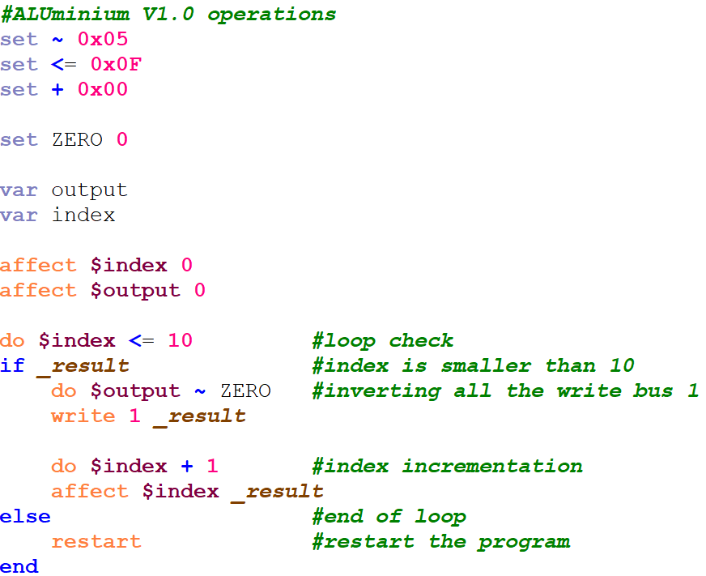

Notepad++
You can find a CodeG_simple.xml file for notepad++ to apply colors.

