GP8B
Datasheet
-
Version 5.x

Copyright (C) 2020 Guillaume Guillet
Licensed under CERN-OHL-W v2 or later

This source describes Open Hardware and is licensed under the CERN-OHL-W v2 or later.

You may redistribute and modify this documentation and make products using it under the terms of the CERN-OHL-W v2 (https:/cern.ch/cern-ohl). This documentation is distributed WITHOUT ANY EXPRESS OR IMPLIED WARRANTY, INCLUDING OF MERCHANTABILITY, SATISFACTORY QUALITY AND FITNESS FOR A PARTICULAR PURPOSE.

Please see the CERN-OHL-W v2 for applicable conditions.

Table of contents
Description 4
Features 4
Blocks details 5
Bus 5
Instruction execution 6
Sequencer 6
Simple instructions 8
Complex instructions 9
Arguments 10
Getting started 12
Changes 12

Description
The GP8B or G_Processor8Bits is a home-made, from scratch, with no micro-controller, only made with logic circuits, 8bits processor.
The goal of this project is to create an 8bit computer community with the help of custom mecanical and electronic standards to build a nice and compatible environnement.

Features

CodeG
GP8B execute the revision 1 of the homemade binary language called CodeG :
CodeG binary revision 1.0
Instruction selection
Opcode | Hex | Name | Description
xxx0’0000 | 0x00 | BWRITE1_CLK | Apply value to bus “write 1”.
xxx0’0001 | 0x01 | BWRITE2_CLK | Apply value to bus “write 2”.
xxx0’0010 | 0x02 | BPCS_CLK | Apply value to bus “peripheral CS”.
xxx0’0011 | 0x03 | OPLEFT_CLK | Apply value to the left operation.
xxx0’0100 | 0x04 | OPRIGHT_CLK | Apply value to the right operation.
xxx0’0101 | 0x05 | OPCHOOSE_CLK | Apply value for choosing the operation.
xxx0’0110 | 0x06 | PERIPHERAL_CLK | Send a clock pulse to the peripheral.
xxx0’0111 | 0x07 | BJMPSRC1_CLK | Apply value to bus “jump source 1”.
xxx0’1000 | 0x08 | BJMPSRC2_CLK | Apply value to bus “jump source 2”.
xxx0’1001 | 0x09 | BJMPSRC3_CLK | Apply value to bus “jump source 3”.
xxx0’1010 | 0x0A | JMPSRC_CLK | Jump to the address of “jump source”.
xxx0’1011 | 0x0B | BRAMADD1_CLK | Apply value to bus “RAM address 1”.
xxx0’1100 | 0x0C | BRAMADD2_CLK | Apply value to bus “RAM address 2”.
xxx0’1101 | 0x0D | SPI_CLK | Send a clock pulse for the SPI.
xxx0’1110 | 0x0E | BCFG_SPI_CLK | Apply value to the config bus SPI.
xxx0’1111 | 0x0F | STICK | Simple tick, do nothing (delay).
xxx1’0000 | 0x10 | IF | Conditional instruction.
xxx1’0001 | 0x11 | IFNOT | Conditional instruction inverted.
xxx1’0010 | 0x12 | RAMW | Write value to the actual address of the memory.
xxx1’0011 | 0x13 | UOP | Undefined operation.
xxx1’0100 | 0x14 | UOP | Undefined operation.
xxx1’0101 | 0x15 | UOP | Undefined operation.
xxx1’0110 | 0x16 | UOP | Undefined operation.
xxx1’0111 | 0x17 | LTICK | Long tick, do nothing (delay).

CodeG binary revision 1.0
Argument selection
Opcode | Hex | Name | Description
000x’xxxx | 0x00 | SRCVALUE | The value stored to the source.
001x’xxxx | 0x20 | BREAD1 | The value of the read bus 1.
010x’xxxx | 0x40 | BREAD2 | The value of the read bus 2.
011x’xxxx | 0x60 | OPRESULT | The value of the operation result (ALU).
100x’xxxx | 0x80 | RAMVALUE | The value of the processor memory.
101x’xxxx | 0xA0 | SPI | The value of the SPI.
110x’xxxx | 0xC0 | EXT_1 | External value 1.
111x’xxxx | 0xE0 | EXT_2 | External value 2.

Blocks details

Bus
Details of essential/fonctionnal bus are listed here :
Bus name | Size (bits) | Direction | Description
BWRITE1 | 8 | out | Bus for external peripheral communication.
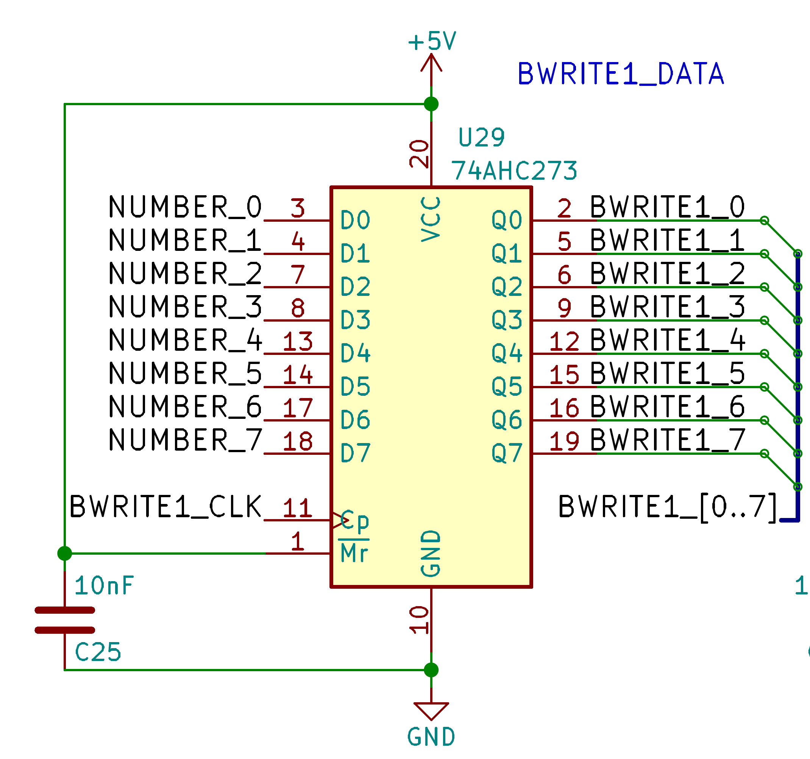
A D-latch chip control the write bus 1.
You can apply a value with the instruction “BWRITE1_CLK”.

BWRITE2 | 8 | out | Bus for external peripheral communication.
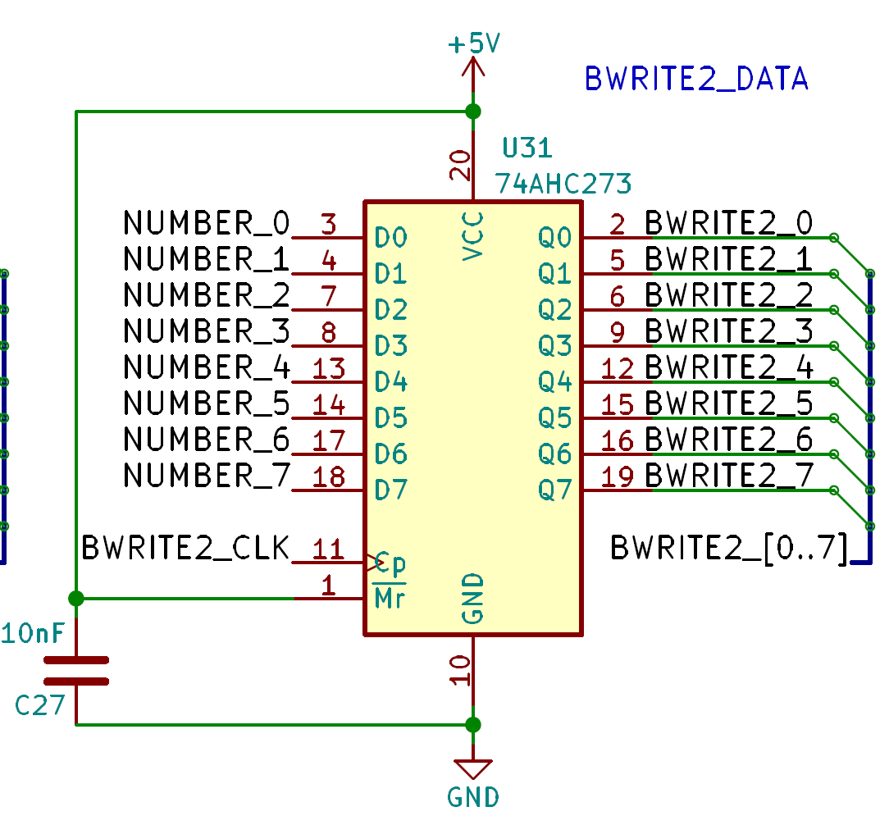
A D-latch chip control the write bus 2.
You can apply a value with the instruction “BWRITE2_CLK”.

Bus name | Size (bits) | Direction | Description
BREAD1 | 8 | in | Bus for external peripheral communication.
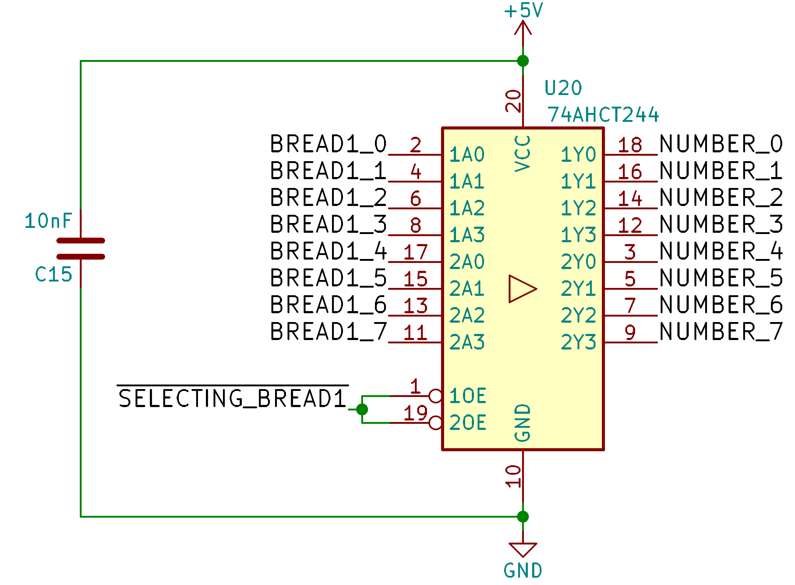
The readable bus 1 can be directly applied as an argument into the “NUMBER” bus.

BREAD2 | 8 | in | Bus for external peripheral communication.
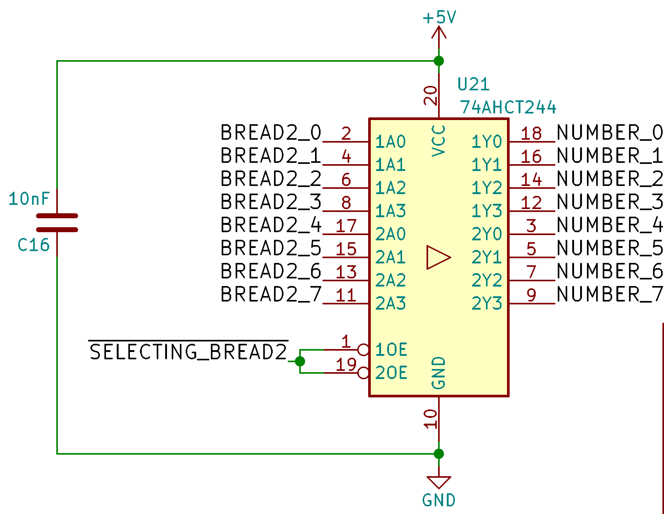
The readable bus 2 can be directly applied as an argument into the “NUMBER” bus.

NUMBER | 8 | in/out | Main argument bus.

Instruction execution

Sequencer
The first main component is a 4bits counter that will receive the “GLOBAL_CLK” of the motherboard.
The goal of this chip is to provide, with the help of a demux, all the pulse required for executing instruction sequentially.
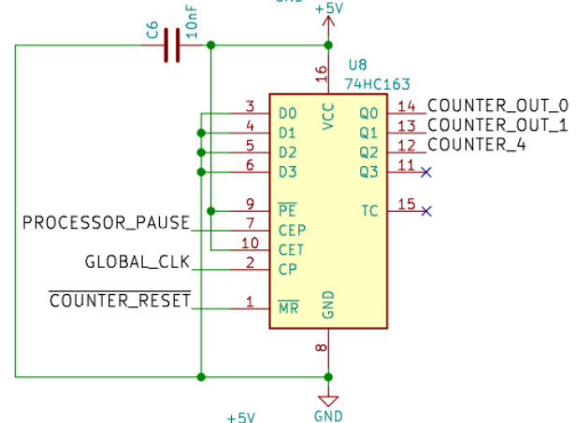
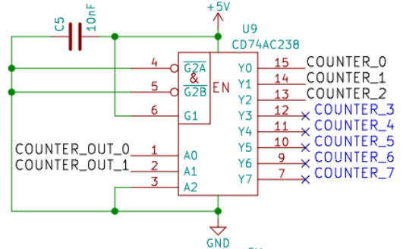

The 4bits count from 0 to 4, the fifth clock reset the counter to 0:
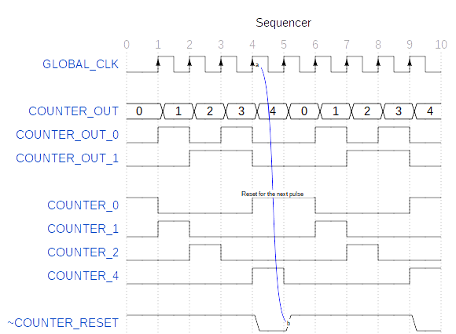

Every pulse from the sequencer represent a stat/action:

Sequence value | Action/Stat | Counter reset? | Next address? | Instruction latched?
0 | Sync bit | No | No | No
At this stat, no instruction are executed and the SYNC_BIT is pulled high, this serve only for syncing with an interface like a debugger and prepare the execution of the next instruction.
1 | Instruction set | No | Yes | Yes
A pulse have been made to ‘U7’ (8bit D-Latch) to save the instruction to execute and the next address is requested (the argument).
2 | Execution | Yes/No | Yes/No | No
“Simple instruction”: One pulse is made to execute the instruction and a reset/next address is requested.
“Complex instruction”: The first part of the instruction is executed with no reset:
IF/IFNOT: If the argument is valid (>0 or =0), then the next instruction is skipped (usually a JMPSRC_CLK instruction) by requesting the next address.
RAMW: The “output enable” pin is pulled high for write preparation.
Noting is executed for UOP/LTICK instructions.
3 | Waiting | No | No | No
At this stat, the processor do nothing (this stat is only useful for write preparation to the memory).
4 | RAM Write or END | Yes | Yes | No
Depending on the instruction:
RAMW: The RAM write the requested data by pulling low the “write enable” pin.
At the end, a reset and the next address is requested.

Simple instructions
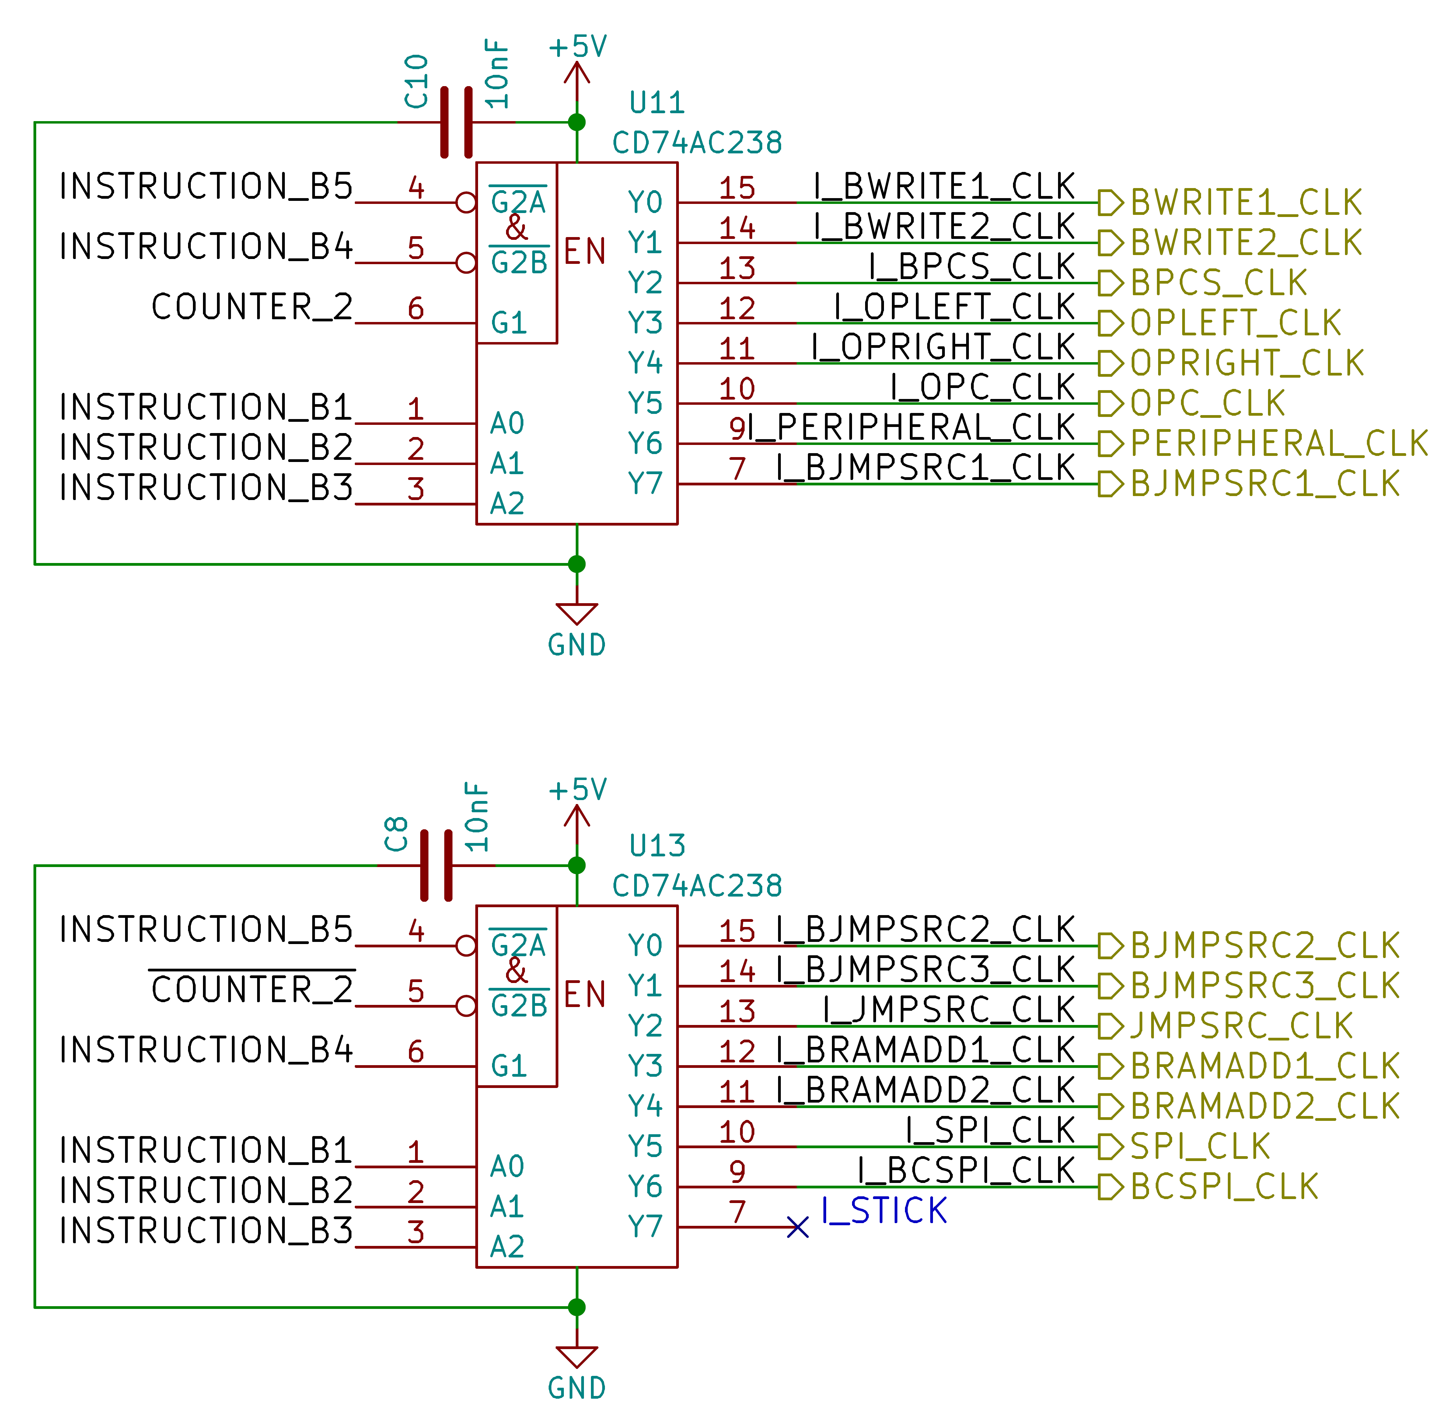
Simple instruction consist of just one pulse and an argument.
Every simple instruction is executed in 3 rising-edges from GLOBAL_CLK.

Opcode | Hex | Name | Description
xxx0’0000 | 0x00 | BWRITE1_CLK | Apply value to bus “write 1”.
xxx0’0001 | 0x01 | BWRITE2_CLK | Apply value to bus “write 2”.
xxx0’0010 | 0x02 | BPCS_CLK | Apply value to bus “peripheral CS”.
xxx0’0011 | 0x03 | OPLEFT_CLK | Apply value to the left operation.
xxx0’0100 | 0x04 | OPRIGHT_CLK | Apply value to the right operation.
xxx0’0101 | 0x05 | OPCHOOSE_CLK | Apply value for choosing the operation.
xxx0’0110 | 0x06 | PERIPHERAL_CLK | Send a clock pulse to the peripheral.
xxx0’0111 | 0x07 | BJMPSRC1_CLK | Apply value to bus “jump source 1”.
xxx0’1000 | 0x08 | BJMPSRC2_CLK | Apply value to bus “jump source 2”.
xxx0’1001 | 0x09 | BJMPSRC3_CLK | Apply value to bus “jump source 3”.
xxx0’1010 | 0x0A | JMPSRC_CLK | Jump to the address of “jump source”.
xxx0’1011 | 0x0B | BRAMADD1_CLK | Apply value to bus “RAM address 1”.
xxx0’1100 | 0x0C | BRAMADD2_CLK | Apply value to bus “RAM address 2”.
xxx0’1101 | 0x0D | SPI_CLK | Send a clock pulse for the SPI.
xxx0’1110 | 0x0E | BCFG_SPI_CLK | Apply value to the config bus SPI.
xxx0’1111 | 0x0F | STICK | Simple tick, do nothing (delay).

Complex instructions
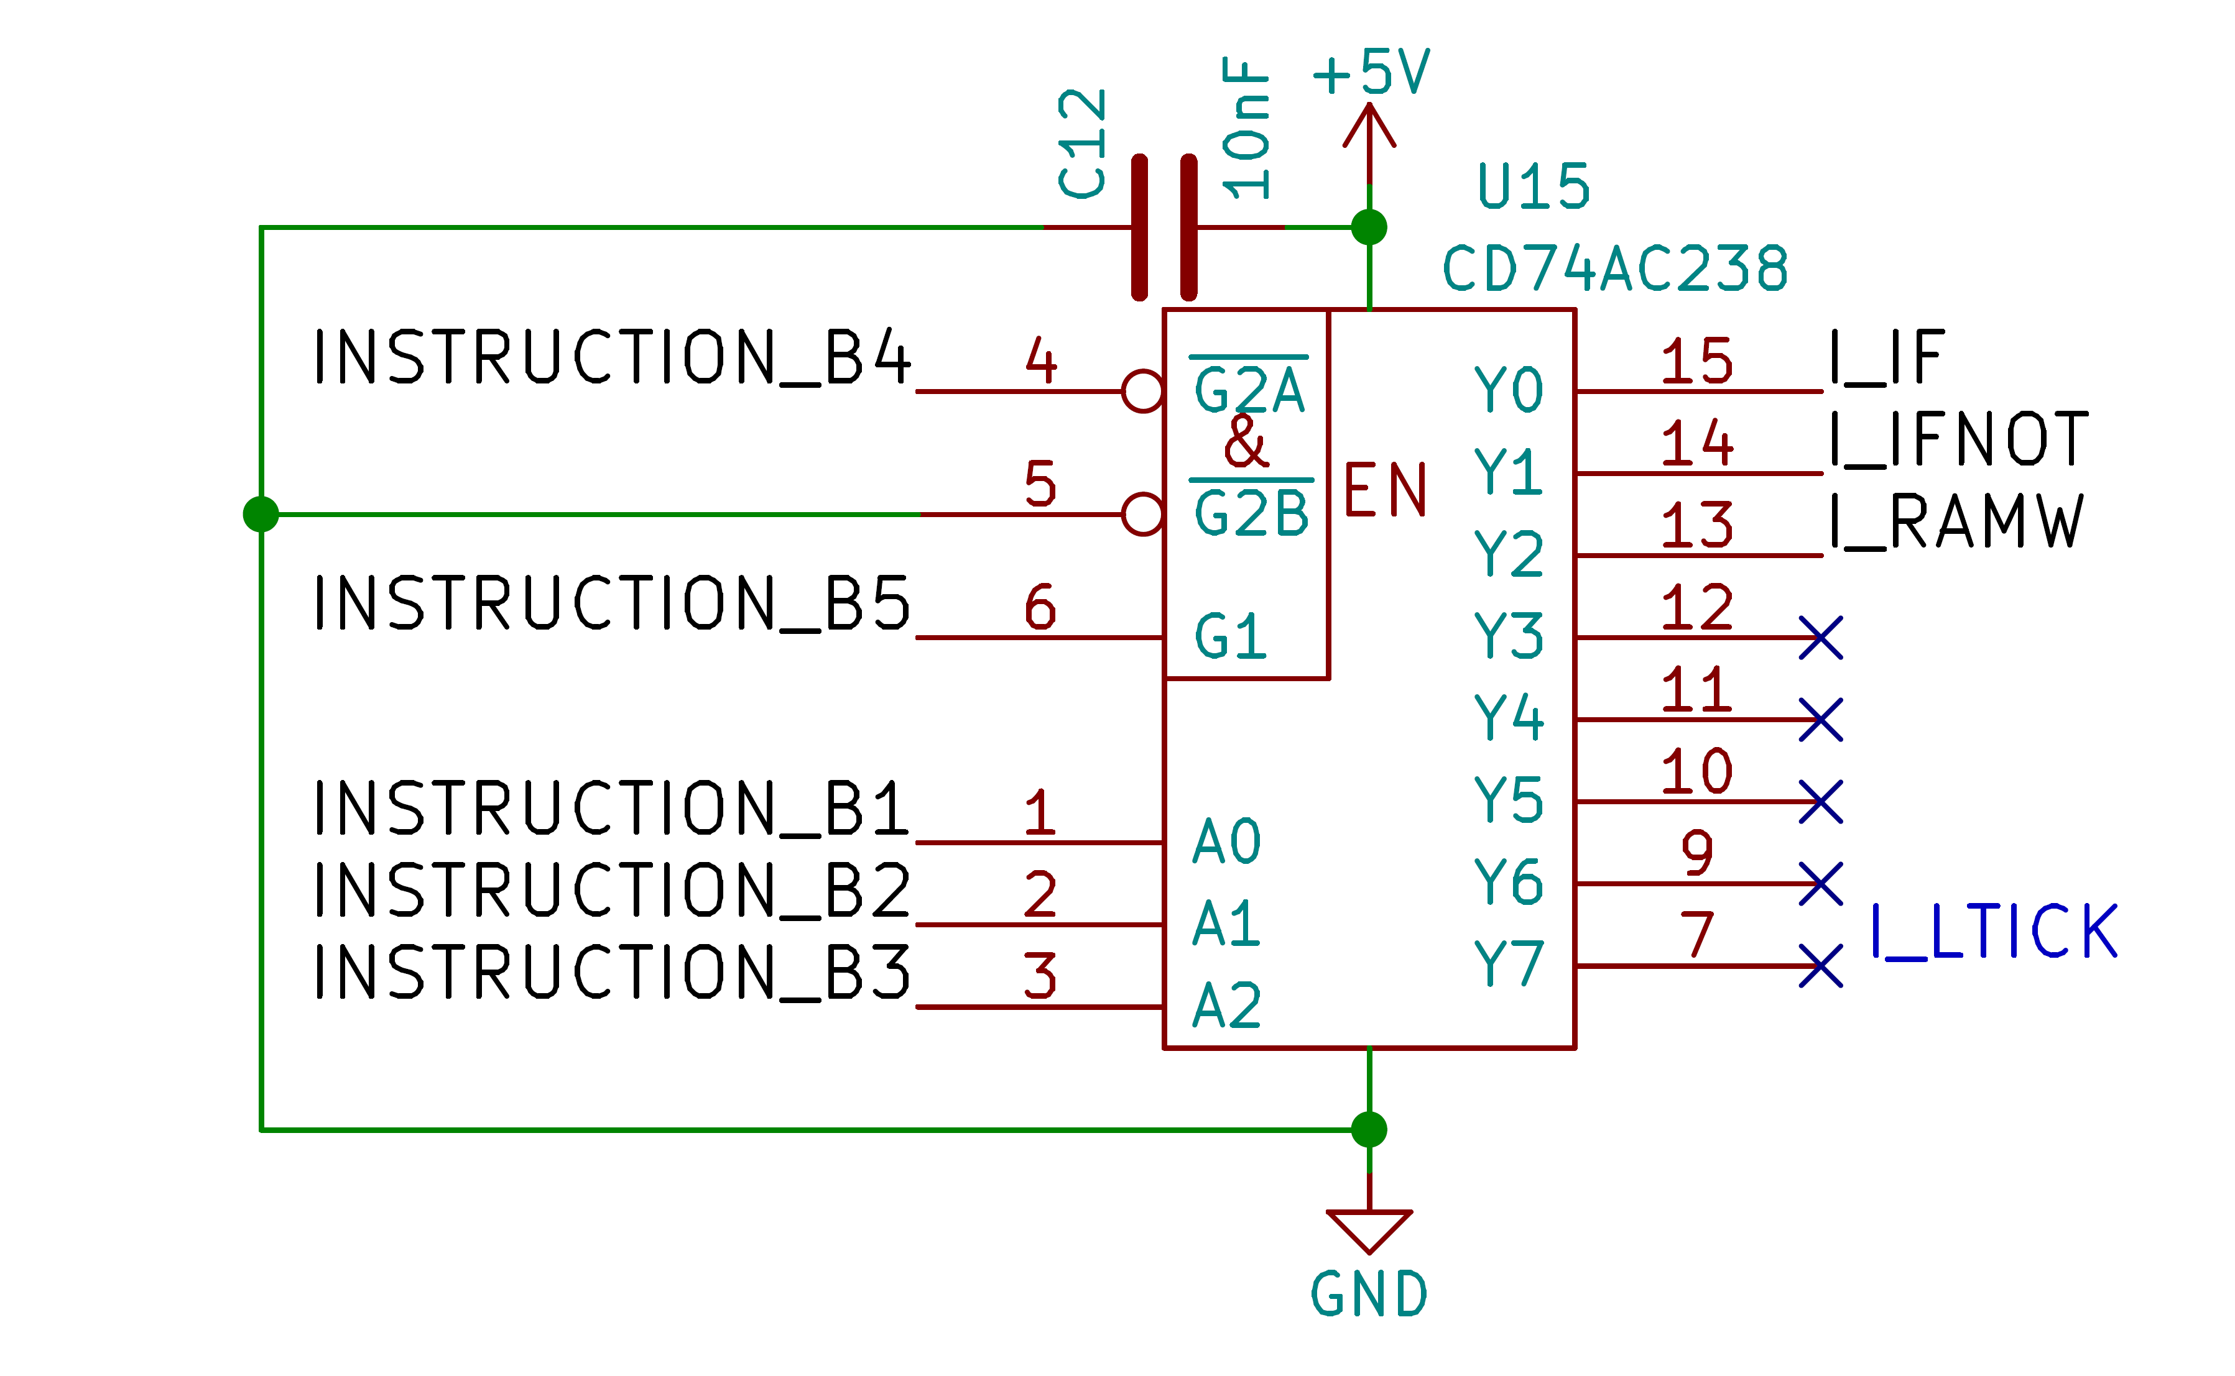
Complex instructions are instructions that takes 5 rising-edges from GLOBAL_CLK to execute.

Opcode | Hex | Name | Description
xxx1’0000 | 0x10 | IF | Conditional instruction.
xxx1’0001 | 0x11 | IFNOT | Conditional instruction inverted.
xxx1’0010 | 0x12 | RAMW | Write value to the actual address of the memory.
xxx1’0111 | 0x17 | LTICK | Long tick, do nothing (delay).

The RAMW instruction consist by pulling OE low when counter is at 2, and send a WE pulse when counter is at 4.
The conditional instruction consist of checking the argument when counter is at 2, if the argument is valid, the next instruction (usually a jump) is skipped else the next instruction is executed.

Arguments

The argument for an operation is selected by changing the last 3bits of the opcode :

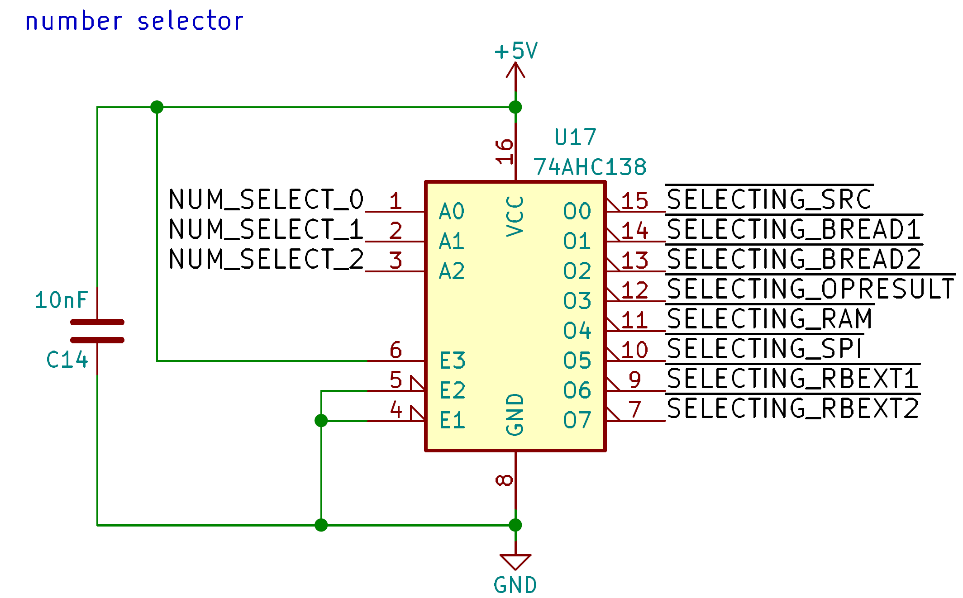
The 3bits, once latched, are connected to the demux “U17”.

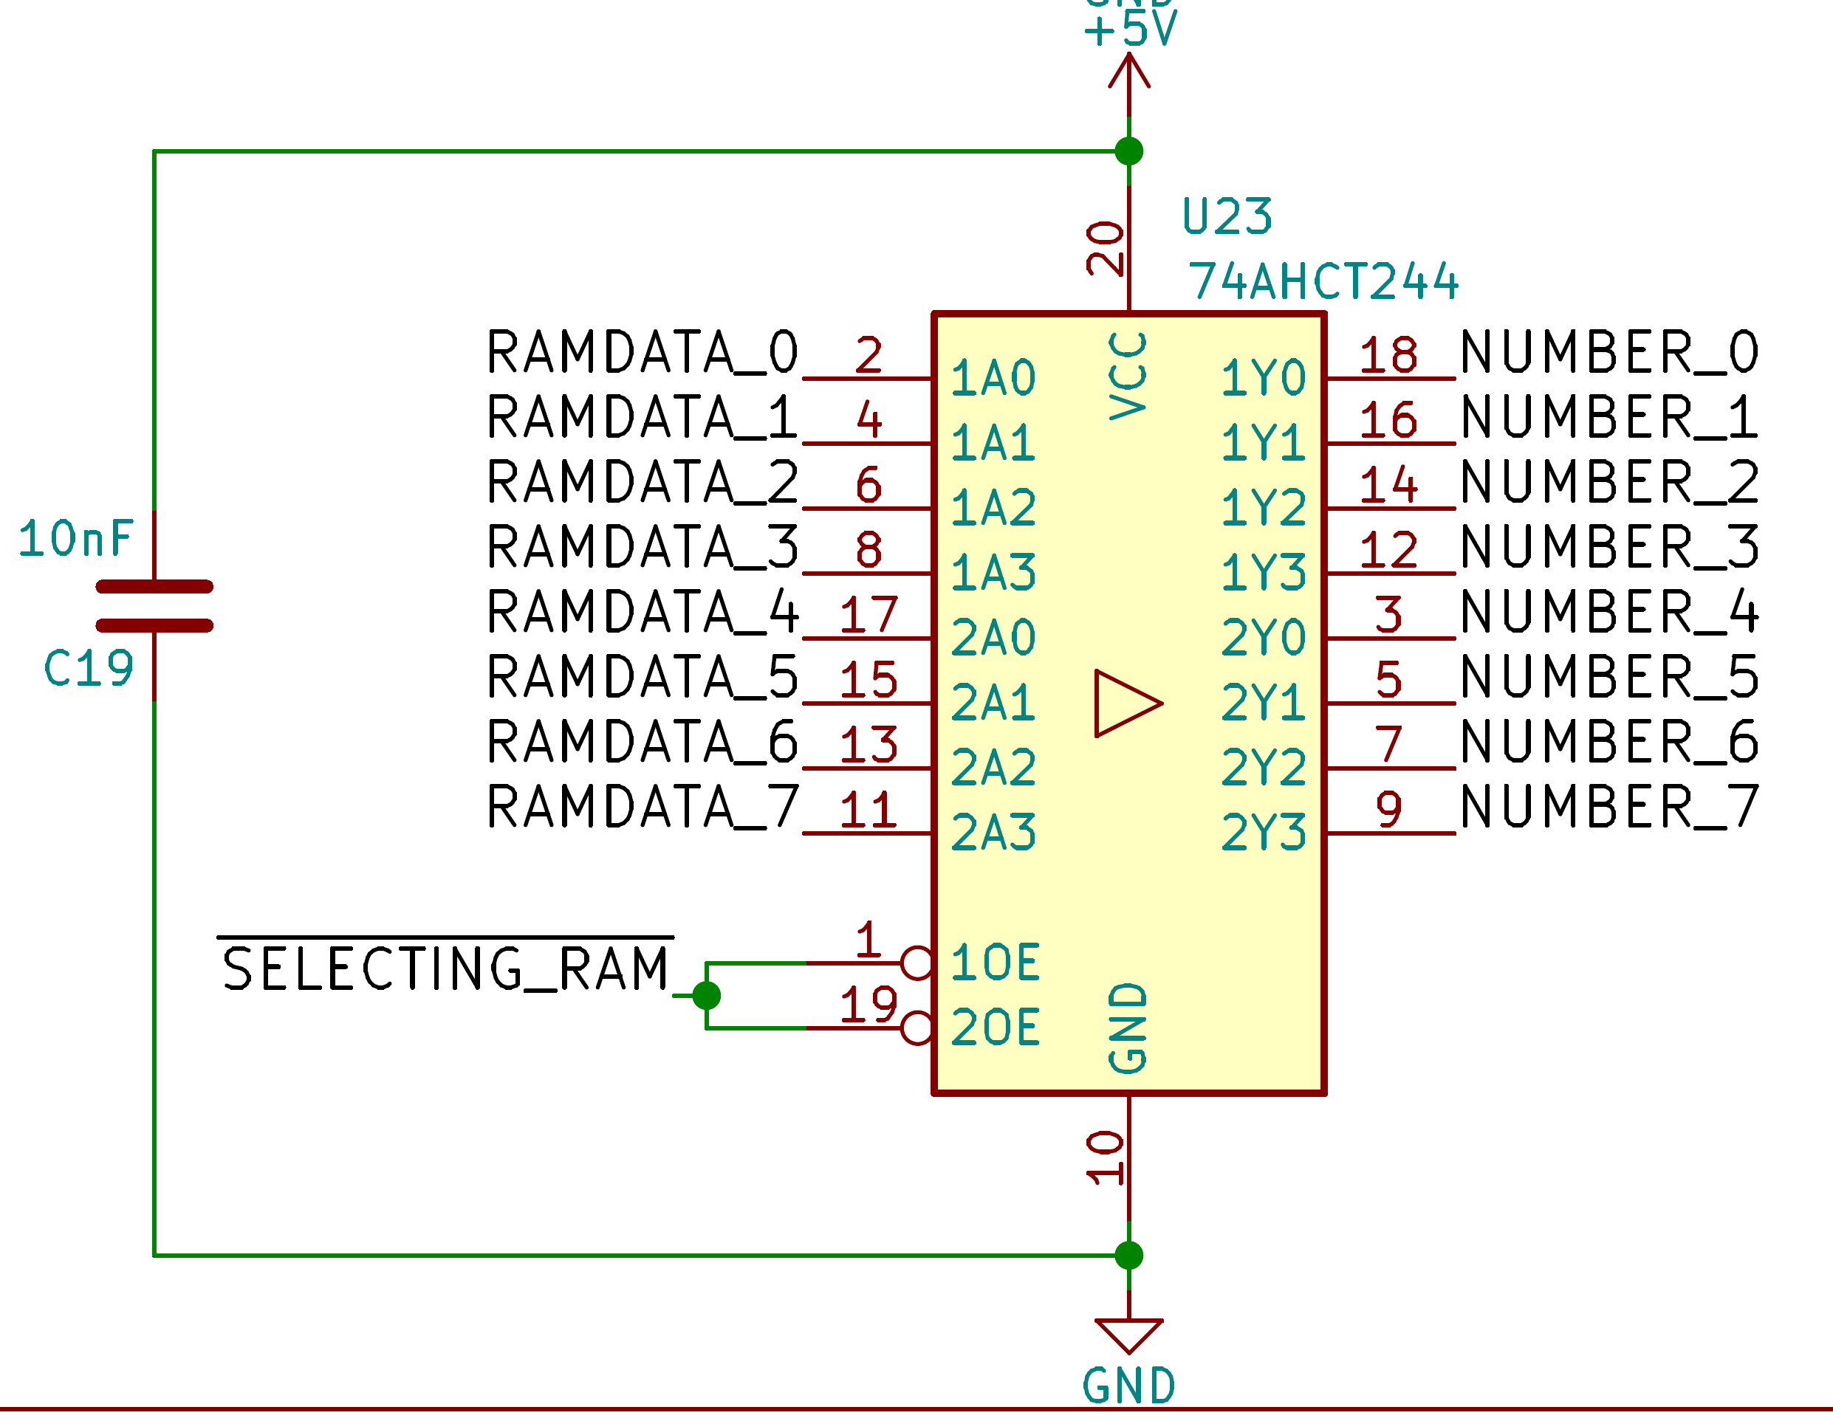
Every “SELECTING” line is connected to a 8bits buffer with tri-state output and all of it is connected to the main argument bus “NUMBER”.

Opcode | Hex | Name | Description
000x’xxxx | 0x00 | SRCVALUE | The value stored to the source.
001x’xxxx | 0x20 | BREAD1 | The value of the read bus 1.
010x’xxxx | 0x40 | BREAD2 | The value of the read bus 2.
011x’xxxx | 0x60 | OPRESULT | The value of the operation result (ALU).
100x’xxxx | 0x80 | RAMVALUE | The value of the processor memory.
101x’xxxx | 0xA0 | SPI | The value of the SPI.
110x’xxxx | 0xC0 | EXT_1 | External value 1.
111x’xxxx | 0xE0 | EXT_2 | External value 2.

Getting started

Changes
Revision 0:
initial release

