GP8B
Datasheet
-
Version 5.x

Copyright (C) 2020 Guillaume Guillet
Licensed under CERN-OHL-W v2 or later

This source describes Open Hardware and is licensed under the CERN-OHL-W v2 or later.

You may redistribute and modify this documentation and make products using it under the terms of the CERN-OHL-W v2 (https:/cern.ch/cern-ohl). This documentation is distributed WITHOUT ANY EXPRESS OR IMPLIED WARRANTY, INCLUDING OF MERCHANTABILITY, SATISFACTORY QUALITY AND FITNESS FOR A PARTICULAR PURPOSE.

Please see the CERN-OHL-W v2 for applicable conditions.

Table of contents
Description 5
Features 5
CodeG 6
Blocks details 8
Bus 8
Instruction execution 11
Sequencer 11
Simple instructions 13
Complex instructions 14
Arguments 15
Getting started 16
Changes 16

Description
The GP8B or G_Processor8Bits is a home-made, from scratch, with no micro-controller, only made with logic circuits, 8bits processor.
The goal of this project is to create an 8bit computer community with the help of custom mecanical and electronic standards to build a nice and compatible environnement.

Features
- 64 kByte of RAM maximum.
- Using ALUminium*¹ in a CPLD for an 8bits ALU (arithmetic-logic unit).
- A simple SPI implementation.
- 16 writable bits for peripheral communication.
- 16 readable bits for peripheral communication.
- Following the custom standard SPS1*².
- Following the CodeG binary rev1 standard.
- Accessible debug pins and Jtag for the CPLD.
- 50Mhz theorical maximum frequency.

*¹ ALUminium is an VHDL 8bits ALU code that you can find here :
https://github.com/JonathSpirit/ALUminium
*² You can find SPS1 standard here :
https://github.com/JonathSpirit/GComputer_standard

CodeG
GP8B execute the revision 1 of the homemade binary language called CodeG :
CodeG binary revision 1.0
Instruction selection
Opcode | Hex | Name | Description
xxx0’0000 | 0x00 | BWRITE1_CLK | Apply value to bus “write 1”.
xxx0’0001 | 0x01 | BWRITE2_CLK | Apply value to bus “write 2”.
xxx0’0010 | 0x02 | BPCS_CLK | Apply value to bus “peripheral CS”.
xxx0’0011 | 0x03 | OPLEFT_CLK | Apply value to the left operation.
xxx0’0100 | 0x04 | OPRIGHT_CLK | Apply value to the right operation.
xxx0’0101 | 0x05 | OPCHOOSE_CLK | Apply value for choosing the operation.
xxx0’0110 | 0x06 | PERIPHERAL_CLK | Send a clock pulse to the peripheral.
xxx0’0111 | 0x07 | BJMPSRC1_CLK | Apply value to bus “jump source 1”.
xxx0’1000 | 0x08 | BJMPSRC2_CLK | Apply value to bus “jump source 2”.
xxx0’1001 | 0x09 | BJMPSRC3_CLK | Apply value to bus “jump source 3”.
xxx0’1010 | 0x0A | JMPSRC_CLK | Jump to the address of “jump source”.
xxx0’1011 | 0x0B | BRAMADD1_CLK | Apply value to bus “RAM address 1”.
xxx0’1100 | 0x0C | BRAMADD2_CLK | Apply value to bus “RAM address 2”.
xxx0’1101 | 0x0D | SPI_CLK | Send a clock pulse for the SPI.
xxx0’1110 | 0x0E | BCFG_SPI_CLK | Apply value to the config bus SPI.
xxx0’1111 | 0x0F | STICK | Simple tick, do nothing (delay).
xxx1’0000 | 0x10 | IF | Conditional instruction.
xxx1’0001 | 0x11 | IFNOT | Conditional instruction inverted.
xxx1’0010 | 0x12 | RAMW | Write value to the actual address of the memory.
xxx1’0011 | 0x13 | UOP | Undefined operation.
xxx1’0100 | 0x14 | UOP | Undefined operation.
xxx1’0101 | 0x15 | UOP | Undefined operation.
xxx1’0110 | 0x16 | UOP | Undefined operation.
xxx1’0111 | 0x17 | LTICK | Long tick, do nothing (delay).

CodeG binary revision 1.0
Argument selection
Opcode | Hex | Name | Description
000x’xxxx | 0x00 | SRCVALUE | The value stored to the source.
001x’xxxx | 0x20 | BREAD1 | The value of the read bus 1.
010x’xxxx | 0x40 | BREAD2 | The value of the read bus 2.
011x’xxxx | 0x60 | OPRESULT | The value of the operation result (ALU).
100x’xxxx | 0x80 | RAMVALUE | The value of the processor memory.
101x’xxxx | 0xA0 | SPI | The value of the SPI.
110x’xxxx | 0xC0 | EXT_1 | External value 1.
111x’xxxx | 0xE0 | EXT_2 | External value 2.

Blocks details

Bus
Details of essential/fonctionnal bus are listed here :
Bus name | Size (bits) | Direction | Description
BWRITE1 | 8 | out | Bus for external peripheral communication.
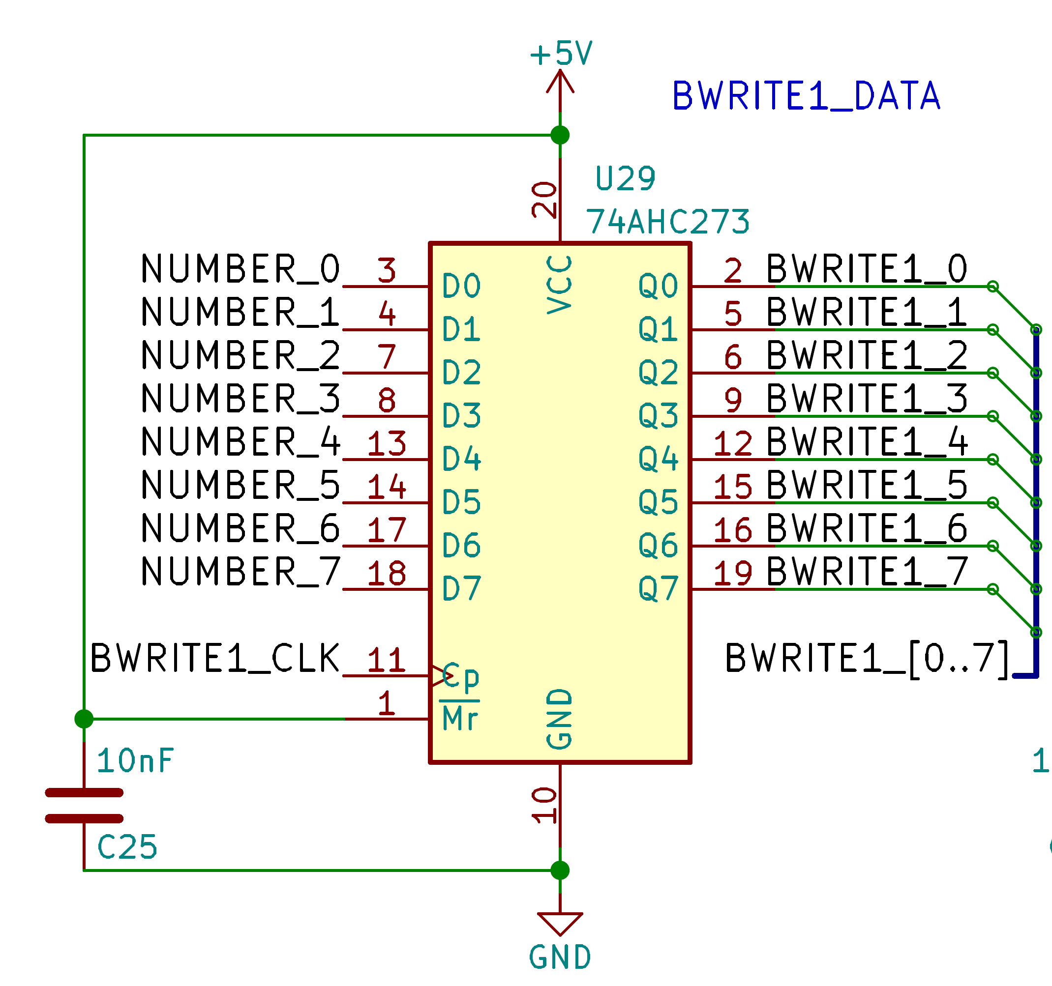
A D-latch chip control the write bus 1.
You can apply a value with the instruction “BWRITE1_CLK”.

BWRITE2 | 8 | out | Bus for external peripheral communication.
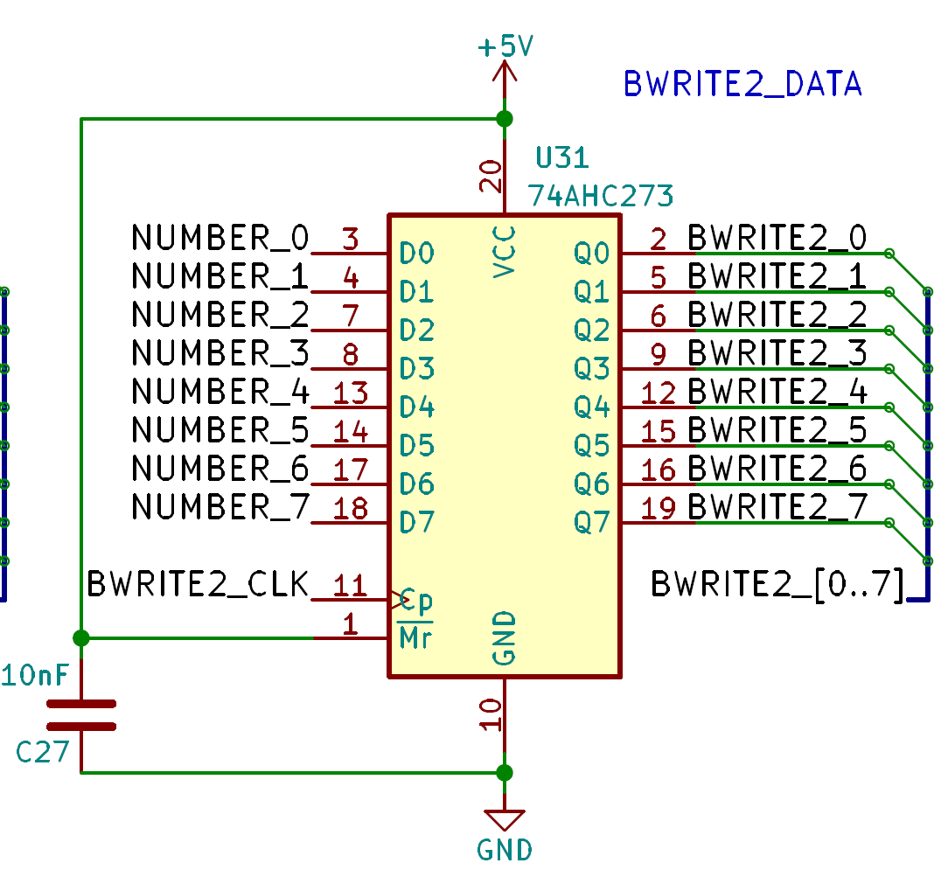
A D-latch chip control the write bus 2.
You can apply a value with the instruction “BWRITE2_CLK”.

Bus name | Size (bits) | Direction | Description
BREAD1 | 8 | in | Bus for external peripheral communication.
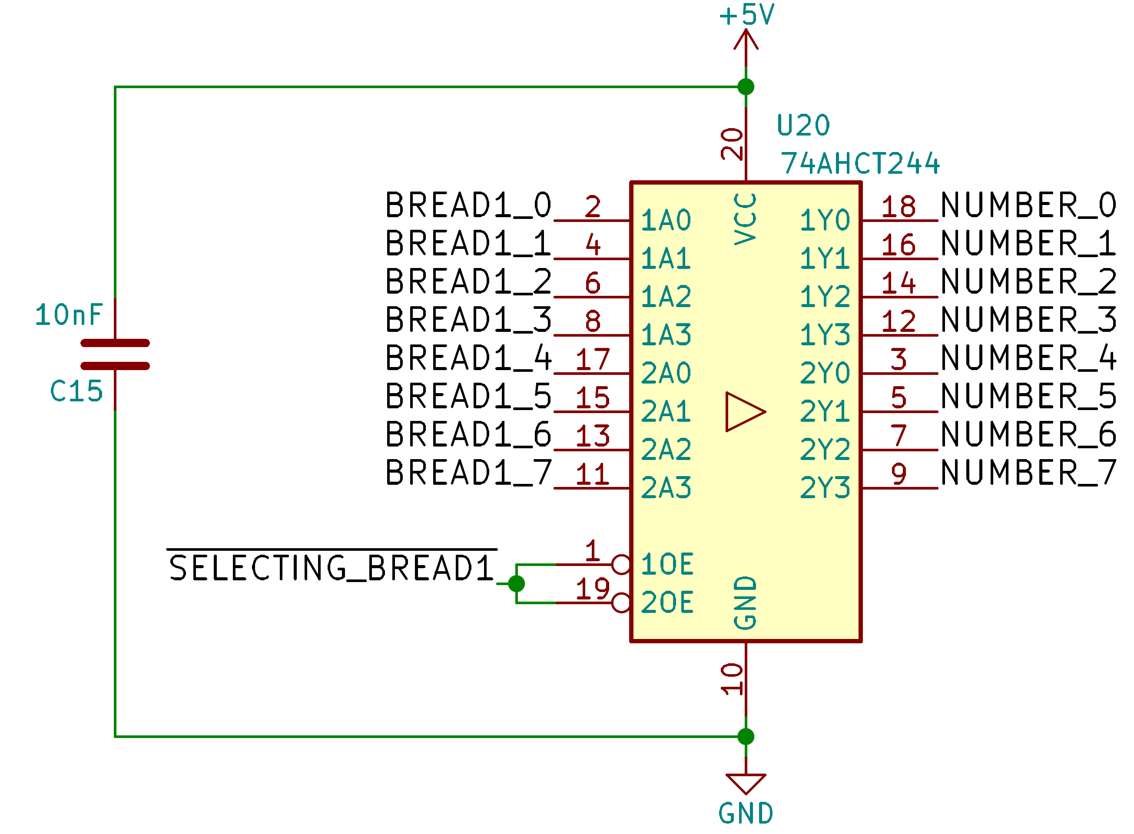
The readable bus 1 can be directly applied as an argument into the “NUMBER” bus.

BREAD2 | 8 | in | Bus for external peripheral communication.
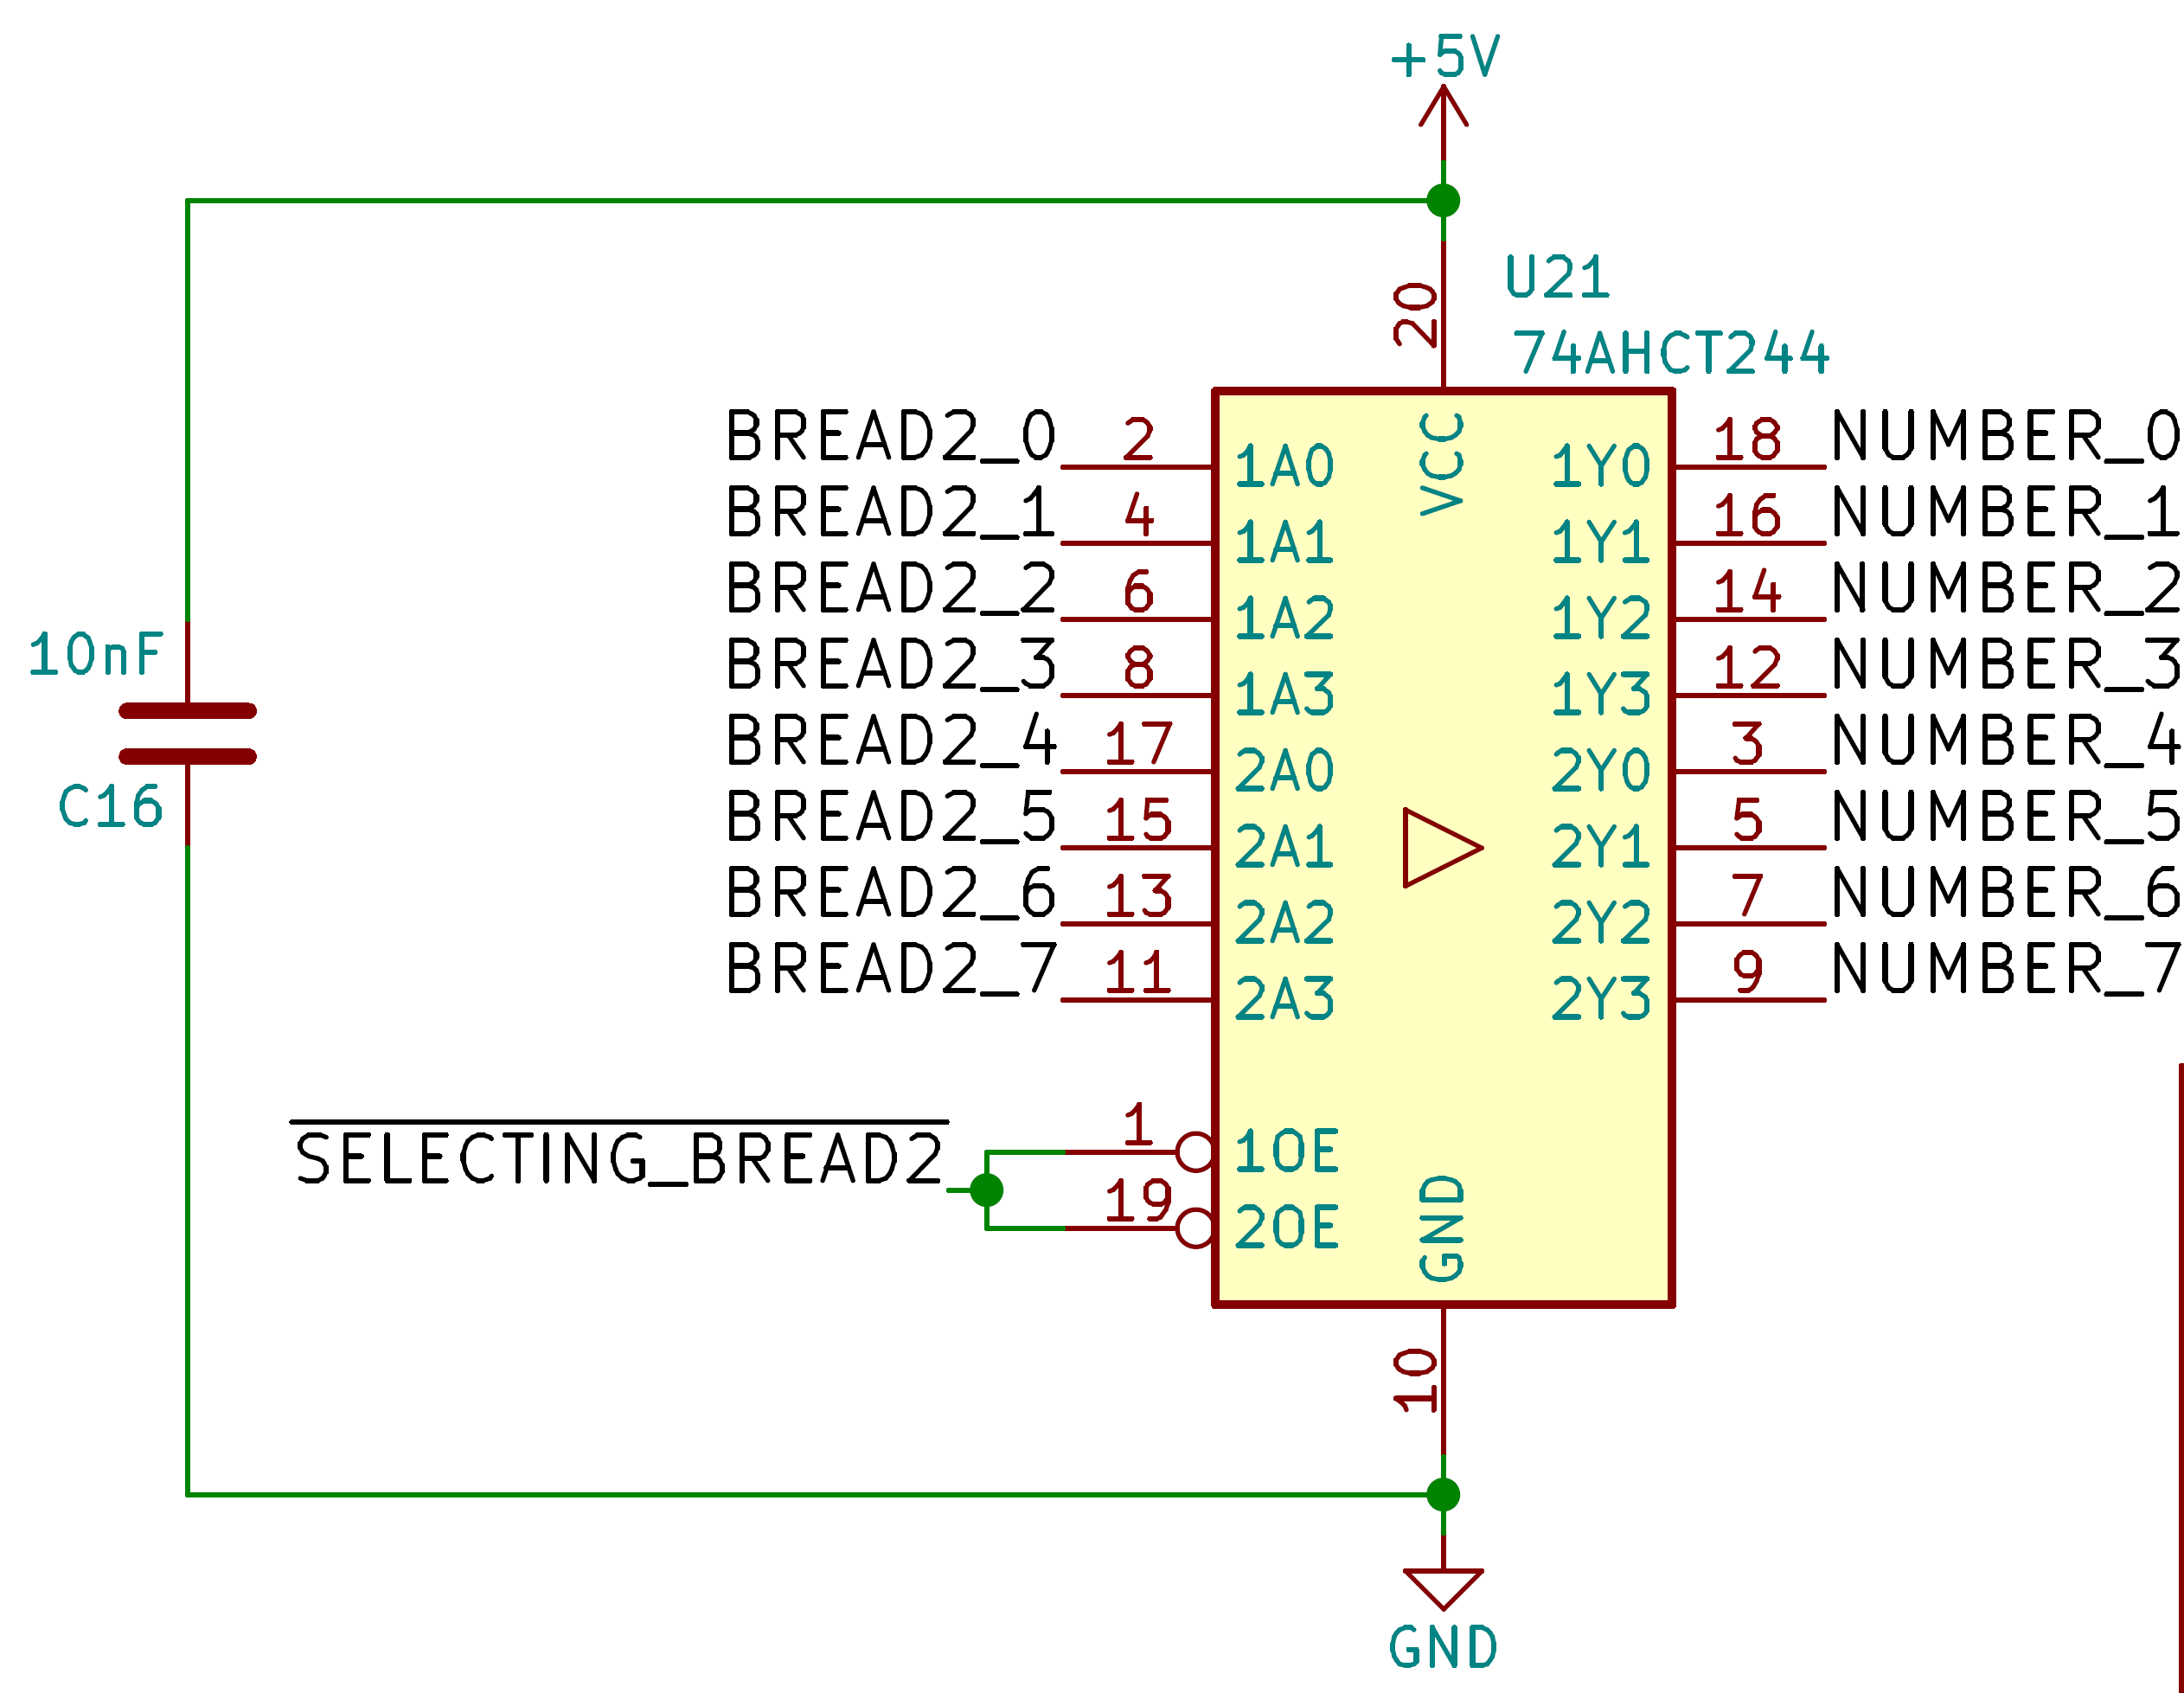
The readable bus 2 can be directly applied as an argument into the “NUMBER” bus.

NUMBER | 8 | in/out | Main argument bus.
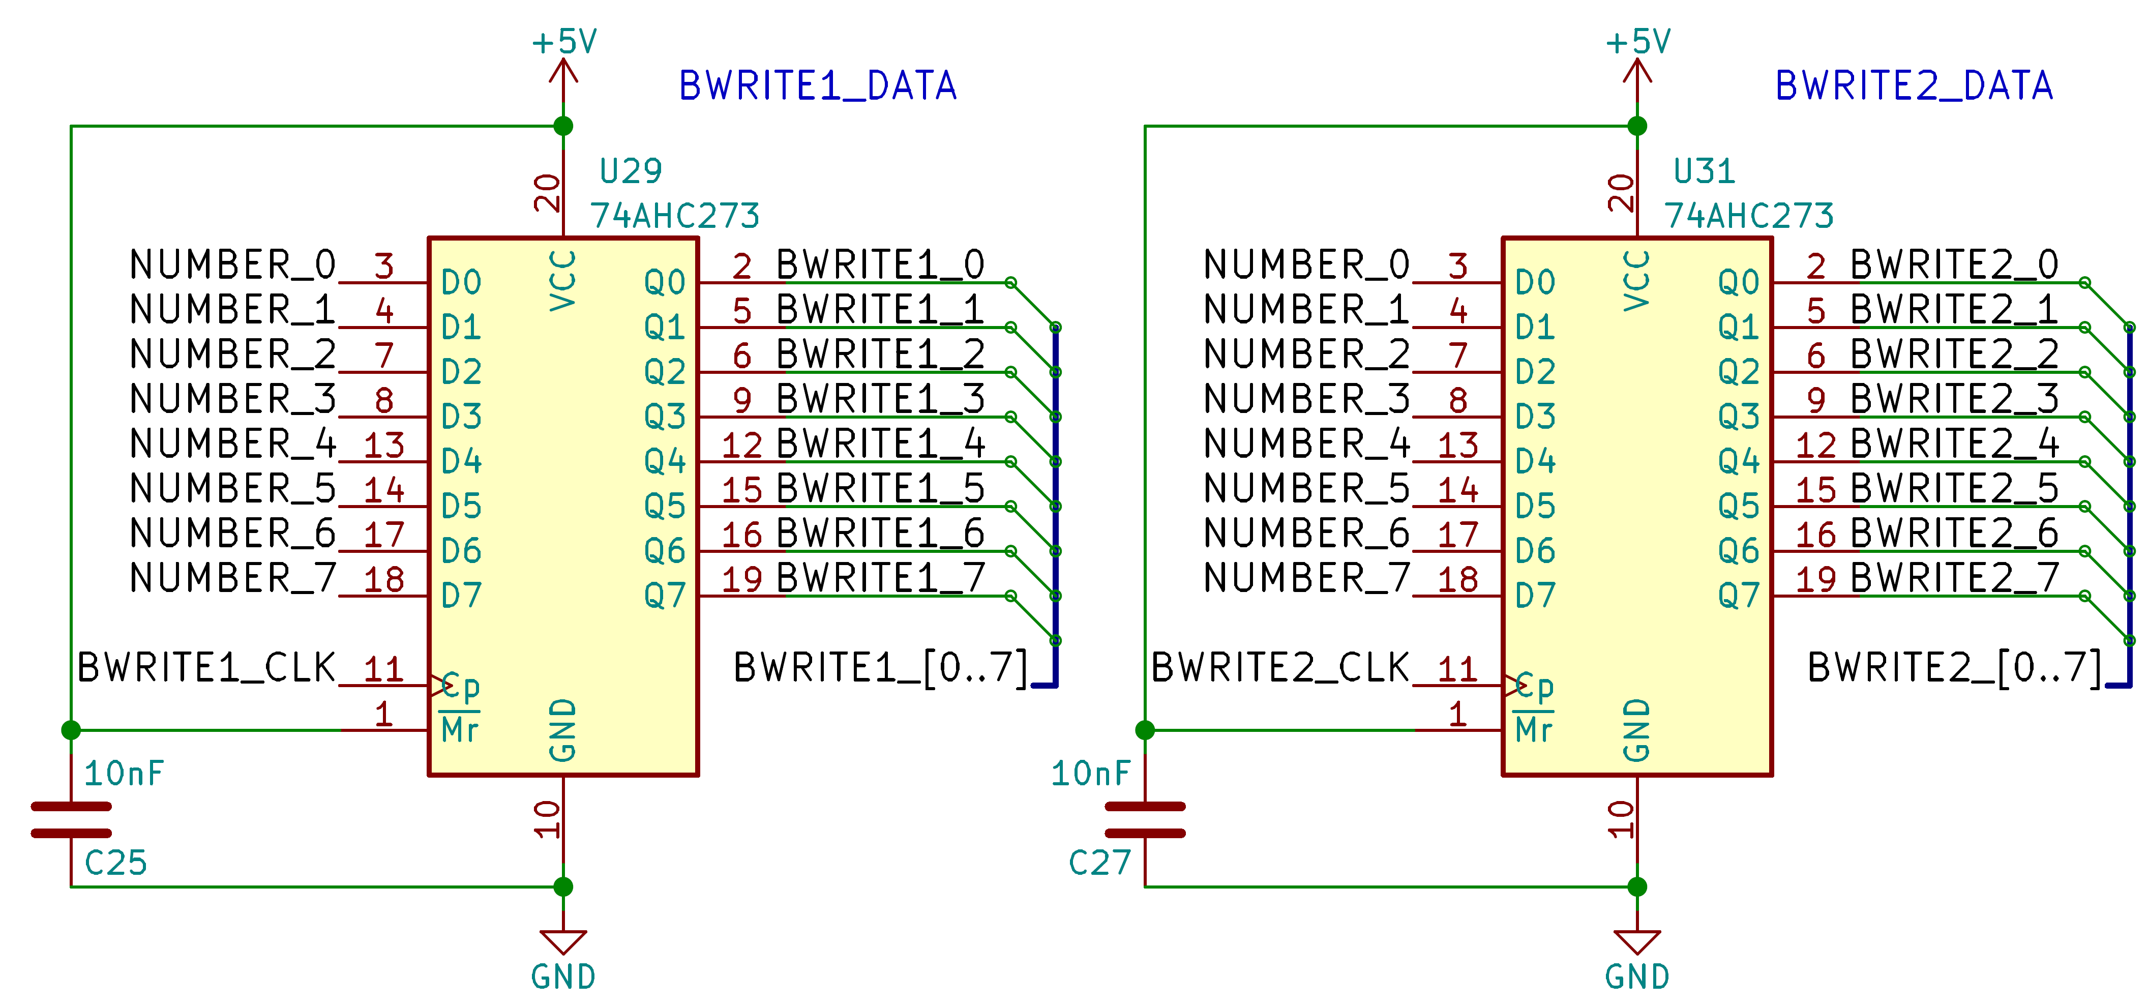
The “NUMBER” bus is applied almost everywhere. With it, you can control most of the register like the writeable bus 1 or 2.

NUMBER | 8 | in/out | Main argument bus.
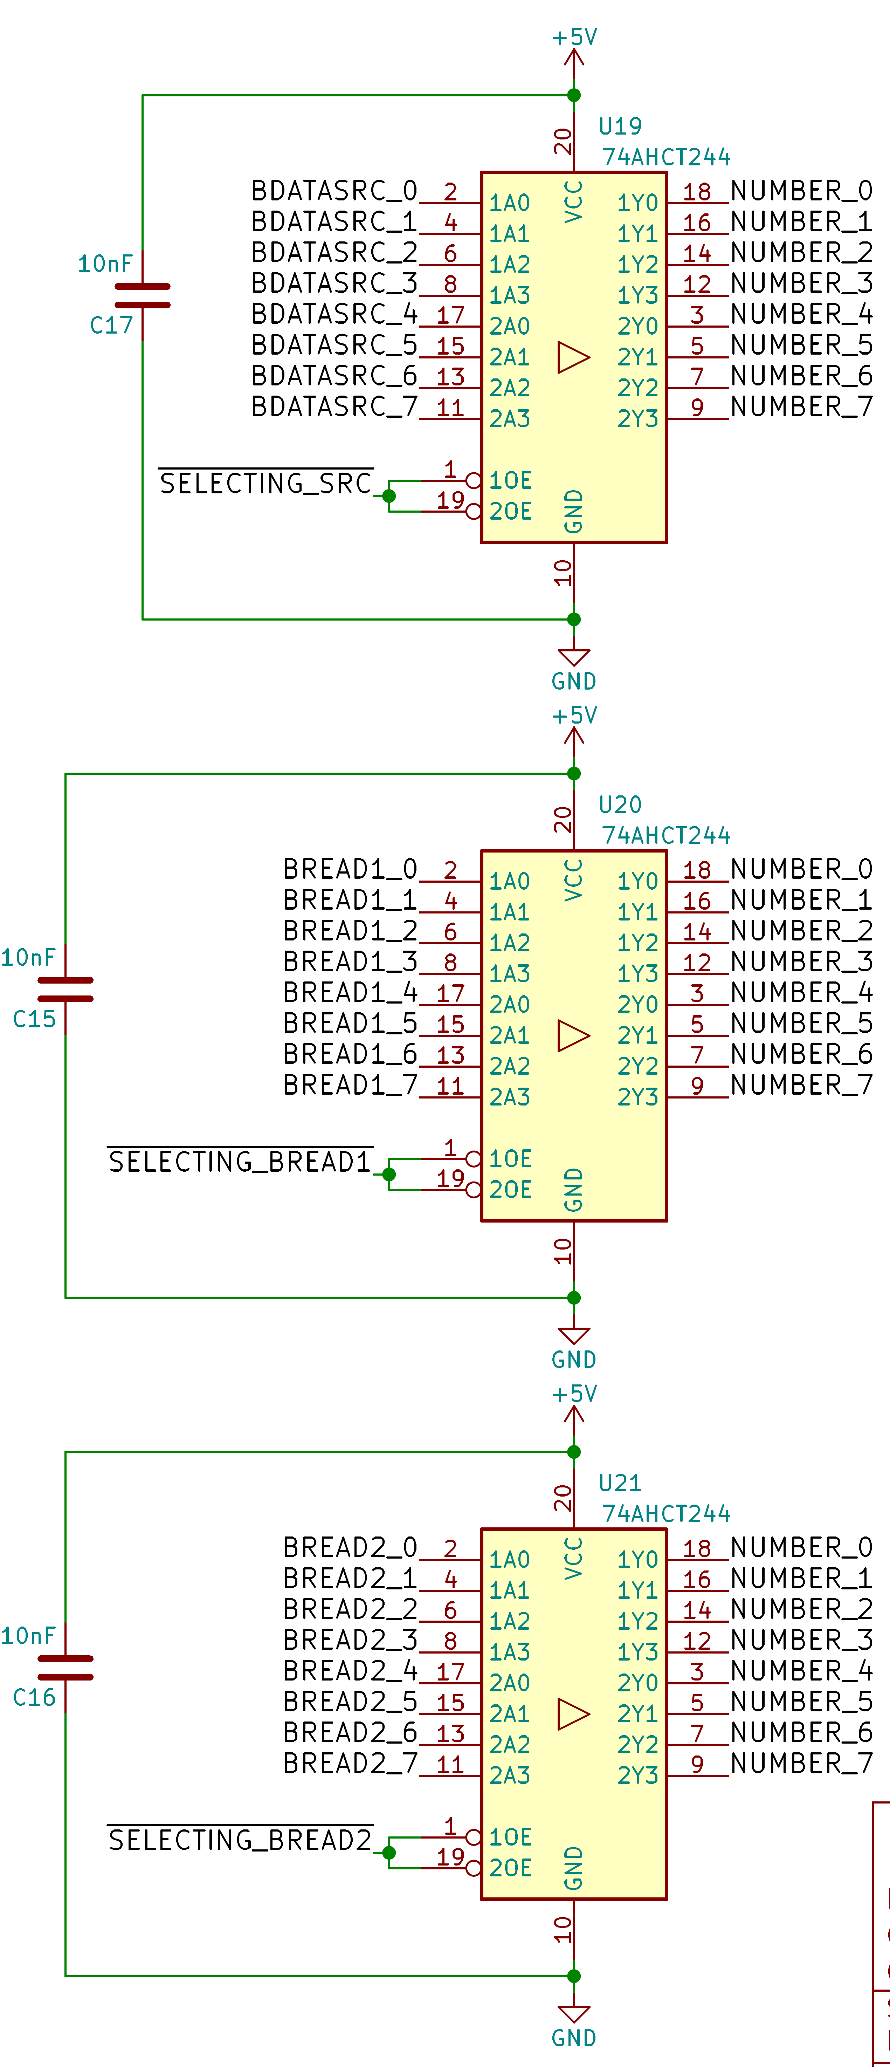
You can choose the value that goes into the “NUMBER” bus by changing the last 3bits of the instruction code.

You can choose 8 differents value :
- The source.
- BREAD1
- BREAD2
- Operation result
- RAM
- SPI
- External bus 1
- External bus 2

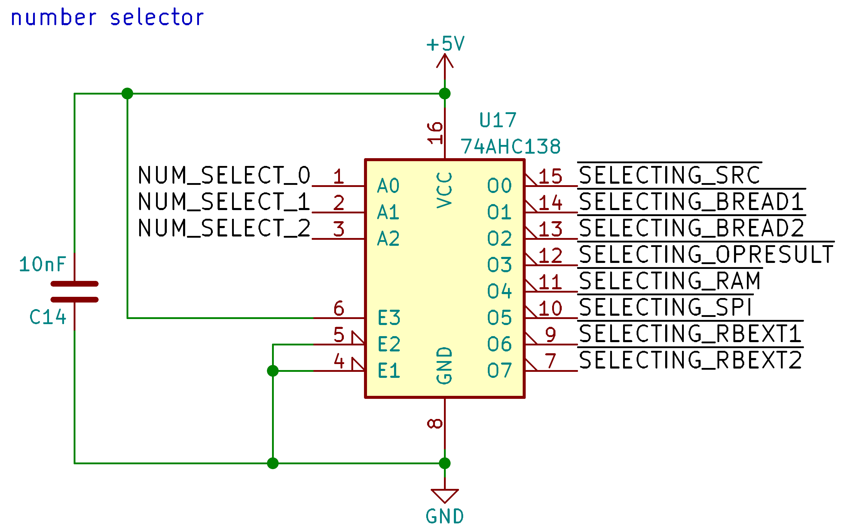

Instruction execution

Sequencer
The first main component is a 4bits counter that will receive the “GLOBAL_CLK” of the motherboard.
The goal of this chip is to provide, with the help of a demux, all the pulse required for executing instruction sequentially.
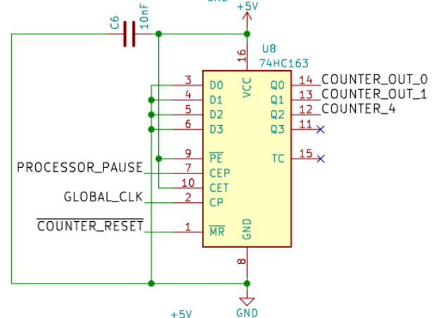
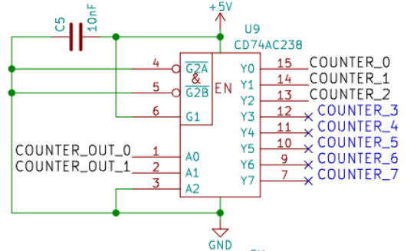

The 4bits count from 0 to 4, the fifth clock reset the counter to 0:
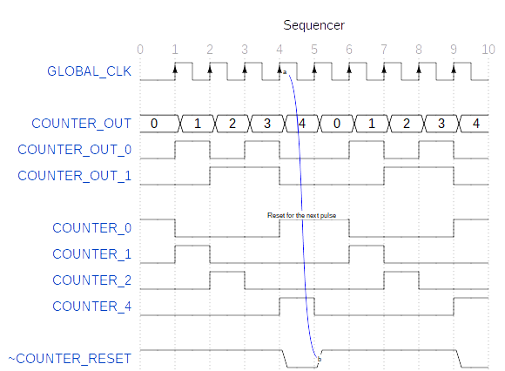

Every pulse from the sequencer represent a stat/action:

Sequence value | Action/Stat | Counter reset? | Next address? | Instruction latched?
0 | Sync bit | No | No | No
At this stat, no instruction are executed and the SYNC_BIT is pulled high, this serve only for syncing with an interface like a debugger and prepare the execution of the next instruction.
1 | Instruction set | No | Yes | Yes
A pulse have been made to ‘U7’ (8bit D-Latch) to save the instruction to execute and the next address is requested (the argument).
2 | Execution | Yes/No | Yes/No | No
“Simple instruction”: One pulse is made to execute the instruction and a reset/next address is requested.
“Complex instruction”: The first part of the instruction is executed with no reset:
IF/IFNOT: If the argument is valid (>0 or =0), then the next instruction is skipped (usually a JMPSRC_CLK instruction) by requesting the next address.
RAMW: The “output enable” pin is pulled high for write preparation.
Noting is executed for UOP/LTICK instructions.
3 | Waiting | No | No | No
At this stat, the processor do nothing (this stat is only useful for write preparation to the memory).
4 | RAM Write or END | Yes | Yes | No
Depending on the instruction:
RAMW: The RAM write the requested data by pulling low the “write enable” pin.
At the end, a reset and the next address is requested.

Simple instructions
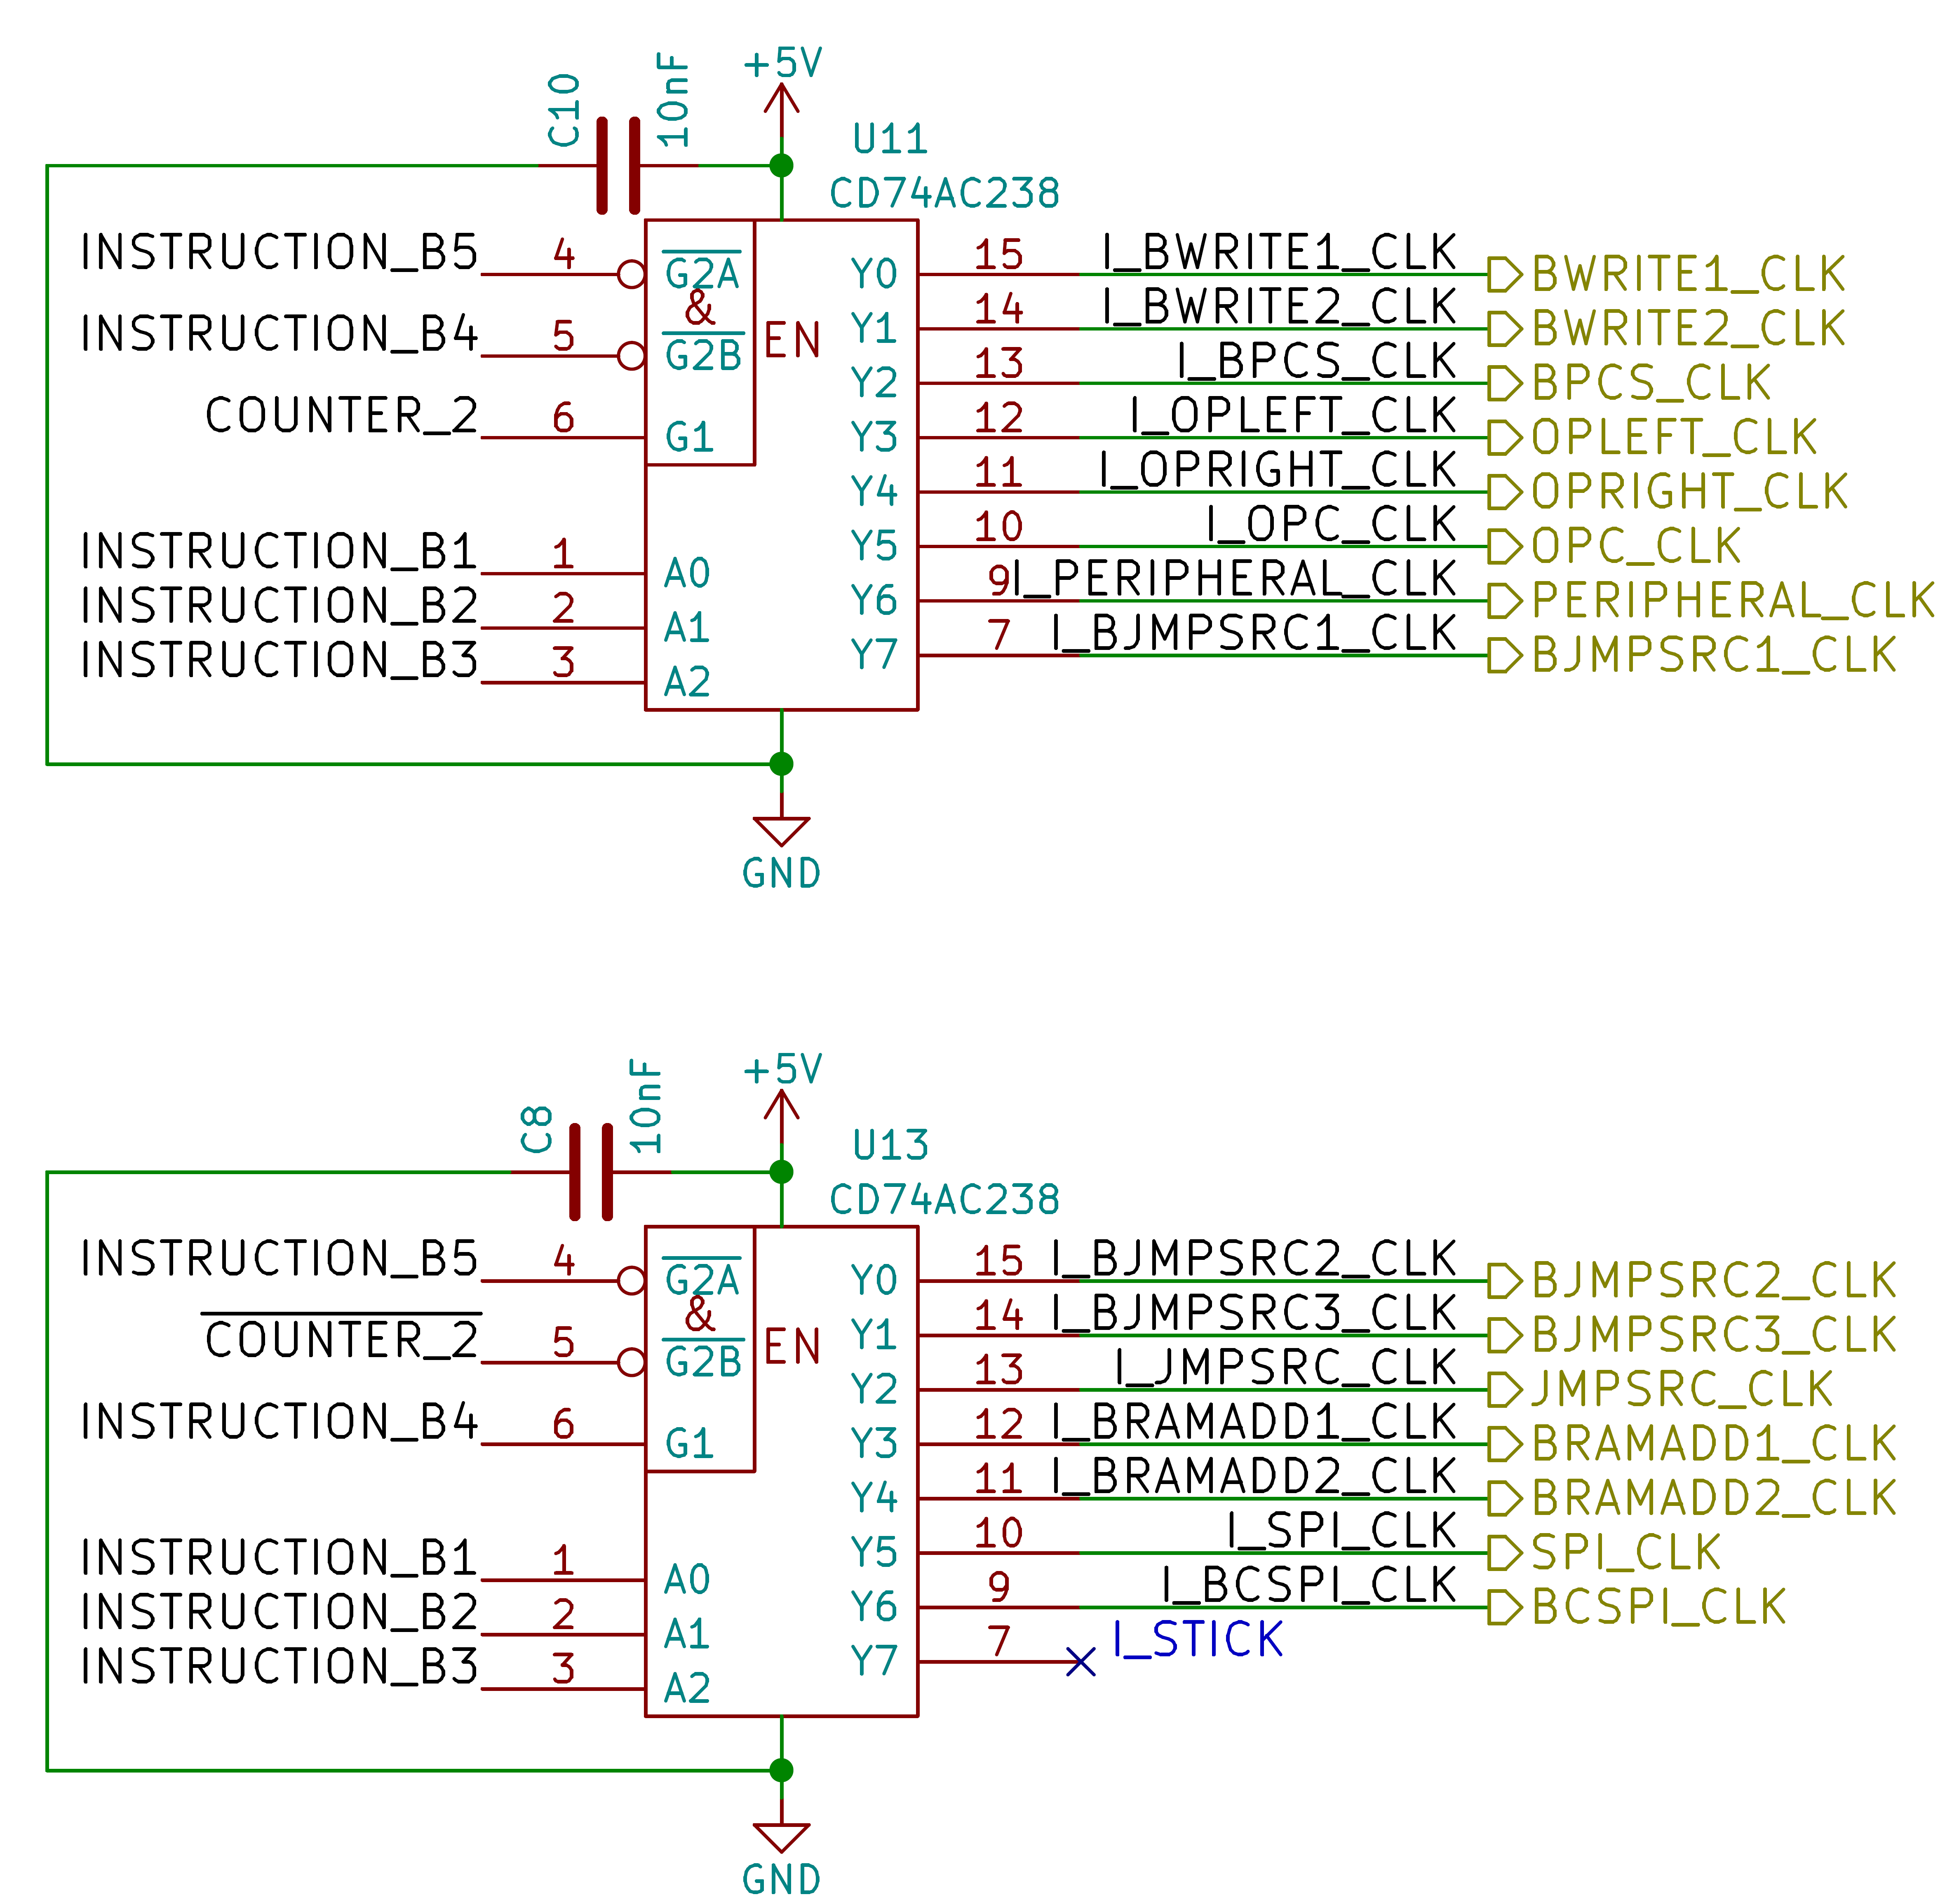
Simple instruction consist of just one pulse and an argument.
Every simple instruction is executed in 3 rising-edges from GLOBAL_CLK.

Opcode | Hex | Name | Description
xxx0’0000 | 0x00 | BWRITE1_CLK | Apply value to bus “write 1”.
xxx0’0001 | 0x01 | BWRITE2_CLK | Apply value to bus “write 2”.
xxx0’0010 | 0x02 | BPCS_CLK | Apply value to bus “peripheral CS”.
xxx0’0011 | 0x03 | OPLEFT_CLK | Apply value to the left operation.
xxx0’0100 | 0x04 | OPRIGHT_CLK | Apply value to the right operation.
xxx0’0101 | 0x05 | OPCHOOSE_CLK | Apply value for choosing the operation.
xxx0’0110 | 0x06 | PERIPHERAL_CLK | Send a clock pulse to the peripheral.
xxx0’0111 | 0x07 | BJMPSRC1_CLK | Apply value to bus “jump source 1”.
xxx0’1000 | 0x08 | BJMPSRC2_CLK | Apply value to bus “jump source 2”.
xxx0’1001 | 0x09 | BJMPSRC3_CLK | Apply value to bus “jump source 3”.
xxx0’1010 | 0x0A | JMPSRC_CLK | Jump to the address of “jump source”.
xxx0’1011 | 0x0B | BRAMADD1_CLK | Apply value to bus “RAM address 1”.
xxx0’1100 | 0x0C | BRAMADD2_CLK | Apply value to bus “RAM address 2”.
xxx0’1101 | 0x0D | SPI_CLK | Send a clock pulse for the SPI.
xxx0’1110 | 0x0E | BCFG_SPI_CLK | Apply value to the config bus SPI.
xxx0’1111 | 0x0F | STICK | Simple tick, do nothing (delay).

Complex instructions
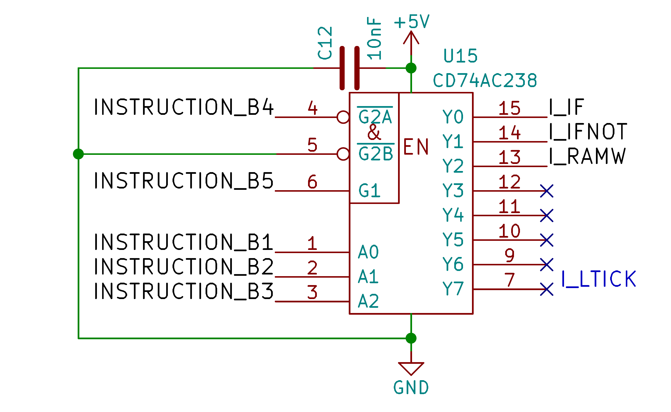
Complex instructions are instructions that takes 5 rising-edges from GLOBAL_CLK to execute.

Opcode | Hex | Name | Description
xxx1’0000 | 0x10 | IF | Conditional instruction.
xxx1’0001 | 0x11 | IFNOT | Conditional instruction inverted.
xxx1’0010 | 0x12 | RAMW | Write value to the actual address of the memory.
xxx1’0111 | 0x17 | LTICK | Long tick, do nothing (delay).

The RAMW instruction consist by pulling OE low when counter is at 2, and send a WE pulse when counter is at 4.
The conditional instruction consist of checking the argument when counter is at 2, if the argument is valid, the next instruction (usually a jump) is skipped else the next instruction is executed.

Arguments

The argument for an operation is selected by changing the last 3bits of the opcode :

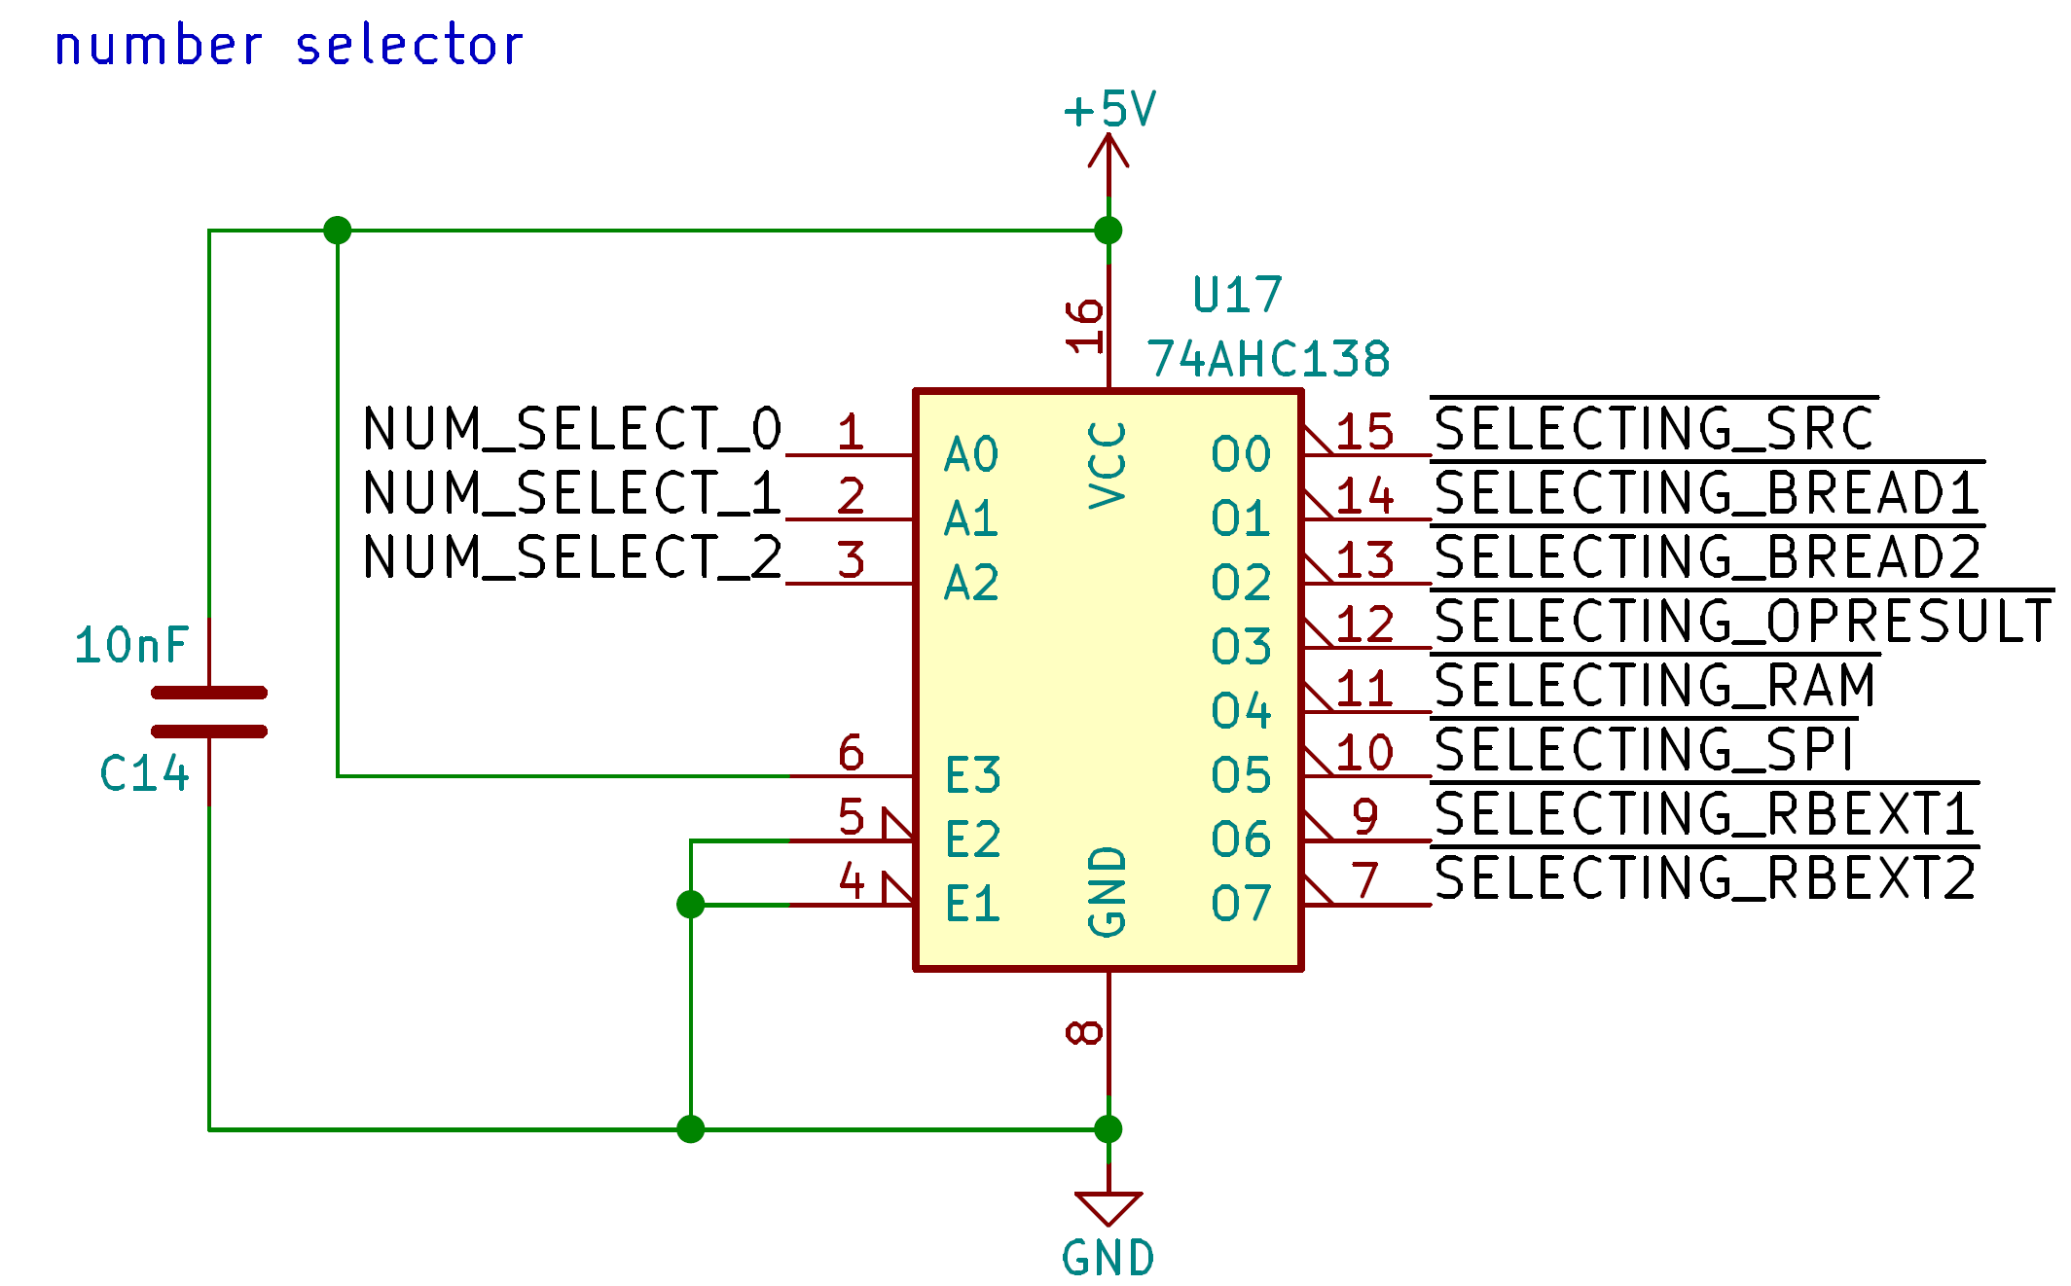
The 3bits, once latched, are connected to the demux “U17”.

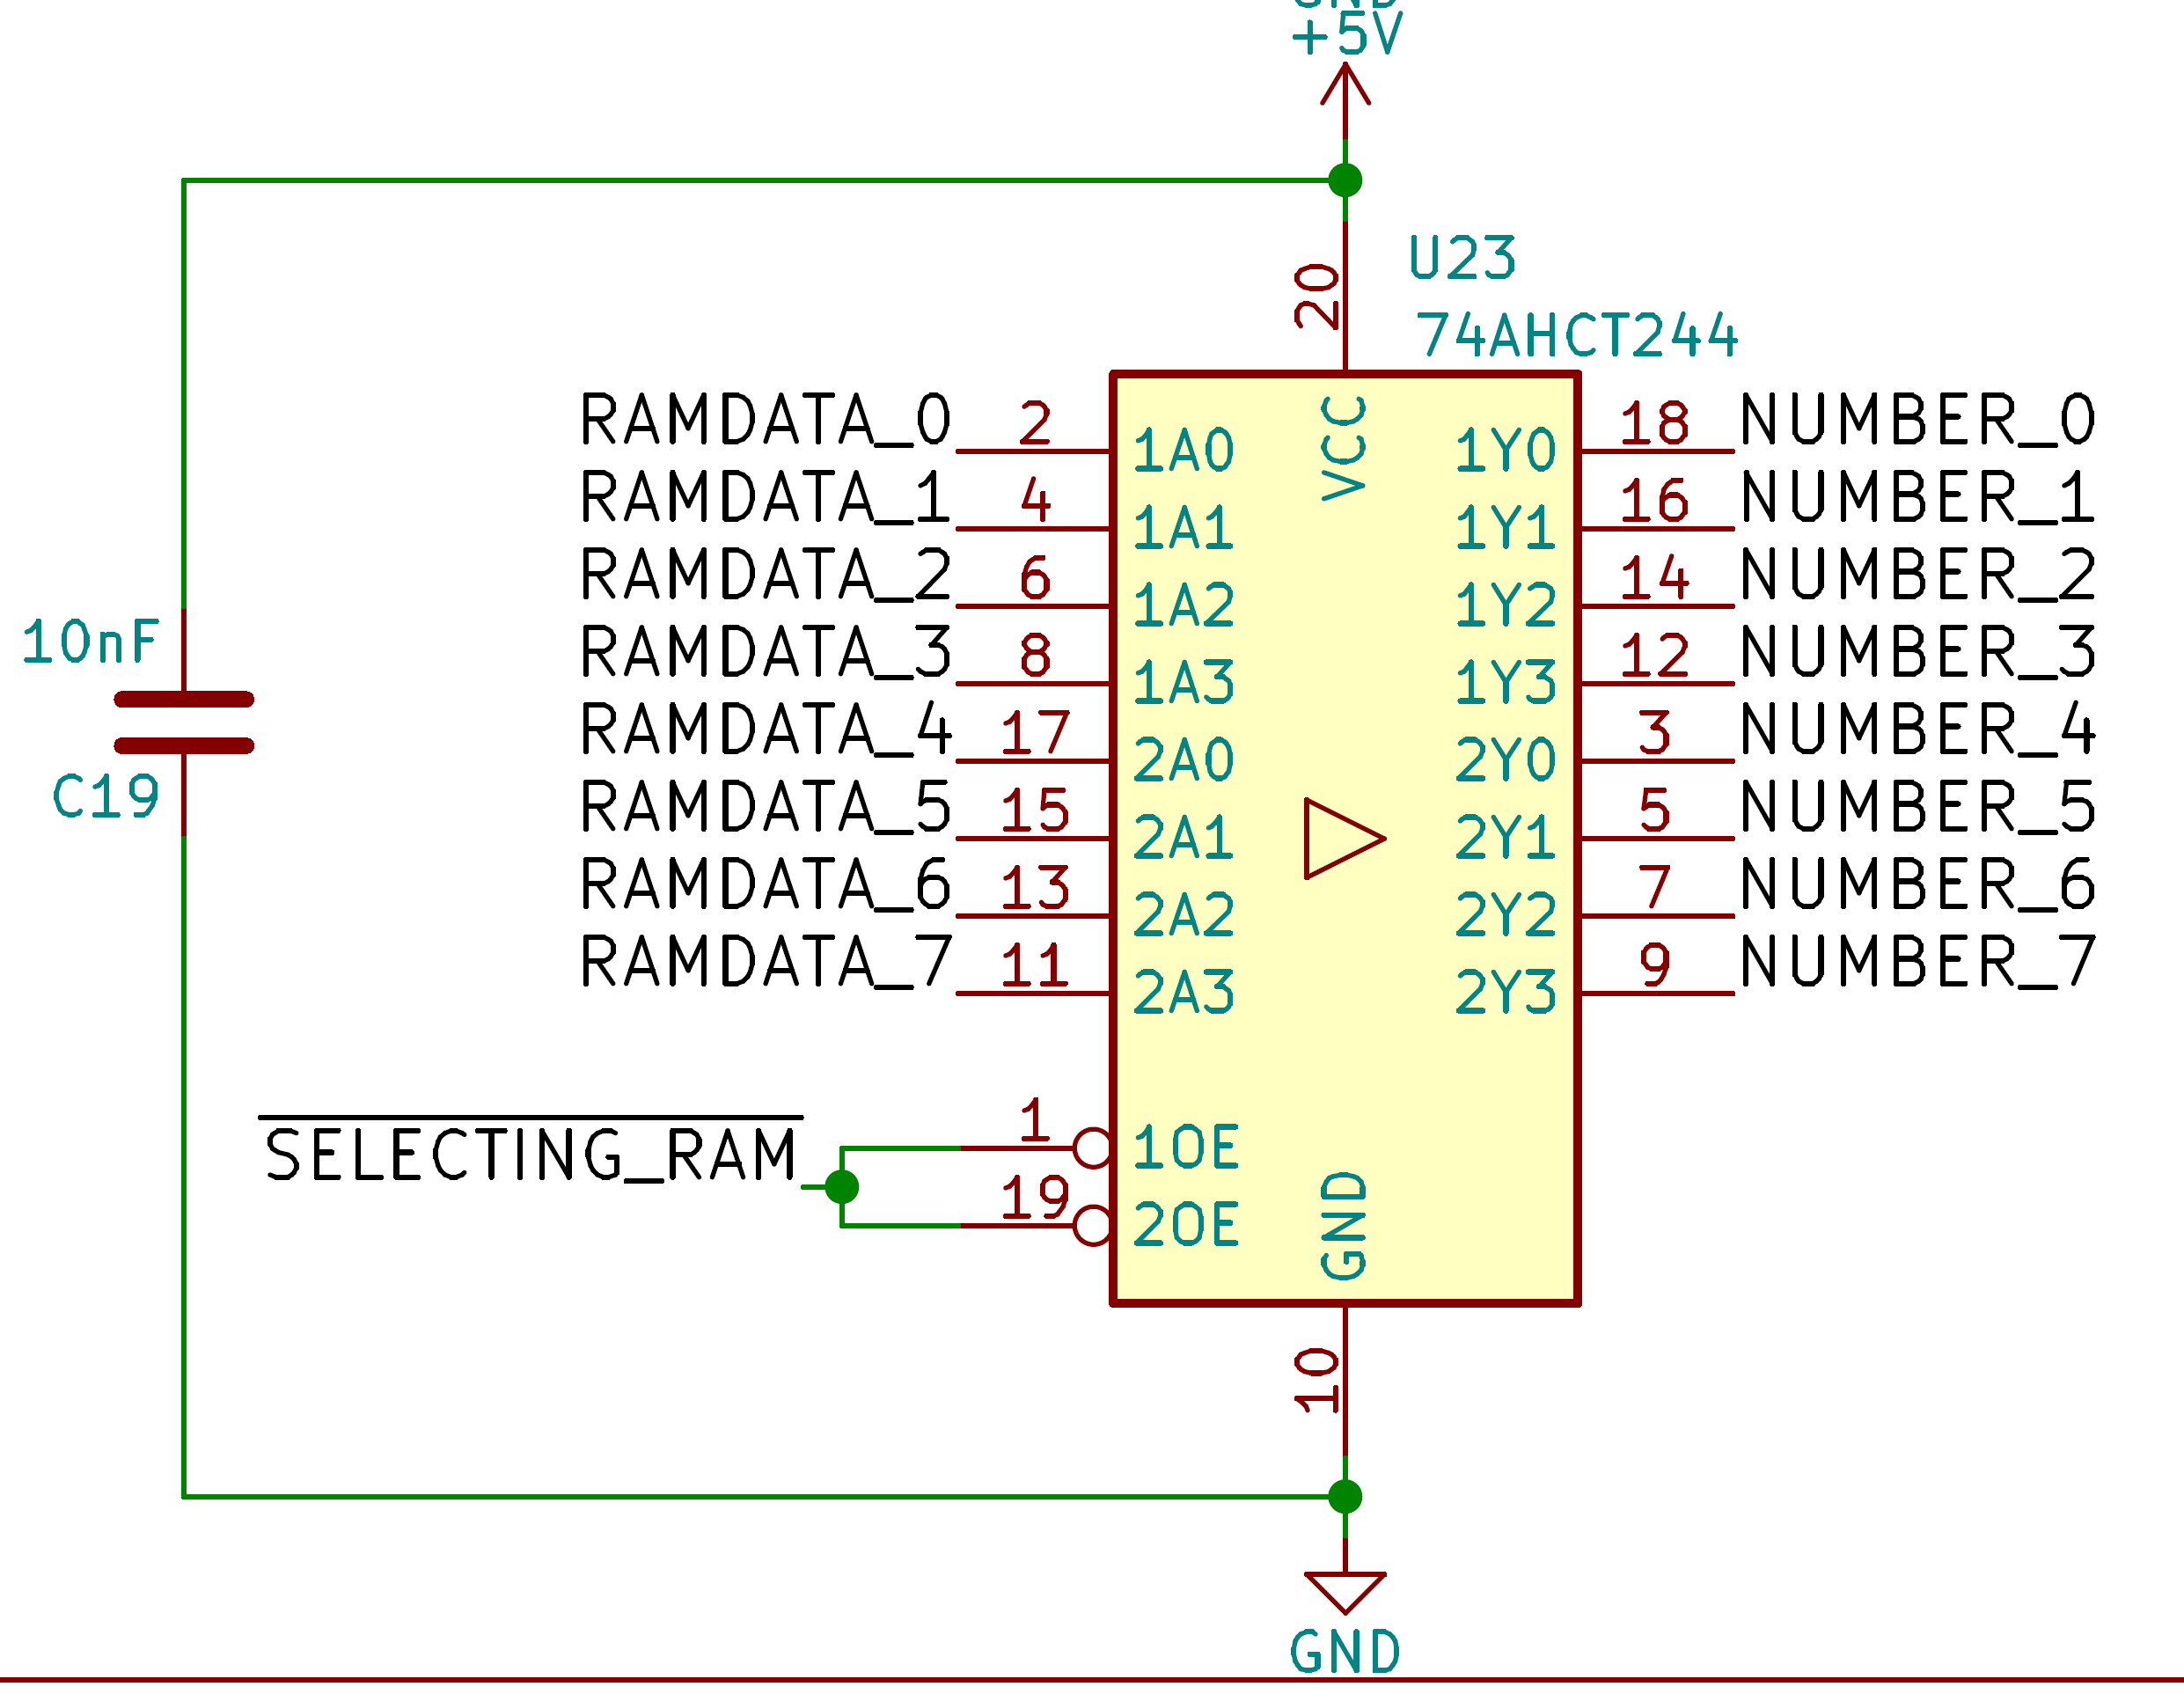
Every “SELECTING” line control a 8bits buffer with tri-state output and every buffer is connected to the argument bus “NUMBER”.

Opcode | Hex | Name | Description
000x’xxxx | 0x00 | SRCVALUE | The value stored to the source.
001x’xxxx | 0x20 | BREAD1 | The value of the read bus 1.
010x’xxxx | 0x40 | BREAD2 | The value of the read bus 2.
011x’xxxx | 0x60 | OPRESULT | The value of the operation result (ALU).
100x’xxxx | 0x80 | RAMVALUE | The value of the processor memory.
101x’xxxx | 0xA0 | SPI | The value of the SPI.
110x’xxxx | 0xC0 | EXT_1 | External value 1.
111x’xxxx | 0xE0 | EXT_2 | External value 2.

Fabrication

Getting the PCB
Fabrication files can be found in the folder : “documents/GP8B_gerbert”.

For JLCPCB, you can zip the fabrication folder and send it to them directly.

Getting the materials
A bill of materials can be found here : “documents/GP8B_materials”. Note that if you want to change the supplier, you have to make sur that the component is fully compatible mostly for the package.

Soldering
If you solder the board manually, a microscope can be useful for small component like the CPLD.
Follow the bill of materials and the PCB placement file to solder the board.

Changes
Revision 0:
initial release

