EXPERIMENT REPORT
KinyaLM Project Report
Performance of the 1,560 cumulative-step targeted adapter
Date: August 11, 2026
Status: Model-assisted development screen complete; native review pending
Model family: Gemma 4 12B with QLoRA adapters
Evaluation: 150 identical prompts per candidate; model identities hidden
BOTTOM LINE This is the strongest KinyaLM adapter trained so far and it shows clear gains in the skills that received targeted data. It still trails the unchanged Gemma model overall and repeats too often, so it remains a research candidate rather than the final release.

Executive Summary
The targeted adapter began from the original step-780 KinyaLM adapter and received 780 additional updates on a 3,858-row targeted curriculum. We therefore describe it as the 1,560 cumulative-step adapter. The second stage used a fresh optimizer and learning-rate schedule, so it was a continuation from trained adapter weights rather than one uninterrupted 1,560-step run.
On the same 150-prompt development screen, the targeted adapter passed 28 prompts. That is four more passes than both the source step-780 adapter and the control continuation, which each passed 24. The targeted curriculum therefore produced a measurable improvement over simply continuing training on the original mixture.
The unchanged Gemma base still passed 33 prompts and repeated far less often. The correct conclusion is not that fine-tuning has already beaten Gemma overall. The evidence shows that targeted supervised fine-tuning can strengthen selected Kinyarwanda abilities, while the present data and training recipe still damage other conversational behaviors.

How the Experiment Reached This Point

1. Finding a credible starting model
The project first compared several openly available multilingual models through direct Kinyarwanda conversation, translation, correction, and tutoring prompts. The smaller Qwen-family and Kinyarwanda-specialized candidates were inconsistent or too weak for the intended assistant. Gemma 4 12B was slower locally, but it was the first baseline that regularly produced coherent Kinyarwanda and useful bilingual explanations. That made it the model worth adapting rather than replacing.

2. Learning from adapters that became worse
The first fine-tuning attempts did not improve the user experience. Some checkpoints repeated a single sentence or phrase and ignored the conversation, even when training loss looked acceptable. Those failures changed the project’s method: loss could help monitor training, but it could not choose the final model. Every serious checkpoint would need fixed prompts, preserved outputs, side-by-side comparison with the base, and native-speaker inspection.

3. Making the experiment controlled
The team then froze a reviewed long-form training set, made the QLoRA scripts reproducible, and tested multiple learning rates while preserving checkpoints throughout training. The strongest full-epoch branch reached 780 optimizer updates. It was more promising than the earlier collapsed adapters, but the 150-prompt screen showed that it still trailed the unchanged base overall and remained vulnerable to repetition.

4. Training directly on observed weaknesses
Instead of merely adding more steps to the same mixture, the next curriculum was expanded to 3,858 rows and aimed more directly at the failures revealed by evaluation. The step-780 adapter supplied the starting weights, and the targeted stage added another 780 updates at a lower learning rate. This produced the current 1,560 cumulative-step adapter: the first continuation to improve clearly over both earlier adapter branches in the shared screen.

5. What progress means now
The project has moved from asking whether a Kinyarwanda adapter can train at all to identifying exactly which behaviors the data can improve and which ones it can accidentally erase. The present checkpoint is evidence of controllable learning, especially in grammar, correction, and Kinyarwanda-to-English translation. The remaining job is to preserve those gains while restoring the base model’s stronger conversation, uncertainty handling, and resistance to repetition.

Training Lineage
NAMING Use “1,560 cumulative-step targeted adapter” in presentations. In technical writing, also state that the final 780-step continuation restarted the optimizer and learning-rate schedule at 2e-6.
Stage | Starting point | Training data | Updates | Learning rate
Initial full epoch | Gemma 4 12B | 3,144 reviewed rows | 780 | 2e-5
Targeted continuation | Step-780 adapter | 3,858-row curriculum | +780 | 2e-6

Comparable Development Results
Each system answered the same prompts with the same system message, greedy decoding, 256-token output limit, base checkpoint, and MLX runtime. Candidate names were hidden from the model judge.
Candidate | Passes | Pass rate | Kinyarwanda score | Repetition
Unchanged Gemma 4 12B | 33/150 | 22.00% | 2.53/5 | 4.67%
Targeted adapter, 1,560 cumulative steps | 28/150 | 18.67% | 2.15/5 | 18.67%
Control continuation | 24/150 | 16.00% | 2.02/5 | 20.67%
Source adapter, step 780 | 24/150 | 16.00% | 2.03/5 | 20.67%
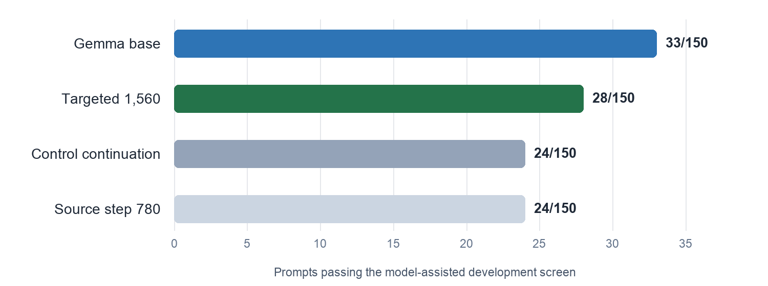
Figure 1. Model-assisted development-screen passes out of 150 prompts.
Relative to the earlier adapters, the targeted continuation gained four passes, or 2.67 percentage points. Relative to the unchanged base, it recovered 16 prompts that Gemma failed but regressed on 21 prompts that Gemma passed. The paired 95% confidence interval was -11.33 to +4.67 percentage points, so this screen does not establish a reliable overall win over Gemma.

Where the Targeted Curriculum Helped
Capability | Gemma base | Targeted | Change
Morphology and grammar | 10% | 20% | +10 pp
Sentence correction | 10% | 25% | +15 pp
Kinyarwanda to English | 40% | 60% | +20 pp
These category gains are the clearest evidence that the adapter learned from the targeted curriculum. They matter because they match three central KinyaLM goals: explaining language structure, correcting learner mistakes, and supporting bilingual understanding. They remain development signals rather than final product claims because each category contains a small number of prompts and the current scoring was performed by a model judge.

Where Performance Still Regressed
Capability | Gemma base | Targeted
Ambiguity and uncertainty | 80% | 20%
Greetings | 40% | 10%
Reading and multi-turn consistency | 20% | 0%
Dialogue | 10% | 0%
English to Kinyarwanda | 20% | 10%
RELEASE BLOCKER The targeted adapter repeated on 28 of 150 prompts, compared with seven for the base. In one live correction test, it consumed the full output allowance repeating the same word while the base supplied a useful correction. This behavior must be fixed before promotion.

What the Result Means
The experiment supports a narrower and more useful conclusion than a simple “fine-tuning worked” claim. Targeted supervised data changed the model in the intended direction, and the targeted continuation outperformed two earlier adapters. At the same time, the adapter did not preserve enough of Gemma’s general conversational stability. More steps alone are therefore unlikely to be the complete answer; the next training mixture must explicitly protect the abilities that regressed.
The evaluation is also a development screen, not a final benchmark. The 150 prompts may overlap conceptually with examples used while shaping the training data, and the scores come from a model judge. Native-speaker review and a new hidden test set are required before any public claim that KinyaLM outperforms its base model.

Recommended Next Step
Keep this checkpoint as the leading adapter candidate, but keep the unchanged Gemma model as the performance baseline. Review the 16 recovered prompts and 21 regressions side by side, retain examples responsible for the Kinyarwanda gains, and add carefully rewritten demonstrations for greetings, uncertainty, dialogue, context retention, English-to-Kinyarwanda translation, and non-repetitive stopping behavior.
The next adapter should be selected by identical blinded generation and native review, not by validation loss alone. Promotion should require a clear overall advantage on a new hidden set and no unacceptable repetition failures.

Reproducibility Record
Item | Pinned value
Base checkpoint | mlx-community/gemma-4-12B-it-qat-4bit@e70c6b3ba097
Targeted adapter | kinyalm/kinyalm-gemma-4-12b-continuation-targeted-lr2e6
Adapter revision | 274504f7bcd029230ea6dfe04bc251964642bbda
Converted adapter SHA-256 | 30fd3c2796843e9f38c42614a3401d66a4d904f1ab770fbf8454a245c913e544
Targeted data revision | 55e8704731fdcbf589da91768bc8739c0ae741b5
Evaluation judge | Gemini 3.1 Pro; 600/600 blinded rows completed
Evaluation role | Development screening; native final evaluation pending
Hugging Face adapter: kinyalm-gemma-4-12b-continuation-targeted-lr2e6

