AI in Browser

Face Mask Detection

Step 1: Load the script files into the editor/visual studio code.

Step 2: Open the index.html on a live server (supported by Node.js).

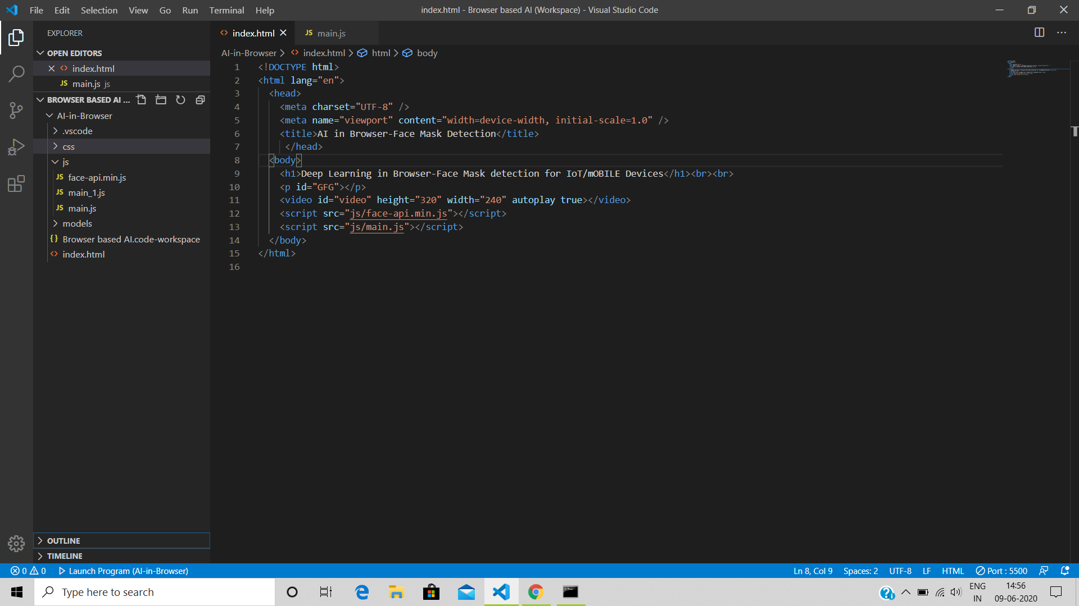

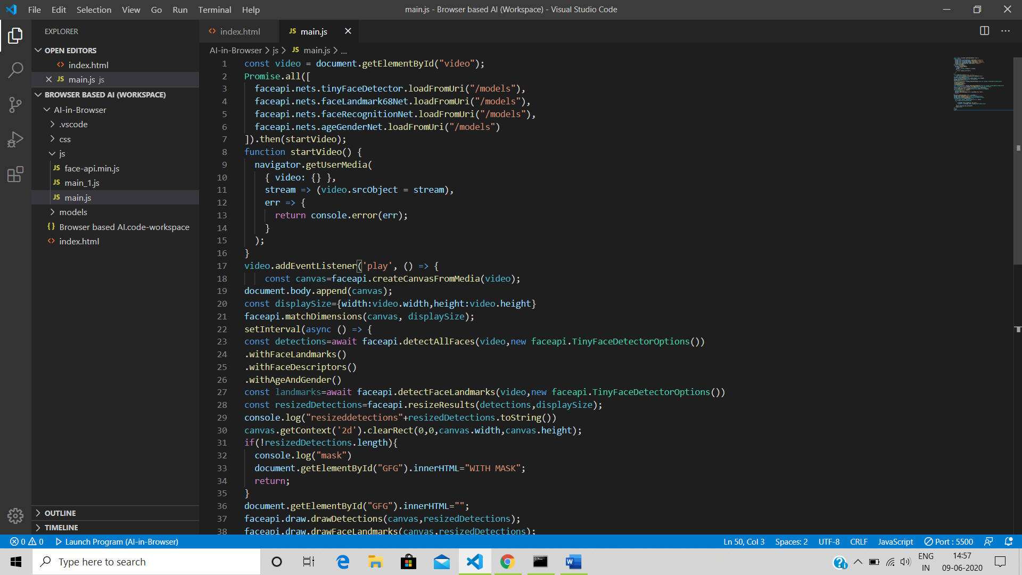

Step 3: See the Output

:Without Mask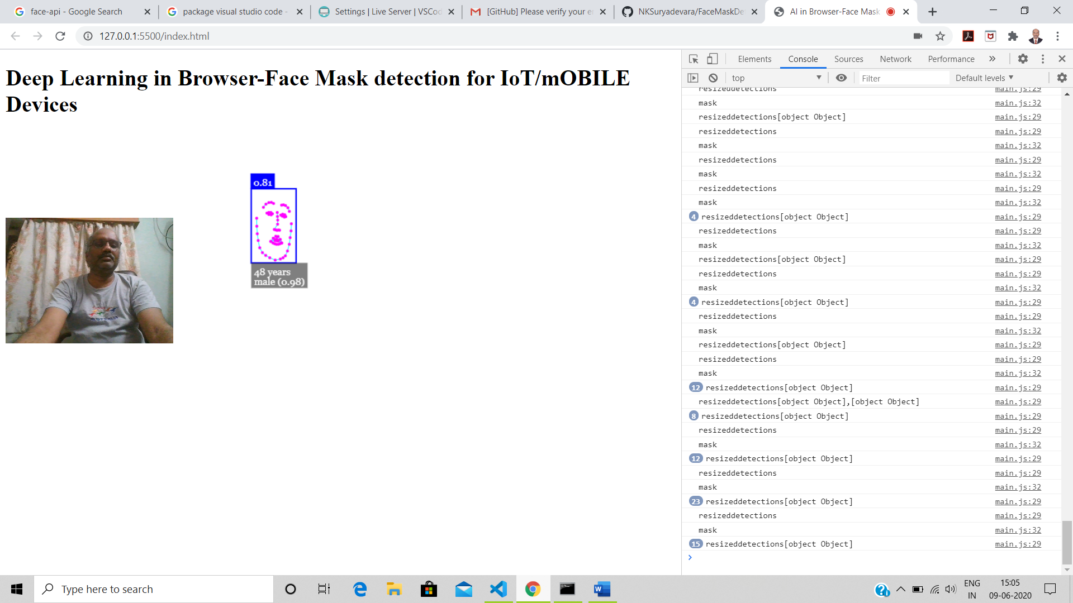

With Mask

