Good day

Hope you’re doing well.

I have attached the screenshots of Angular 13 + .Net Core 3.1. I used entity framework as the ORM, also used Auto Mapper to map my models and view models back and forth.

1. **Backend**

**Swagger UI**

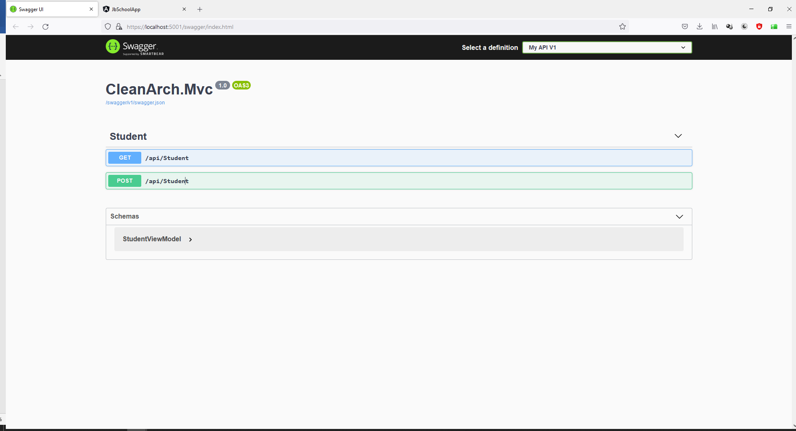

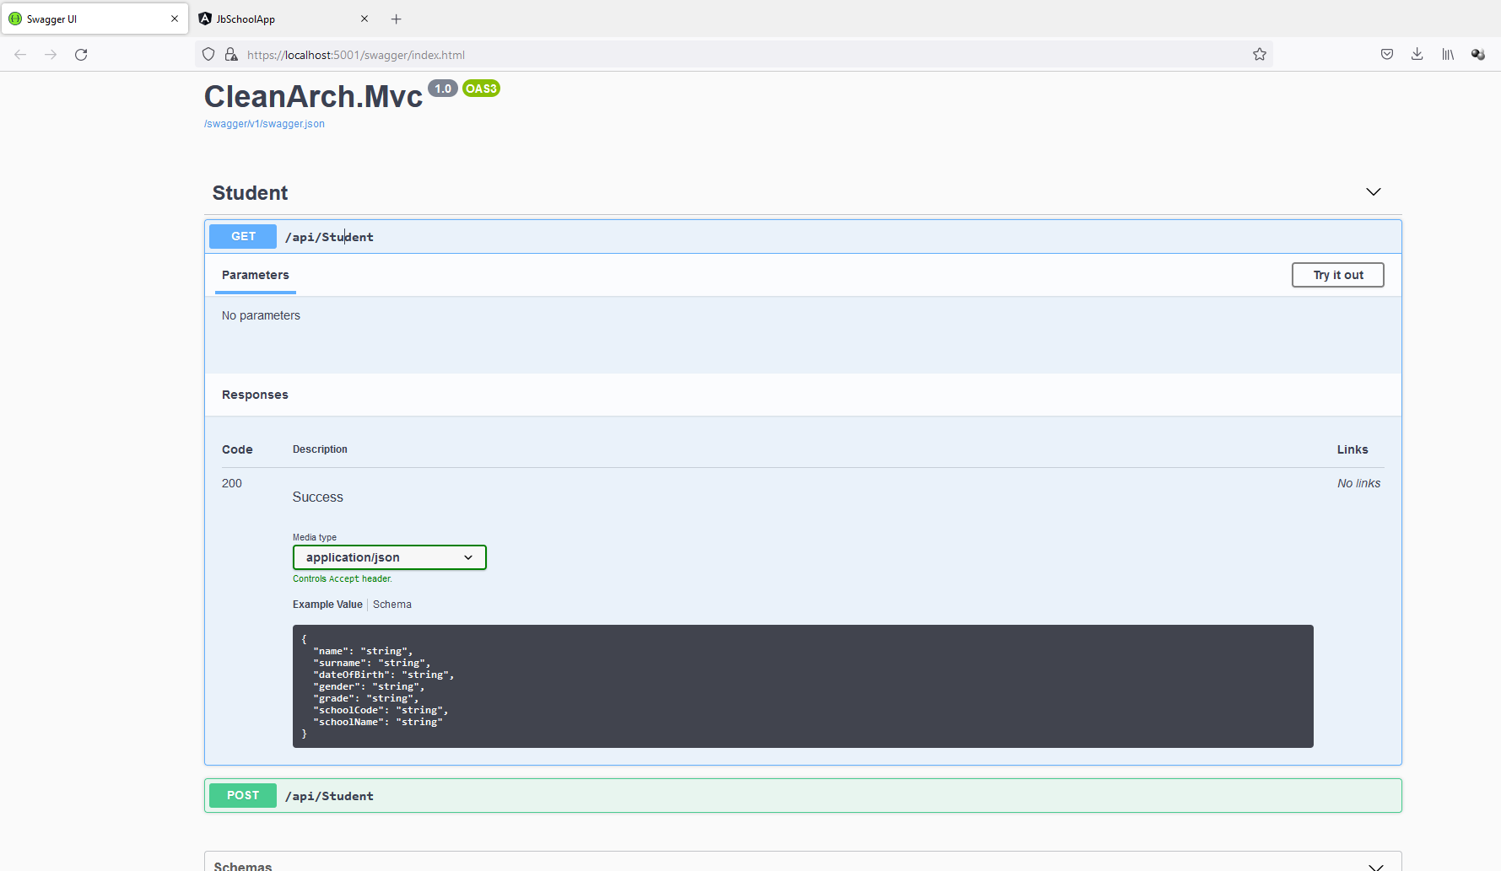

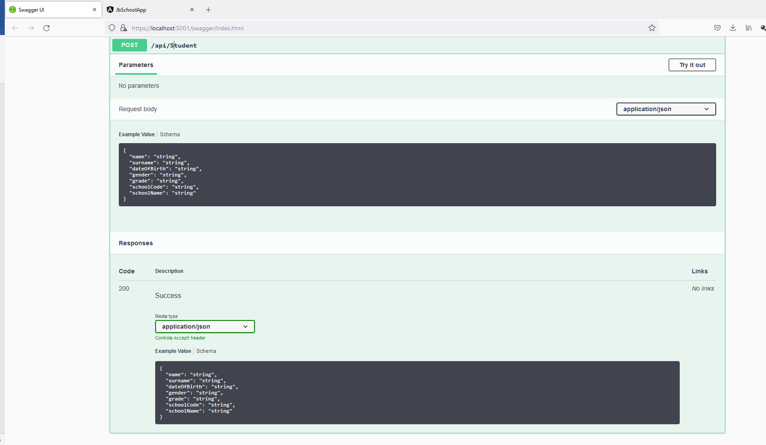

1. **FRONTEND**

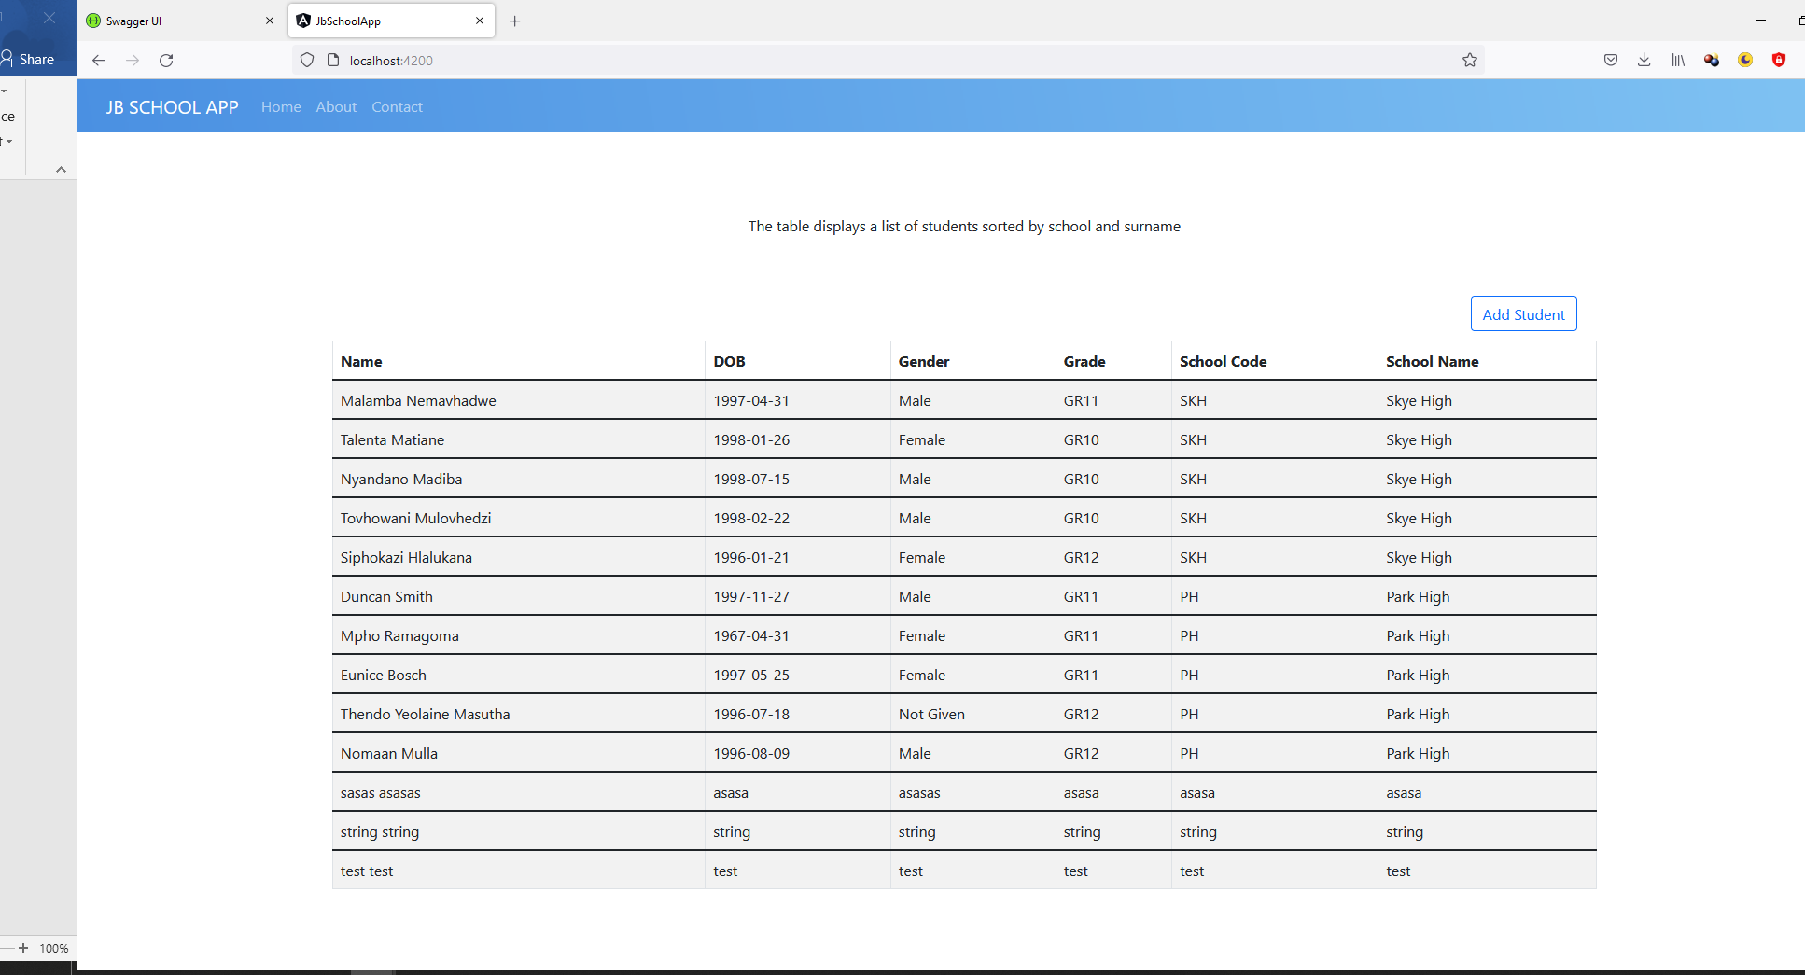

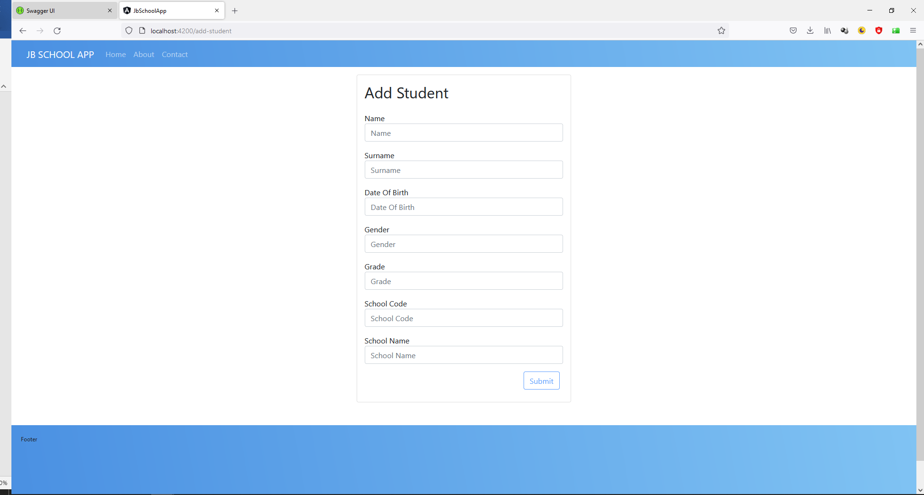

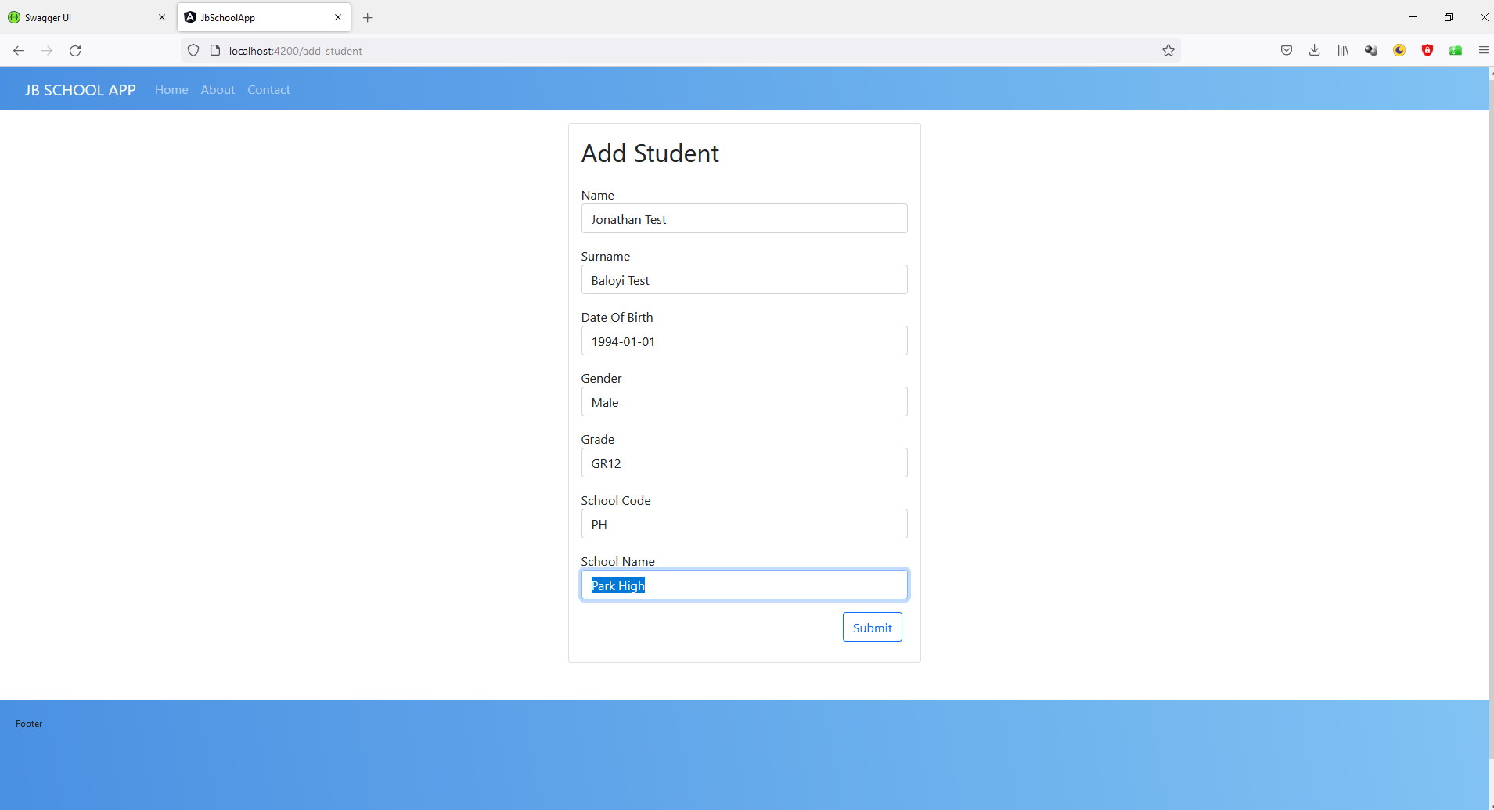

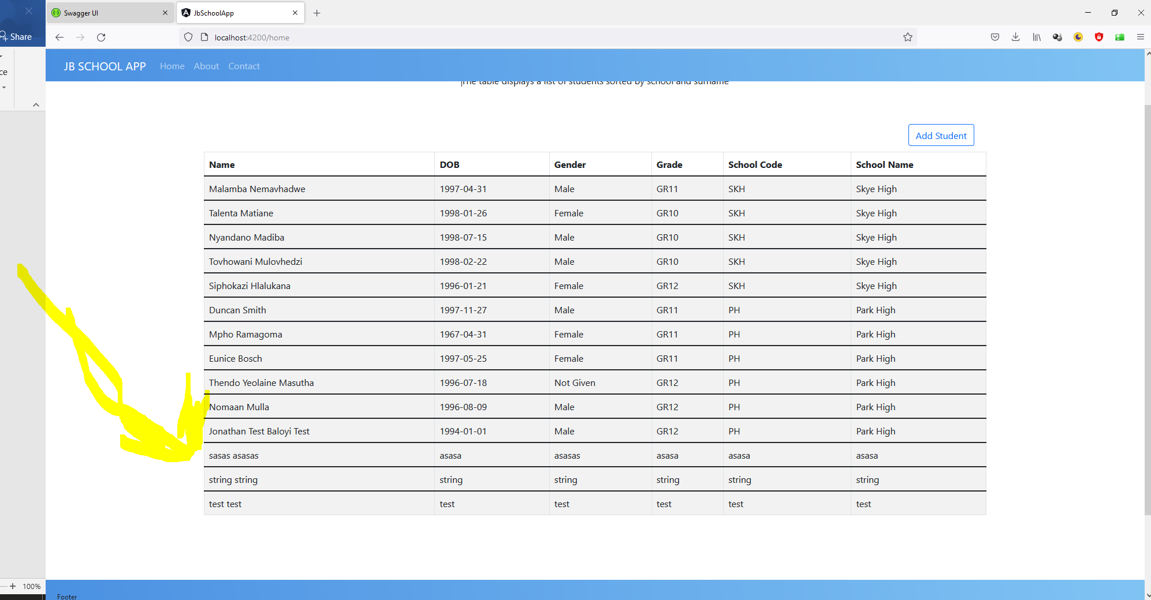

**Kind Regards**

**Jonathan Baloyi**