Group 1

LERATO ORPHANAGE: DIGITAL TRANSFORMATION Phase 2

Table of Contents
Group 1 Participants: 2
Children and Parents 3
Children and Services 3
Children and Activities 3
Parents and Programs 3
Employees and Volunteers 3
Donors, Sponsors, and Financial Records 4
Governance 4
Alumni 4
ER diagram 0
1
Logical design (Logical data model) 2


Group 1 Participants:
Nyengedzo Jonathan Cherane
Database Manager/Group Leader,
45683638


Marthinus von Holtzhausen,
Database Administrator,
45628467

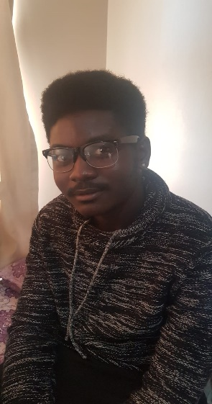
Tanyi Samuel Mthuli,
Lead Database Designer,
45672202
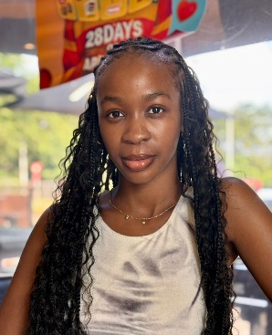

Muvhuya Shanel Kwinda,
Database Designer (Support),

42651530

Neo Von Benecke,
Database Analyst,
40898253

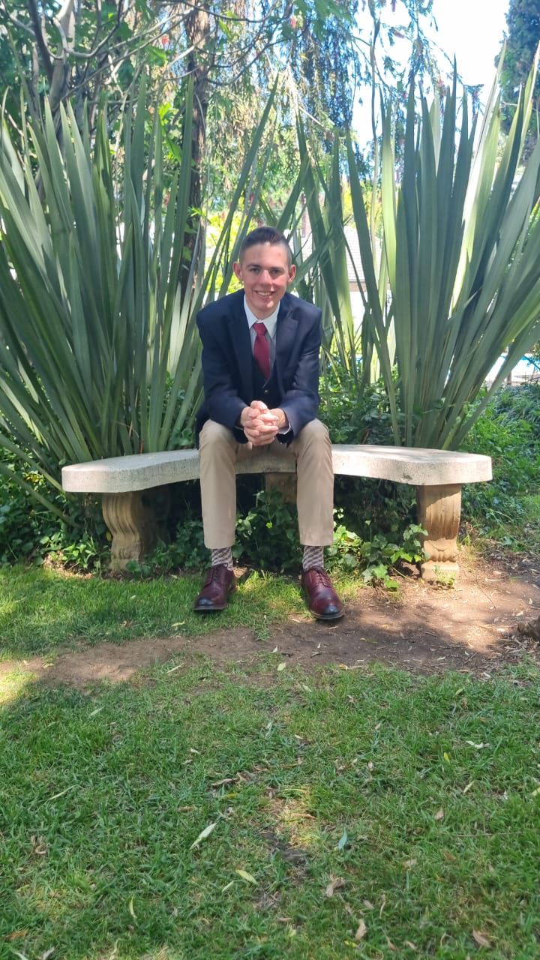
Henko van Greunen,
Database Builder
50258796
Business Rules for Lerato Orphanage

Children and Parents
- A Child must be linked to at least one and at most two Biological Parents.
- A Biological Parent may be linked to many Children.
- A Child may be assigned to zero or one Foster Family at a time.
- A Foster Family may foster many Children.
- A Child may be adopted by zero or one Adoptive Family.
- An Adoptive Family may adopt many Children.

Children and Services
- A Child may be assigned to many Healthcare Providers.
- A Healthcare Provider may be assigned to many Children.
- A Child may be taught by many Teachers/Tutors.
- A Teacher/Tutor may teach many Children.
- A Child may be supported by many Counsellors.
- A Counsellor may handle many Children.

Children and Activities
- A Child may participate in many Events.
- An Event may involve many Children.
- A Child may participate in many Training Programs.
- A Training Program may include many Children.

Parents and Programs
- A Parent (Foster or Adoptive) may participate in many Training Programs.
- A Training Program may include many Parents.

Employees and Volunteers
- An Employee must have one role.
- An Employee may be assigned to many Children or administrative tasks.
- A Volunteer may participate in many Events.
- An Event may involve many Volunteers.
- A Volunteer may assist many Children.
- A Child may be assisted by many Volunteers.

Donors, Sponsors, and Financial Records
- A Donor may make many Donations.
- A Donation must be linked to one Donor.
- A Sponsor may support many Sponsorships.
- A Sponsorship must be linked to one Sponsor.
- A Financial Record must be linked to one Donor, Sponsor, or Event.
- A Donor, Sponsor, or Event may be linked to many Financial Records.

Governance
- A Board Member may oversee many Events and Financial Records.
- An Event or Financial Record may be overseen by many Board Members.
- A Government Authority may conduct many Inspections.
- An Inspection must be linked to one Government Authority.

Alumni
- An Alumni record must be linked to one Child.
- A Child may have one Alumni record after leaving the orphanage.
- An Alumni may participate in many Events.
- An Event may include many Alumni.

ER diagram
To view the ERD, you have to zoom in to at least 160% to see the full details. When we tried division, unfortunately, there was less detail, which made the whole document unprofessional and bulky.
Thank you for understanding.
ERD is on the next page.

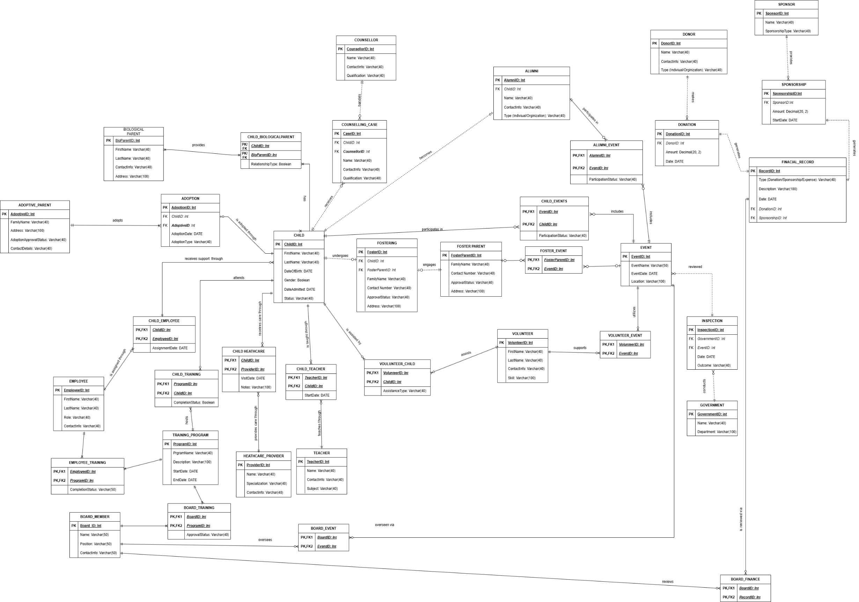

Logical design (Logical data model)
To view the LDM, you have to zoom in to at least 160% to see the full details. When we tried division, unfortunately, there was less detail, which made the whole document unprofessional and bulky.
Thank you for understanding.
LDM is on the next page.

