Assignment 11 Markdown File

Jonathan

March 30, 2017

# SNP 500

This document is a word document generated by the markdown file availible at the following link: <https://github.com/Jonathan-Knowles/Assignment11>.

## Install required packages and load them.

### Install Packages

install.packages("tseries", repos='http://cran.us.r-project.org')

## Installing package into 'C:/Users/Jonathan/Documents/R/win-library/3.3'  
## (as 'lib' is unspecified)

## package 'tseries' successfully unpacked and MD5 sums checked  
##   
## The downloaded binary packages are in  
## C:\Users\Jonathan\AppData\Local\Temp\RtmpuctOGY\downloaded_packages

### Load Packages

library(tseries)

## Warning: package 'tseries' was built under R version 3.3.3

## Gather Data

SNPdata <- get.hist.quote('^gspc',quote="Close")

## Calculate the Log returns.

SNPret <- log(lag(SNPdata)) - log(SNPdata)

## Calculate the volatility measure.

SNPvol <- sd(SNPret) * sqrt(250) * 100

## Create function determining volatility.

getVol <- function(d, logrets) {  
 var = 0  
 lam = 0  
 varlist <- c()  
   
 for (r in logrets) {  
 lam = lam*(1 - 1/d) + 1  
 var = (1 - 1/lam)*var + (1/lam)*r^2  
 varlist <- c(varlist, var)  
 }  
   
 sqrt(varlist)  
}

## Calculate the volatility measure of the entire series using 3 different decay factors.

### Factor of 10

volest <- getVol(10, SNPret)

### Factor of 30

volest2 <- getVol(30, SNPret)

### Factor of 100

volest3 <- getVol(100, SNPret)

## Plotting the data.

plot(volest,type="l")  
lines(volest2, type="l",col="red")  
lines(volest3, type="l",col="blue")

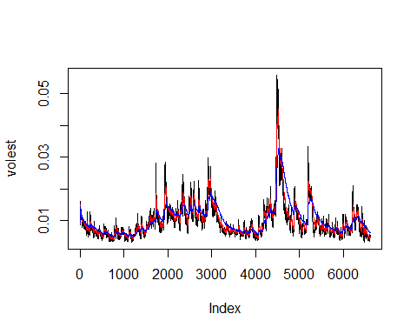

print.eval = TRUE