**What is Blockchain: Explained for Beginners**

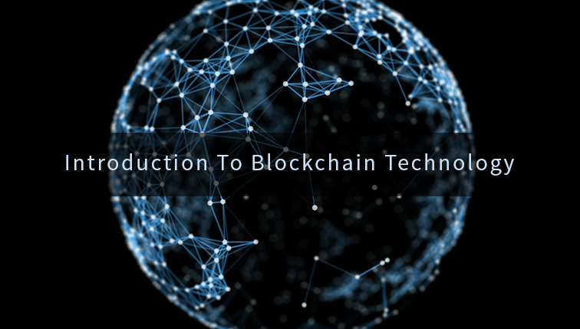

WHY YOU SHOULD CARE

The industry of blockchain promises to change dozens of industries from financial tools and payments to real estate and voting. The space has attracted billions of dollars in investments from some of the biggest firms (Fidelity, IBM, JP Morgan) and has spawned several Unicorns ([11 and counting](https://coinmarketcap.com/)). Already millions of people around the world are using blockchain to save money and make their lives easier. Understanding this technology is the first step to be able to benefit from its strengths and profit from its explosion.

IN SHORT

It’s not often a single technology comes around and changes an entire industry. It’s even more rare that a single technology rises to challenge incumbents in dozens of industries, but that’s exactly what the new technology of Blockchain is busy doing. Spawning such billion-dollar projects as Bitcoin, Ethereum, and Ripple, as well as thousands of other Digital Currencies (Cryptocurrencies), blockchain promises to reshape the way we think about money.

With new processes like Initial Coin Offerings (ICOs), blockchain is changing the way startups raise money, and making it possible for ordinary people to invest in what was once only available to Venture Capitalists. This technology is creating better products and services in Real Estate ([BitProperty](http://www.newsbtc.com/2017/10/03/bitproperty-announces-token-sale-beta-release-real-estate-investment-platform/)), Online Publishing ([Steemit](https://steemit.com)), Voting and Elections ([VoteLock](https://www.votelock.com)), Investments ([Iconiq Lab](https://iconiqlab.com/)), Remittances ([see article](https://cointelegraph.com/news/receiving-remittances-in-india-with-rupee-you-lose-with-bitcoin-you-profit)), the Internet of Things ([IOTA](http://iota.org/)), etc., etc.; [the list](https://www.stateofthedapps.com/) goes on.

WHAT IT IS

Blockchain is a public record of transactions. It’s also distributed, so instead of one person controlling everything, there are thousands of computers around the world connected to a network, and these thousands of computers together come to an agreement on which transactions are valid.

Whenever someone makes a transaction, it is broadcasted to the network, and the computers run complex algorithms to determine if the transaction is valid. If it is, they add it to the record of transactions, linking it to the previous transaction. This chain of linked transactions is known as the blockchain. Since the transactions all reference the one before them, you can figure out which ones came first, thus ordering them.

SECURITY

This process is also a lot more secure than a traditional database: Since thousands of computers are involved in validating transactions, to hack the network you need to break into not one computer, but thousands of computers spread throughout the world: much harder. Also, all of these computers keep records of the blockchain, so if you want to manipulate it, you again need to manipulate it on thousands of computers at once. This is a feat that is significantly more difficult than hacking a traditional database, and no one has managed to come close to ever hacking a blockchain.

COST

Blockchain also has the potential to reduce costs and eliminate a lot of waste. It’s shared, public ledger can make the job of auditing records much faster and easier, but the big gains here come from Smart Contracts. Smart Contracts are simply pieces of code that sit on the blockchain. What makes them special is that because they are a part of the blockchain, no one can manipulate them. Anyone can write a Smart Contract and add it to the blockchain, but once there, it acts exactly as it was programmed to act: everyone can see exactly how it behaves, and no one can alter it.

Of course, if everyone wanted to change the contract, you could do this by making a new one and all agreeing to use that, but the old one would remain unaltered. In other words, to change the deal, everyone has to agree to move to a new Smart Contract, and no one can do this without consent of the other parties; no one can unilaterally change the terms of the agreement. This means there is now an incorruptible trusted means of conducting transactions, whether it is the sale of a house or the passage of a law: the rules are clear and can’t be changed.

A NEW FRONTIER

This immutable, transparent means of conducting transactions through a smart contract has profound implications for how we buy and sell goods, exchange information, and agree on what is true. In this new world, we don’t need to trust another party, we can always verify the contract, its contents, and its history for ourselves. We don’t need to worry about Facebook or Google algorithms manipulating the news (on a Smart Contract, everyone could see how the algorithm works). Corrupt governments and hackers can’t rig elections when voting records are designed to be uneditable. This is a major shift in thinking that opens up worlds of new possibilities, and the benefits are still just emerging (checkout [this list](https://www.stateofthedapps.com/) for just a few of these new projects).

BUT HOW CAN YOU USE IT

Some projects, like Steemit for publishing content, or Abra for currency exchanges, simply let you make an account like a normal app. Other projects like Bitcoin let you have a lot more control, but then require more effort. There are plenty of free wallets available for receiving or sending bitcoin (such as [this guide](https://blog.coingate.com/2017/02/setup-electrum-guide/) to using Electrum Wallets). Other tools act like blockchain scanners, allowing you to look up the details of a given transaction or wallet, just by looking up its address (Also called ‘Block Explorers’: checkout [etherscan](https://etherscan.io/) for searching the Ethereum Blockchain, or [blockchain.info](https://blockchain.info/) for the Bitcoin Blockchain).

HOW CAN YOU MAKE MONEY

Investing is the easiest way to make money with blockchain, and the best part is that blockchain is specifically designed to be easy to invest in. You don’t need to be a Venture Capitalist of Accredited Investor to buy in to blockchain. It’s as easy as setting up an account on Bittrex, Coinbase, Poloniex, or any number of other online exchanges, and you can start buying ‘cryptocurrencies’ and ‘tokens’, the units of value from blockchains.

RESTRAINED EXUBERANCE

Of course, many blockchain projects are still new. When using them, and particularly before investing in them, do your homework: read the website, ask questions on their public forums, and understand what the service is doing. Just like with any industry, there are hoax projects and scammers, but the gems of the industry are revolutionizing the world. For those who are looking to change the world, blockchain technology represents a powerful force, just waiting for you to exploit it.

DISCLAIMER: I have invested in several projects mentioned in this article. I’m not an investment adviser: Do your own due diligence before investing in anything, blockchain or otherwise.

*Jonathan Wood is a Serial Entrepreneur and Emerging Technologies Consultant. He builds businesses and systems to solve problems in the world, such as* [*voting*](https://www.votelock.com) *and education. At the same time, he is working to help others understand new technologies, such as* [*Blockchain*](https://www.jonathanpaulwood.com/blockchain)*, and how to adapt to them. If you want to be the first to read more ideas like this, consider signing up to his* [*email list*](https://jonathanpaulwood.com/html/subscribe.html)*, sent only when there's something really worth sharing.*