

Moylish Market

***Student Name:***

*Jonathan Roddy*

***Date Finished:***

*February 08rth, 2020*

# Log in Details

|  |  |
| --- | --- |
| Customer Details | |
| Email | jonathan.roddy1@gmail.com |
| Password | 123 |

|  |  |
| --- | --- |
| Admin Details | |
| Username | Jonathan |
| Password | 123 |

*Or register as new user.*

*Can not register as an Admin for security reasons.*

# Excel Template

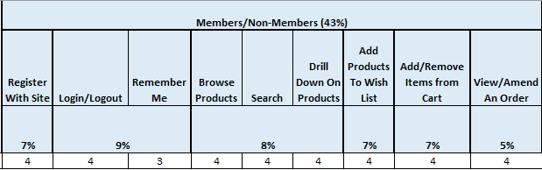

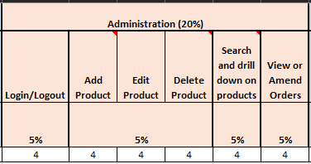

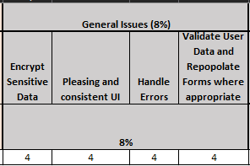

# ER Diagram

# Known Errors/Bugs

*Log in working as normal without remember me checkbox working.*

*Logging off working as normal when remember me not implemented.*

Remember Me:

When clicking the checkbox for login in this error shows up.  
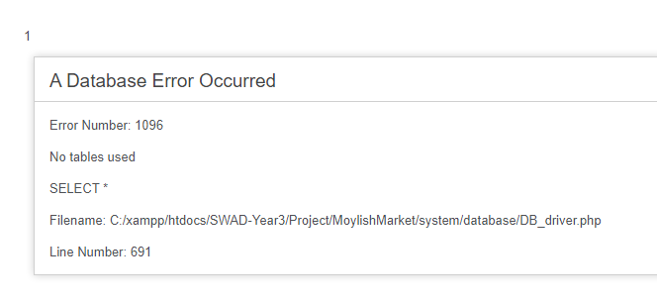

But going back on the browser brings you back to the log in page but user is logged in and remember me function is working.

When Logging off and remember me function was implemented this error shows up.

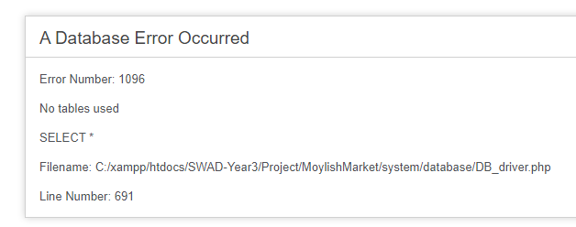

Refreshing the website, logs the user off as normal

*Remember me function works as follows.*

Checks on ‘index.php’ if any customer has a string on the ‘remember_me_token’.  
 If no customer has a string on this column proceed as normal.

If a customer has a string in this column then sign that user in as normal.

Therefore, allowing the browser to be closed and open anytime anywhere and having the remember me “Working”

# Files and folder Structure

|  |  |  |
| --- | --- | --- |
| *Model* | *View* | *Controller* |
|  | *In ‘ProductViews’ Folder* |  |

# List of Extra Features

|  |  |  |
| --- | --- | --- |
| ***Guest - All*** | ***Customer***  <- Inherits all from below | ***Admin***  <- Inherits all from below |
| Bootstrap – navbars for logo, control panel and productviews | Add to cart from Wishlist | JavaScript -confirm deleting product |
| Map embed of LIT on index | Empty all using sessions from Cart | View Visitor info |
| Mail to: connecting to an email | Empty All Wishlist | View all Order details |
| JavaScript -Sort Table by header | Hiding Wishlist and cart if they are empty | View All Customers  {Stored Procedure} |
| Pagination on all products | Creating Order | Search an Order by customer ID |
| Title Page :  Contact info | View Product from Order Details | View all Product details –  Including Buying Price |
| Total Visitors count on index  Storing browser, session id, ip | Cancel an order only if not shipped. |
| Hoover and view select product | Change add to remove icon if they are in the wishlist already |
| Hide Buying Price on product | Image for :  No Search results found,  Order Placed,  Cart Empied. |