Requirements:

-Something that can run a kali Linux vm (laptop, desktop, whatever you want)
-1 x kali Linux VM (other distros might work but I used this one)

How to set up the OWSAP Juice Shop Docker Container!

Step 1: Install Docker
Step 1.1: sudo apt update
Step 1.2: sudo apt install -y ca-certificates curl gnupg
Step 1.3: sudo install -m 0755 -d /etc/apt/keyrings
Step 1.4: curl -fsSL https://download.docker.com/linux/ubuntu/gpg | sudo gpg --dearmor - o /etc/apt/keyrings/docker.gpg
Step 1.5: sudo chmod a+r /etc/apt/keyrings/docker.gpg
Step 1.6: echo \ "deb [arch=$(dpkg --print-architecture) signed by=/etc/apt/keyrings/docker.gpg] \ https://download.docker.com/linux/ubuntu \ $(lsb_release -cs) stable" | \ sudo tee /etc/apt/sources.list.d/docker.list > /dev/null
Step 1.7: sudo apt update
Step 1.8: sudo apt install -y docker-ce docker-ce-cli containerd.io docker-buildx-plugin docker-compose-plugin
Step 1.9: sudo docker run hello-world
Step 1.10: Everything should work (yippee!)
Step 2: Set up OWSAP Juice Shop Container (Juice-Shop, n.d.)
Step 2.1: sudo docker pull bkimminich/juice-shop
Step 2.2: sudo docker run --rm -p 127.0.0.1:3000:3000 bkimminich/juice-shop
Step 2.3: Browse to http://localhost:3000
Step 2.4: Incredible work, you have everything set up!

Attack Time!
Here I (your fearless leader) will walk you through the attack steps. For this part of the final we are doing Cross Site Scripting (aka XSS) because its almost XMAS (haha get it?)

What the heck is Cross Site Scripting?
Well it is a web security vulnerability that allows attackers to compromise interactible content on a web site such as file uploads, text boxes, etc.

Step 1: Boot up your Docker contaiter and head to http://localhost:3000
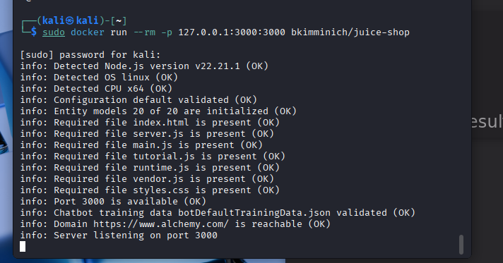
Step 2: Head to the Login In page in the top right corner and then make a new account by clicking the new user button at the bottom.
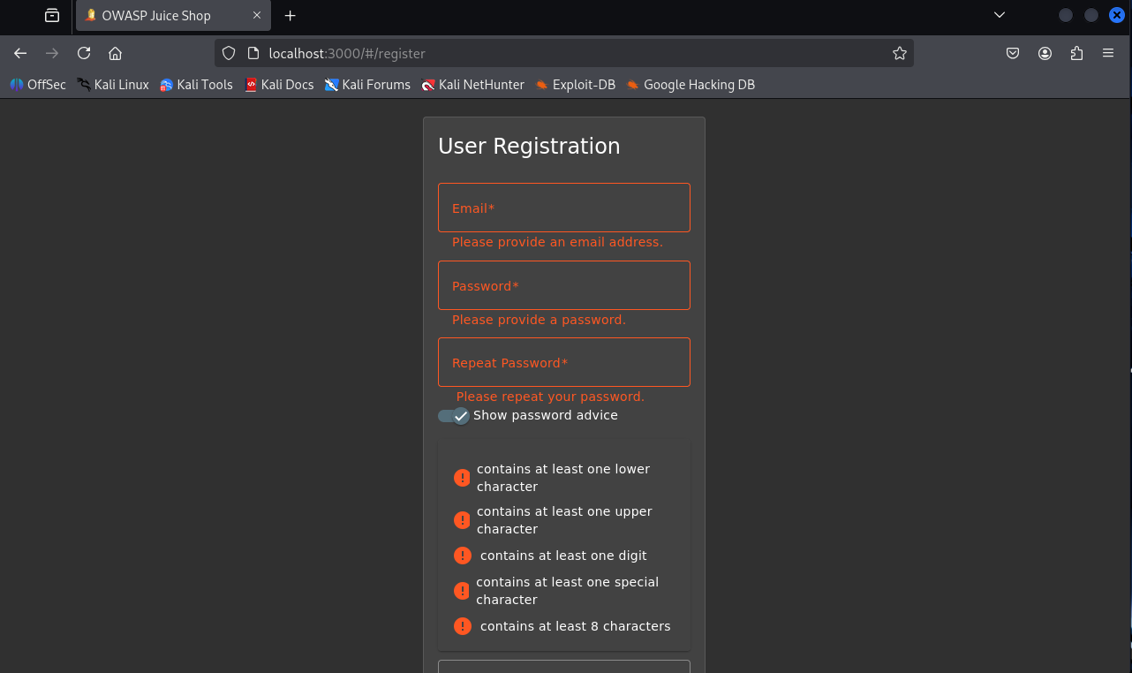
Step 3: Add something to your cart and then go to your cart and check out. Go through all the screens and enter random information until you reach this screen:
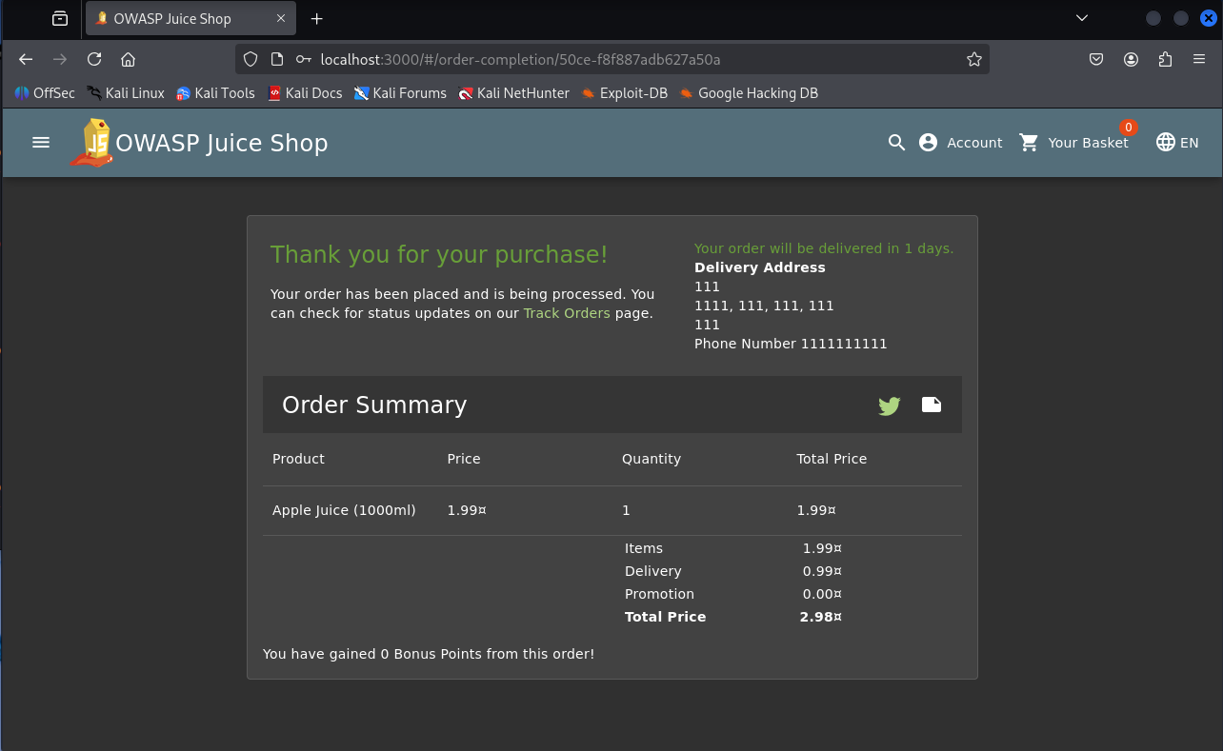
Step 4: After the order confirmed screen go to the the top right corner and click on Account -> Orders and Payment -> Order History. You should come to this screen:
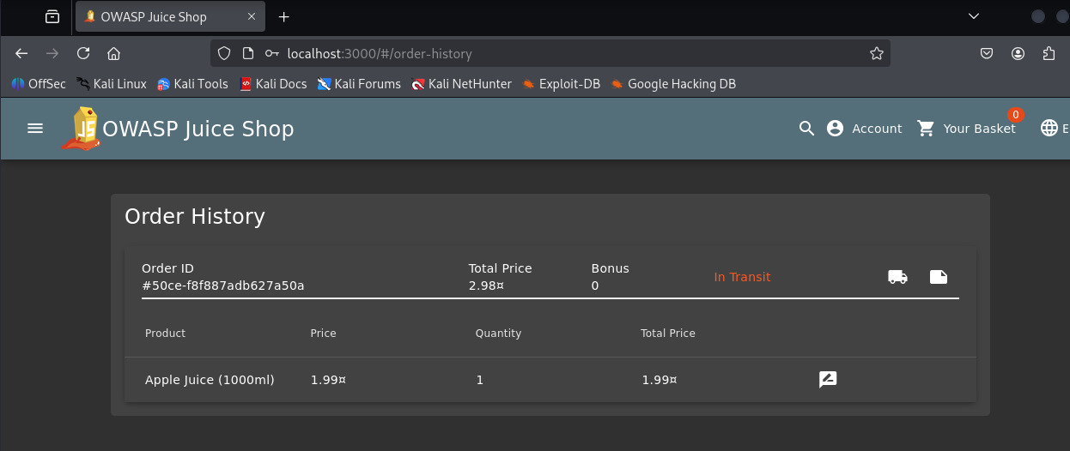
Step 5: Click on the little image of the truck in the order information (when you hover over it it should show "Track Order") and it should bring you to this screen:
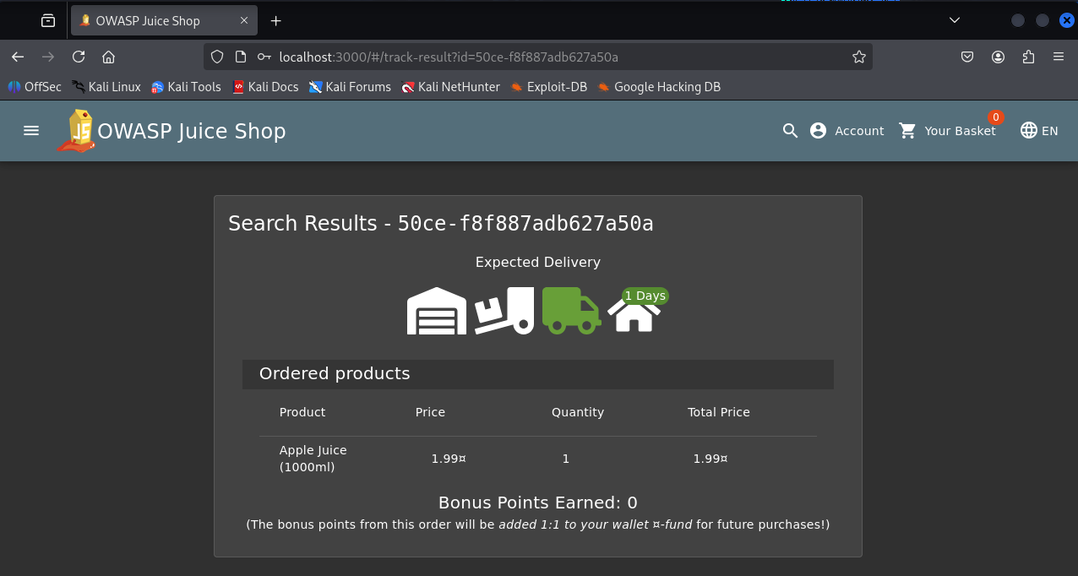
Step 6: In the url bar replace the current url with this: http://localhost:3000/#/track-result?id=IcanputanythingIwanthere (F5, n.d.) Then reload the page, it should display IcanputanythingIwanthere in the search results as seen here:
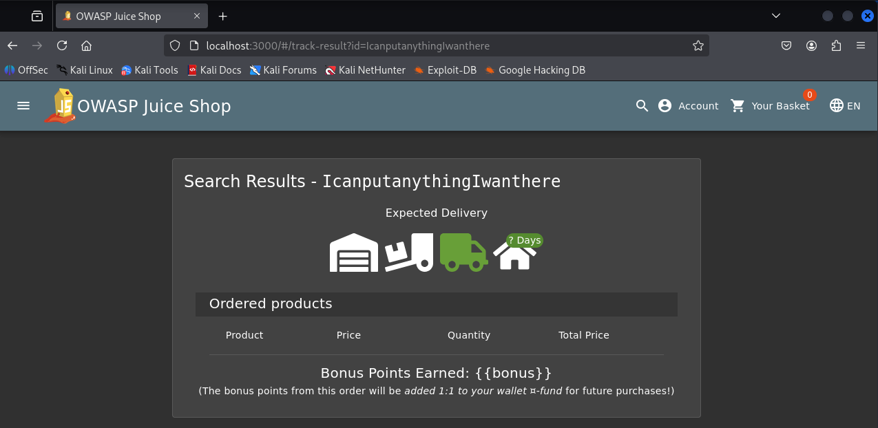
!!!!!BONUS!!!!!

Cross Site Scripting can also be used in another place!

If you go to the search bar up in the top right and type in (or copy paste if we are being realistic) this:

<iframe src="javascript:alert('Get Got!')"> (Automat‑IT, 2022)

You should get a popup that says "get got!"
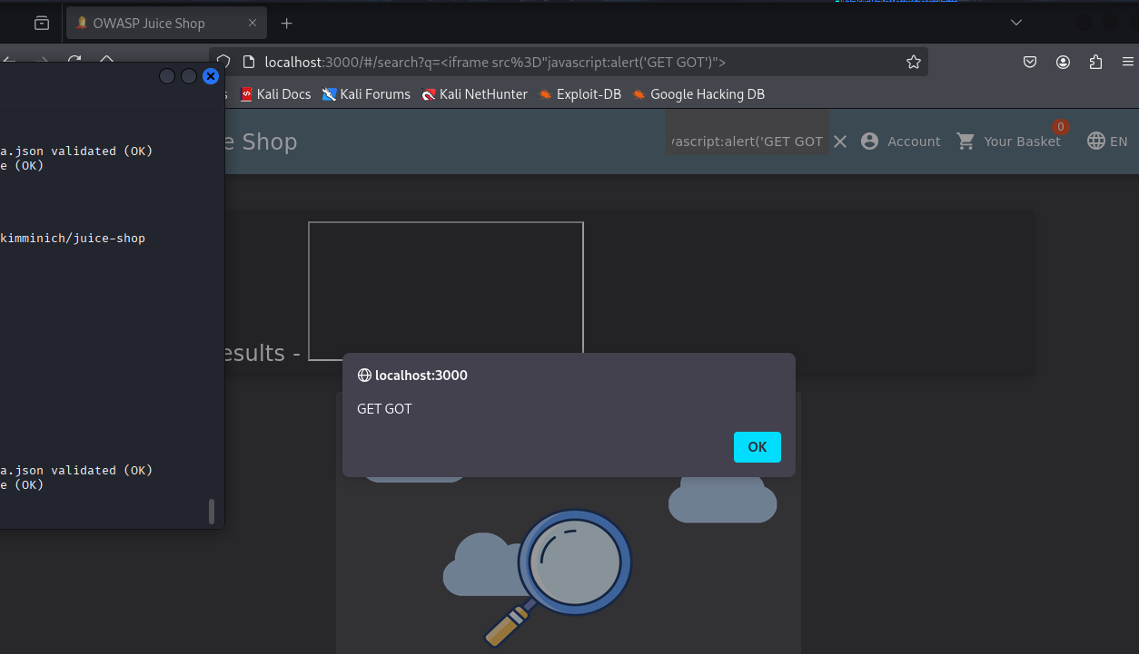

Purple Team

To fix XSS attacks you can do a few things:

Encode data on output
Validate input on arrival

When encoding data on output it prevents the browser from running bad/malicious code, instead of executing anything as a script, the browser displays them safely as text.
Input validation means checking incoming data before the application processes it, this makes sure that the data is safe and properly formatted.

Now that the two ways of defending against this are explained, you might be wondering: Well that seems really general, how do I actually fix this? And that would correct, these are categories that all the ways of fixing XSS fall into, so lets break it down:
 (A little Olympics humor for you)

For the first attack, I changed the text in the URL, and the page showed it. Even though I didn’t inject a <script> tag, this shows the page is vulnerable to future XSS. A Content Security Policy would help by stopping the browser from executing any scripts if an attacker tried to turn this into a XSS attack. This would be classified as encoding over validation (PortSwigger, n.d.).

Automat-IT also has a great portion of their article talking about how to prevent XSS with AWS which really talks about and walks through how to combat XSS with WAF rules.

References:
F5. (n.d.). Module 2 – Discover the OWASP Dashboard (Lab 2). F5 Web Application Firewall Solutions. https://clouddocs.f5.com/training/community/waf/html/waf2023/module1/lab2.html
PortSwigger. (n.d.). Preventing cross-site scripting (XSS). PortSwigger Web Security Academy. https://portswigger.net/web-security/cross-site-scripting/preventing
Automat-IT. (2022, March 15). Hack the OWASP Juice Shop application and protect it with AWS WAF — Part 2. Automat-IT Blog. https://www.automat-it.com/blog/hack-the-owasp-juice-shop-application-and-protect-it-with-aws-waf-part-2/#0e6c
Juice-Shop. (n.d.). OWASP Juice Shop · GitHub. GitHub. https://github.com/juice-shop/juice-shop?tab=readme-ov-file#docker-container

