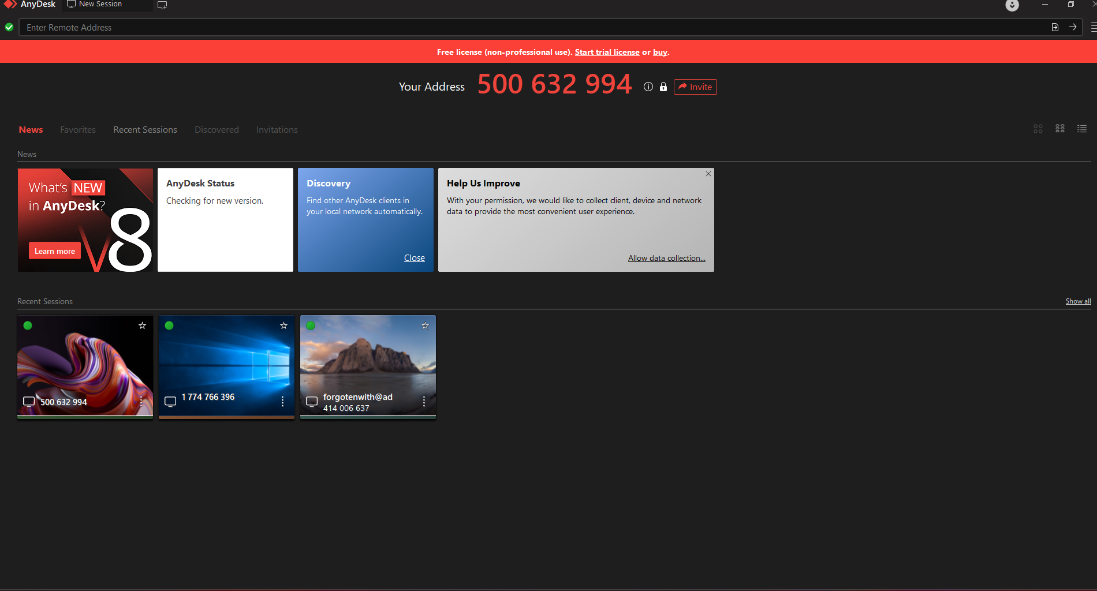
This is your first interface.
- you click the “Invite” button on the top.
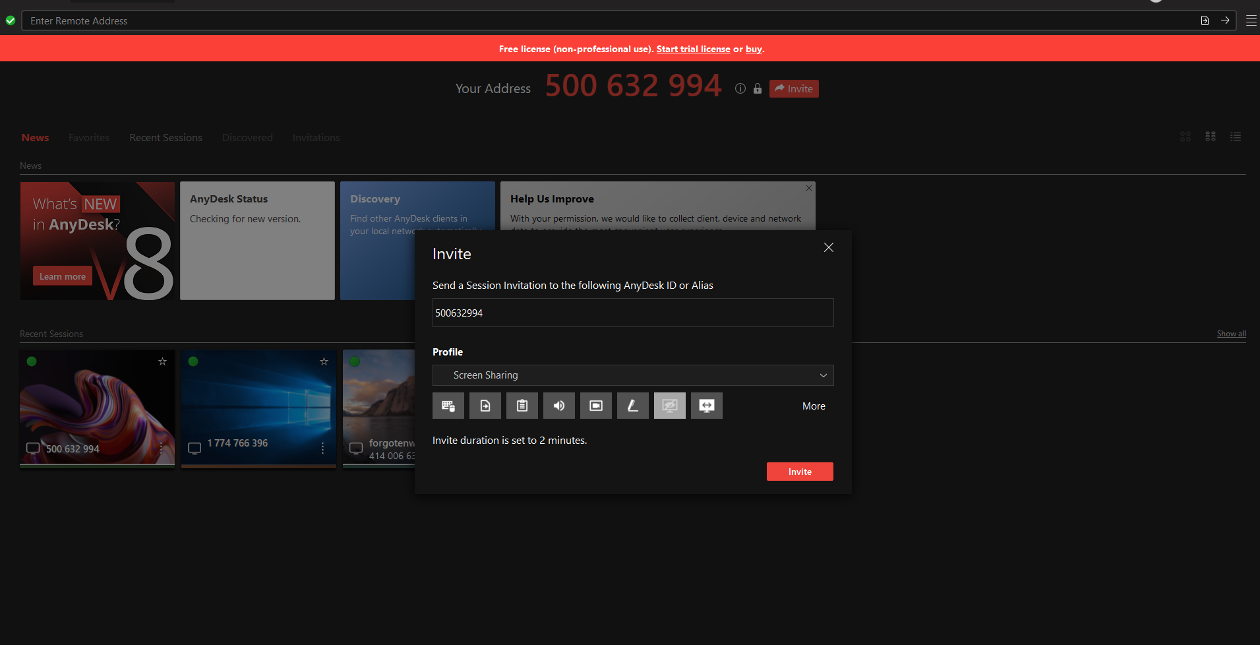
- Entry your address to the first input element.
- And you select the “Screen Sharing” method.
- Then Click “invite” button in Modal dialog box.
- Send me your address.

