符号计算-1
1、计算符号表达式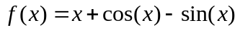在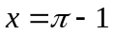处的值.
>> x=pi-1;y=x+cos(x)-sin(x)
y =
503/662
2、设为符号变量，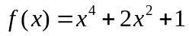，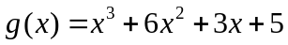，试进行如下运算。
>> f=sym('x^4+2*x^2+1')
f =
x^4+2*x^2+1
>> g=sym('x^3+6*x^2+3*x+5')
g =
x^3+6*x^2+3*x+5

（1）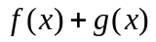，
>> f+g
ans =
x^4+8*x^2+6+x^3+3*x

（2）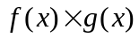，
>> f*g
ans =
(x^4+2*x^2+1)*(x^3+6*x^2+3*x+5)

（3）对进行因式分解，
>> factor(f)
ans =
(x^2+1)^2

（4）求的反函数。
>> finverse(f)
ans =
(-1+x^(1/2))^(1/2)

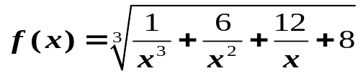3、化简
>> f=sym('(1/x^3+6/x^2+12/x+8)^(1/3)')
f =
(1/x^3+6/x^2+12/x+8)^(1/3)
ans =
(2*x+1)/x
4、 因式分解：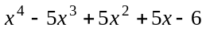
>> f=sym('x^4-5*x^3+5*x^2+5*x-6')
f =
x^4-5*x^3+5*x^2+5*x-6

>> factor(f)
ans =
(x-1)*(x-2)*(x-3)*(x+1)

5、设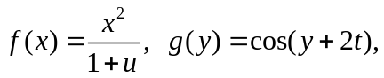求复合函数 f(g(z));
>> syms x y z;
>> f=sym('x^2/(1+u)');g=('cos(y+2*t)');
>> compose(f,g,z)
ans =
cos(z+2*t)^2/(1+u)

6、使用sym函数生成如下符号矩阵，，
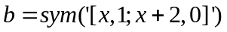，试对这两个符号矩阵分别进行如下操作。
>> a=sym('[1/x,1/(x+1);1/(x+2),1/(x+3)]')
a =
[ 1/x, 1/(x+1)]
[ 1/(x+2), 1/(x+3)]
>> b=sym('[x,1;x+2,0]')
b =
[ x, 1]
[ x+2, 0]
（1）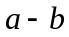
>> a-b
ans=

[ 1/x-x, 1/(x+1)-1]
[ 1/(x+2)-x-2, 1/(x+3)]
（2）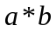
>> a*b
ans =
[ 1+1/(x+1)*(x+2), 1/x]
[ 1/(x+2)*x+1/(x+3)*(x+2), 1/(x+2)]
（3）求的行列式
>> det(a)
ans =
2/x/(x+3)/(x+1)/(x+2)
（4）求的逆
>> inv(b)
ans =
[ 0, 1/(x+2)]
[ 1, -1/(x+2)*x]
（5）求的秩
>> rank(a)
ans =
2

（6）求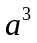
>> a^3
ans =

[ 1/x*(1/x^2+1/(x+1)/(x+2))+1/(x+1)*(1/(x+2)/x+1/(x+3)/(x+2)), 1/x*(1/x/(x+1)+1/(x+1)/(x+3))+1/(x+1)*(1/(x+1)/(x+2)+1/(x+3)^2)]
[ 1/(x+2)*(1/x^2+1/(x+1)/(x+2))+1/(x+3)*(1/(x+2)/x+1/(x+3)/(x+2)), 1/(x+2)*(1/x/(x+1)+1/(x+1)/(x+3))+1/(x+3)*(1/(x+1)/(x+2)+1/(x+3)^2)]

7、 求矩阵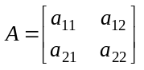的行列式值、逆和特征根。
>> A=sym('[a11,a12;a21,a22]')
A =
[ a11, a12]
[ a21, a22]
>> det(A)
ans =
a11*a22-a12*a21

>> inv(A)
ans =
[ -a22/(-a11*a22+a12*a21), a12/(-a11*a22+a12*a21)]
[ a21/(-a11*a22+a12*a21), -a11/(-a11*a22+a12*a21)]

>> [x,y]=eig(A)
x =
[ -(1/2*a22-1/2*a11-1/2*(a22^2-2*a11*a22+a11^2+4*a12*a21)^(1/2))/a21, -(1/2*a22-1/2*a11+1/2*(a22^2-2*a11*a22+a11^2+4*a12*a21)^(1/2))/a21]
[ 1, 1]

y =
[ 1/2*a22+1/2*a11+1/2*(a22^2-2*a11*a22+a11^2+4*a12*a21)^(1/2), 0]
[ 0, 1/2*a22+1/2*a11-1/2*(a22^2-2*a11*a22+a11^2+4*a12*a21)^(1/2)]

