**Computer Graphics Project #4: SkyBox Design**

* Extend the project three to display SkyBox using single image

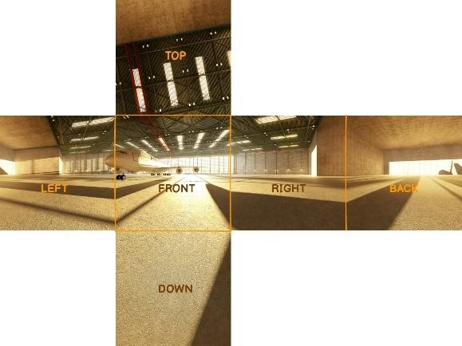

* Create a 3D model using cube WaveFront obj file and place it in the middle of the room Use proper malloc/realloc memory allocation (Then you can load more models than just a cube)
* follow the steps
  + Use “a w d s “ keys to rotate the model
  + Use arrow keys to rotate skybox
  + Use “j k i l “ to move camera left, right, top, bottom and “o” to reset
  + Move **Light** position using keys “1 2 3 4” and 0 to reset
  + Use “ z x” to zoom in and out the scene
  + Use “space bar” to rest the whole scene

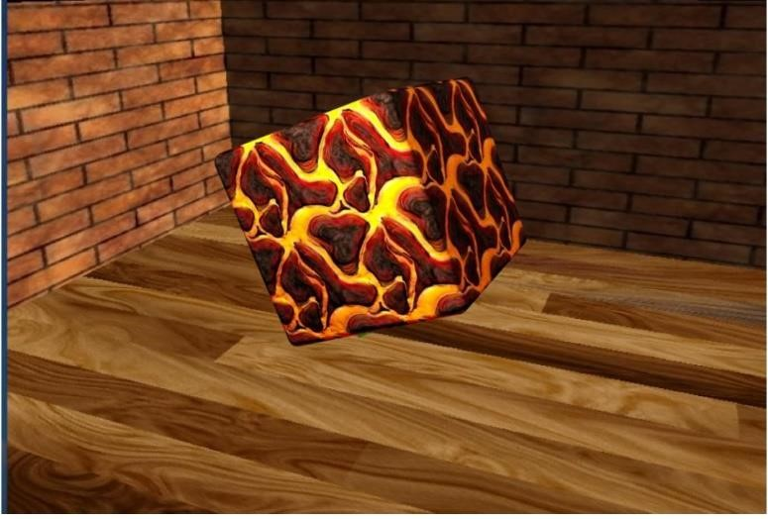

Include your *Name*, *ID*, *Class* and *Project Name* at the top of the code. Please comment your code describing what each of your code line dose. Save the file as “projectXX.cpp”