ALUCollab: A Flutter-Based Platform for Connecting ALU Students and Student-Led Startups
Abstract
ALUCollab is a mobile application designed to connect ALU students seeking opportunities with student-led startups and early-stage ventures within the ALU ecosystem. The app addresses the gap in the campus innovation environment by providing an ALU centralized platform where startups can publish opportunities and students can discover, evaluate, and apply for roles. The app was made using Flutter, Firebase and Provider for state management and Firestore for persistent data storage. The system is a role-based system that supports students, startup and administrators through authentication, opportunity discovery, the way it handles application, notifications and verifying the startups, users and opportunities. The project supports the entire ALU ecosystem because it directly supports student employability, startup growth, and community collaboration.
Introduction
Access to internships and job openings is quite challenging for many learners since these openings are mainly found within well-established companies that are not easily accessible to the new generation of learners (OECD, 2025). On the other hand, student-owned enterprises usually require assistance in fields such as software engineering, design, marketing, research, and management. ALUCollab was created to bridge this gap by offering a digital marketplace for practical experience. The platform is intentionally focused on the ALU ecosystem rather than a generic job board, because the user base, startup context, and verification process are all specific to the university community. The application therefore combines a clear user problem, a practical workflow, and a technically maintainable architecture.
Problem Statement and Design Goals
The fundamental issue that ALUCollab aims to solve is the disconnect between the talents of the students and the needs of the startups. The students require internships and exposure, while the startups require help to grow and work efficiently. The solution to the problem was implemented using an elegant and effective workflow where the startups generated the opportunities, the students looked for them and applied, and the administrators verified the ventures. The design objectives of the project include usability, practicality, secure authentication, efficient data synchronization, and state management. The system also emphasizes scalability, allowing more features to be added in the future without any changes in the system architecture.
System Architecture
The software employs an architectural model that divides the user interface, business logic, and backend into layers. The mobile app is written using Flutter, which enables a single codebase to be shared for both Android and iOS devices while still being provided with a modern UI library. Firebase Authentication is utilized for Identity and Access Management (Identity and Access Management (IAM), n.d.), whereas Firestore is employed to store users, startups, opportunities, applications and notifications in documents. Provider manages the state of the entire application, particularly authentication state, opportunities, theme settings, and routing based on roles, in a clear manner. This type of architecture is suitable for our project as it makes the app responsive, updatable in real-time and extensible with further modules.
Backend Design and Firebase Integration
Firebase was chosen to be the backend since it offers fast development and has integrated services which suit the needs of this project. Authentication is used for sign-in and registration processes and also maintains sessions. Firestore is used to store data in the form of collections. Some of the collections which have been used in the project include: Users, startups, opportunities, applications, and notifications. In the users collection, role-based profiles of students, startups, and administrators are stored. The startups collection has information about ventures and their verification status. Opportunities collection contains information regarding internships, skills required, time period, and activities. Applications collection holds each of the student applications, whereas notifications provide real-time communication between users and administrators.

Data Model and Workflow Design
The ALUCollab data model is comprised of five primary entities, namely, UserModel, StartupModel,OpportunityModel, ApplicationModel and NotificationModel. The user profile and role details are stored in the UserModel, whereas the StartupModel handles all details of startups along with verification status. The opportunities related to internships and collaborations are stored in the OpportunityModel, whereas the students are linked with the opportunities through the ApplicationModel with application status as well. Finally, NotificationModel is responsible for providing users with real-time notifications, such as status of applications, verification of startups and other system notifications. The workflow starts with user authentication, whereafter the startup owners register their ventures for administrator approval. Upon verification, startups publish opportunities that students browse and apply to.
State Management and Application Structure
The Provider was employed as the state management architecture due to its simplicity, clarity, and integration capability within the framework of Flutter applications. The AuthProvider is responsible for handling the current user profile and authentication loading states. The OpportunityProvider helps with creating, deleting, and accessing in real-time streams of opportunities. The ThemeProvider controls dark and light mode settings in order to have consistent UI design across screens. The structure of the application is organized according to the role-based navigation principles. Students get access to the dashboard where opportunity discovery, applications, profile management, and notifications are provided. Start-up owners get access to the venture dashboard which allows managing opportunities and analysis.
User Interface and User Experience Design
Both UI and UX designs have been made modern, clear, and functional. There has been consistency in terms of color schemes and visuals within the application through use of a dark-themed, high-contrast, round-edged interface and clear navigation. There has been personalization according to the roles involved in such a way that the user sees workflows associated with their own role and nothing else. For instance, students will get a news feed and a search interface, whereas startup owners will get a dashboard for managing things and a post form for putting opportunities. In terms of usability, the cognitive load has been decreased, and key functionalities are easy to access and intuitive. This is in line with the actual need for making this application useful to both students and entrepreneurs within the busy academic world. As you notice, the majority of colors used will likely be blue in nature which is the most common color used in almost all ALU things(African Leadership University (ALU), 2021).
Feature Implementation and Functional Workflow
The application at the moment has been designed to perform operations such as authentication and onboarding, role-based routing, startup registration, listing opportunities, discovering opportunities, submitting applications, notifications, and admin verification. Students are able to discover active opportunities and apply for them. On the other hand, the startup owner is able to create and delete opportunities as well as see how many applications he/she has gotten. Finally, administrators are able to view pending startups and either approve or deny them. In addition to that, there is also loading states, form validation, and feedback messages which make the interaction more reliable.
Testing, Reliability, and Quality Assurance
The app was tested manually via re-execution of the core flows multiple times. The authentication flows were verified by making sure the accounts work and users navigate accordingly based on their roles. The opportunity posting and application flows were tested using Firestore updates in the backend. The app was additionally verified in terms of consistency in navigation, validation and error handling. Although currently there is no automated test suite in the project, the app architecture is such that allows for further unit and widget tests in the future.
Challenges, Limitations, and Future Work
The most difficult part of developing ALUCollab was creating a flexible theme system that would support dark and light modes and keep UI design consistent since I wanted to use some specific colors. In the first place, working with colors on various pages proved difficult, so a Color utility and ThemeProvider components were created to make colors depend on the current theme. Also, PDF resume upload during job applications is another challenge because although it was planned, Firebase have made this functionality impossible since a paid plan is needed in order to use this approach for file storage (Default Bucket and Billing Requirements for Cloud Storage for Firebase after September 2024, n.d.) while the project is being developed using the free one. Other features to be implemented are administration actions like deleting users and data moderation, which required to learn how to configure Firestore security rules. This part was not trivial and was quite interesting to do since I had little experience with Firebase security before this project. In the future, other improvements might include resume upload, chat in the app, advanced searching and recommendations, and analytics.
Conclusion
ALUCollab is a solution that works perfectly well in helping ALU students connect with student startups because of its functionality of helping users discover openings, submit applications, and conduct startup recruitment. It allows collaboration using features designed for the roles of the students, startup owner, and administrator, which results in a process that is much more efficient and organized. With such a scalable solution, it has the possibility of making a great impact at ALU.
Diagram and Screenshot Placement
System Architecture:
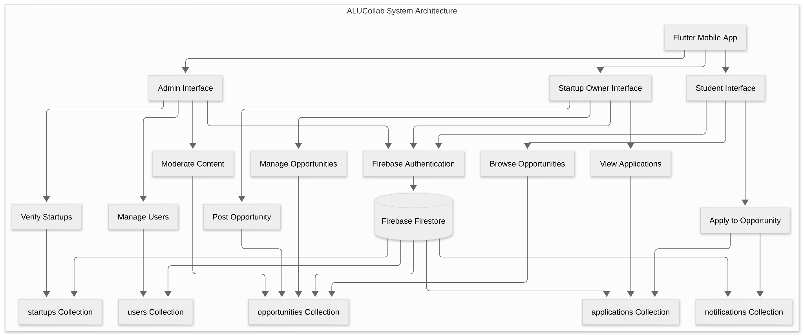
This architecture of ALUCollab shows how the three user roles (student, startup and administrator) interact with the mobile application, authentication service, and Firestore database to manage users, startups, opportunities, applications and notifications.

This is the ERD:
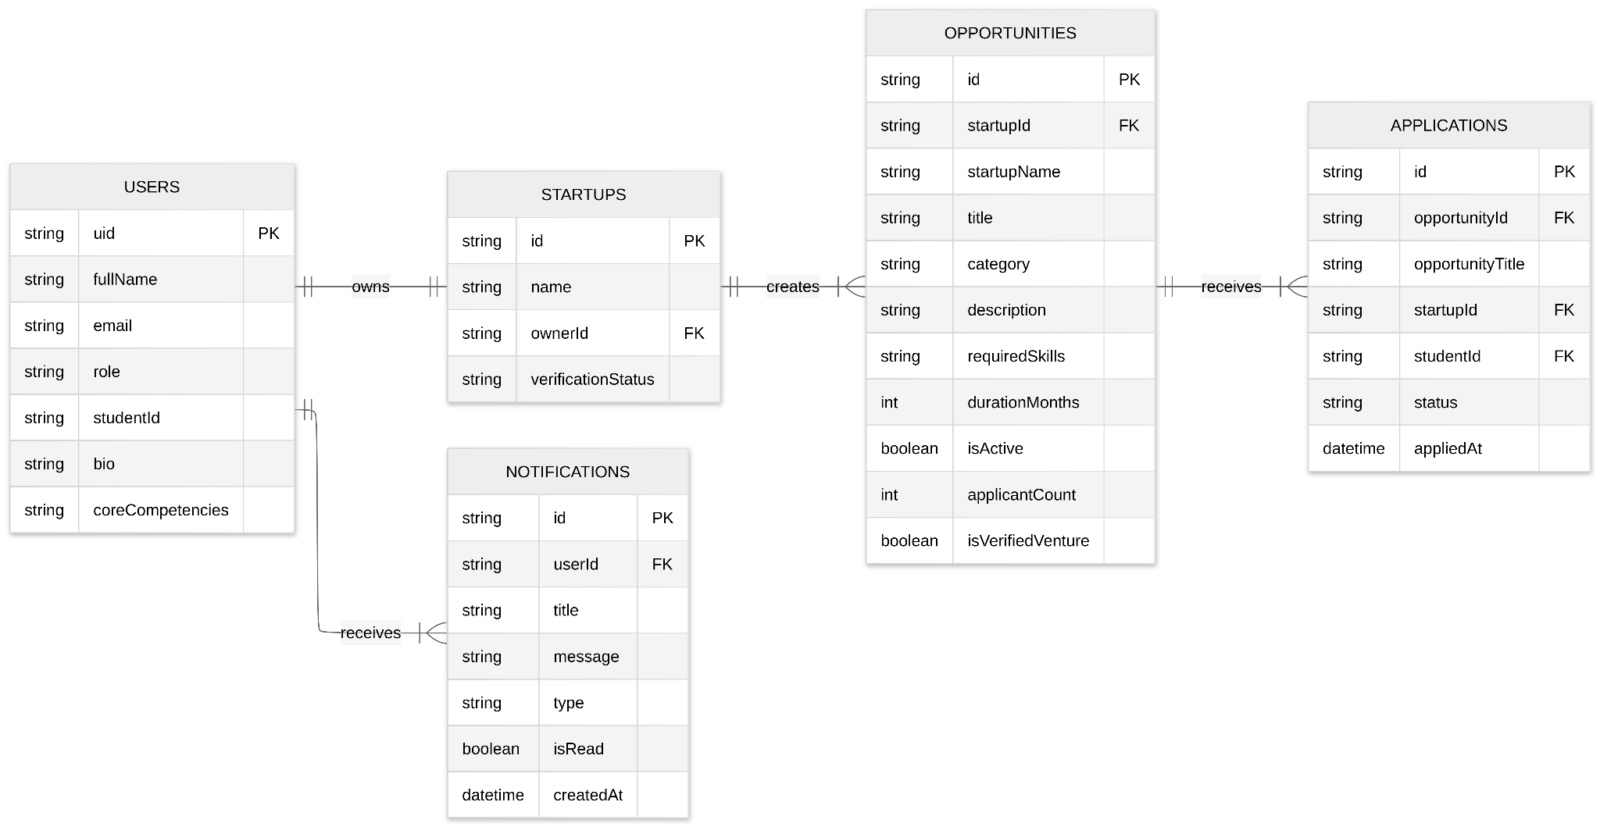ALUCollab’s ERD shows the relationships between the Users, Startups, Opportunities, Applications, and Notifications collections, demonstrating how data is linked to support role-based operations and application workflows.
ALUCollab’s Workflow:
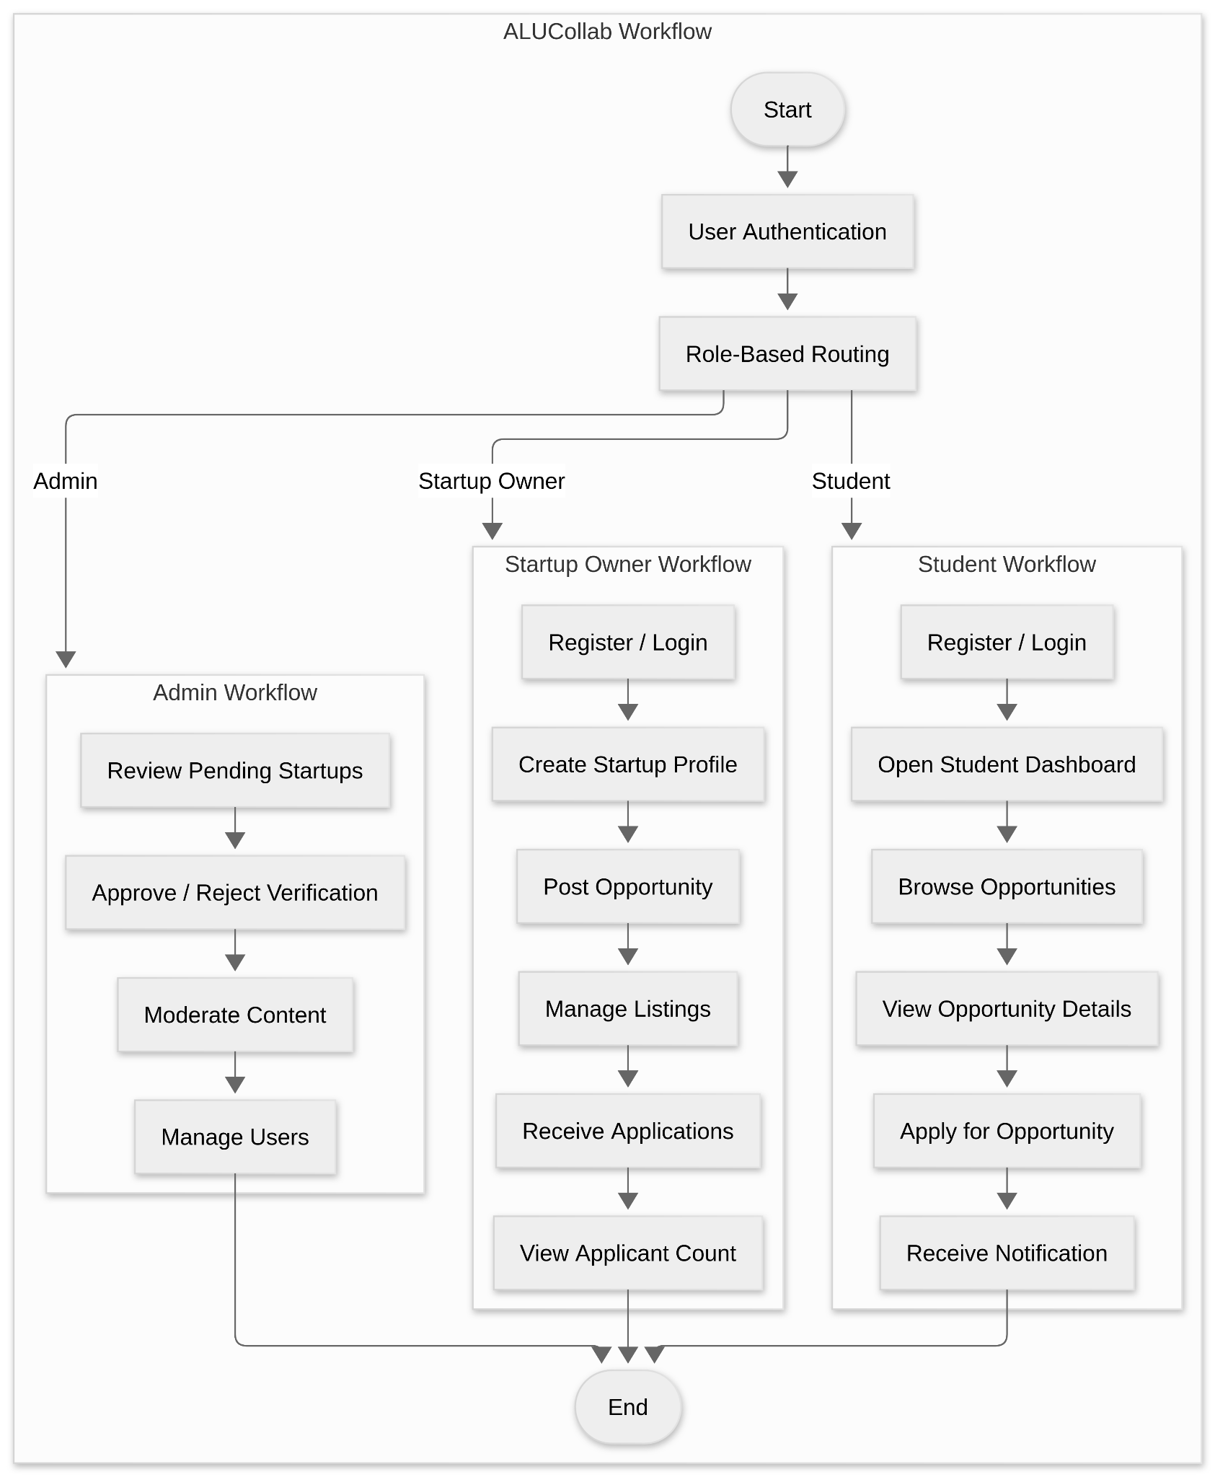
The workflow of ALUCollab demonstrates how users have to first authenticate after role-based routing happens, then each user follows a specific process: administrators verify startups and manage the platform, startup owners create and manage opportunities, and students browse and apply for opportunities while receiving notifications throughout the process.
Screenshots
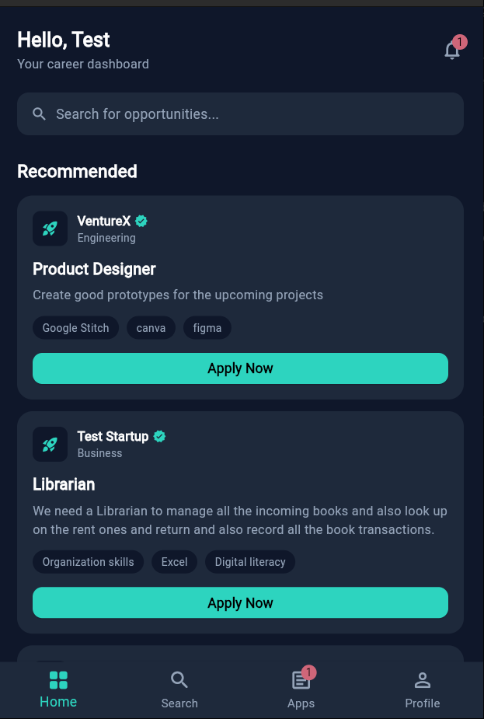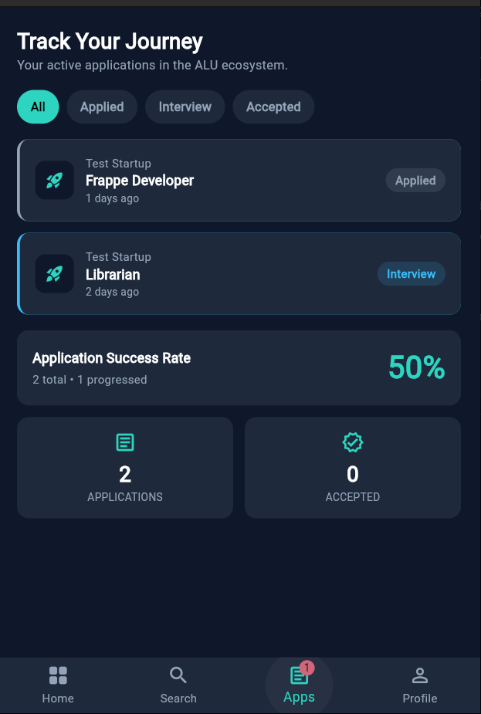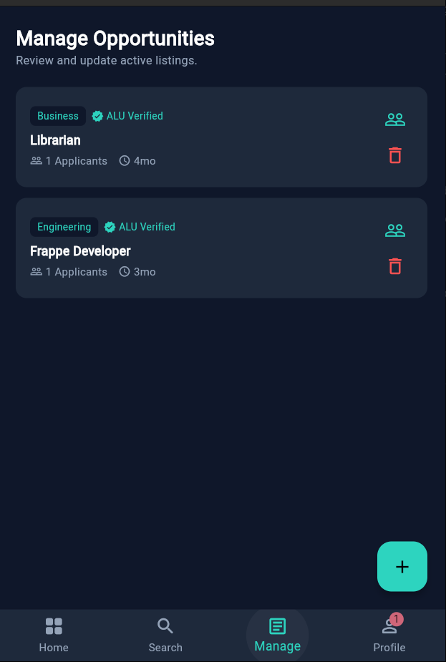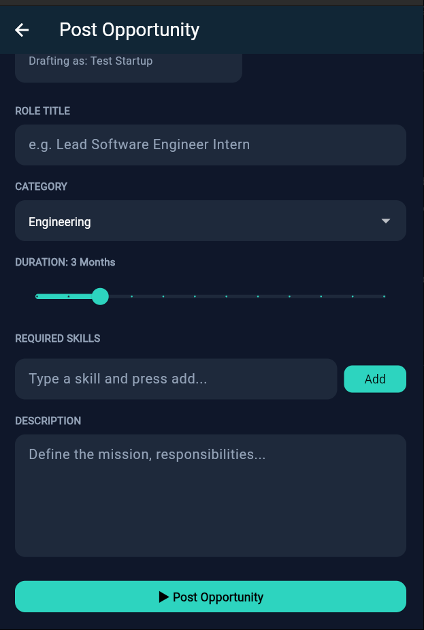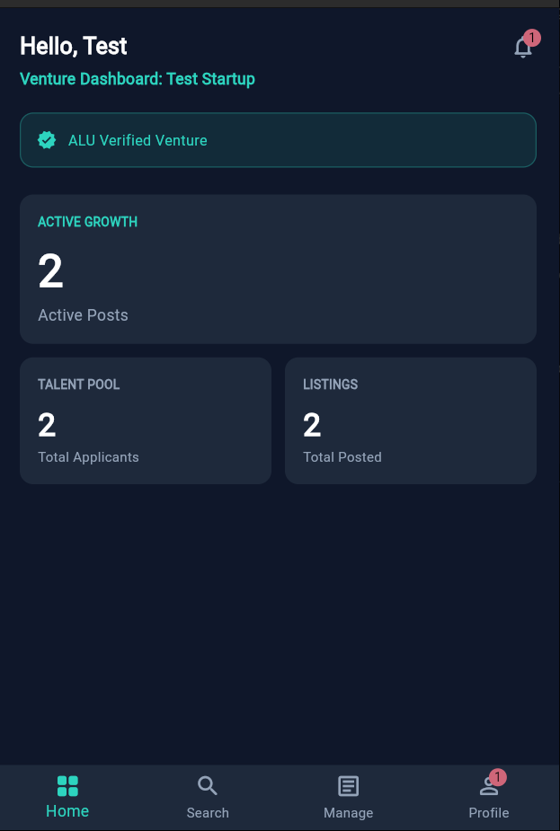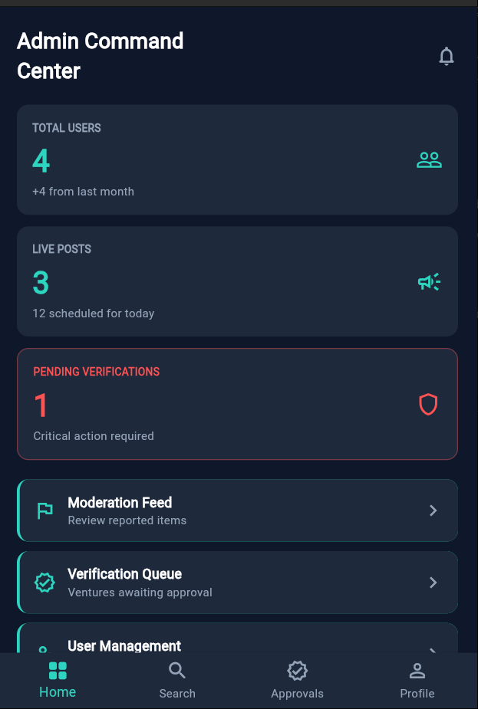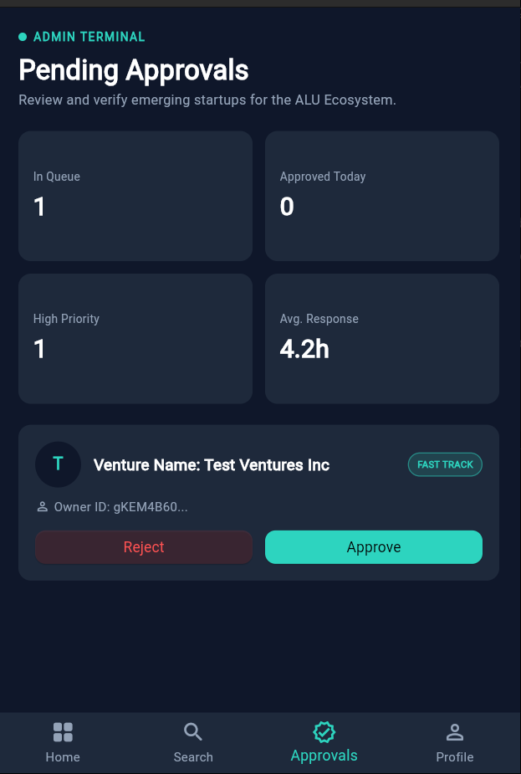

References
African Leadership University (ALU). (2021, April 20). African Leadership University. https://www.alueducation.com/
Default bucket and billing requirements for Cloud Storage for Firebase after September 2024. (n.d.). Firebase. Retrieved July 12, 2026, from https://firebase.google.com/docs/storage/faqs-storage-changes-announced-sept-2024
Identity and Access Management (IAM). (n.d.). Firebase. Retrieved July 12, 2026, from https://firebase.google.com/docs/firestore/security/iam?utm_source=google&utm_medium=cpc&utm_campaign=Cloud-SS-DR-Firebase-FY26-global-gsem-1713590&utm_content=text-ad&utm_term=KW_firebase%20authentication&gclsrc=aw.ds&gad_source=1&gad_campaignid=23417478209&gclid=CjwKCAjw9szSBhBNEiwAC57Sq4So10Ue7yj4V3qMhtjQTCCt91LH9sfadsgwGDb6Csv2McR3IZZ-rhoCEnIQAvD_BwE
Oecd. (2025, May 20). The state of global teenage career preparation. OECD. https://www.oecd.org/en/publications/the-state-of-global-teenage-career-preparation_d5f8e3f2-en.html

