Current problem:

Special registers class have their CheckPermission() rule -> need many special registers class and they are only different in CheckPermission() function.

Try to improve:

Remove these classes of small difference.

EP 2199:

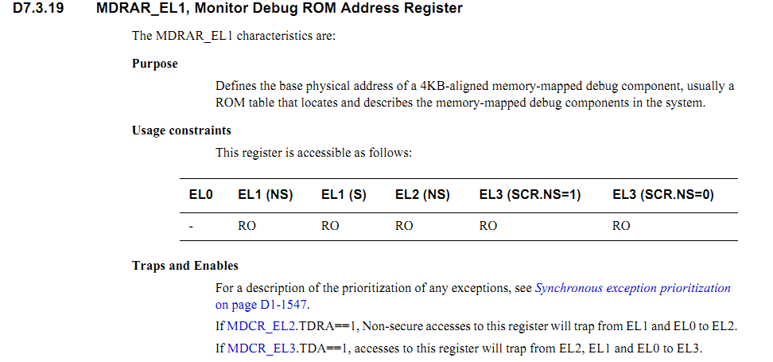

__define_sys_reg_with_opcode(ClsSysReg, 32, MDRAR, EL1, "MDRAR_EL1", …)

Define_Trap(“1==QRegField(MDCR,EL2,TDRA) && NSAccess() && level <= EL1”, EL2)

Define_Trap(“1==QRegField(MDCR,EL3,TDA) && level <= EL2”, EL3)

Define_EL_MODE(E1.NS=RO, E1.S=RO, ...)

__define_sys_reg_with_opcode(ClsSysReg, 32, MDRAR, EL1, "MDRAR_EL1", …)

Define_Trap(“1==MDCR_EL2.TDRA && NS && level <= EL1”, EL2)

Define_Trap(“1==MDCR_EL3.TDA && level <= EL2”, EL3)

…

CodeGen:

CheckWritePermission_MDRAR_EL1(level, el[4 ], …)

{

If (1==QRegField(MDCR,EL2,TDRA) && NSAccess() && level <= EL1) return EL2;

If (level==1 && RO==el[1].mode && SECURE==e1[1].type) return EL2;

If (level==1 && RO==el[1].mode && NON_SECURE==e1[1].type) return EL2;

If (level==2 && RO==el[2].mode && SECURE==e1[1].type) return EL3;

…

TypUlong64 tdra;

tdra = context.aarch64.pSysRegManager->QueryReg(EL2, MDCR)->ReadByField(nsFIELD::TDRA, tdra);

If (1==tdra && NSAccess() && level <= EL1) return EL2;

TypUlong64 tda;

Tdra = context.aarch64.pSysRegManager->QueryReg(EL3, MDCR)->ReadByField(nsFIELD::TDA, tda);

If (1==tda && level <= EL2) return EL3;

return NO_TRAP;

}

Test:

ClsSysReg.CheckTrap = CheckTrap_MDRAR_EL1; // set function pointer

Cls.SysReg->CheckTrap(level); // trigger test

**Solution:**

EP 2199:



__define_sys_reg_with_opcode(ClsSysReg, 32, MDRAR, EL1, "MDRAR_EL1", …)

Define_Trap(“1==MDCR_EL2.TDRA && NS && level <= EL1”, EL2)

Define_Trap(“1==MDCR_EL3.TDA && level <= EL2”, EL3)

…

CodeGen:

CheckPermission_MDRAR_EL1(int RW, TypExceptionLevel level, int op0)

{

TypException ret = ClsRTLSyncSysReg::CheckReadPermission(level, context);

if(NO_TRAP == ret)

{

If (1==QueryRegField(MDCR,EL2,TDRA) && !IsSecureAccess() && level <= EL1) return Trap(EL2);

If (1==QueryRegField(MDCR,EL3,TDA) && level <= EL2) return Trap(EL3);

}

return ret;

}

Test:

ClsSysReg.CheckPermissionPtr = CheckPermission_MDRAR_EL1; // set function pointer

Cls.SysReg->CheckPermission(level); // trigger test

P 2221:

D7.4.2 PMCCNTR_EL0, Performance Monitors Cycle Count Register

EL0 EL1 (NS) EL1 (S) EL2 (NS) EL3 (SCR.NS=1) EL3 (SCR.NS=0)

Config-RW RO RO RW RW RW

If PMUSERENR_EL0.CR==0, and PMUSERENR_EL0.EN==0, read accesses to this register will trap from EL0 to EL1.

__define_sys_reg_with_opcode(ClsSysReg, 32, PMCCNTR, EL0, " PMCCNTR _EL0", …)

Define_Trap(“level==EL1 && WRITE”,undefine)

Define_Trap(“0==PMUSERENR_EL0.CR && 0==PMUSERENR_EL0.EN && level == EL0”, EL1,opcode)

CodeGen:

CheckPermission_ PMCCNTR _EL0(int RW, TypExceptionLevel level, int op0)

{

TypException ret = ClsRTLSyncSysReg::CheckReadPermission(level, context);

if(NO_TRAP == ret)

{

If (level==EL1 && WRITE==RW) return Trap(UNDEF, op0);

If (READ=RW && 0== QRegField(PMUSERENR,EL0,CR)==0 && QRegField(PMUSERENR,EL0,EN)==0 && level == EL0) return Trap(EL1, op0);

}

return ret;

}

TypException Trap(TypExceptionLevel el, int op0)

{

TypWord opcode;

FaultRecord fault;

context.aarch64.pMMU->ReadInsn(context.aarch64.pProcessorState->ReadPC(), opcode, context, fault);

context.aarch64.pExceptionManager->SystemRegisterTrap(el, op0, opcode, context);

return el;

}

Int QRegField(PMUSERENR,EL0,CR)

{

}

bool IsSecureAccess()

{

}