TVMon Release Plan for QIPH and DCX Products 08/20/07

Links to QIPH Releases

Links to DCX Releases

Figure 1: QIPH/DCX TVMon Release Map
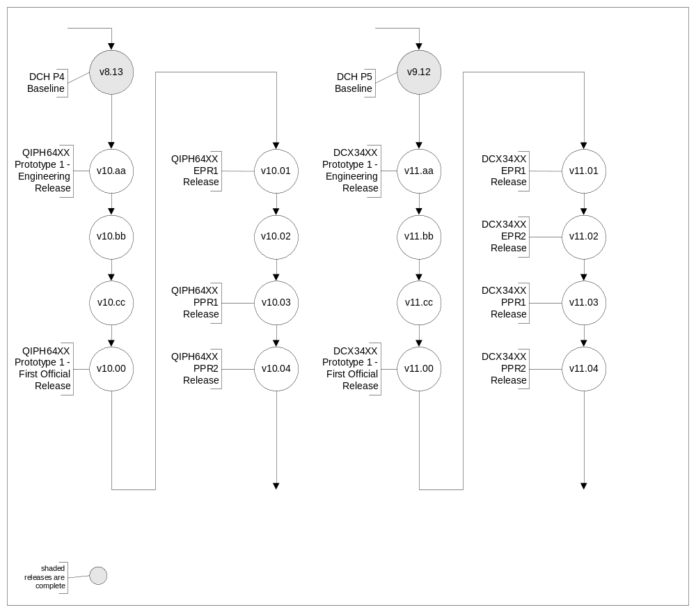
-------------------------------------------------------------------------------------------------------------------------------------------------
QIPH Products
-------------------------------------------------------------------------------------------------------------------------------------------------

TVMon Release – 10.aa Engineering Build for QIPH64XX Prototype 1
Build 9/14/07
Release to Factories
Release to Broadcom 9/14/07
Features:
- The features in this release are compatible with the following products, only:
  - QIPH64XX Proto 1 with BCM7400.
Notes:
- Engineering build release to support QIPH64XX Prototype 1 board bring-up and TVMon debug. As of the date of this release, QIPH Prototype 1 hardware is not yet available, so the release cannot be tested. Therefore, no functionality is guaranteed to execute correctly.
- This release is not backward compatible with DCT, QIP, DCH and LMH ASTB products.
Bug Fixes and Enhancements:
- Phase 0.5 Broadcom release – 09/11/07
  - Includes BCM7400 reference software phase 3.7 (to keep in sync with TC/MTC)
- BSP update to support the BCM7400 (non-secure boot)
- BRCM HAL update to support the BCM7400
- UART and serial port support (9600 8/O/1)
- TVMon main menu
- I2C (HDMI, Front Panel, PSOC)
  - Functions to access all I2C devices and associated registers, similar to CMA
- CMA (Continuous Memory Access)
  - Read/write memory and registers
- Flash init (using CFI) - Spansion
- Tests for memory controllers
- Settop Config (“setc”) and Board ID (“swb”) functions
- General GPIO initialization
- PCI (Entropic, 1394 Jedi, BCM3250)
  - Bus enumeration, initialize I/O and memory
  - Access PCI devices via PCI config cycles

TVMon Release – 10.bb Engineering Build for QIPH64XX Prototype 1
Build 9/21/07
Release to Factories 9/21/07
Release to Broadcom 9/21/07
Features:
- The features in this release are compatible with the following products, only:
  - QIPH64XX Proto 1 with BCM7400.
Notes:
- This release is not compatible with DCT, QIP, DCH and LMH ASTB products.

Bug Fixes and Enhancements:
- Corrected functions from v10.aa based on Proto 1 board bring-up
- InBand tuning support
- Inband 64 QAM demod support (paths 1 and 2)
- Digital video decode and display (M-Card bypass)
  - Currently supported formats from DCH
- Digital audio decode and output (M-Card bypass)
- DMA
- Cache Functions (cached/un-cached, write-through/write-back)
- BCM3250 memory tests
- Flash tests with auto size detection (16MB, 32MB, 64MB)
- DDR Memory Tests – 128MB or 256MB with auto size detection
- PFD (Protected Flash Data) functions
- Front Panel LED Display, Keypad, IR Receiver

TVMon Release – 10.cc Engineering Build for QIPH64XX Prototype 1
Build 10/05/07
Release to Factories 10/05/07
Release to Broadcom 10/05/07
Features:
- The features in this release are compatible with the following products, only:
  - QIPH64XX Proto 1 with BCM7400.
Notes:
- This release is not compatible with DCT, QIP, DCH and LMH ASTB products.
Bug Fixes and Enhancements:
- Inband 256 QAM demod (path1 and path 2)
- OOB QPSK demod
- RF upstream
- Memory tests
- MPEG-4 support
- Routing clear A/V through the Cable Card
- AC Outlet Control
- Add support for setting NVRAM parameters (for BTSC and US Offset structure).
  - We may remove BTSC from this structure and add the BTSC Types to the MNDS script. MTC must be updated.
- Update IO Control Driver for GPIO

TVMon Release – 10.dd Engineering Build for QIPH64XX Prototype 1
Build 10/12/07
Release to Factories 10/12/07
Release to Broadcom 10/12/07
Features:
- The features in this release are compatible with the following products, only:
  - QIPH64XX Proto 1 with BCM7400.
Notes:
- This release is not compatible with DCT, QIP, DCH and LMH ASTB products.
Bug Fixes and Enhancements:
- PSOC support
- Macrovision support
- HDMI support
- Performance and Heat-up tests
- Nvmlog?? No NVMEM??
- Gathering of M-Card U/A and firmware versions
- 1394 transmission and reception support
- Support for flash password protection functions
- Updated PFD functions for erasing specific PFD areas
- TVMon to Flash
- Downloadable TVMon image

TVMon Release – 10.00 Build for QIPH64XX EPR 1
Build 11/02/07
Release to Factories 11/02/07
Release to Broadcom 11/02/07
Features:
- The features in this release are compatible with the following products, only:
  - QIPH64XX EPR 1 with BCM7400.
Notes:
- This release is not compatible with DCT, QIP, DCH and LMH ASTB products.
Bug Fixes and Enhancements:
- PIP support
- 1080p support
- Add support for Entropic functions, as follows:
  - Read Entropic Chip ID
  - Enable Entropic CW output (at fixed power level) for the following frequencies:
    - 1150 MHz through 1500 MHz in 50MHz increments
  - Entropic Microcode download
  - Enable continuous modulated signal output for the following frequencies:
    - 800 MHz through 1575 MHz in 25MHz increments
- HDD and SATA (including patterns tests)
- Signed TVMon image
- Ethernet tests
- USB tests
- Update all PFD enumerations and structures based on PFD Layout Spec dated TBD.
- Update QAM/QPSK acquisition scripts.
- Update beat frequency tables.
- Protect sensitive memory/registers in CMA mode.

TVMon Release – 10.xx Build for QIPH64XX PPR 1
Build 1/9/08
Release to Factories 1/9/08
Release to Broadcom 1/9/08
Features:
- The features in this release are compatible with the following products, only:
  - QIPH64XX PPR 1 with BCM7400.
Notes:
- This release is not compatible with DCT, QIP, DCH and LMH ASTB products.
Bug Fixes and Enhancements:
- TBD

TVMon Release – 10.xx Build for QIPH64XX PPR 2
Build 4/24/08
Release to Factories 4/24/08
Release to Broadcom 4/24/08
Features:
- The features in this release are compatible with the following products, only:
  - QIPH64XX PPR 2 with BCM7400.
Notes:
- This release is not compatible with DCT, QIP, DCH and LMH ASTB products.
Bug Fixes and Enhancements:
- TBD

Unscheduled CRs:
- TBD

-------------------------------------------------------------------------------------------------------------------------------------------------
DCX Products
-------------------------------------------------------------------------------------------------------------------------------------------------

TVMon Release – 11.aa Engineering Build for DCX34XX Prototype 1
Build 9/14/07
Release to Factories
Release to Broadcom 9/14/07
Features:
- The features in this release are compatible with the following products, only:
  - DCX34XX Proto 1 with BCM7400.
Notes:
- Engineering build release to support DCX34xx Prototype 1 board bring-up and TVMon debug. As of the date of this release, DCX Prototype 1 hardware is not yet available, so the release cannot be tested. Therefore, no functionality is guaranteed to execute correctly.
- This release is not backward compatible with DCT, QIP, DCH and LMH ASTB products.
Bug Fixes and Enhancements:
- Phase 0.5 Broadcom release – 09/11/07
  - Includes BCM7400 reference software phase 3.7 (to keep in sync with TC/MTC)
- BSP update to support the BCM7400 (non-secure boot)
- BRCM HAL update to support the BCM7400
- UART and serial port support (9600 8/O/1)
- TVMon main menu
- I2C (HDMI, Front Panel, PSOC)
  - Functions to access all I2C devices and associated registers, similar to CMA
- CMA (Continuous Memory Access)
  - Read/write memory and registers
- Flash init (using CFI) - Spansion
- Tests for memory controllers
- Settop Config (“setc”) and Board ID (“swb”) functions
- General GPIO initialization
- PCI (1394 Jedi 2)
  - Bus enumeration, initialize I/O and memory
  - Access PCI devices via PCI config cycles

TVMon Release – 11.bb Engineering Build for DCX34XX Prototype 1
Build 9/21/07
Release to Factories 9/21/07
Release to Broadcom 9/21/07
Features:
- The features in this release are compatible with the following products, only:
  - DCX34XX Proto 1 with BCM7400.
Notes:
- This release is not compatible with DCT, QIP, DCH and LMH ASTB products.

Bug Fixes and Enhancements:
- Corrected functions from v11.aa based on Proto 1 board bring-up
- Integrate on-board 1 GHz tuner driver into BCM3255 image – InBand, only
- InBand tuning support
- Inband 64 QAM demod support (paths 1 and 2)
- Digital video decode and display (M-Card bypass)
  - Currently supported formats from DCH
- Digital audio decode and output (M-Card bypass)
- DMA
- Cache Functions (cached/un-cached, write-through/write-back)
- BCM3255 memory tests
- Flash tests with auto size detection (16MB, 32MB, 64MB)
- DDR Memory Tests – 128MB or 256MB with auto size detection
- PFD (Protected Flash Data) functions

TVMon Release – 11.cc Engineering Build for DCX34XX Prototype 1
Build 10/05/07
Release to Factories 10/05/07
Release to Broadcom 10/05/07
Features:
- The features in this release are compatible with the following products, only:
  - DCX34XX Proto 1 with BCM7400.
Notes:
- This release is not compatible with DCT, QIP, DCH and LMH ASTB products.
Bug Fixes and Enhancements:
- Integrate on-board 1 GHz tuner driver into BCM3255 image – DOCSIS
- DOCSIS tuning support
- DOCSIS Demod and Demux
- Cable Modem functions
  - TBD
- Inband 256 QAM demod (path1 and path 2)
- OOB QPSK demod
- RF upstream
- Memory tests
- MPEG-4 support
- Routing clear A/V through the Cable Card
- AC Outlet Control
- Front Panel LED Display, Keypad, IR Receiver??? (New front panel)
- Add support for setting NVRAM parameters (for BTSC and US Offset structure).
  - We may remove BTSC from this structure and add the BTSC Types to the MNDS script. MTC must be updated.
  - No NVRAM…
- Update IO Control Driver for GPIO

TVMon Release – 11.dd Engineering Build for DCX34XX Prototype 1
Build 10/12/07
Release to Factories 10/12/07
Release to Broadcom 10/12/07
Features:
- The features in this release are compatible with the following products, only:
  - DCX34XX Proto 1 with BCM7400.
Notes:
- This release is not compatible with DCT, QIP, DCH and LMH ASTB products.
Bug Fixes and Enhancements:
- PSOC support
- Macrovision support
- HDMI support
- Performance and Heat-up tests
- Nvmlog?? No NVMEM??
- Gathering of M-Card U/A and firmware versions
- 1394 transmission and reception support
- Support for flash password protection functions
- Updated PFD functions for erasing specific PFD areas
- TVMon to Flash
- Downloadable TVMon image

TVMon Release – 11.00 Build for DCX34XX EPR 1
Build 11/02/07
Release to Factories 11/02/07
Release to Broadcom 11/02/07
Features:
- The features in this release are compatible with the following products, only:
  - DCX34XX EPR 1 with BCM7400.
Notes:
- This release is not compatible with DCT, QIP, DCH and LMH ASTB products.
Bug Fixes and Enhancements:
- PIP support
- 1080p support
- MII (Media Independent Interface) initialization (for MoCA)
- Add support for Entropic functions, as follows:
  - Read Entropic Chip ID
  - Enable Entropic CW output (at fixed power level) for the following frequencies:
    - 1150 MHz through 1500 MHz in 50MHz increments
  - Entropic Microcode download
  - Enable continuous modulated signal output for the following frequencies:
    - 800 MHz through 1575 MHz in 25MHz increments
- HDD and SATA (including patterns tests)
- Signed TVMon image
- DDPC Dump

TVMon Release – 11.xx Build for DCX34XX EPR 2
Build 2/06/08
Release to Factories 2/06/08
Release to Broadcom 2/06/08

Features:
- The features in this release are compatible with the following products, only:
  - DCX34XX EPR2 with BCM7400.
Notes:
- This release is not compatible with DCT, QIP, DCH and LMH ASTB products.
Bug Fixes and Enhancements:
- Ethernet tests
- USB tests
- Update all PFD enumerations and structures based on PFD Layout Spec dated TBD.
- Update QAM/QPSK acquisition scripts.
- Update beat frequency tables.
- Protect sensitive memory/registers in CMA mode.

TVMon Release – 11.xx Build for DCX34XX PPR 1
Build 4/4/08
Release to Factories 4/4/08
Release to Broadcom 4/4/08
Features:
- The features in this release are compatible with the following products, only:
  - DCX34XX PPR 1 with BCM7400.
Notes:
- This release is not compatible with DCT, QIP, DCH and LMH ASTB products.
Bug Fixes and Enhancements:
- TBD

TVMon Release – 11.xx Build for DCX34XX PPR 2
Build 6/6/08
Release to Factories 6/6/08
Release to Broadcom 6/6/08
Features:
- The features in this release are compatible with the following products, only:
  - DCX34XX PPR 2 with BCM7400.
Notes:
- This release is not compatible with DCT, QIP, DCH and LMH ASTB products.
Bug Fixes and Enhancements:
- TBD

Unscheduled CRs:
- TBD

-------------------------------------------------------------------------------------------------------------------------------------------------
Future Enhancements
-------------------------------------------------------------------------------------------------------------------------------------------------

