   |  | asizemot.dot | 473452-001 Rev N
General Instrument of Taiwan, Ltd. |  | 8
This document is the property of Motorola, Inc., Connected Home Solutions. This document may only be distributed to: (i) a Motorola employee ("Motorola") having a legitimate business need for the information contained herein, or (ii) a non-Motorola having a legitimate business need for the information contained herein. No license, expressed or implied, under any patent, copyright or trade secret right is granted or implied by the conveyance of this document. No part of this document may be reproduced, transmitted, transcribed, stored in a retrieval system, translated into any language or computer language, in any form or by any means, electronic, mechanical, magnetic, optical, chemical, manual, or otherwise without the prior written permission of Motorola, Inc. Connected Home Solutions. (See Document Security Standard, 320190-000 for details.)
MOTOROLA, the Stylized M Logo and all other trademarks indicated as such herein are trademarks of Motorola, Inc. ® Reg. U.S. Pat. & Tm. Off. All other product or service names are the property of their respective owners.
Copyright © 2000-2026 Motorola, Inc. All rights reserved.
Document Title | DCX BLTC Software Low Level Design (LLD)
Number
Revision | Z1
Revision Date | 11/06/2008
Author(s) | Gamma Chen
Internal
Level 2

Revision History – see Workflow History for approvers and approval dates, and Notice for release dates
Rev | Notice # | Description | Author | Revision Date

Table of Contents
1. Software Architecture 9
5.1. BLTC Basic Type 59
5.2. Class Diagram (API quick view) 9
6. Sequence Diagram 10
6.1. Class Diagram (API quick view) 9
5.2. Class Diagram (API quick view) 9

Follow are the Software Structure we mentioned in HLD. In LLD, we will explain class diagram and Sequence Diagram according the Software Layer we use in BLTC design.
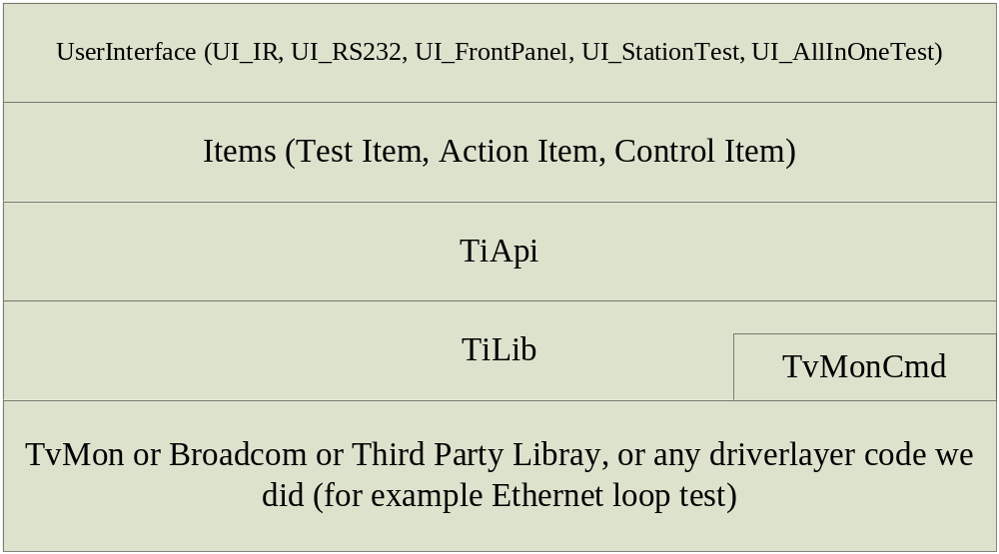

Class Diagram

BLTC Basic Type
Broadcom used to using their basic type (U8, U16, …). BLTC should avoid to define the same type name.
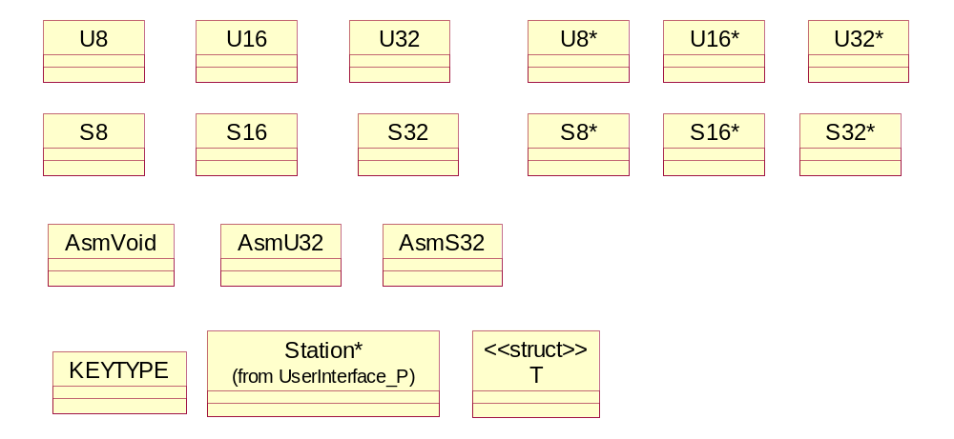

BltcBasicType.h contents as follow,

#include "gitypes.h" // "gitypes.h" include above type and const.

// Follows for Code Generation Function of QIP7xxx BLTC can work in Rational Ross (UML tool).
#define AsmVoid asm void
#define AsmU32 asm U32
#define AsmS32 asm S32

Rational Ross be chosen as OOA (Object Oriented Analysis) tool. I made AsmVoid define since “asm void” will make the Rational Ross dead in Code Generation Function or Reverse Engineer Function.

Pattern
A couple of pattern used in QIP7xxx BLTC design (Refer book, Design Patterns, published by Addison Wesley in 1995). They are:
Iterator pattern
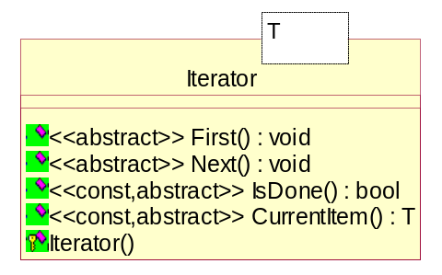
Observer pattern
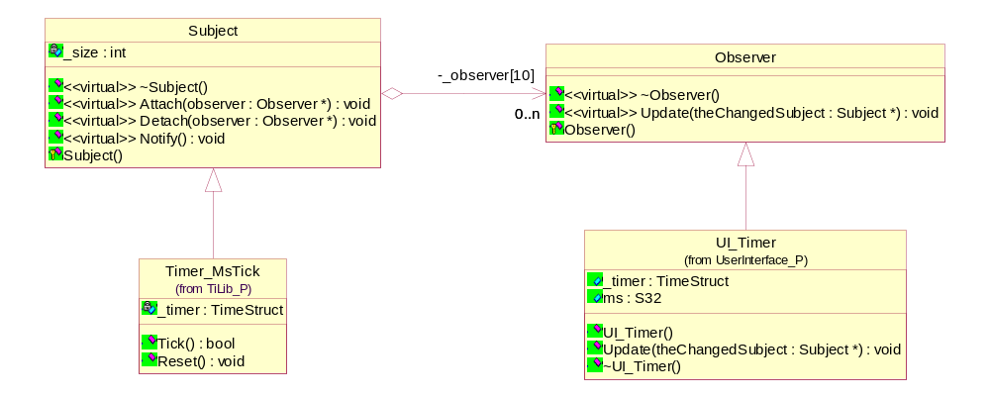
Composite pattern
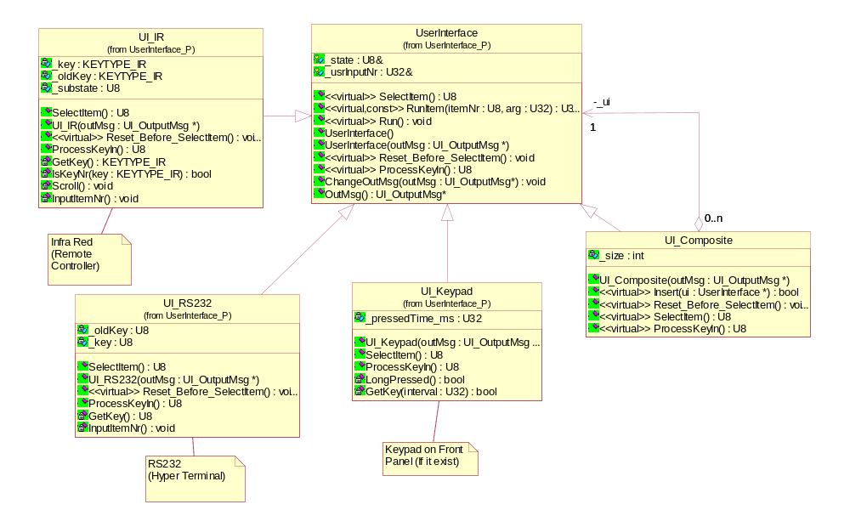
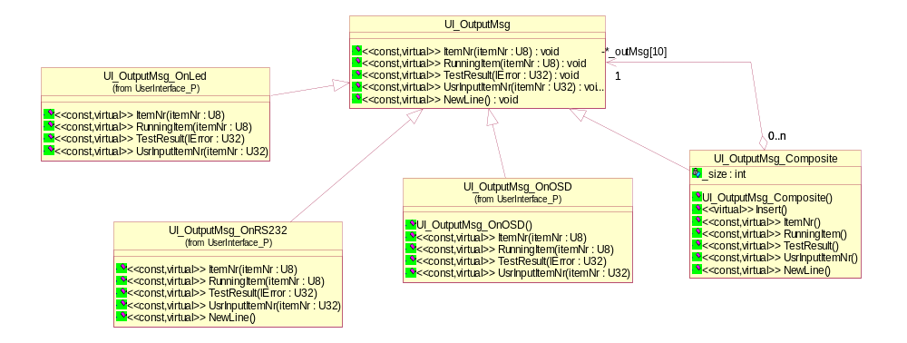
Decorator pattern
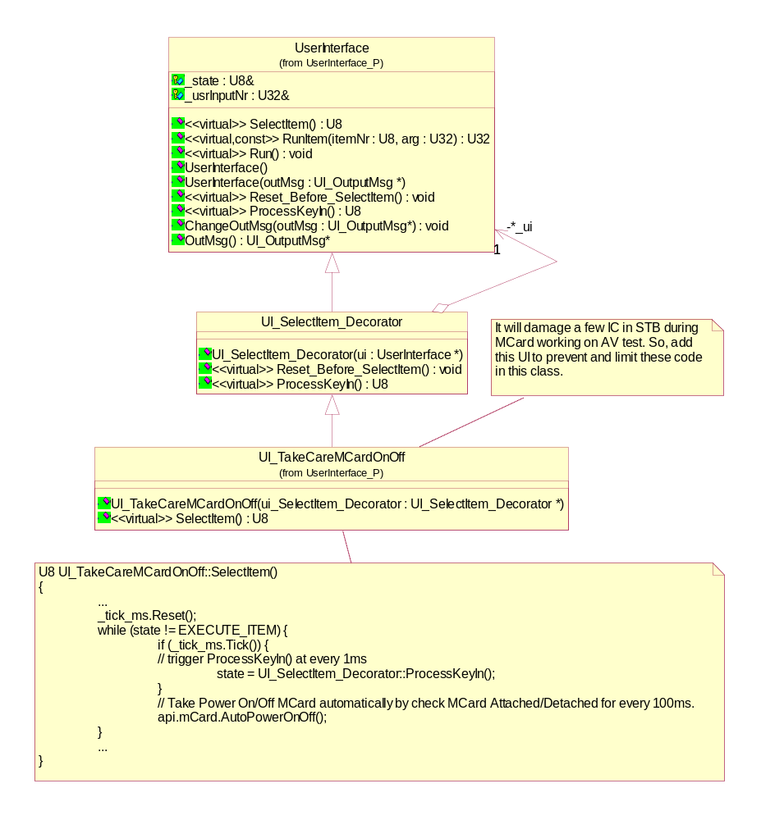

User Interface
For lab, select test item by Remote Controller (IR: Infra Red) or Front Panel (Keypad) or RS232, run single test item for debug (UI_IR, UI_RS232, UI_FrontPanel user interface), (refer Decorator Pattern as above).

In production-line, we using Station Test, UI_StationTest, currently, and have a plan All In One Test, UI_AllInOne, in future.

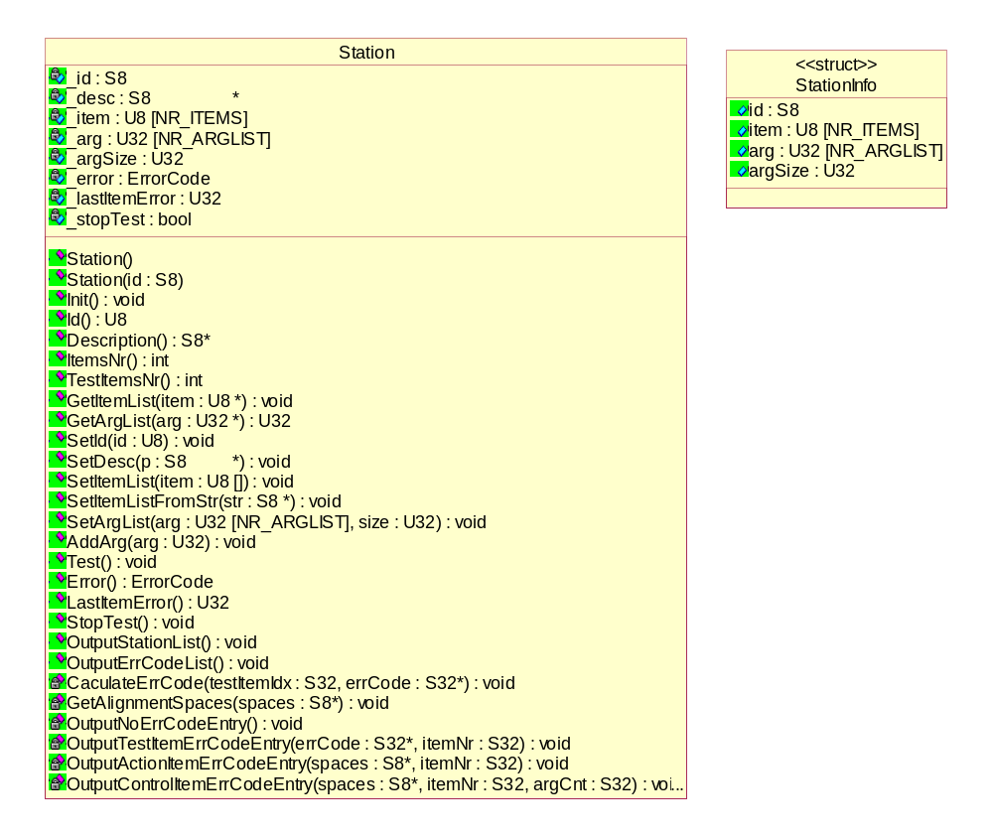

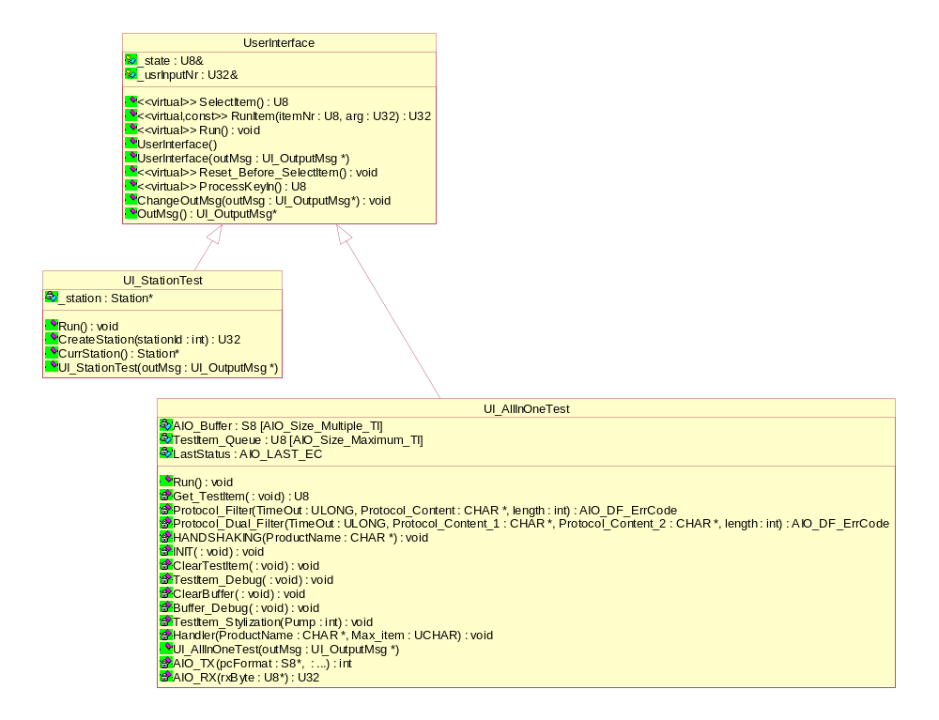

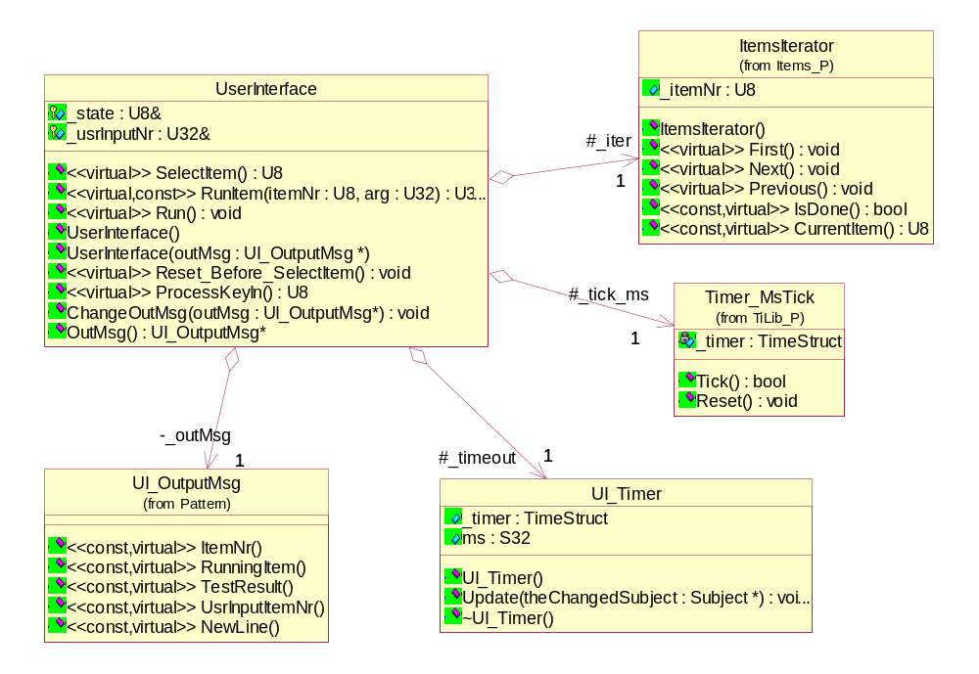

Items
Give a number for each test item, it’s purpose is to communicate with PE clearly.
For example,
TI000: "Display station information on RS232, setting:(38400,8,O,1,n)"
TI103: “Tuner 1(64QAM, channel=8, pid=8c0 8c0 8c1) A/V test, and 1394 Tx Test"
TI105: “Tuner 1(256QAM, channel=6, pid=310 310 311) A/V test, and 1394 Tx Test"
When operator report to PE, and PE told us the test item number has trouble, eg.103, then we know exactly the TI103: “Tuner1(64QAM)…” has trouble.
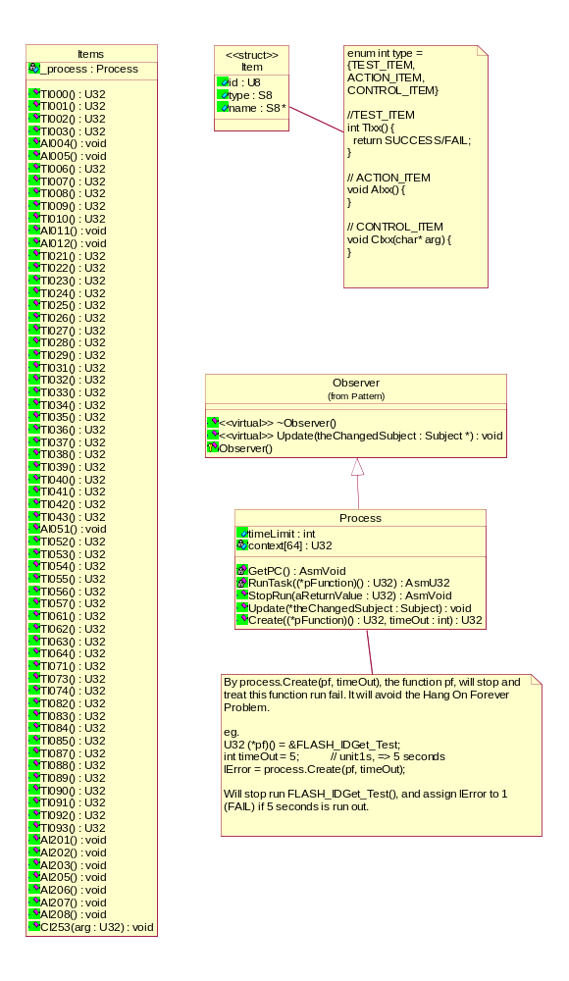
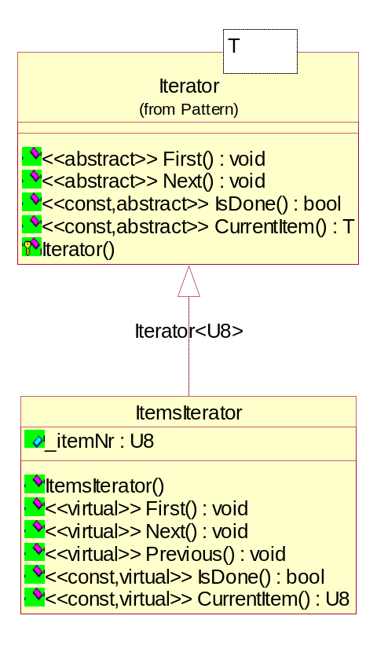

TiApi
The layer be called by layer items or above.
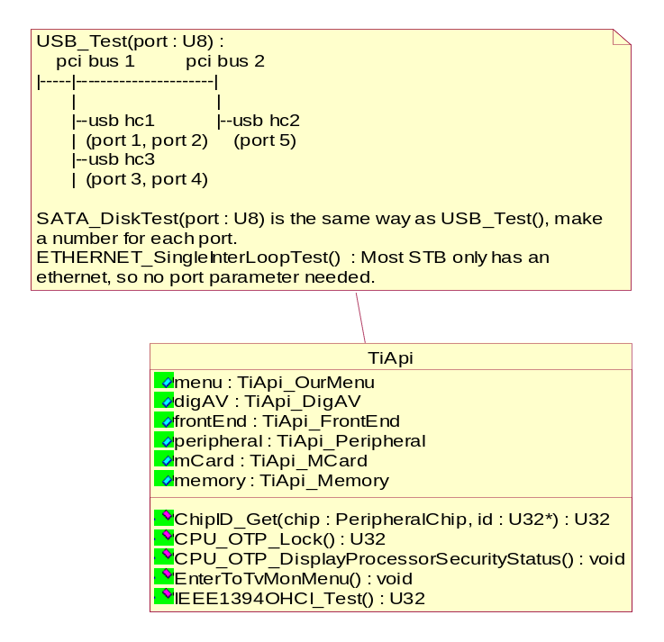
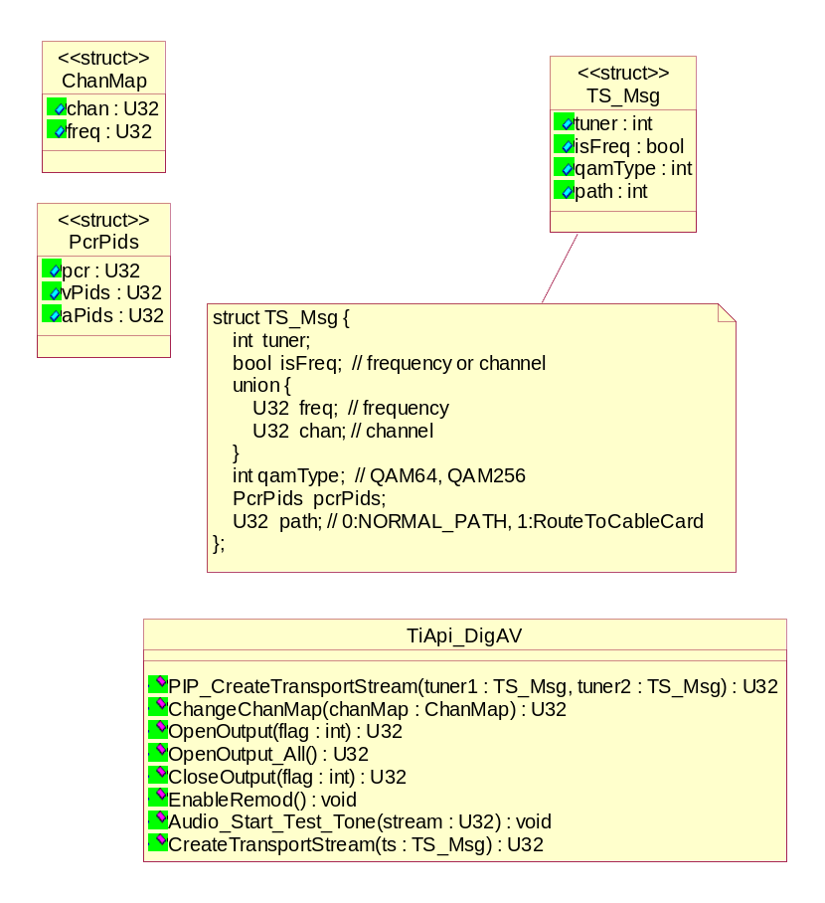
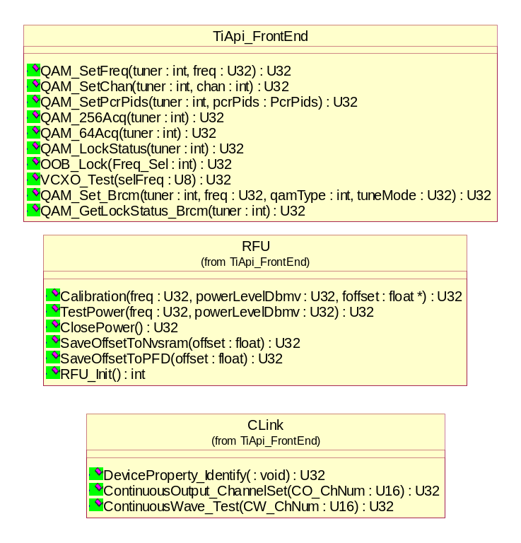
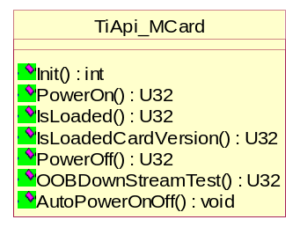
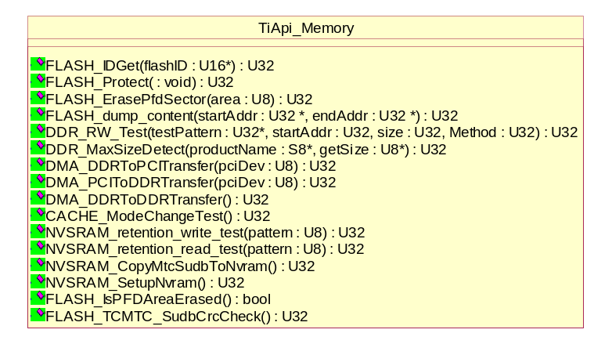
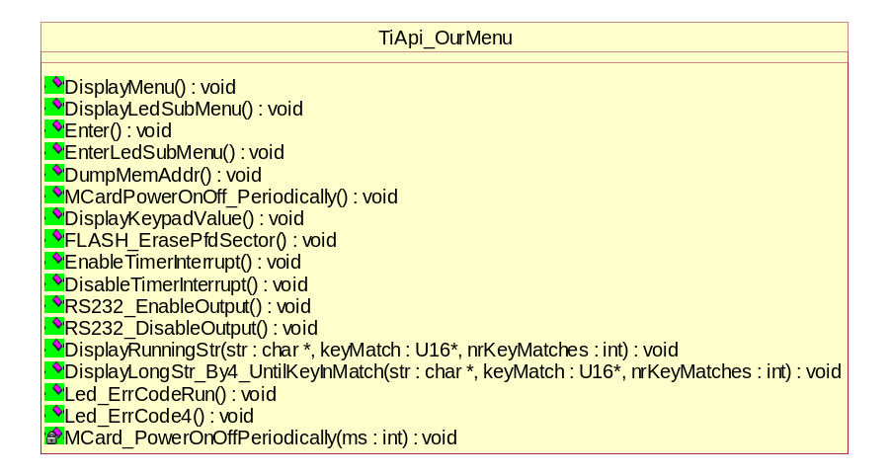
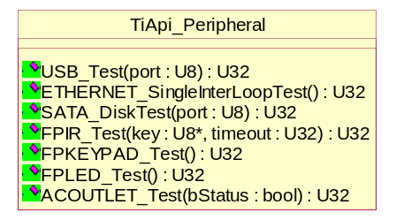

TiLib
The layer be called by layer TiApi or above.

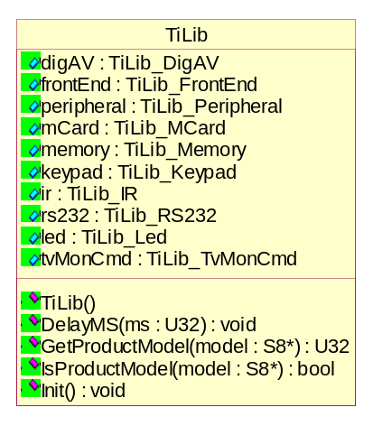
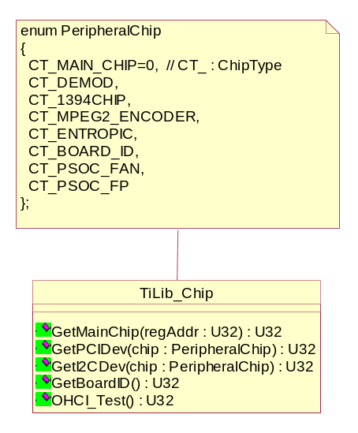
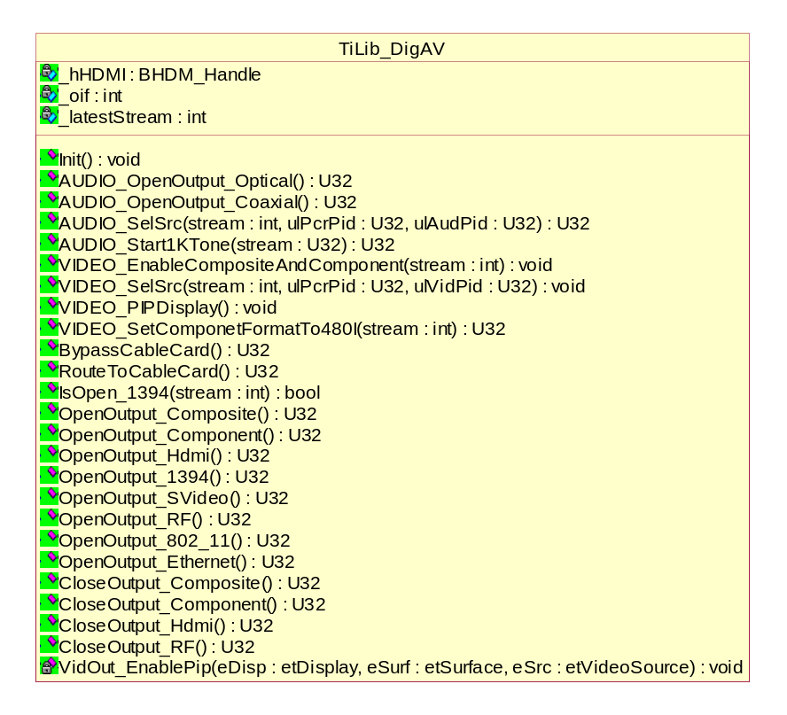
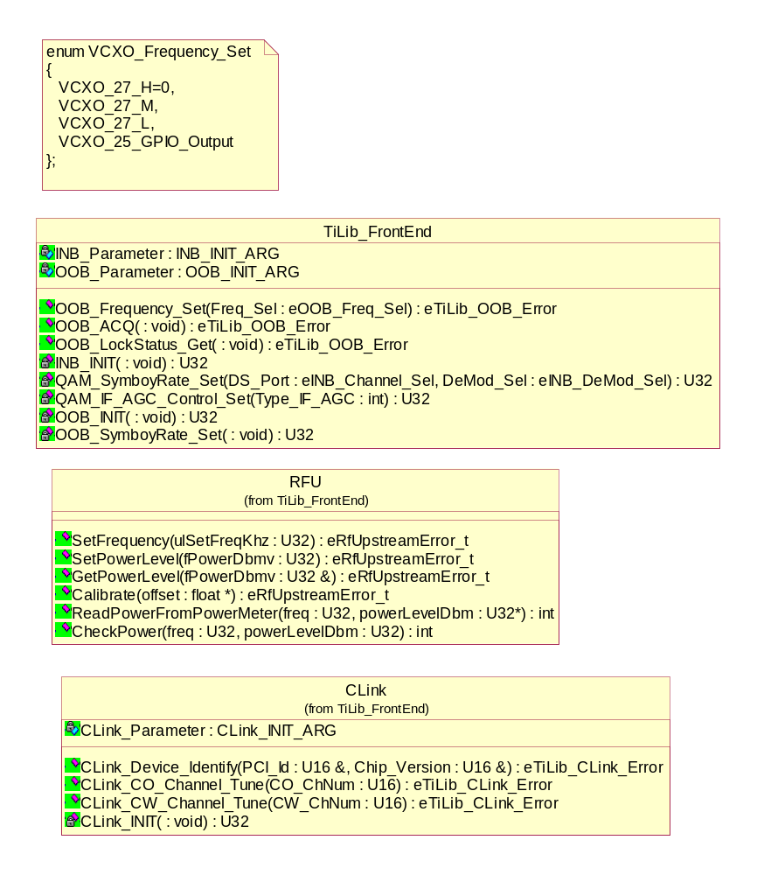
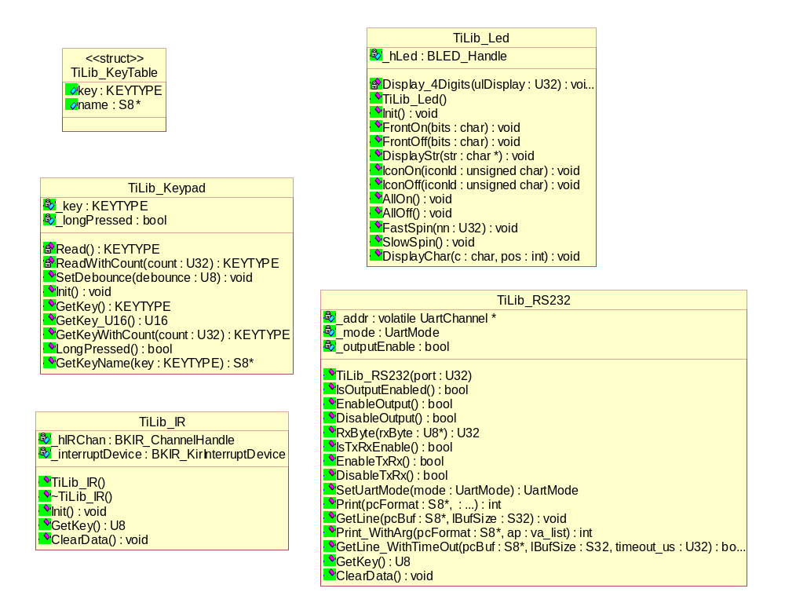
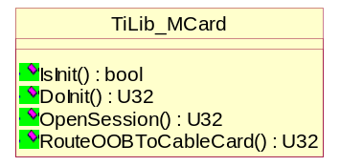
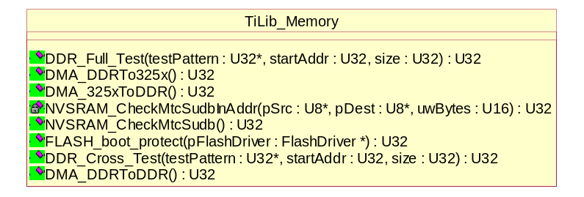
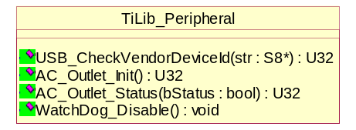
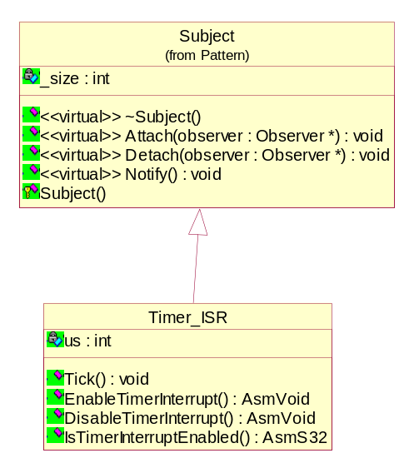

TvMonCmd
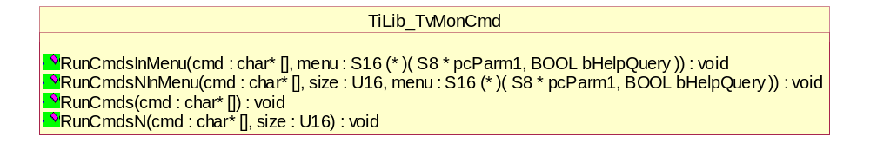

TvMonIO Function Pointer and TvMonIO (in Broadcom Hal Layer)
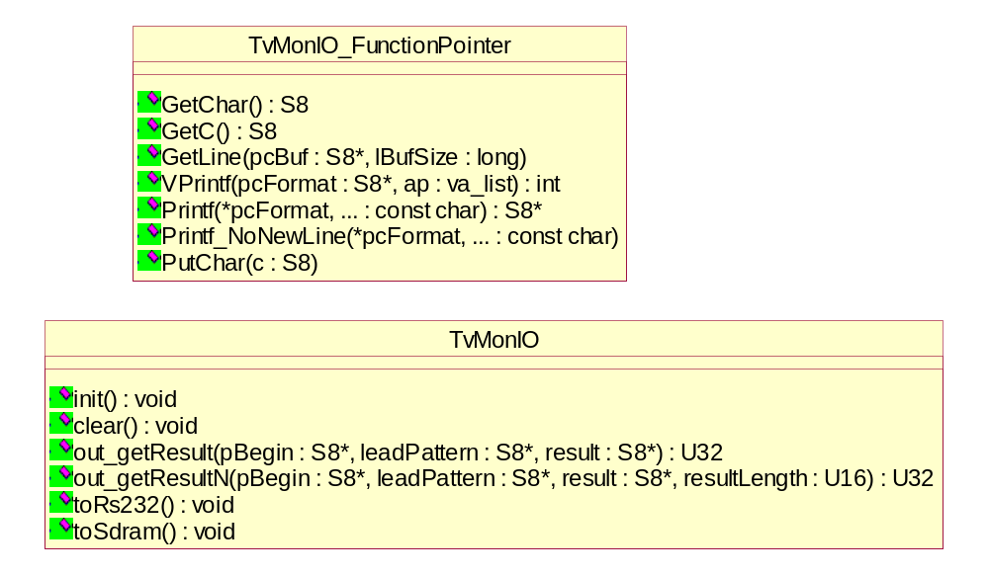

Sequence Diagram
This section using sequence diagram to describes how objects co-work to finish the system functions. UI_DebugTest and UI_StationTest are described in 6.1 User Interface. Some test items are described in 6.2 Items.

User Interface
UI_StationTest:
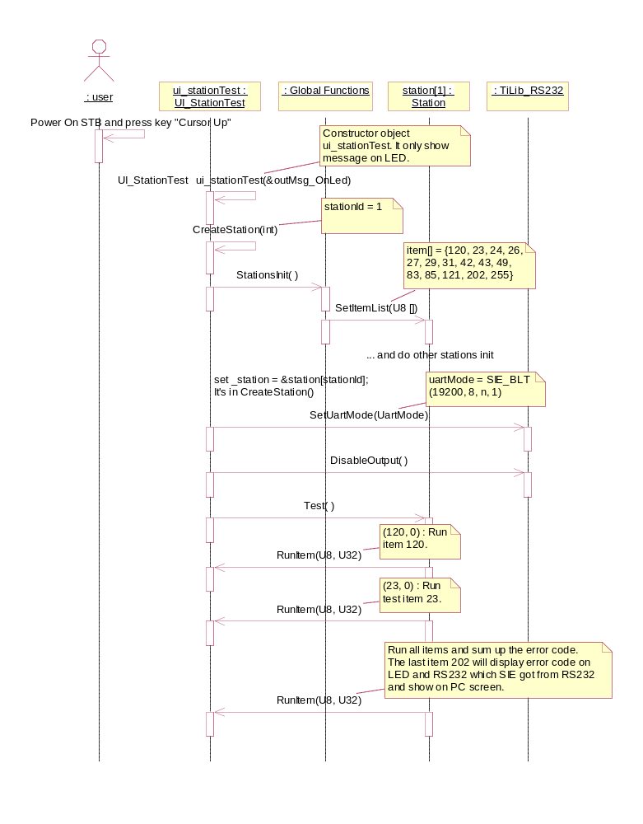

UI_DebugTest:
It will damage a few IC in STB during MCard working on AV test. So, add this UI_TakeCareMCardOnOff to prevent and limit these code in this class. The ui_mui is an object as type of class UI_TakeCareMCardOnOff, and include object ui_mui->ui which include 3 UI objects, UI_FrontPanel, UI_IR and UI_RS232.

SelectItem() will Scroll item No. when user press "Channel Up" or "Channel Down", and escape while loop when press key "Select".

The sequence diagram as follow,
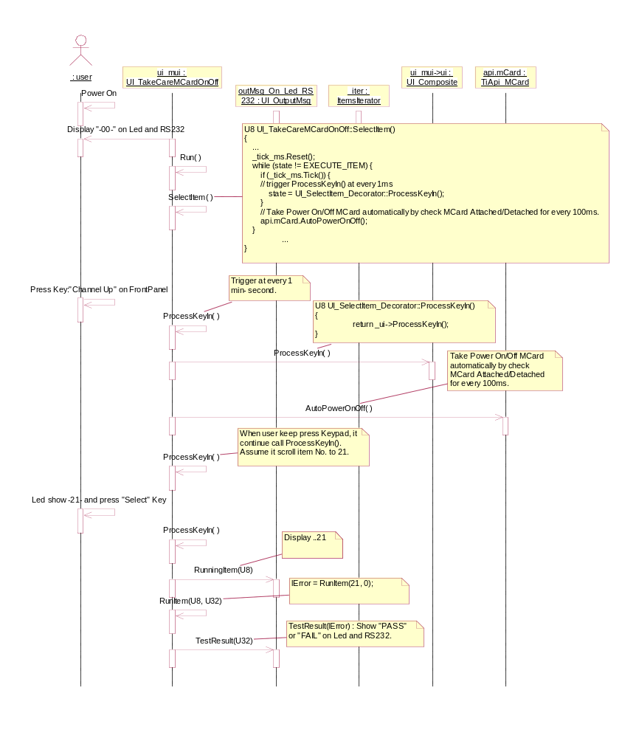
The SelectItem() part as follow,
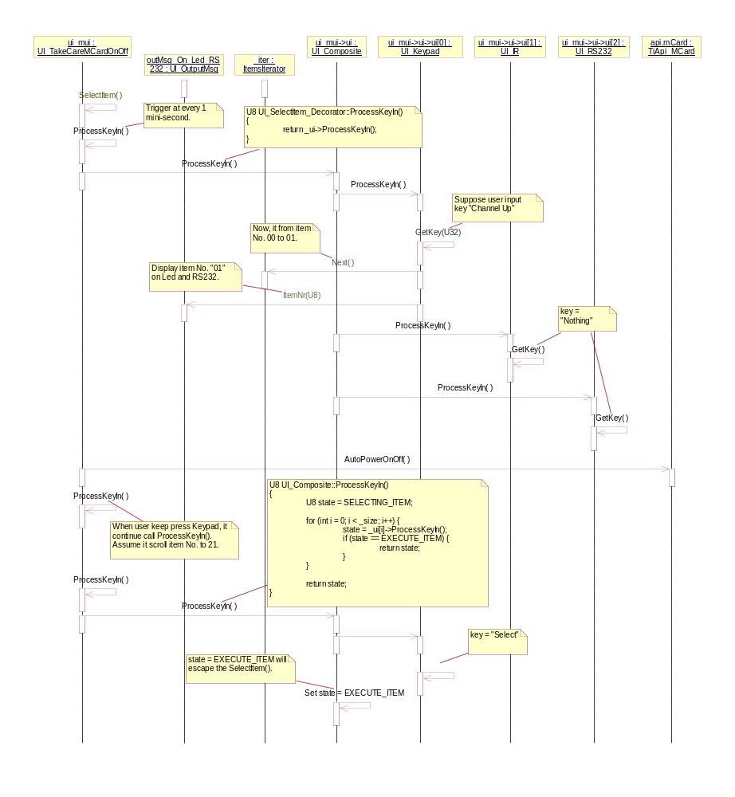

Items
Run Item with Time Out:
I implement the time out mechanism and used in every test items. BLTC give every test item a time limit to run. If it over, then treat this test item is FAIL. The reasons for time out mechanism as follow,
1. Sometimes especially in EPR or PPR stage (still in implement new test item), BLTC will hang on the test items, for example, the Ethernet Loop Test Item, SATA Test Item, and Flash Vendor ID Test Item will have chance to hang on forever (I have this experience in DCT34xx and DCH P5 and QIP7216 EPR, and I know it came from the TvMon Layer in some special test order). When it happen, the whole station test cannot go on, and we have no idea to go on. The only way to run the EPR is by skip the whole station test and ask operator to run single item test, one by one. With this mechanism, I don’t have to worry about this situation any more (it’s a nightmare).
2. BLTC abandoned the solution that stop test as soon as it meet FAIL in run any test item. It run all test items of station and display error code. It’s better for rework (find all bad part at one time).
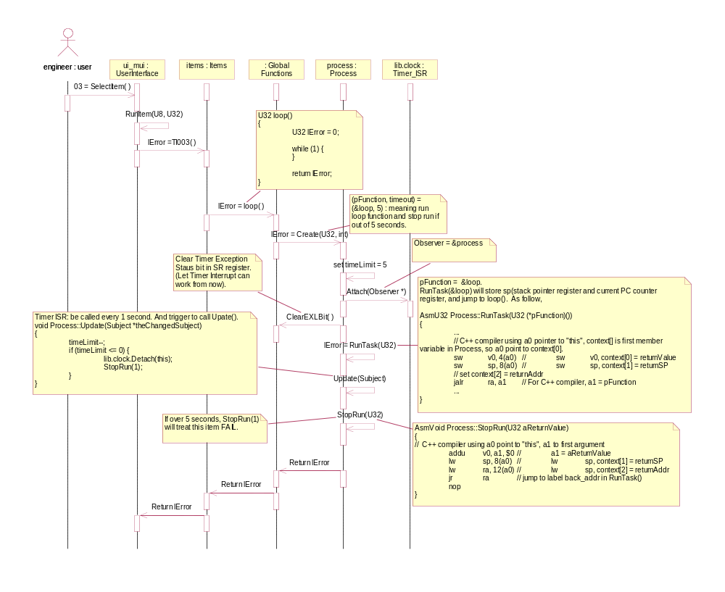

Run Item with Time Out::Process::Update() part,
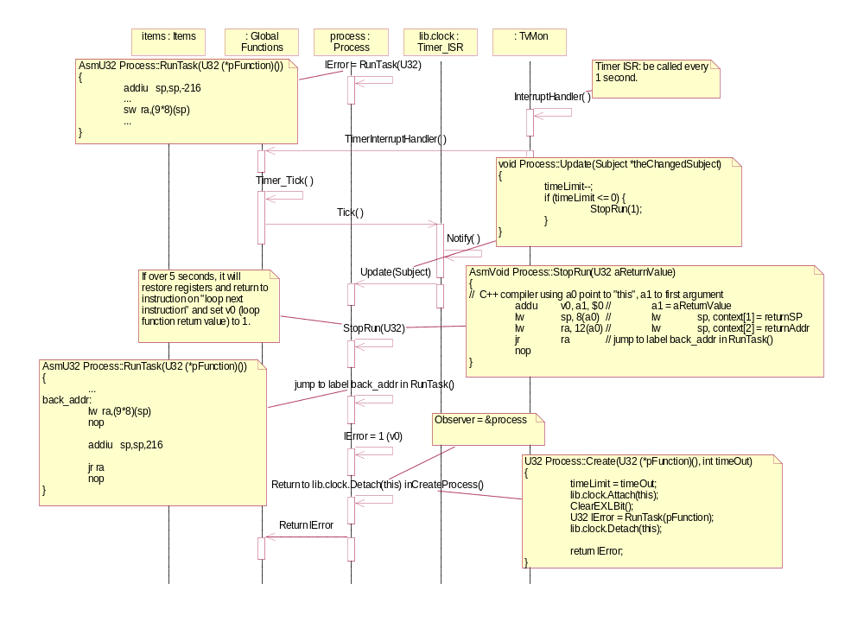
DigAV_CreateTransportStream(NORMAL_PATH)
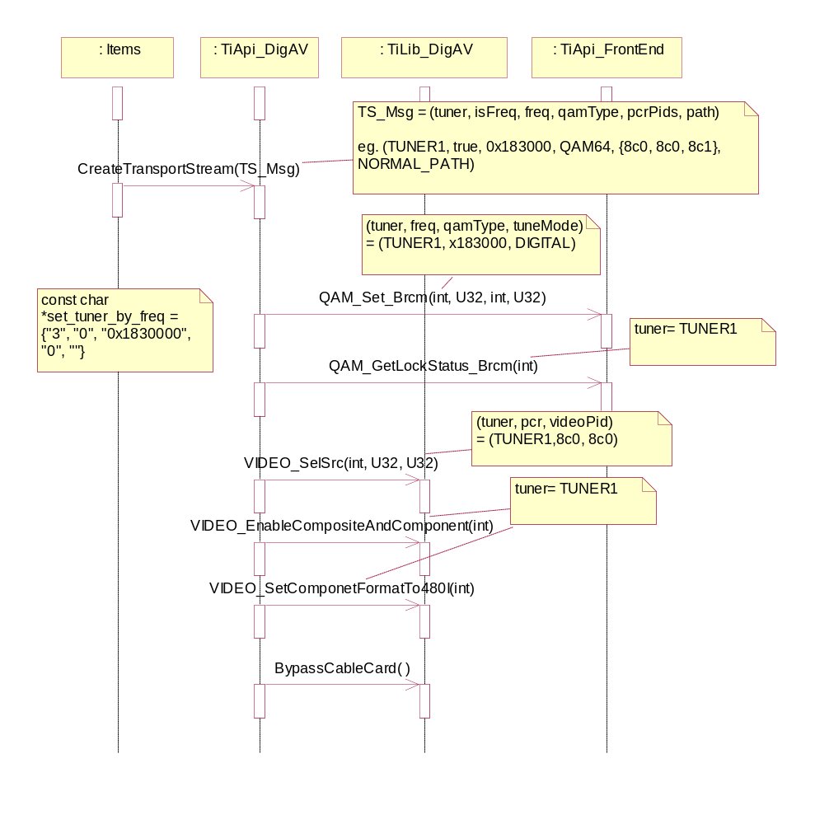
DigAV_CreateTransportStream(ROUTE_TO_CABLECARD)
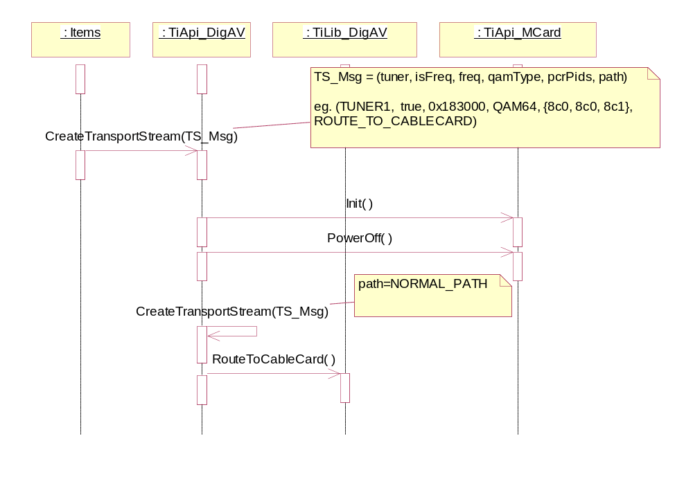
Digital AV PIP Test (Normal Path)
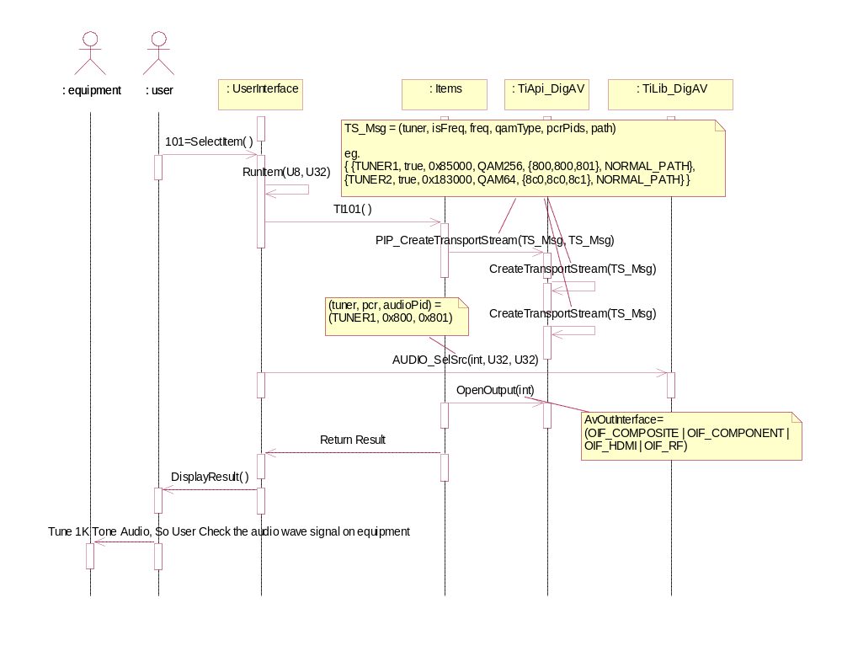
Digital AV Test (CableCard and 1394)
