- Run TVMON_build.bat to ensure it’s work.
- Change MotorolaTvMonQiph.mcp as follow,
Create group Bltc, and subgroup Items, TiApi, TiLib and UserInterface as follow
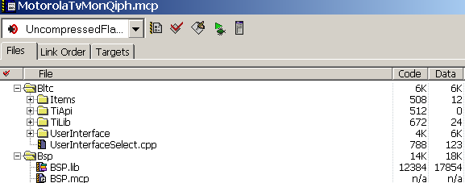

- Create dir TvMon\Libs\Broadcom_Hal\src\TvMonIO, and copy those 5 files to it. And modify project bcmhal7400.mcp as follow,
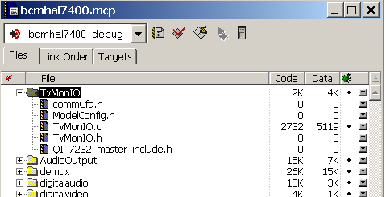

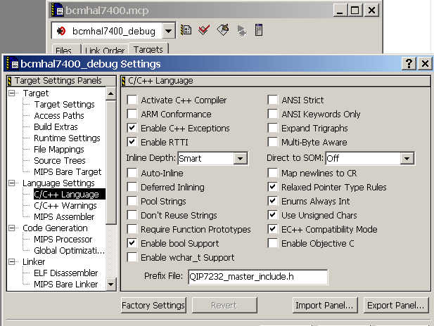
- Search “Gamma modify” (case sensitive) in TvMon dir and update them.
(1). For porting BLTC,
main.c
(2). For porting TvMon Command mechanism,
userio.h , bcmdbg.h , mainmenumgr.c, atatest.c, bCmdDigAudioDec.c , prompt.c
(3). For Software disable RS232 Tx solution,
hw_init.c, bkni.c

(4). In P5, more
bCmdKpd.c, bCmdVidOut.c, elibc.h, bCmdQus.c, bqds.c, bqus.c, bqus_3255_scripts.c, EntropicPower.c, LsiDmnEncoderMenu.c.

- Follows files only for TvMon9.10 to fix the bug in DCH3416P5. TvMon9.11 has fix this bug, so no need any more. I write them down for check,
btnr_mtm.h, btnr_mtm.c, bCmdDigAudioDec.c.

