Hub 1.0
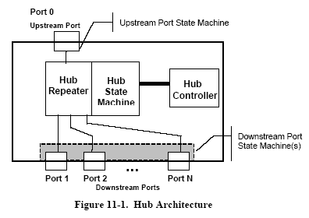
Hub 2.0
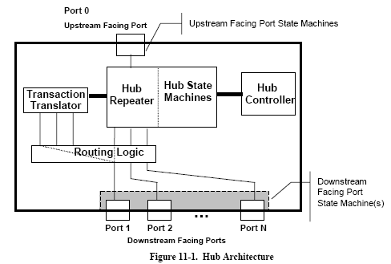

When Port 0 was HS and Port 1 was FS/LS, Port 1 be switched to connect to Transaction Translator while Port 2 to Port N stay in HS, ref. p298.

Adjust HS to FS/LS ref. p201, p441
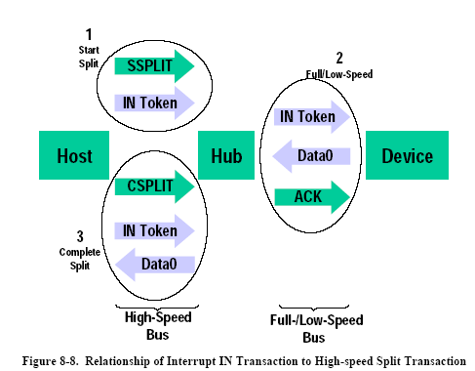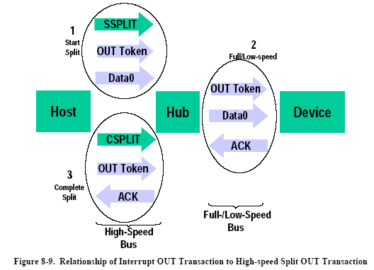

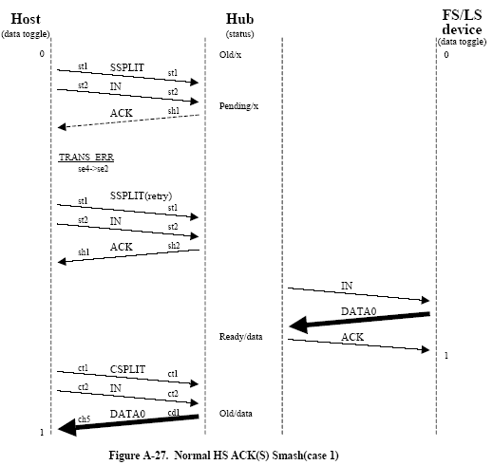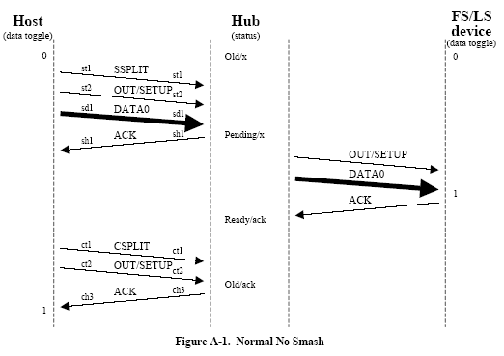

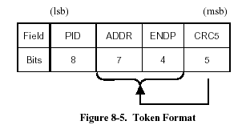
OUT, IN, SETUP, PING

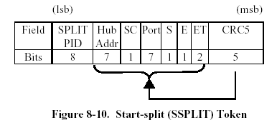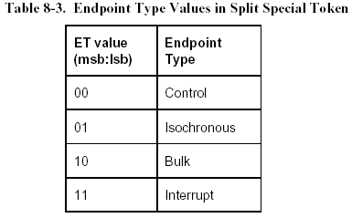
S (Speed) :
0 – Full speed 1 – Low speed

The U bit is reserved/unused and must be reset to zero(0B).
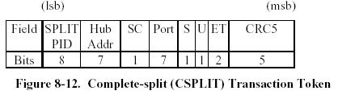
DATA0, DATA1, DATA2, MDATA
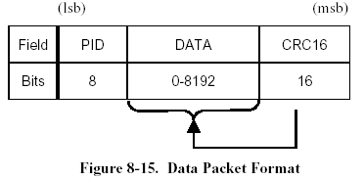

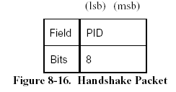
ACK, NAK, STALL, NYET, ERR

Adjust FS to LS ref. p235
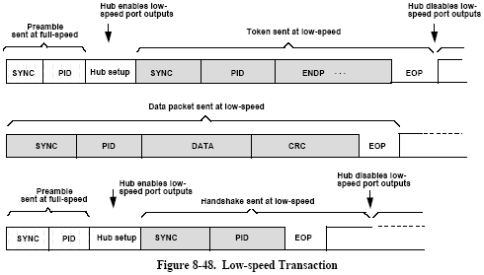

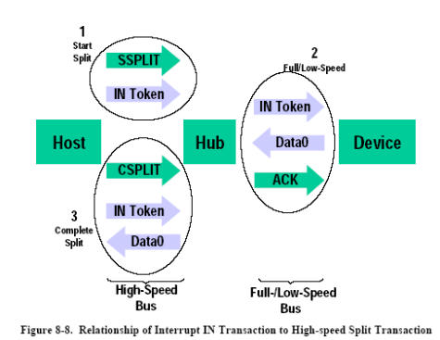
Routing

Host
Hub 2.0 (1)
Hub 1.0 (2)
Hub 2.0 (3)
Hub 1.0(4)
LS device (5)
FS device (7)
HS device (8)
LS device (9)
Port1
Port2
Port3
Port1
Port2
SSPLIT(HubAddr=1, port=1, speed = LS)
PRE+IN(addr=5)
FS device (6)
Hub 2.0 (1) received SSPLIT, then sent PRE+IN to Port 1. Hub 1.0 (2) received PRE packet, then enable LS downstream port buffer. Lately it received IN and broadcast to all it’s LS port.
IN(addr=5)
This in full speed.

This in high speed.

Host
Hub 2.0 (1)
Hub 1.0 (2)
Hub 2.0 (3)
Hub 1.0(4)
LS device (5)
FS device (7)
HS device (8)
LS device (9)
Port1
Port2
Port3
Port1
Port2
DATA
CSPLIT+PRE+IN
FS device (6)
ACK
Step1
Step2
Step3
This in low speed.

This in full speed, ref. p331.

This in high speed.

Ref. UML::Example_AdjustSpeed sequence diagram.

