GetHubDescriptor( ) as follows,
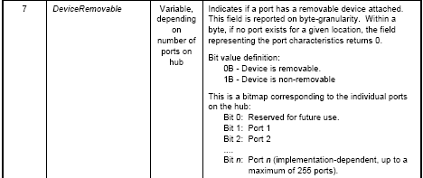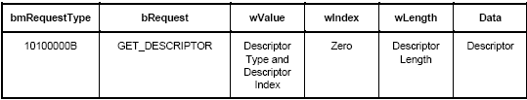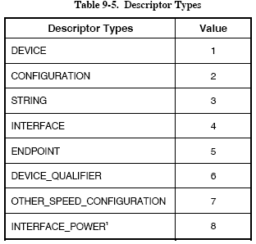

Bitmap : Is a status change Bitmap. (p338, p424, p417, p418)

Reset() ref. p150
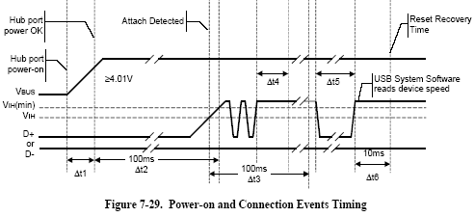
Reset() 10ms to 20ms.

SetAddress() ref. p256
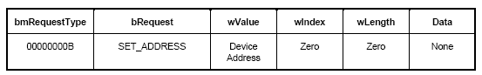
For example that Device Address is 1, the contents is 0x 00 05 01 00 00 00 00 00, wValue low byte 01 send first and high byte 00 follows.
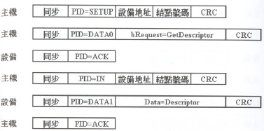
SET_ADDRESS
All these 2 transfer, (Device Address, Endpoint Number) = (0, 0)

GetDescriptor(DescriptorIndex = 0, DescriptorType = DEVICE, wIndex = 0, wLength = 8 ) => Get the first 8 bytes of Device Descriptor, ref. p253.

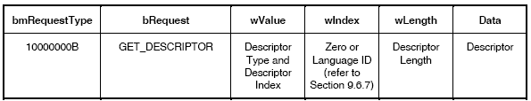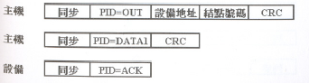
8
GET_DESCRIPTOR
GET_DESCRIPTOR = 0x 80 06 00 01 00 00 08 00. In wValue, Descriptor Index is low byte = 0, Descriptor Type is high byte = 01.
0
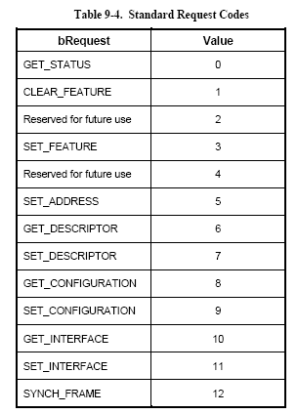

GetDescriptor(DescriptorIndex = 0, DescriptorType = DEVICE, wIndex = 0, wLength = 12 ) => Get the whole of Device Descriptor, ref. p253.

GetDescriptor(DescriptorIndex = 0, DescriptorType = CONFIGURATION, wIndex = 0, wLength = 8 ) ) => Get the first 8 bytes of Configuration Descriptor, ref. p253.

8
GET_DESCRIPTOR
GET_DESCRIPTOR = 0x 80 06 00 02 00 00 08 00.
0

SetConfigure() ref. p257
