Ref. p141
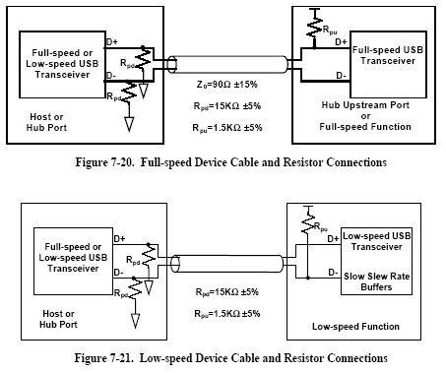
ref. p141
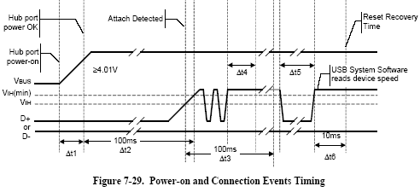
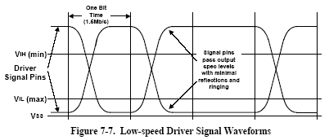
J state
D-
D+
K state

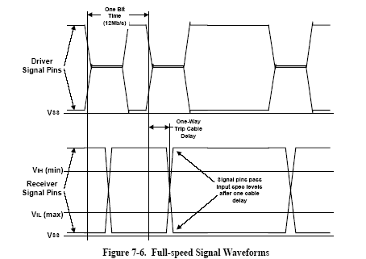
J state
K state
D+
D-

High Speed detection
Some device can support HS and FS. So the procedure as follow,
If the device connect on Hub 2.0 =>
Device signal ChirpK, hub reply ChirpK-J-K-J…(a sequence of switch signal) in reset signal time, and device detect ChirpK-J-K-J…, then device operate as HS (enter HS default state immediately)..
If the device connect on Hub 1.0 =>
Device signal ChirpK, hub reply nothing in reset signal time, then device operate as FS
, ref p153.

