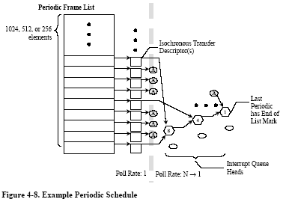
Can link to iTD, siTD or Queue Head (for interrupt).
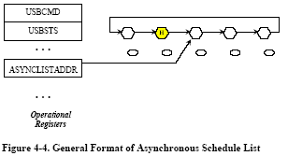
- For each u-frame, process the Periodic first, then switch to Asynchronous (So, in Bus Enumeration, software must promises the bandwidth is fit in.).
- When no Periodic job to do, and few Head Queue (HQ) in Asynchronous, device will busy to responds with Nak/Nyet. EHCI have a solution for this situation, ref. p74.
- By setting S-Mask, can decide the HQ (for interrupt transfer) or siTD (for start split) run at which u-frame. For example, 00000011b meaning 0th and 1st u-frame run this HQ or siTD.

