- Suppose we set CBSR of HcControl = 3 (4:1, p110, p93).
- Isochronous always in the tail of 1-ms interrupt list O.
- A transfer(=IRP) has one or more transaction; A td, Transfer Descriptor, is; a Transaction or more than one transaction; Transaction = 3 or 2 stage of packet (usb 2.0 spec. p10, p63).
- Each General td and Isochronous td contains more than one packet data, (p8, p21, p25) and after transfer a packet (a single transaction), HC move to next ED. (p95)
- HC will server control and bulk first and switch to serve interrupt and isochronous. (Ref. Fig3-6 as below)
(1). Only a TD in ED is processing, then HC move to next ED (P95). TD is either be sent at least a packet in a frame or not sent any bit, ref. Figure 3-6 as follows.
(2). HcBulkCurrentED/HcControlCurrentED is advanced to the next ED after HC served the present TD. (P119)
- HC serve control and bulk according 4-frame :1-frame (p110).

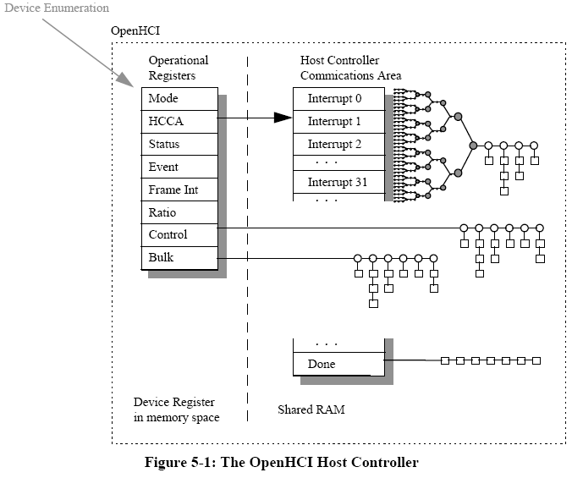
TD
ED

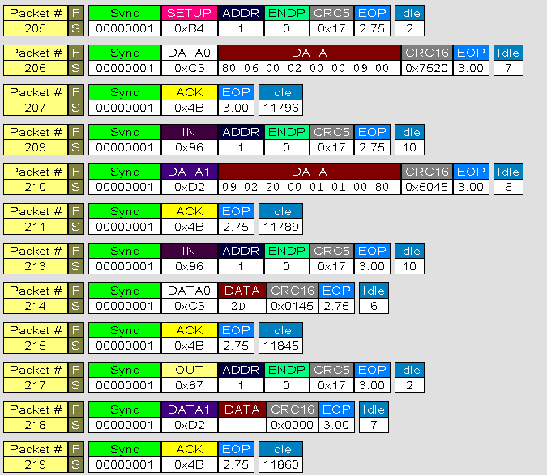
Transaction / td
Transaction
td
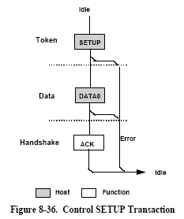
A setup TD = Token + Data + Handshake

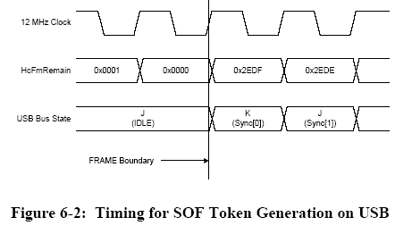

Algorithm that HC decide the Generous TD should be issued or not.
HC must check the non-periodically transfer can be finished in following two NP period. Periodic is satisfied since the periodic device is connected (In Bus Enumeration, the descriptor tell HC the bandwidth it will use). Rule as follows,

When HcFmRemaining = HcPeriodicStart, ref. figure 7-17
Full Speed : Bit count = min(MPS of ED, td->be – td ->cbp), if bit count > FSMPS of HcFmInterval - HcFmRemaining * 7/6 then quit to transfer packet..

Full Speed : if bit count > FSMPS of HcFmInterval then quit to transfer packet.. p101, 102
Low Speed : all low speed are <= 8 bytes packet, so if bit count < LST of HcLSThreadhold then quit.
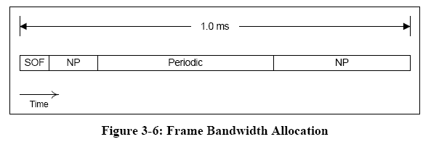

When a new frame starts, the Host Controller processes
control and bulk Endpoint Descriptors until the Remaining field of the HcFmRemaining registeris less than or equal to the Start field of the HcPeriodicStart register. It then runs a periodicEndpoint Descriptor list by using the lower five bits of the current frame number as an index into HccaInterruptTable. Once this is complete, the Host Controller has fulfilled its obligated frame processing; it then fills the remaining frame time by processing the control and bulk Endpoint Descriptor lists. Therefore, for time scheduled events on USB, Host Controller Driver utilizes the various interrupt Endpoint Descriptor lists and other USB work is scheduled into either the control or bulk Endpoint Descriptor lists. (ref. p45)

FrameInterval is loaded with a default value of 0x2EDF (11,999 decimal) at reset. This value produces a USB frame consisting of exactly 12,000 bit times.
The FrameRemaining field functions as a 14-bit frame counter. When operating, the register value decrements once per USB bit time. When FrameRemaining reaches a value of 0, it is loaded with the value of the FrameInterval field at the next bit-time boundary. The frame boundary is the bit boundary on which the value of FrameRemaining transitions from 0 to FrameInterval (a J to K transition is seen on the USB at this boundary signifying the first bit of the sync field of an SOF Token - see Section 6.3.2). (ref. p90)

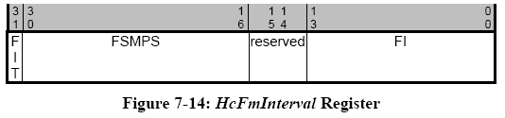

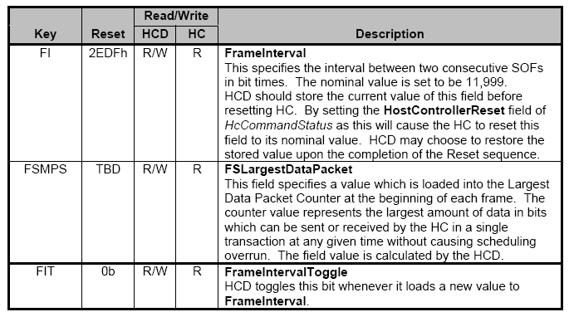

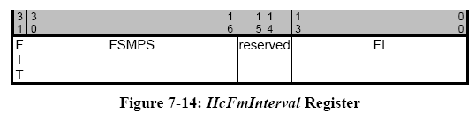

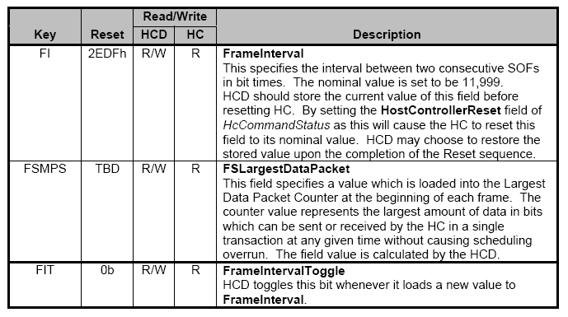

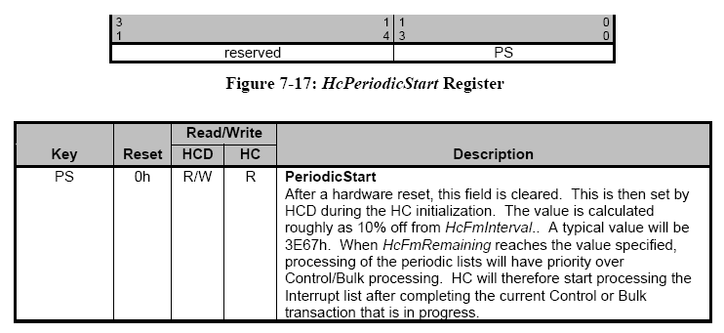
Error! Should be 2E67h

ED and TD
ED: pED=0001d300 (0xa001d300V); control=00082002
MaxPkt=8; TDFmt=0; Skip=0; Speed=1;
Dir=0; EP=0; FuncAddr=02;
TailP=00000000; HeadP=0001d700; Next_ED=00000000
Length is 8, PidDir = 0 (setup), so 1 SETUP packet.
TD: pTD=0001d700 (0xa001d700V); control=f2040000
CondCode=15; ErrCnt=0; Toggle=2
DelayInt=0; PidDir=0; BufRound=1
CurrBufPtr=0001d800; Next_TD=0001da00; BufEnd=0001d807
Buf=01 00 06 80 00 12 00 00
Length is 18, so 2 IN packet.
TD: pTD=0001da00 (0xa001da00V); control=f3140000
CondCode=15; ErrCnt=0; Toggle=3
DelayInt=0; PidDir=2; BufRound=1
CurrBufPtr=0001dc00; Next_TD=0001d900; BufEnd=0001dc11
TD: pTD=0001d900 (0xa001d900V); control=f30c0000
CondCode=15; ErrCnt=0; Toggle=3
DelayInt=0; PidDir=1; BufRound=1
CurrBufPtr=00000000; Next_TD=00000000; BufEnd=00000000

