Ref. p333, 334
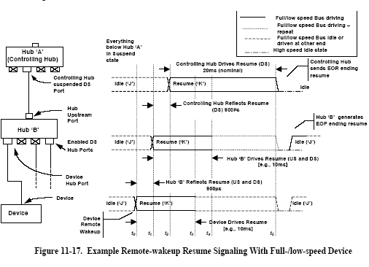
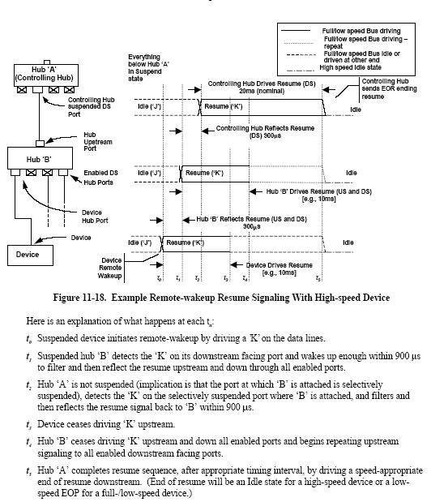
Figure 11-17, device is a FS/LS device, so hub B will send EOP on port which device connect to. Figure 11-18, device is a HS device, so hub B keep idle state.

Figure 11-17, if device is a LS, then it won’t enter suspend while hub B is active. Every SOF (SOF must came from up face stream) received, hub B send EOP to all it’s LS port. Ref. p332 11.8.4.1 Low-speed Keep-alive. Of course, in figure 11-17 example, hub B entered suspend, so device won’t keep alive.

