GetDescriptor(DescriptorIndex = 0, DescriptorType = STRING, wIndex = DeviceDescriptor.iManufacture, wLength = bLength)

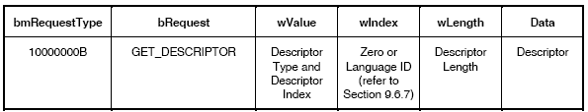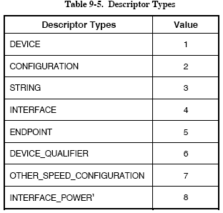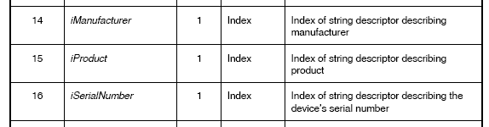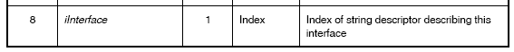
Descriptor Index :
iManufacture, iProduct, …
All these 3, if index value is 0, meaning not available.
