CLIENT: iClink
POSITION: RISC-V Compiler and Toolchain Engineer

PERSONAL INFORMATION

Name | Jonathan Chen 陳鍾樞 | Gender | Male
Nationality | Taiwan | Residence | Taipei

CAREER SUMMARY

- Over 20 years’ experience in C/C++ embedded system programming.
- 5 years’ compiler toolchain related experience and research in parallel processing for master degree.
SKILLS SUMMARY

- Proficient
  - Embadded system
    - C/C++, Linux, bare metal, mips, assembly
  - Compiler design
    - llvm backend/ lld/ polly, glsl/ yacc/ lex, cmake
- Intermediate
  - Linux programming
    - gcc, device driver, Bash, USB
  - Software engineering
    - OOP/ OOA, design pattern
- Basic
  - CPU & GPU design
    - simulator, Verliog, mips, arm
  - UI design
    - VC, Borland C++, VB, HTML/ CSS/ JavaScript
  - Documentation writing
    - Sphinx, UML, HTML/ CSS/ JavaScript
  - Equipment usage
    - scope, spectrum, power meter

EMPLOYMENT PERIOD

Huawei/Hisilcon 2017/4 – Present
主任工程師（準專家）

- Responsibilities
glsl frontend + LLVM backend compiler development for a whole new GPU

Work in home 2016/11 – 2017/4
Programmer

- Responsibilities
  - Web and document software study and design (html/css/javascript, Graphivz, ...)

Marvell 2013/3 – 2016/11
Senior Software Engineer

- Responsibilities
  - llvm optimization for ARM
  - The simulator programmer of Marvell’s ARM SOC chips
- Achievement
  - Implement semi-auto software system of running benchmark and generating report for gcc toolchain.
    - Purpose is to make sure the code change of gcc has no side effect in optimization (expain in flow chart).
    - Implemented bash script which can compare any two version of gcc toolchain and generate report. Similar as above.
  - Introduce polly for Marvell llvm toolchain optimization. Polly is a software for loop optimization.
    - The advantage is that it might be 500% speed up in some numerical application program, such as matrix multiplication, or other kind of matrix operation.
    - Sadly, Marvell's CPUs are not used in numerical applications. But maybe it will have for 64 bits ARM in future.
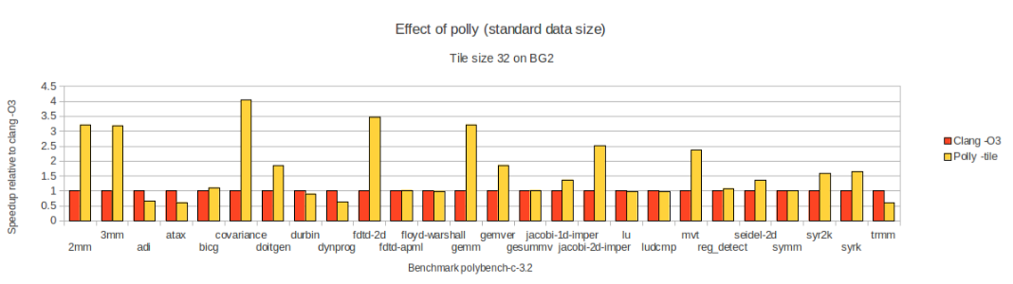
- Implement co-simulator (name:Csim) for a few Marvell's ARM based cpu.
- Apply compiler code generation idea to propose a solution and Csim team adopted it.
https://jonathan2251.github.io/ws/en/RL_Marvell.pdf
  - ARM spec → script → generate C++ .h .cpp
  - Mouse hover the above (in html) for explanation, obviously the script is simple, match ARM spec and easy to read more then the C++ program.
- Complete cmake and adjust python programs to build Csim with cmake. It saves effort in maintaining both make and windows project file. In addition, cmake also support iMac user.
https://jonathan2251.github.io/ws/en/RL_Marvell.pdf
  - Present the better option for cmake writting.
    - The version of cmake in Csim server is 2.6.x, however, the cmake 2.8.8 provides shared object to save the unnecessary compilation.
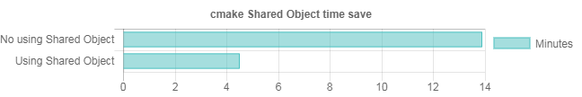
  - Report performance comparing between cmake and ninja for other manager’s concern. The result is”no difference”
- Reason for leaving

Programmer, LLVM 2012/8 – 2013/3

- LLVM open source project
  - The upper half of the following figure is the work flow and software package of a computer program be generated and executed.
  - IR stands for Intermediate Representation.
  - The lower half is the llvm's work flow. The yellow and green parts are implemented inhis books (listed as open source project above), Tutorial: Create an LLVM Backend compiler and Tutorial: Create an LLVM Backend toolchain respectively.
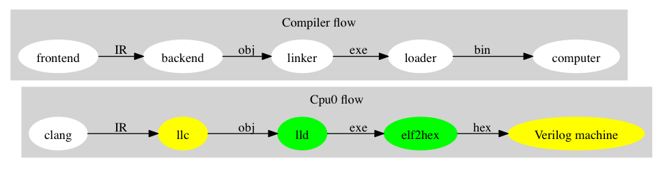

Motorola 2004/9 – 2012/8
Senior Software Engineer 2004/9 – 2012/8

- Designe QIP7kP1 and P2 board level production line testing code. Over 5 millions units of QIP7k model of Set Top Box are tested with this code on production line and shipping to market. Other major products DCX33, DCX34 and DCX35 (over 10 millions of box) are ported from QIP7kP1 & QIP7kP2.
- Combine mips cpu and software engineer knowledge, lead and cowork with other four members to create a frame work for board level testing code as manager request.

Proton 2014/3 – 2014/9
Manager
- Dgital TV programming

Abocom 2013/6 – 2014/3
Senior Engineer
- 802.11b programming

Dbtel 2011/11 – 2013/6
Engineer
DECT wireless phone (DBTEL) programming
Symmetry 2011/2 – 2011/11
Engineer
- SGSN and GGSN for GPRS&3G programming

Cando 2010/7 – 2011/2
Engineer
- CAM programming

Spirox 2009/12 – 2010/7
Engineer
- CAM programming

Intech 2009/6 – 2009/12
Senior Engineer
- CAM programming

財政部財稅資料中心 1993/12 – 1997/8
Programmer
- Programmer for data processing

OPEN SOURCE PROJECT

- Accepted by LLVM documentation
http://llvm.org/docs/tutorial/#external-tutorials
- Create an LLVM Backend compiler
http://jonathan2251.github.io/lbd/index.html
- Create an LLVM Backend Toolchain
http://jonathan2251.github.io/lbt/index.html

OTHER WORK
    - Take course”Image processing” and program: Jpeg decoder
https://github.com/Jonathan2251/ow/tree/master/master-homework/image_processing/JPEG
    - Graphivz: as some graph diagrams used in this CV.
http://www.graphviz.org/Home.php
      - Source code: mywork_1.gv and study_and_apply.gv
https://jonathan2251.github.io/ws/images/mywork_1.gv
https://jonathan2251.github.io/ws/images/study_and_apply.gv
EDUCATION

- M.S. in Information Science, National Taiwan Normal University 1997/9 – 1999/6
  - Master’s Thesis
    - The Researches of Column Sort and Related Problems the Researches of Column Sort and Related Problems
    - https://github.com/Jonathan2251/ow/tree/master/sortingnetwork/ThesisMaster
  - Proposal of Ph.D. Study
    - The Researches of Sorting Network and Related Algorithm the Researches of Sorting Network and Related Algorithm
    - https://github.com/Jonathan2251/ow/tree/master/sortingnetwork/PHD
- B.S. in Industry Engineer, National Taiwan Technology University of Science and Technology 1991/9 – 1994/6

LICENSE

- Taiwan National Computer Engineer license 1995

CPU, COMPILER, OS AND SOFTWARE ENGINEERING RELATED LEANING & APPLY

- CPU architecture study
  - Study books “Computer Organization and Design: The Hardware/Software Interface”, “Computer Architecture – A Quantitative Approach”, Mips and Broadcom CPU user manual and Verilog.
  - Apply in work:
    - Find the bug of Code Warrior’s compiler in supporting Mips cpu and notify Code Warrior. The bug come from code generation for #pack(1) statement.
    - Implement the”tiny OS” mechanism with mips assembly language to solve the halting problem in some program.
      - After this implementation, the code has run more stable and fast. It is a serious problem since when one test item “halting”, the other test items scheduled after that one won’t be run. In this situation, operator has no idea of the test result since test result is displayed after all test items finish execution. I implement a “time out” mechanism to jump out from the test item (by restore the stack and cpu registers status). My USA’s coworker call it “tiny OS”. It’s C++ plus few hundred lines of mips assembly with “observe pattern” of “design pattern”.
    - Apply knowledge from Verilog and book”Computer Architecture” to change the Verilog code of Cpu0 to become a cpu design for my llvm backend compiler support.
- Compiler study:
  - Study llvm frontend & backend design. Study book “Compilers – Principles, Techniques, & tools 2nd Aho, and so on”, yacc and lex tool.
  - Apply in work:
    - Implement the Cpu0 llvm compiler backend from scratch for tutorial purpose, and writing books as in my publish books.
    - Apply the compiler syntax parsing tool, yacc & lex, in test station design.
- OS study:
  - Study book “Linux Device Driver (2nd & 3rd edition)”
  - Apply in work:
    - Implement the “tiny OS” mechanism as mentioned in above section “CPU architecture study”.
    - Implement the I/O redirection mechanism to make the new version of code porting task easier in Motorola.
- Software Engineering study:
  - Study book “Design Patterns” and “OOA Analysis related books and tools (Rational Rose, and so on)”
  - Apply in work:
    - During working the Board Level Test Code framework project in Motorola as mentioned above:
      - Utilize five patterns in “design pattern” and Rational Ross tool to create framework, document and generate code in Motorola.

