
Candidate Report
Recommending Date: Apply for:
General Information

Personal Information:
Name: Chung-Shu Chen
Gender: Man
Age: 52
Mobile: +886 970577923
Email: gamma_chen@yahoo.com.tw
Location: Taiwan

Education:
1997-1999 Master, June 1999, National Taiwan Normal University (國立台灣師範大學), Taipei, Major: Information Science.
1991-1994 B.S., June 1994, National Taiwan Technology University of Science and Technology (國立台灣科技大學), Taipei, Major: Industry Engineer.
Skill：
llvm cpu and gpu backend, lld linker, npu/onnx, c++, OpenGl/glsl and simulator.
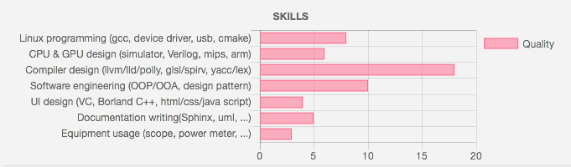
Working Experience:
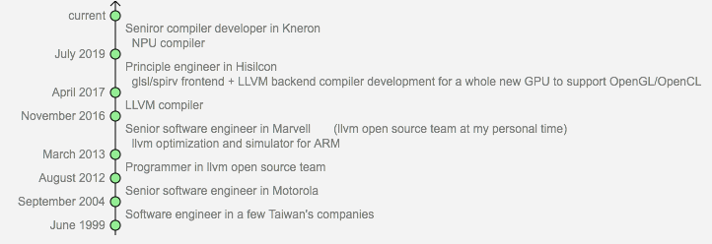

Project Experience:
Open source project:
Tutorial: Create an LLVM Backend compiler http://jonathan2251.github.io/lbd/index.html
Tutorial: Create an LLVM Backend Toolchain http://jonathan2251.github.io/lbt/index.html
The concept of GPU compiler http://jonathan2251.github.io/lbd/gpu.html

Work project:
GPU compiler for OpenGL/OpenCL(Spriv): Compiler development for generating gpu instructions for both texture related functions and Spriv packed load/store

ARM CPU compiler based on llvm; polly; DSL; optimization

