

|  |
| --- |
| Turma: EIN422 |
| Professor: Oswaldo Borges Peres |
| Semestre: 2019-2/01 |
| Aluno(a): Jonathan Cordeiro Gomes Matrícula: 5405422 |

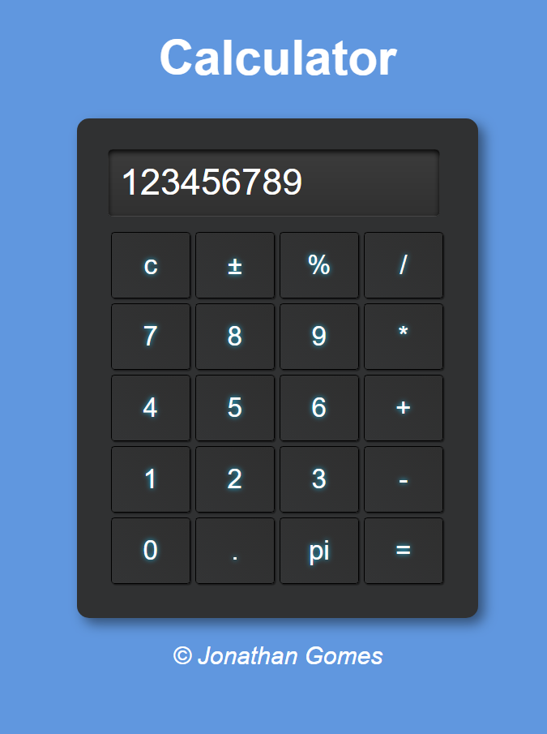

**Código HTML5**

<!DOCTYPE html>

<html lang="pt-BR">

<head>

<meta charset="UTF-8">

<meta name="viewport" content="width=device-width, initial-scale=1.0">

<meta http-equiv="X-UA-Compatible" content="ie=edge">

<title>Calculator</title>

<link rel="stylesheet" href="css/style.css">

<script src="js/script.js"></script>

</head>

<body>

<header>

<h1>Calculator </h1>

</header>

<section >

<form name="calcform" method="post" action="">

<input type="text" name="visor" id="visor" />

<table>

<tr>

<td><input type="button" name="cls" class="oper" value="c" onclick="clearNum()" /></td>

<td><input type="button" name="convert" class="num" value="±" onclick="conversor()"/> </td>

<td><input type="button" name="%" class="num" value="%" onclick="calcNum('%')" /></td>

<td><input type="button" name="division" class="oper" value="/" onclick="calcNum('/')" /> </td>

</tr>

<tr>

<td><input type="button" name="seven" class="num" value="7" onclick="calcNum(7)" /></td>

<td><input type="button" name="eight" class="num" value="8" onclick="calcNum(8)" /></td>

<td><input type="button" name="nine" class="num" value="9" onclick="calcNum(9)" /></td>

<td><input type="button" name="mult" class="num" value="*" onclick="calcNum('*')" />

</td>

</tr>

<tr>

<td><input type="button" name="four" class="num" value="4" onclick="calcNum(4)" /></td>

<td><input type="button" name="five" class="num" value="5" onclick="calcNum(5)" /></td>

<td><input type="button" name="six" class="num" value="6" onclick="calcNum(6)" /></td>

<td><input type="button" name="add" class="oper" value="+" onclick="calcNum('+')" /></td>

</tr>

<tr>

<td><input type="button" name="one" class="num" value="1" onclick="calcNum(1)" /></td>

<td><input type="button" name="two" class="num" value="2" onclick="calcNum(2)" /></td>

<td><input type="button" name="three" class="num" value="3" onclick="calcNum(3)" /></td>

<td><input type="button" name="subtract" class="oper" value="-" onclick="calcNum('-')" /></td>

</tr>

<tr>

<td><input type="button" name="zero" class="num" value="0" onclick="calcNum(0)" /></td>

<td><input type="button" name="dot" class="num" value="." onclick="calcNum('.')" /></td>

<td><input type="button" name="pi" class="oper" value="pi" onclick="calcNum(3.14)" /> </td>

<td><input type="button" name="equals" class="num" value="=" onclick="result()" /></td>

</tr>

</table>

</form>

</section>

<footer>

<p>&copy; Jonathan Gomes</p>

</footer>

</body>

</html>

**Código CSS**

body {

    background: rgb(96, 151, 223);

    font: normal 15pt Arial;

}

header {

    color: white;

    text-align: center;

}

section {

    background-color: #303132;

    border-radius: 10px;

    padding: 25px;

    width: 280px;

    margin: auto;

    box-shadow: 5px 5px 10px rgba(0, 0, 0, 0.459);

}

#visor{

    width: 253px;

    font-size: 30px;

    padding: 10px;

    border-radius: 4px;

    margin-bottom: 10px;

    box-shadow: 0px 2px 5px black inset;

    background-image: linear-gradient(#3C3C3C, #303030);

    border-width: 0.3px;

    border-color: black;

    color: white;

}

footer {

    color: white;

    text-align: center;

    font-style: italic;

}

.num {

    width: 65px;

    height: 55px;

    font-size: 22px;

    border-radius: 3px;

    background-image: linear-gradient(45deg, #333435, #2F2F2F);

    color: white;

    text-shadow:0 0 0.2em rgb(31, 203, 255);

    border-color:black;

    border-width: 0.5px;

    box-shadow: 1px 1px 1px rgba(0, 0, 0, 0.459);

}

.oper{

    width: 65px;

    height: 55px;

    font-size: 22px;

    border-radius: 3px;

    background-image: linear-gradient(45deg, #333435, #2F2F2F);

    color: white;

    text-shadow:0 0 0.2em rgb(31, 203, 255);

    border-color:black;

    border-width: 0.5px;

    box-shadow: 1px 1px 1px rgba(0, 0, 0, 0.459);

}

**Código JavaScript**

function calcNum(num) {

    var valor = document.calcform.visor.value;

    document.calcform.visor.value = valor + num;

}

function clearNum() {

    document.calcform.visor.value = '';

    delete num;

}

function result(){

    var res = 0;

    res = document.calcform.visor.value;

    document.calcform.visor.value = '';

    document.calcform.visor.value = eval(res);

}

function conversor(){

    var res = 0;

    res = document.calcform.visor.value;

    document.calcform.visor.value = '';

    document.calcform.visor.value = -1*(res);

}

function percent(){

    var perc = 0;

    perc = (num/100);

    document.calcform.visor.value = perc;

}