CMPE 100 Lab 7:
Bee Hive

Name: Jonathan Alvarez
Lab Section: Section 1C
TuTh 1:30-3:20pm
Due: 06/07/2019

Description:
In this lab, we focused on implemented all concepts from previous labs, such as Counters, State Machines, LFSR, Selector, Ring Counter, Hex 7 Seg, Edge Detectors, etc. However, in this new lab, we focused on implementing this information to build a video game. We did this by implementing some logic for a VGA port on our Basys 3 Board. The video game was to have a beehive to catch eight bees in the matter of given time via the switches. The beehive will move around by itself or by the use of the buttons on the board. The display had four bars around the edges to create borders and we used the same logic to create the beehive.

Method:

Horizontal Counter:
In this portion, we implemented a ten bit counter using the same logic for our four-bit counter but just expanding upon it making it work for ten bits rather than four. Using this ten bit counter we set up as a one-bit increase then we set Din as ten bits of zero since we are not using it. After that, we set our reset as the ten-bit number 799. This was because this is the maximum span for the horizontal region of the display. Then we implemented an output HUTC which would be an output signal for our Vertical counter. This signal will be high when our counter reaches the value 799. Then our output of this module will be the current horizontal position.

Vertical Counter:
In this portion, it is essentially the same as the horizontal counter, however, rather than continuously counting we want to wait for the horizontal counter to reach its maximum value or wait for our HUTC signal. This signal will be our count enable for our ten bit counter. Other than that we have our reset equal to 524 which is the maximum for the vertical range. Then the output of the ten-bit counter will be our current position on the vertical axis.

Time Counter:
In this module, we took in a count enable, clock, and reset outputted qsec, Q, and onesec. The count enable was the frame rate which we got from our edge detector. The edge detector took in our Vsync value and used it produces our frame rate. We used Vysnc because we knew that its refresh rate was slower than Hsync. This was because of Hsync produces a pixel so frequently compared to Vsync is dependent off of Horizontal counter. Then for reset is waiting for the reset timer signal from the state machine or when we are in our catching state with a refresh rate that is one second. Then we used the output of this to produced one second and qsec. We were not provided qsec for this lab so we needed to recreate it so to do this we used the fact the refresh rate is 64 frames per cycle so for a quarter of a second to occur we need to multiply 64 by 0.25 or a quarter of a second. This produced the value 16 which is $2^{4}$which is equivalent to Q[4]. We used the same logic for one second. Then the output of this would produce the current time.

State Machine: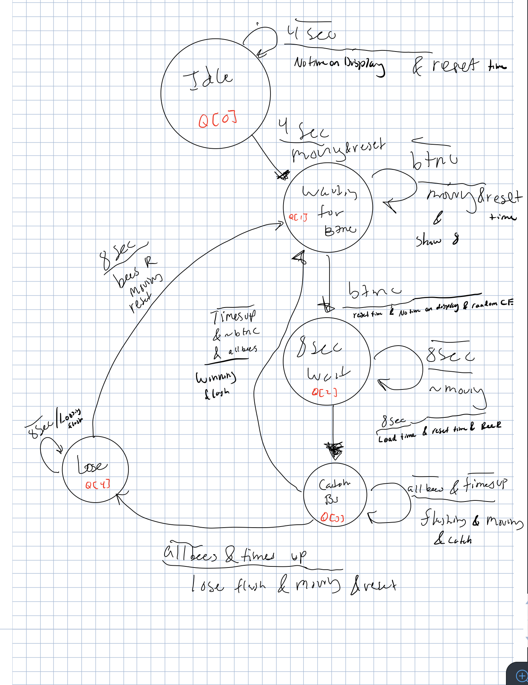
Figure 1:
(Source: Lab Notebook)
Idle:
The game starts off at the idle position or $Q[0]$ while being in this state we need to wait four seconds for the game to initialize. The output of this specific state would be no time on display and reset time. No time on the display is when there's no time on the Hex Seven Display and Reset Timer is resetting the time counter.

Waiting for button C:
Then after four seconds, we move to the next state and in this transition, the hive starts to move and the time is reset. In this next state $Q[1]$, we are waiting for the user to press button C. We are constantly moving until button C and constantly resetting the timer until we leave the state. Then we also what to show the number eight on the Hex Seven Display.

Eight Second Wait:
In this state, $Q[2]$in this state the user pressed button C and now the bees are being dispersed from the hive. On the transition over time is reset, there is no time the display, and the randomCE is triggered which enables the LFSR. While in this state the hive is not moving and the bees are being dispersed using the LFSR to make them move in random directions.

Catching Bees:
After eight seconds has passed we move on to the next state $Q[3]$, in this state we focus on the actual game logic. On the transition over to this state we load time from the switches, reset our time counter, and the bee reset signal is triggered. From here it could go either to win or lose. If “allbees” are caught and the “timesUp” not triggered then we would go back to the waiting for button C state. This would be the winning state in which we would start another round. The output of this transition would be a winning flash signal to trigger the flashing on the Hex Seven Display specifically the number of bees caught (all eight).

Lose:
In this state Q[4] it would be triggered if allbees are not caught and TimesUp is triggered. Then the output of the transition from state Q[3] the output would be the losing flas. This would trigger the Hex Seven Display to flash the time. This would continue until eight seconds has past. Then this would reset the bees to its proper place to start the game again. While this is occurring the hive is constantly moving until the game until button C is pressed.

Top Module:
In this portion we are putting all the logic together and allocating the proper variables. First we defined our borders from the output of the horizontal and vertical position. We also used this logic to form our Hsync and Vsync. We just used the schematic provided to know the range. We did the same thing with the active region. We passed these values through flip flops to stabilize our output. We also put the the boarders in the flop to do the same thing. We also did this with the logic for hive and the bees.
Then we added the logic for the anodes which took in the qsec to take care of flashing logic and we added the logic for no show for lab requirements.

Switch Time:
In this module we added logic for taking input front the switches from the board. We did this by using our ten-but counter. Then the output of this went into to our Hex Seven Display to present our result on the display.

Bees:
This module took care of the logic for the one bee and we made multiple on the top module to make eight bees. We used similar logic from the hive for the bees. However this time we needed to implement a trick logic to trick the beginning state to present eight on the hex seven and this was done based on the specifications of the game. We did this by setting the bees to be all caught at the initial portion of the game.

Simulation:
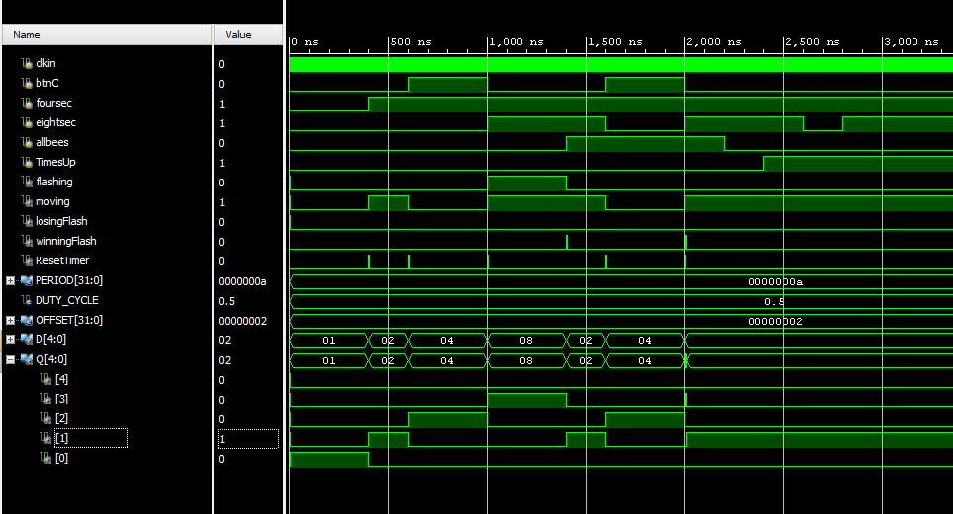
In this portion we tested each state by triggering what was needed to go into each state. Here in figure 2 we can see the state machine go each state and return back into its start game state .

Results:
We produced logic that would make our stationary objects on the display using the VGA move and produce a working proper logic.

Top level schematic:
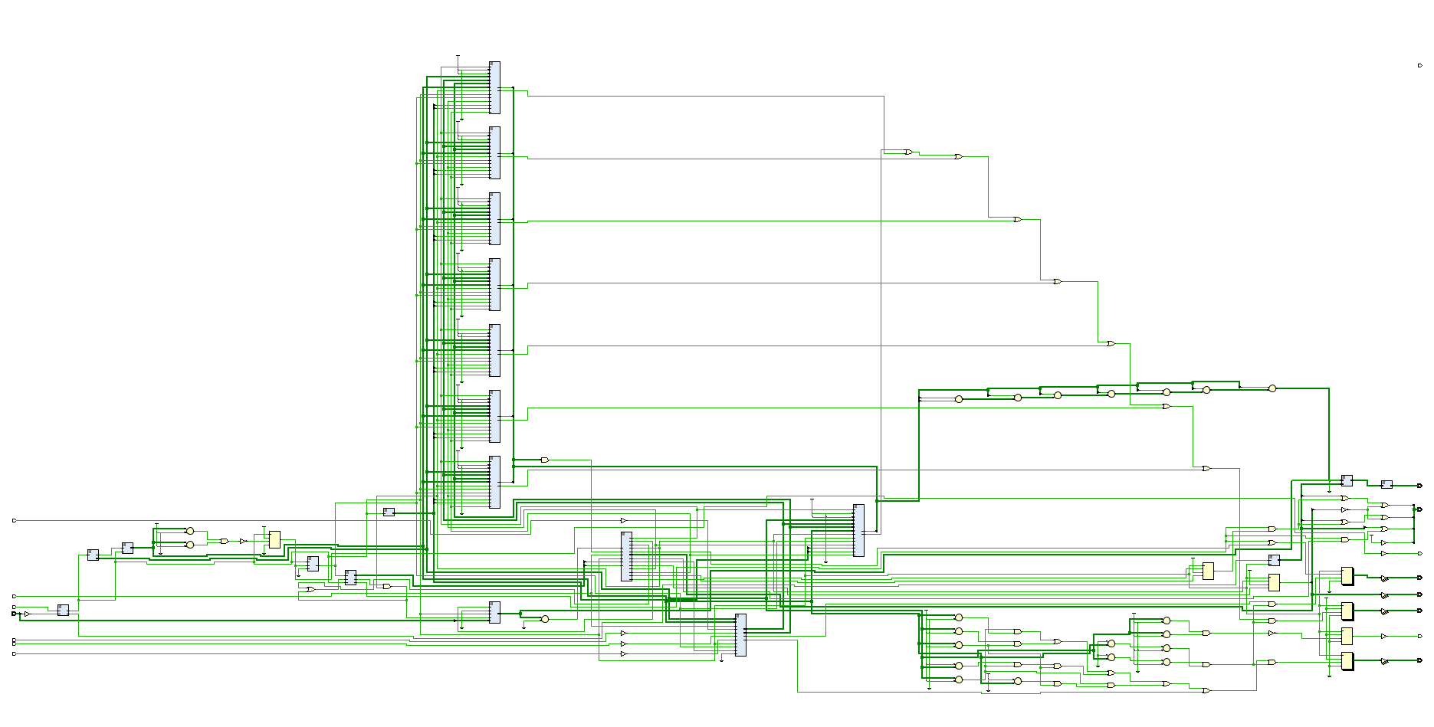
In this picture we can see the overarching schematic for our video game in which there were a various wires and D flip flops.

Conclusion:
Overall we combined all the logic from the class specifically a state machine that told our game what to do and produce the proper outcome. From this we formed a fully functioning video game.

Appendix:

