Colour analysis of simulated polyenes

# Summary

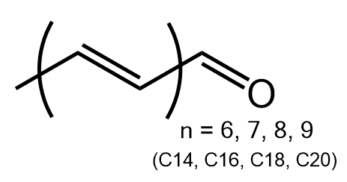

Figure The aldehyde polyene system responsible for yellow, orange, red and pink pigmentation in some parrot species. For detailed analysis of these systems observation of potential physical colour tuning see our [paper](https://royalsocietypublishing.org/doi/10.1098/rsos.172010).

The colour profile arising from the combination of a range of simulated polyene pigments (C14-C20) found in parrot pigments was explored. This involved the simulation of absorption properties of the polyene pigments (C14-C20) using density functional theory calculations and exploring the impact of functional group. It was found that protonation of the aldehyde resulted in significant shifts of the simulated absorption profile of polyene pigments (λmax from 495-450 nm to 510-640 nm), while shifts due a carboxylic acid group had limited impact on the absorption profile (λmax 490-450nm). Using a python script, the various combinations of pigments for each functional group set, and for the combined set with the parent aldehydes were generated with varying contributions (0/1, 1/2, and 1/1). These resulting ranges of colours were then projected on to a CIE colour space using Fluroacle.

The large variation in absorption profile due to protonation means gives rise to a significant colour tuning ability based on a mixture of protonated and aldehyde pigments (**Figure 2**). This potential chemical tuning is much larger than for the aldehyde or carbocyclic acid functional group sets which are limited to the yellow transmission region (see data points C14-C20). These results conflict with the conclusion from [Cooke et. al. 2017](https://doi.org/10.1016/j.cell.2017.08.016) the colour tuning mechanism in budgerigar *Melopsittacus undulatus*, and presumably other similar parrot systems, arises due to the lack of the C20 pigment; however, it may support the alternative conclusion that turning arises from a different oxidation state such as the protonated polyene form.

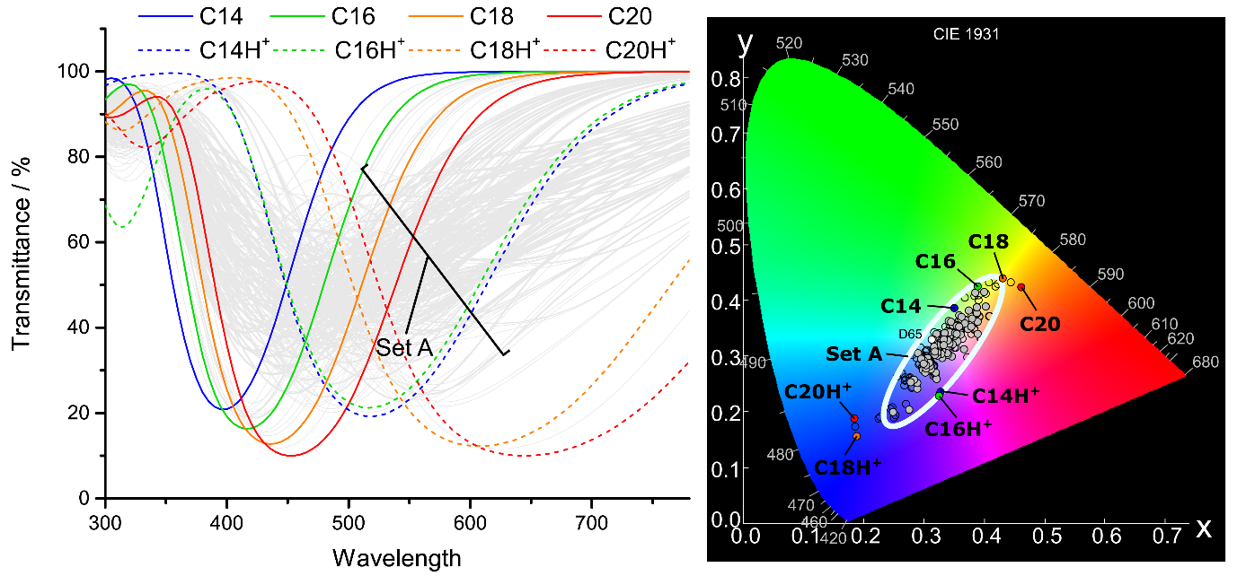

Figure Aldehyde and protonated polyene transmission spectra and the associated CIE 1931 values. Set A (grey circles) shows the spectra and values for combinations of either C14+C16+C18 or C14H++C16H++C18H+ or a mixture there of (yellow feather), or C14+C16+C18+C20 or C14H++C16H++C18H++C20H+ (red feather) or a mixture there of. The remaining combinations are shown in thin spectra and empty circles.