Agile Multi-Team Coordination

Cohesively Building Small Components of Large Projects

Jonathan Bush  
School of Computing, Informatics, and Decision Systems Engineering  
Arizona State University  
Tempe, Arizona, United States  
 jeb@asu.edu

ABSTRACT

In this sample-structured document, neither the cross-linking of float elements and bibliography nor metadata/copyright information is available. The sample document is provided in “Draft” mode and to view it in the final layout format, applying the required template is essential with some standard steps.

These steps, which should require generation of the final output from the styled paper, are mentioned here in this paragraph. First, users have to run “Reference Numbering” from the “Reference Elements” menu; this is the first step to start the bibliography marking (it should be clicked while keeping the cursor at the beginning of the reference list). After the marking is complete, the reference element runs all the options under the “Cross Linking” menu.

For accuracy check of the structured paper, user can run the option **Manuscript Validation**. It informs the user of the wrong or missing values in the paper. The user must correct the paper as per validation messages and rerun **Manuscript Validation**.

Now, to generate the required layout of the paper, the user should select one of the template styles under the Define Template Style option (choose the required layout design, i.e. choose between Journals and Proceedings).

∗Article Title Footnote needs to be captured as Title Note

†Author Footnote to be captured as Author Note

Permission to make digital or hard copies of part or all of this work for personal or classroom use is granted without fee provided that copies are not made or distributed for profit or commercial advantage and that copies bear this notice and the full citation on the first page. Copyrights for third-party components of this work must be honored. For all other uses, contact the owner/author(s).

*WOODSTOCK’18, June, 2018, El Paso, Texas USA*

© 2018 Copyright held by the owner/author(s). 978-1-4503-0000-0/18/06...$15.00

https://doi.org/10.1145/1234567890

Some specific values are required to create a standard layout by choosing a template for the journals or proceedings. So once the user chooses one of the template layout styles, the respective Journal or Conference details dialog box (i.e. **journal/conference acronym, DOI, ISBN, copyright, year, etc.**) will appear as a prompt during the Define Template Style functionality. The user should fill these values, after which the template creates the desired layout of the paper. The user can now create a PDF of his/her manuscript using the “*Save as PDF*” option.

If the user is adding any new data, they should make sure to style it as per the instructions provided in previous sections. Carry out the steps for Cross-linking, Fundref data, adding Document History (specific to journal submission), and finally, Manuscript validation and placing the respective metadata (Bibstrip/copyright text)[1] while applying the required template.

CCS CONCEPTS

• Software and its engineering---Software creation and management---Collaboration in software development---Programming teams

KEYWORDS

Agile, architecture, Scrum

1 Conventional Processes and Agile

In many large-scale development projects, traditional software development life cycles (SDLCs) have been utilized because of their well-understood natures. Large projects often dictate the creation of substantial documentation and may have additional traceability requirements for safety-critical systems. Although conventional methods have advantages in these areas, they also represent a substantial overhead that does not necessarily contribute business value that can be offered to the customer.

Considering this overhead, agile processes attempt to directly provide business value by relying on iterative design and customer interaction to guide the development process. This approach has been successfully applied to many small-to-medium sized projects but experiences some difficulties when applied to large projects with many development teams working on different parts of the overall systems.

One potential difficulty of applying agile methods (namely scrum) to large-scale projects lies in coordinating the distribution of work and the communication between many smaller agile teams working on the same overall product. Communication difficulties in agile methods are particularly apparent in global software development, where teams do not have access to the face-to-face communication typically required for agile software development [1]. In addition to geographic constraints on communication, the meetings involving many teams with distinct roles may also be difficult to manage and may provide little value to the teams. A typical approach is scrum-of-scrums (SoS), where meetings consisting of delegates from each scrum team are held in an attempt to coordinate the efforts between the teams. However, it was found that such “Grande SoS” meetings are limited in effectiveness due to time limits on scrum meetings and the relevance of information presented during the meetings [2].

Despite these challenges, the benefits of agile methods in terms of business value and flexibility [3] have driven agile methods to be adapted for large software projects.

2 Adapting Scrum for Large-Scale Projects

When building a complex software product, it is necessary to break down the development into parts that can be developed by separate groups and individuals before integrating the parts into the final product. In scrum, it is customary to deliver new working functionality at the end of each sprint. This ensures that the development process is continuing to meet the developing requirements of the customer. This iterative development makes scrum suitable for high-risk projects, where all requirements cannot be clearly established at the beginning. Agile methods have also demonstrated “shorter development cycles, higher customer satisfaction, [and] lower bug rates” [3]. However, as the complexity of a project increases, it becomes more difficult to manage through scrum.

One possible way to deal with the complexity issue is to utilize scrum within the context of a conventional SDLC that is intended for managing large projects. Such a system was proposed by Cho, who suggested combining a streamlined version of the Rational Unified Process (RUP) with scrum to accommodate the “strengths while suppressing the weaknesses of both methods” [3]. This hybrid system works by bounding the scrum process within the phases of RUP, as shown in Figure 1. This union provides the structure and predictability of RUP while also accommodating the benefits of an iterative agile development process. The structure of RUP and the big-up-front design in terms of system architecture guide the scrum teams to work cohesively throughout the remainder of development. Without this structure, significant additional communication between scrum teams would be required to coordinate product development between teams focused on distinct components.

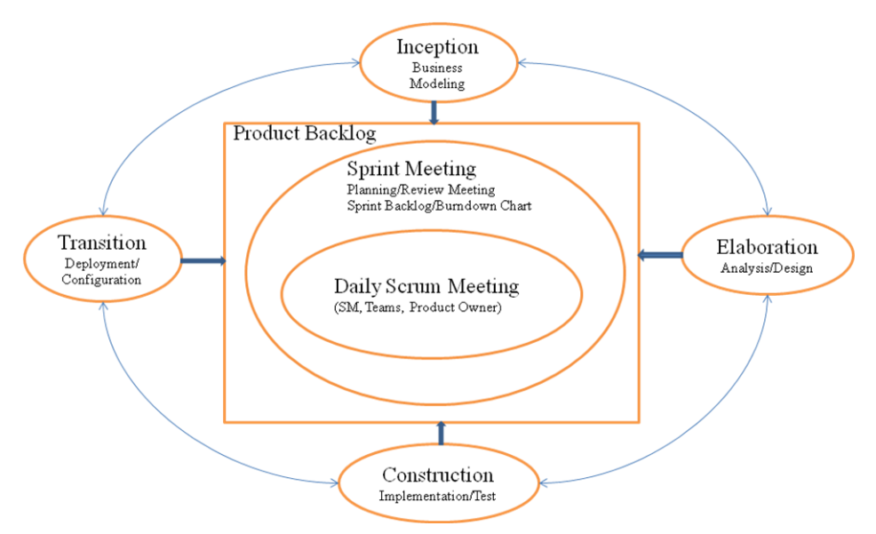

Figure 1: Hybrid RUP/Scrum model suggested by Cho [3].

Although the hybrid approach proposed by Cho takes steps to reduce process overhead within the adopted RUP disciplines [3], the process still results in constraints on the scrum process. A second possible way to apply scrum to large-scale projects is through the scrum-of-scrums (SoS) system. SoS involves scrum meetings between teams instead of individuals, typically held at least twice each week [2]. Paasivaara, et al. investigated the application of SoS within large-scale projects and identified several difficulties and possible solutions. One “challenge of the SoS meeting is not make [sic] it into a status reporting meeting for management, but to keep it as a synchronization meeting between teams” [4]. However, 15-minute meeting time may lead teams to gloss over problems, assuming that they are not relevant to other teams [2]. The case studies noted that a multi-layered approach with meetings focused by a “content/architecture-based model” were more effective than one project-wide meeting [2]. This approach increases the relevance of discussions between team representatives, yielding more useful results.

Paasivaara, et al. also suggested modifying the basic scrum meeting questions to make them more applicable for SoS meetings (Table 1). Note that these questions focus only on information relevant to other teams, as other information is shared within team scrum meetings.

Table 1: Modified SoS meeting questions [2].

|  |
| --- |
| What did your team do since the previous meeting that is relevant to some other team? |
| What will your team do by the next meeting that is relevant to other teams? |
| What obstacles does your team have that affect other teams or require help from them? |

3 The Significance of Project Architecture

**Theorem/Proof/Lemma.** Insert text here for the enunciation or Math statement. Insert text here for the enunciation or Math statement. Insert text here for the enunciation or Math statement. Insert text here for the enunciation or Math statement. Insert text here for the enunciation or Math statement.

....Insert text here for the Quotation or Extract, Insert text here for the Quotation or Extract, Insert text here for the Quotation or Extract, Insert text here for the Quotation or Extract, Insert text here for the Quotation or Extract, Insert text here for the Quotation or Extract.

ACKNOWLEDGMENTS

Insert paragraph text here. Insert paragraph text here. Insert paragraph text here. Insert paragraph text here. Insert paragraph text here. Insert paragraph text here. Insert paragraph text here. Insert paragraph text here. Insert paragraph text here. Insert paragraph text here. Insert paragraph text here.

# References

|  |  |
| --- | --- |
| [1] | M. Paasivaara, S. Durasiewicz and C. Lassenius, "Distributed Agile Development: Using Scrum in a Large Project," in *2008 IEEE International Conference on Global Software Engineering*, Bangalore, India, 2008. |
| [2] | J. Cho, "A hybrid software development method for large-scale projects: rational unified process with scrum," *Issues in Information systems,* vol. 10, no. 2, pp. 340-348, 2009. |
| [3] | T. Dingsøyr and N. Moe, "Towards principles of large-scale agile development," in *International Conference on Agile Software Development*, Rome, 2014. |
| [4] | R. Nord, I. Ozkaya and P. Kruchten, "Agile in Distress: Architecture to the Rescue," in *International Conference on Agile Software Development*, Rome, 2014. |
| [5] | M. Paasivaara, C. Lassenius and H. Ville, "Inter-team coordination in large-scale globally distributed scrum: do scrum-of-scrums really work?," in *ACM-IEEE International symposium on Empirical software engineering and measurement*, 2012. |
| [6] | J. Eckstein, "Architecture in Large Scale Agile Development," in *International Conference on Agile Software Development*, Rome, 2014. |

Conference Name:ACM Woodstock conference

Conference Short Name:WOODSTOCK’18

Conference Location:El Paso, Texas USA

ISBN:978-1-4503-0000-0/18/06

Year:2018

Date:June

Copyright Year:2018

Copyright Statement:rightsretained

DOI:10.1145/1234567890

RRH: F. Surname et al.

Price:$15.00

1. The existing Bibstrip data, copyright text and permission block in the sample file are dummy values, so the user needs to provide the correct values required for the submission in the metadata dialog box.