1.2.1

Q1.A) R = 10k, Vout = 725.818 mV

R = 25k, Vout = 295.504 mV

R = 50k, Vout = 134.110 mV

R = 200k, Vout = -12.620 mV

R = 1000k, Vout = -68.571 mV

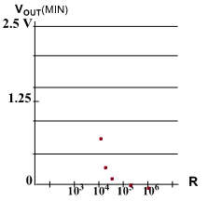

Q1.B) Vin start rise at 1 ns

Vout falls to 1.2584 V at 1.6660 ns

Delay = 1.6660 ns – 1 ns = 0.666 ns

Q1.C) If the R value is very high then the output charging time is very long.

Q2.A)

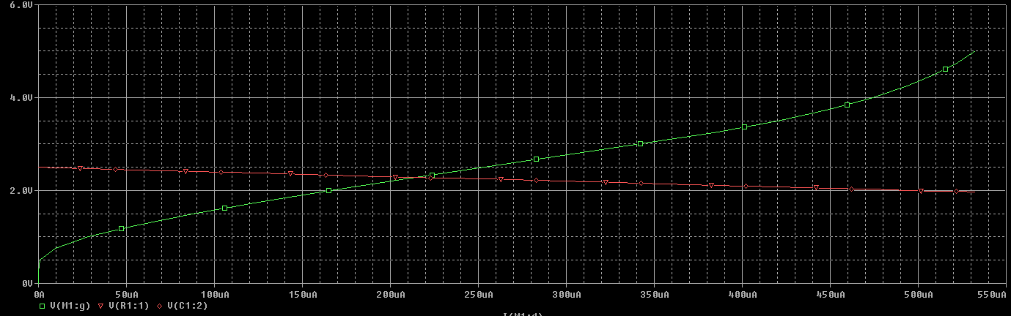

Q2.B) From the plot there is a sharply defined threshold voltage, where above it the transistor starts conducting.

Q2.C) From the plot, the sharply defined threshold voltage is about 253 mV and the corresponding current is 12.689nA.The maximum current is 532.515 µA

Q3. W = 2.5 um: delay = 1.3585 ns - 1 ns = 0.3585 ns

W = 5 um: delay = 1.2546 ns - 1 ns = 0.2546 ns

W = 7.5 um: delay = 1.2223 ns – 1 ns = 0.2223 ns

W = 10 um: delay = 1.2063 ns – 1 ns = 0.2063 ns

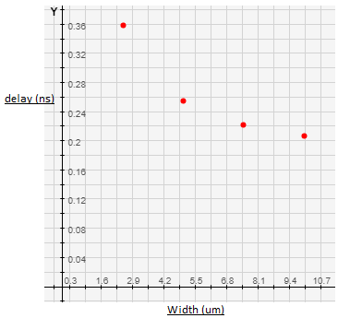

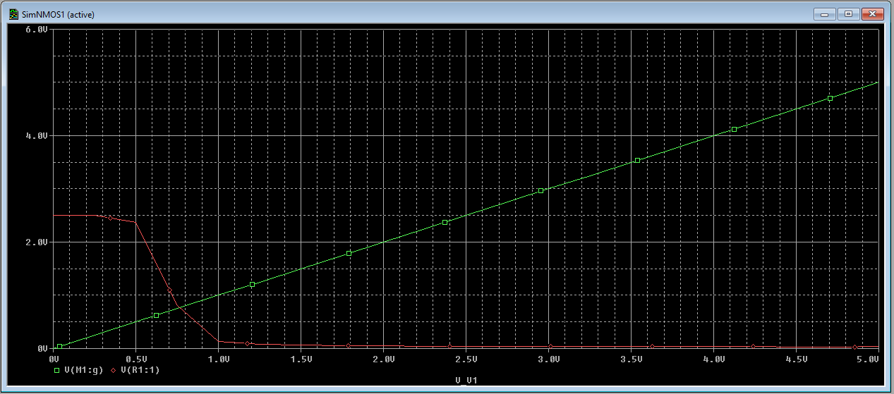

Q4. HEEERRREEE

1.2.2

Q5.A) R = 100, Vout = 26.377 mV

R = 1k, Vout = 208.950 mV

R = 10k, Vout = 856.327 mV

R = 100k, Vout = 1.430 V

R = 1000k, Vout = 1.6669 V

R = 10000k, Vout = 1.7544 V

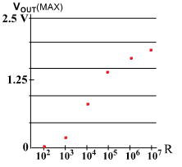

Q5.B) Estimate threshold voltage to be: Vt= Vdd – Vout(max); 2.5 - 1.7544 = 0.7456 V.

Q6. NMOS better as pulldown since cannot pull all the way up to vdd. At most Vout = VDD-Vt.

1.3.1

Q7.A) Charges slower as R increases

R = 100, Vout = 2.4909 V

R = 1k, Vout = 2.4423 V

R = 10k, Vout = 2.1214 V

R = 100k, Vout = 1.5071 V

R= 1000k, Vout = 1.294 V

R = 10000k, Vout = 0.971333 V

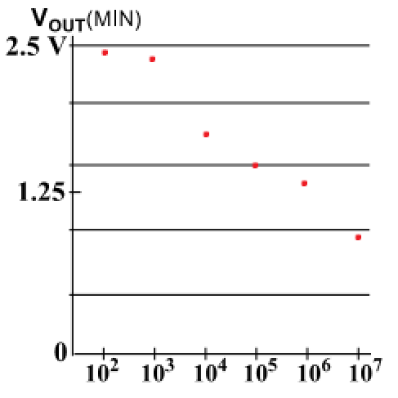

Q7.B) About 0.879 V with R = 10000k

Q7.C) Estimate threshold Vt = GND – Vout; Vt = 0 - 0.879 V = 0.879 V.

1.3.2

Q8. Discharge slower as R increases

R = 10k, Vout = 608.946 mV

R = 100k, Vout = 2.1743 V

R = 1000k, Vout = 2.5283 V

R = 10000k, Vout = 2.5619 V

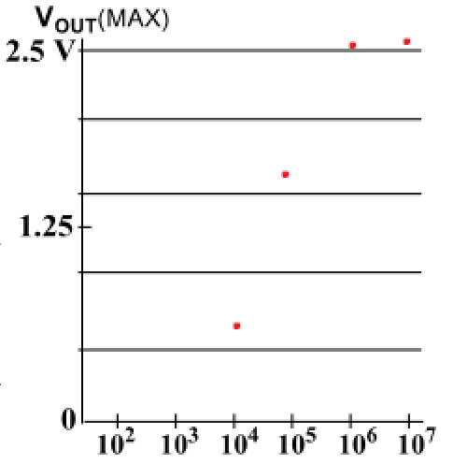

Q9. I think in a digital circuit would perform better with the PMOS transistor in pull up because PMOS cannot pull all the way to ground, approximately GND-Vt.

Q10.A) Vin = 2.5 at t = 21.13 ns

Vout = 1.25 at t = 22.129 ns

Delay = 0.999 ns

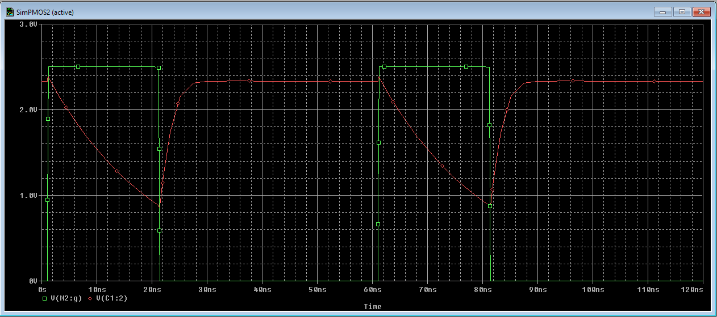

Q10.B) Slower than NMOS. NMOS has delay of 0.666 ns