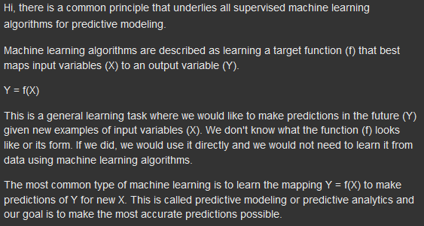

*The Principle That Underpins All Algorithms from Jason@ML Mastery*

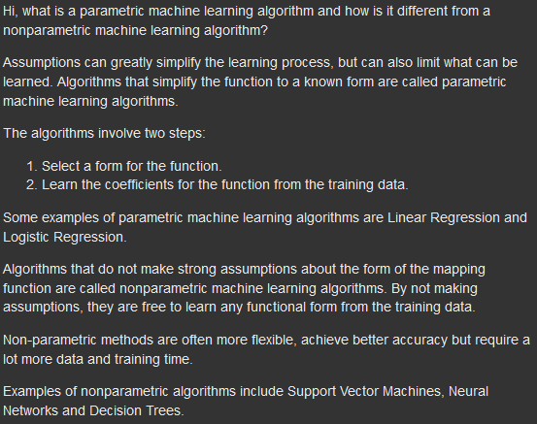

*Parametric and Nonparametric Algorithms from Jason@ML Mastery*

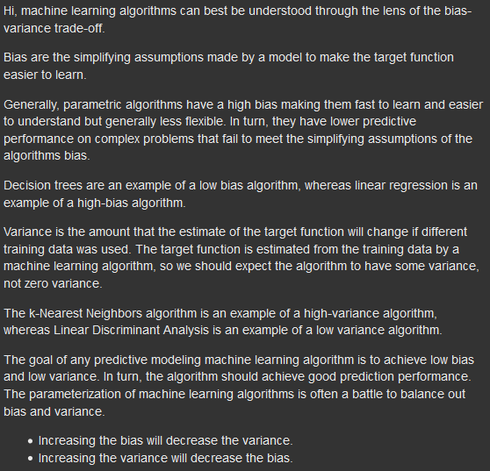

*Bias, Variance and the Trade-off from Jason@ML Mastery*

1. Regression: is used to determine how strongly correlated one attribute is to another within the training data and tries to determine a mathematical relationship between all the attributes.

2. In linear regression it tries to determine the line of best fit for the data, the linear equation y = mx + b + u is formulated to fit the dataset where:

* y is the predicted outcome that is dependent variable to X.
* m is the slope of the line.
* x is the independent variable.
* b is the y intercept
* u is the regression residual.
  + When a prediction value, ŷ, is made the difference from the observed value, y, is called the residual, e. e = y – ŷ. Therefore, each data point will have one residual value. When a random pattern of residuals is observed then it indicates that is supports a linear model.

2.1 Logistic Regression:

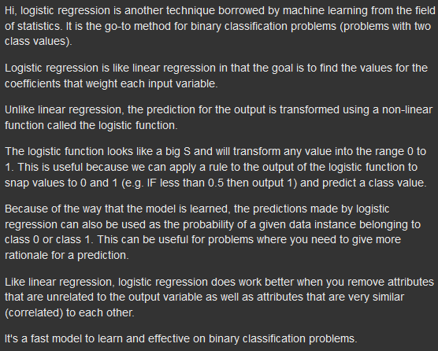

*From Jason@ML Mastery*

2.2 Linear Discriminant Analysis (LDA); linear

3. In non-linear regression, a polynomial of higher power than 1, Y = a + b1X1 + b2X2 + ... + btXt + u, is formulated to fit the dataset because it uses two or more independent attributes for the prediction.

K-Nearest Neighbors (KNN); nonlinear

* Classification and Regression Trees (CART); nonlinear
* Gaussian Naive Bayes (NB); nonlinear
* Support Vector Machines (SVM); nonlinear