COMP 445 - Theoretical Assignment 1 (TA1)

Winter 2018

Tristan Glatard

[tristan.glatard@concordia.ca](mailto:tristan.glatard@concordia.ca)

Concordia University

Department of Computer Science and Software Engineering

Instructions

- Please submit your assignment as a pdf le on Moodle. The name of the pdf file must contain your name and student id.

- All questions will receive equal points.

- Each question may have zero, one, or more than one correct choices. { Wrong answers will be penalized with negative points.

- Partial answers will not receive any point.

- Blank answers (no answer) will not be penalized.

Student ID: 40031689

First Name / Last Name: Jonathan Del Corpo

Signature: Jonathan Del Corpo

Introduction

Q1: A protocol of the application layer is implemented:

1. At the network core.
2. At the network edge.
3. Both at the network core and at the network edge.

Q2: Consider two hosts A and B connected through a single router X (the net-work looks like A - X - B). Assume that the link between A and X is of capacity RA-X=8 Gbps and the link between X and B is of capacity RX-B=16 Gbps. What is the time required for N=5 packets of size L=1 MB to be delivered from A to B, assuming that all delays except the transmission delay are negligible? We assume that 1 Gb=1000 Mb.

1. 5.5 ms
2. 7.5 ms
3. 1.5 ms
4. None of the above.

Q3: Starting from the same network as in the previous question, we now assume that propagation delays are not negligible:

- A and X are connected by a 5000-km link (lA X=5000 km) where the prop-agation speed is s=108 m/s.

- B and X are connected by a 20-km link (lX B=20 km) where the propagation speed is s=108 m/s.

What is the new delivery time between A and B for the same N=5 packets?

1. 45.7 ms
2. 55.5 ms
3. 51.5 ms
4. 55.7 ms

Q4: In the Internet protocol stack, the transport layer can directly use services from:

1. The application layer.
2. The network layer.
3. The link layer.
4. All of the above.

Q5: What is the probability that more than 5 users are active at the same time in a network of 15 users where each user is active 20% of the time?

1. 1
2. 0.6
3. 0.04
4. 0.06

Application layer

Q6: The content below was captured using Wireshark:

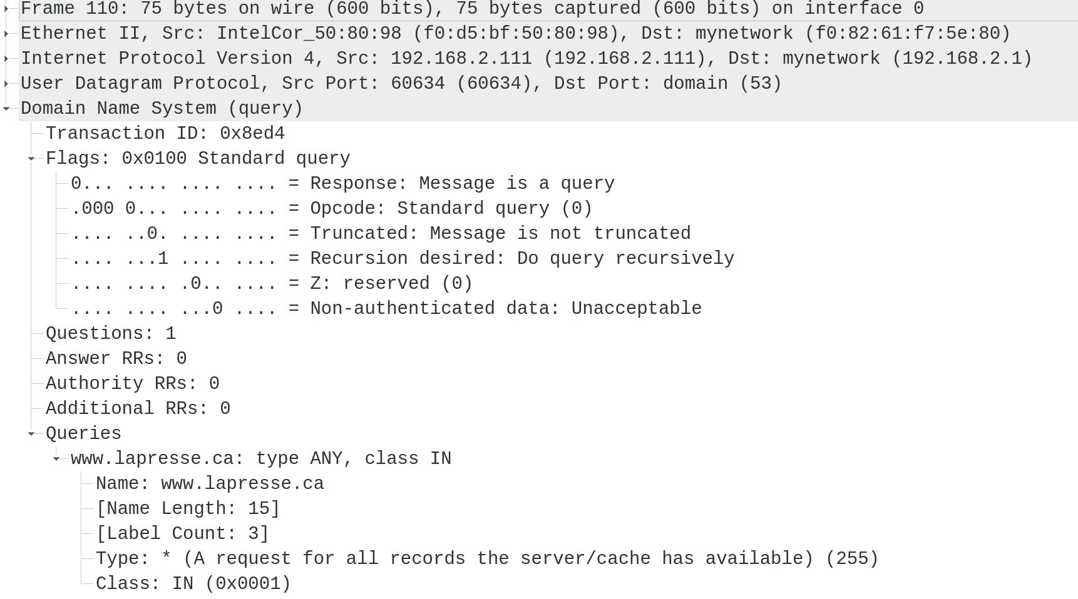

This trace contains:

1. An HTTP request encapsulated in a DNS query.
2. A DNS query encapsulated in a TCP segment.
3. An IP datagram encapsulated in a UDP datagram.
4. A DNS query encapsulated in a UDP datagram.

Q7: Among the following HTTP methods, which one(s) may be used to upload a file to a Web server?

1. GET
2. POST
3. PUT
4. HEAD

Q8: Among the following protocols, which one(s) are not involved in the re-trieval of the Web page at URL http://www.concordia.ca/ with a Web browser?

1. TCP
2. DNS
3. HTTP
4. SMTP

Q9: DNS may be used to retrieve the name of the email server of a specific domain:

1. by querying records of type CNAME.
2. by querying records of type NS.
3. through any type of iterated query.
4. through any type of recursive query

Q10: SMTP is:

1. a push protocol.
2. a deprecated protocol.
3. a transport protocol (a protocol belonging to the transport layer).
4. a text (ASCII) protocol.