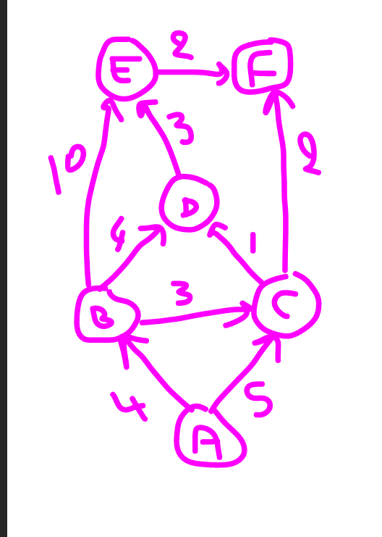

|  |  |  |  |  |  |  |  |
| --- | --- | --- | --- | --- | --- | --- | --- |
| A | B | C | D | E | F | On garde |  |
| 0 | ∞ | ∞ | ∞ | ∞ | ∞ | A |  |
| X | 4A | 5A | ∞ | ∞ | ∞ | B |  |
| X | X | 5A | 8B | 14B | ∞ | C |  |
| X | X | X | 8C | 14B | 7C | F |  |
| x | X | X | 8C | 14B | X | D |  |
| X | X | x | X | 11D | X | E |  |
| A | A-B | A-C | A-C-D ou A-B-D | A-B-D-E | A-C-F |  |  |