Before the detailed steps on how to work in FRAGSTATS, we quickly walk you through how we produced an integer based map from GIS software so that you can repeat this procedure again on your own in the future. We used ArcGIS. However, other GIS software such as QGIS can also be used for the same purpose.
First, we stated with land cover data for Alachua County in 2011. We attained these data from downloading the Nation Land Cover Data Set from the US Geological Survey at https://gapanalysis.usgs.gov/gaplandcover/data/download/. Then using the clip function in ArcGIS we clip these national land cover datasets to only include data for Alachua County. We then reclassified different land cover types to be specified by integers using ArcGIS’ reclassify tool. Figure 8 shows the original land cover data for Alachua County, FL and then the reclassified raster file for 2011. Green is upland forests (1), red is urban areas (2), and white areas are all other land cover types combined (0).
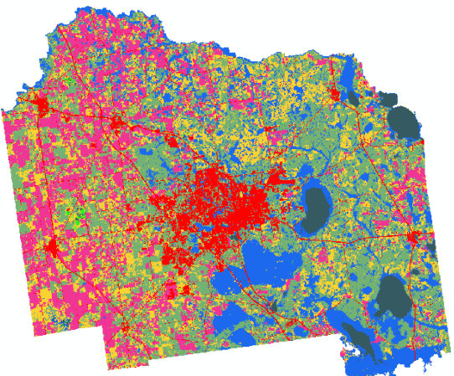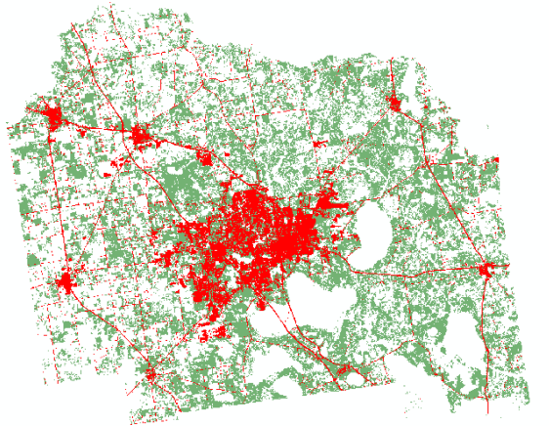
Figure 8. Land cover map in Alachua County (Before and after the reclassification)
We then converted the reclassified range data for 2001 and 2011 into a format that FRAGSTATS accepts. Here we give the example of GeoTiff grid, (.tif) but note FRAGSTATS could support other formats. In ArcGIS, this is achieved by exporting a raster layer as another file type. The resulting GeoTiff grid (i.e., .tif) files are what you will work with for this example. These files can be accessed from the Institutional Repository at the University of Florida (IR@UF). Download these data, as well as the accompanying text file entitled XXX, into a folder on your desktop for easy access. All three files will be needed for our example.

