# Research Assignment

DELIVERABLE: A supporting document that provides evidence of your research into the background documents and a detailed explanation to support your design and layout decisions.

## The question

The objective of this assignment is to develop a simple but engaging web base 3 tier C#.Net active video game. In this assignment, you are required to firstly research all requirements for developing an intuitive Web Application that would have a long-term appeal for the child and adolescent user. Then, you are required to develop an engaging Web Application that incorporates the identified requirements in the scenario that will be given in the next section.

### Colour Psychology- how did he choose the colours

All video games have one aspect in common: that they seek the commitment of the player through exciting emotions and challenges (Erik Geslin, 2016). It can be seen that the brightness and intensity of the colours used within a video game environment can have a profound effect on the emotional response of players, in particular the emotions of joy, sadness, fear and serenity. Figure 1 refers to the impact luminosity has on a player, while Figure 2 outlines a model for the selection of colours in video games with respect to the emotion/s they induce in a player.

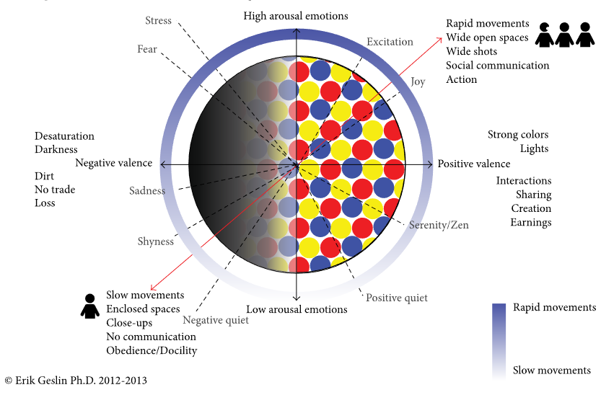

Figure Model for emotions induction in video games and virtual environments (Erik Geslin, 2016)

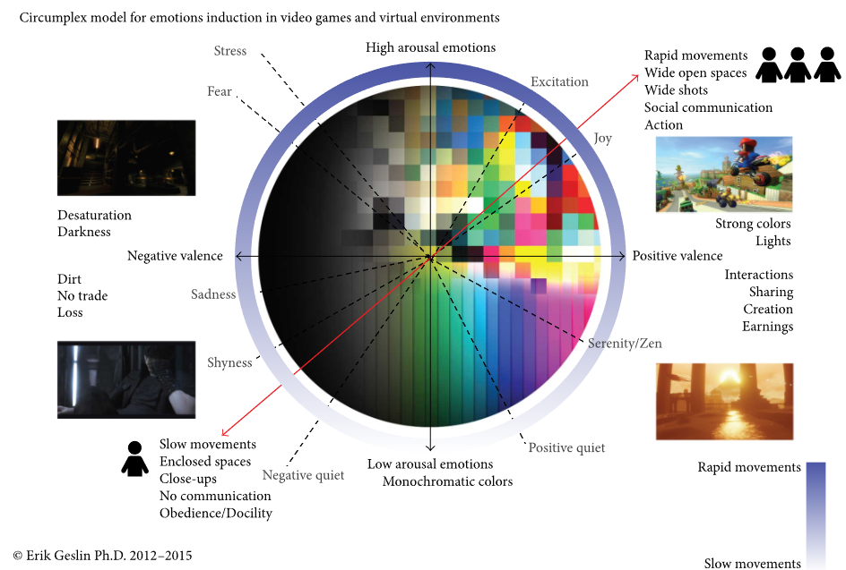

Figure Model for colour scripting in video games (Erik Geslin, 2016)

### Responsive Web-design

Responsive web-design is that which makes content exciting and accessible across all platforms, not just desktop or mobile. They are based on a fluid grid wherein media queries are applied to resize the grid for a given users screen, this ensures a smooth experience for users. This fluidity needs to be extended to your fonts, margins, padding, images and other media (Frederick, n.d.).

### Market Research

A survey of 1254 children in Pennsylvania and South Carolina brings to light the fact that video games are absolute commonplace for most children aged 7-14. By the age of 14 two-thirds of boys and more than one quarter of girls had played an m-rated title.

The survey used focus groups to discuss reasons why boys might like to play video games. They found that the boys enjoyed the skills, costumes, weapons and personalities of favored characters and were quoted to say such things as “The swords in Mortal Kombat are fun to use; they look cool.”. The boys were picking up on the colour and brightness of the weapons and costuming, this then elicited a strong emotional response from them.

Expressions of excitement and fun regarding the “action” presented in some video games also shows a clear link between the vivid imagery potentially used within a game to craft a world of wonder or indeed excited. If a game has a competitive aspect to it this can also have a strong impact on the long-term appeal of a game as children, especially preteen boys, love to be able to compete with one another – it is in fact a primary method of socializing for them. (Cheryl K.Olson, n.d.).