What Are Pandas

Pandas is a powerful data analysis library in Python that is especially well-suited for working with tabular data. In this tutorial, we'll explore its two core data structures: the DataFrame, which represents tabular data with labeled axes (rows and columns), and the Series, a one-dimensional labeled array.
We'll work with real-world weather data retrieved using the isd-fetch tool, which queries records from the National Centers for Environmental Information (NCEI). This dataset is ideal for our purposes—it combines DataFrame and Series structures and includes some irregularities that we'll clean up as part of our data preparation.

Throughout the tutorial, you'll learn how to:
- Load and explore raw data
- Clean and transform it for analysis
- Use Pandas to generate insights
- Create visualizations to better understand patterns and trends

Set Up a Python Virtural Envirnment
We'll begin by setting up your Python environment, creating a virtual environment, and installing the necessary packages. From there, we'll walk step-by-step through data analysis with Pandas, ending with a few visualizations to illustrate the power of what you've learned.

Getting Started
To get started you will need to have Python3 installed. We will also need to import the packages I recomend using a verirural envirmoment. To create a quick and esay Venv envrioment inyour termial run the following commands:
# Create a virtual environment named "pandas-tutorial-env"
python3 -m venv pandas-tutorial-env
# Activate the virtual environment (on macOS/Linux)
source pandas-tutorial-env/bin/activate
# If you're using Windows, activate with:
# pandas-tutorial-env\Scripts\activate
# To deactivate the virtual environment when you're done
deactivate
For more info on virtual enviroment and detailed install instructuion checkout this toturial How to Set Up a Virtual Environment in Python – And Why It's Useful.
Once you have created your virtual environment, make sure that you select it as your Python kernel for the workbook.

Installing Packages

In this tutorial, we will be using packages that are not in Python's standard library. We will need to install these packages. Will need to install the following packages:
- pandas
- geopandas
- matplotlib
- cartopy
- isd-fetch
- pillow
pip install pandas geopandas matplotlib cartopy isd-fetch pillow
import pandas as pd
import geopandas as gpd
import matplotlib.pyplot as plt
import matplotlib.animation as animation
import cartopy.crs as ccrs
import cartopy.feature as cfeature
import cartopy.io.img_tiles as cimgt
from pyisd import IsdLite
from functools import reduce
/home/jk/cityU/programing_for_computing_cs506/team-project/TP-01/venv/lib/python3.10/site-packages/tqdm/auto.py:21: TqdmWarning: IProgress not found. Please update jupyter and ipywidgets. See https://ipywidgets.readthedocs.io/en/stable/user_install.html
from .autonotebook import tqdm as notebook_tqdm
Pick a Location

The first step is to choose a location to pull data from. In the example below, we define geo_box, a list of longitude and latitude coordinates. I’m based in the Pacific Northwest, so I’ve used a bounding box that covers that area.
You’re welcome to use the geo_box I’ve provided or feel free to modify the coordinates to focus on a different region. We'll also look at the option of querying data by country later if you’d rather query data by country.
# Define the bounding box (lon_min, lon_max, lat_min, lat_max)
geo_box = [-128, -116, 45, 52] # Example: part of Washington State
# Create the plot
fig, ax = plt.subplots(figsize=(10, 8), subplot_kw={'projection': ccrs.PlateCarree()})
# Add map features
ax.add_feature(cfeature.COASTLINE)
ax.add_feature(cfeature.BORDERS)
ax.add_feature(cfeature.STATES)
ax.add_feature(cfeature.LAND, color='gray')
ax.add_feature(cfeature.OCEAN, color="skyblue")
# Set map extent to the geo box
ax.set_extent(geo_box, crs=ccrs.PlateCarree())
# Draw the bounding box
lon_min, lon_max, lat_min, lat_max = geo_box
ax.plot(
[lon_min, lon_max, lon_max, lon_min, lon_min],
[lat_min, lat_min, lat_max, lat_max, lat_min],
color='red',
transform=ccrs.PlateCarree()
)
plt.title("Geo Box on Map")
plt.show()
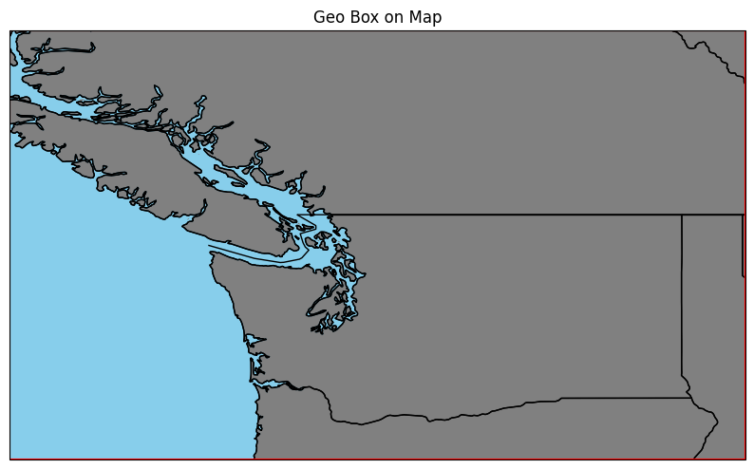
Get Weather Data

Now that we've defined our geo_box, we can fetch weather data. We don't need a large dataset for this tutorial—so it's best to keep the time range and geographic area relatively small to speed up processing.
We'll use the isd-fetch tool from the NCEI (National Centers for Environmental Information), which gives us access to weather data from around the world—some of it dating back to the 1940s.
In the code below, we're retrieving data for January, limited to the geographic region defined by our geo_box in the previous step.
With as is it took about ten minuets to down load. 12687 records. Just enough time to make an other coffee and a snak.
# Initialize the client
isd = IsdLite(crs=4326, verbose=True)
# geo box around state of washington
pnw_data = isd.get_data(
start='2025-01-01',
end='2025-01-10',
geometry=geo_box, #set geobox
organize_by='field'
)
100%|██████████| 12687/12687 [15:49<00:00, 13.36it/s]
OK, lets dig into pnw_data and see what we've got:
print("pwn_data type: ", type(pnw_data))
print("pnw_data.columns: ", pnw_data.keys())
print("pnw_data['temp'] type", type(pnw_data['temp']))
print("pnw_data", pnw_data['temp'].index)
pnw_data['temp'].sample(4)
pwn_data type: <class 'dict'>
pnw_data.columns: dict_keys(['temp', 'dewtemp', 'pressure', 'winddirection', 'windspeed', 'skycoverage', 'precipitation-1h', 'precipitation-6h'])
pnw_data['temp'] type <class 'pandas.core.frame.DataFrame'>
pnw_data DatetimeIndex(['2025-01-01 00:00:00', '2025-01-01 01:00:00',
'2025-01-01 02:00:00', '2025-01-01 03:00:00',
'2025-01-01 04:00:00', '2025-01-01 05:00:00',
'2025-01-01 06:00:00', '2025-01-01 07:00:00',
'2025-01-01 08:00:00', '2025-01-01 09:00:00',
...
'2025-01-10 14:00:00', '2025-01-10 15:00:00',
'2025-01-10 16:00:00', '2025-01-10 17:00:00',
'2025-01-10 18:00:00', '2025-01-10 19:00:00',
'2025-01-10 20:00:00', '2025-01-10 21:00:00',
'2025-01-10 22:00:00', '2025-01-10 23:00:00'],
dtype='datetime64[ns]', length=240, freq='h')
892570 889630 890550 890590 892660 892620 890630 \
2025-01-06 23:00:00 NaN 5.0 3.7 NaN -6.4 1.4 NaN
2025-01-09 00:00:00 -1.2 1.0 0.3 0.0 -3.3 -0.6 1.6
2025-01-08 18:00:00 0.4 6.5 4.9 0.0 -1.9 NaN 3.0
2025-01-10 12:00:00 -2.6 0.7 -2.0 -2.0 -3.8 -1.5 0.0
890570 892510 890530 ... 714170 718140 714060 \
2025-01-06 23:00:00 NaN NaN 2.8 ... 0.9 1.6 NaN
2025-01-09 00:00:00 3.7 4.0 4.5 ... -0.7 -2.4 -0.8
2025-01-08 18:00:00 3.5 4.5 5.7 ... 0.7 0.7 0.8
2025-01-10 12:00:00 2.0 1.3 1.7 ... 0.2 1.3 0.2
718190 715840 718080 715580 713130 714210 715120
2025-01-06 23:00:00 1.0 NaN 1.0 NaN 2.0 -1.9 0.5
2025-01-09 00:00:00 -0.4 0.1 -0.3 NaN 0.0 -0.7 -0.7
2025-01-08 18:00:00 -0.7 3.8 0.6 NaN 4.0 -0.8 4.0
2025-01-10 12:00:00 0.5 0.4 0.9 NaN 0.0 -5.8 0.6
[4 rows x 4780 columns]

Understanding the Data

- pnw_data: <class 'dict'>
- pnw_data.keys(): dict_keys(['temp', 'dewtemp', 'pressure', 'winddirection', 'windspeed', 'skycoverage', 'precipitation-1h', 'precipitation-6h'])
- pnw_data['temp']: type <class 'pandas.core.frame.DataFrame'>
- pnw_data['temp'].index: timestamps
We downloaded a Python dictionary with keys for temperature, dewtemp, pressure, wind direction, wind speed, sky coverage, one-hour precipitation, and six-hour precipitation. Each object value in the dictionary is a Pandas DataFrame, which is indexed with a timestamp and has a column for each weather station in our geo box

Looking at Data

Let's use the pandas. Use the DataFrame method info() and describe(). Info shows us that there are 4780 columns and 240 indexes for weather stations. Describe how many of the weather stations are missing information. If we look at the count, we can see that not all stations have a count equal to 240, which means there are some missing values in the data.
pnw_data['temp'].info()
<class 'pandas.core.frame.DataFrame'>
DatetimeIndex: 240 entries, 2025-01-01 00:00:00 to 2025-01-10 23:00:00
Freq: h
Columns: 4780 entries, 892570 to 715120
dtypes: float64(4780)
memory usage: 8.8 MB
pnw_data['temp'].describe()
892570 889630 890550 890590 892660 892620 \
count 77.000000 147.000000 237.000000 74.000000 227.000000 224.000000
mean -3.881818 4.226531 2.323629 -0.175676 -2.875330 -0.718304
std 2.780985 2.602563 3.070877 0.816912 3.159591 1.725092
min -10.400000 -0.400000 -3.700000 -2.000000 -9.000000 -7.400000
25% -5.800000 2.350000 -0.200000 -1.000000 -5.200000 -1.800000
50% -3.100000 4.200000 2.100000 0.000000 -3.200000 -0.900000
75% -2.000000 5.500000 5.400000 0.000000 -1.300000 0.600000
max 1.100000 13.500000 8.400000 1.000000 6.200000 2.900000
890630 890570 892510 890530 ... 714170 \
count 80.000000 78.000000 40.000000 153.000000 ... 235.000000
mean 1.183750 2.267949 2.597500 2.970588 ... 0.620851
std 1.168624 0.847225 1.175495 1.302673 ... 0.936003
min -0.800000 0.500000 0.500000 0.500000 ... -2.600000
25% 0.300000 1.700000 1.700000 2.000000 ... 0.200000
50% 0.800000 2.150000 2.550000 3.000000 ... 0.600000
75% 2.100000 2.700000 3.200000 3.600000 ... 1.200000
max 5.600000 5.000000 5.200000 6.500000 ... 3.300000
718140 714060 718190 715840 718080 715580 \
count 237.000000 238.000000 238.000000 78.000000 239.000000 0.0
mean 0.802954 1.300840 0.704202 0.237179 1.272385 NaN
std 1.708538 1.340948 1.059368 2.540585 1.337685 NaN
min -5.900000 -3.200000 -3.000000 -6.100000 -3.000000 NaN
25% 0.400000 0.500000 0.000000 -0.775000 0.700000 NaN
50% 1.200000 1.300000 1.000000 0.850000 1.500000 NaN
75% 1.900000 2.175000 1.200000 2.000000 2.000000 NaN
max 3.200000 4.000000 3.100000 4.100000 4.000000 NaN
713130 714210 715120
count 238.000000 239.000000 239.000000
mean 0.310924 -3.166946 0.373222
std 2.551571 3.021706 2.634156
min -6.000000 -11.100000 -5.600000
25% -1.000000 -5.650000 -1.400000
50% 1.000000 -2.000000 1.100000
75% 2.000000 -0.900000 2.000000
max 4.000000 0.600000 5.100000
[8 rows x 4780 columns]

Prep to Plot Data

We have a nice shiny map just sitting there—let’s put some data on it! Right now, our pnw_data only contains measurements. We don’t yet know the physical location of the weather stations that collected this data. To plot them accurately, we need metadata about the station locations.

Getting Metadata

To get the station metadata, we can use the same isd object we used earlier to fetch the weather data. The following code will retrieve the metadata (including station IDs, names, and coordinates) so we can link each station to a location on the map:
# View available stations
metadata = isd.raw_metadata
metadata.head()
USAF WBAN STATION NAME CTRY ST CALL ELEV(M) BEGIN \
4 008268 99999 WXPOD8278 AF NaN NaN 1156.7 2010-05-19
11 010010 99999 JAN MAYEN(NOR-NAVY) NO NaN ENJA 9.0 1931-01-01
13 010014 99999 SORSTOKKEN NO NaN ENSO 48.8 1986-11-20
14 010015 99999 BRINGELAND NO NaN NaN 327.0 1987-01-17
15 010016 99999 RORVIK/RYUM NO NaN NaN 14.0 1987-01-16
END x y geometry
4 2012-03-23 65.567 32.950 POINT (65.567 32.95)
11 2025-04-29 -8.667 70.933 POINT (-8.667 70.933)
13 2025-04-29 5.341 59.792 POINT (5.341 59.792)
14 1997-12-31 5.867 61.383 POINT (5.867 61.383)
15 1991-08-06 11.233 64.850 POINT (11.233 64.85)
metadata.info()
<class 'geopandas.geodataframe.GeoDataFrame'>
Index: 28094 entries, 4 to 29659
Data columns (total 12 columns):
# Column Non-Null Count Dtype
--- ------ -------------- -----
0 USAF 28094 non-null object
1 WBAN 28094 non-null int64
2 STATION NAME 28092 non-null object
3 CTRY 28006 non-null object
4 ST 6520 non-null object
5 CALL 10798 non-null object
6 ELEV(M) 27988 non-null float64
7 BEGIN 28094 non-null datetime64[ns]
8 END 28094 non-null datetime64[ns]
9 x 28094 non-null float64
10 y 28094 non-null float64
11 geometry 28094 non-null geometry
dtypes: datetime64[ns](2), float64(3), geometry(1), int64(1), object(5)
memory usage: 2.8+ MB

Accessing Records

Pandas package allows us acces data a number of ways. We can used the methods mentioded above see a high levelview of the dataset. Head() and tail(), allow us access the first 5 and last 5 row respectivly. And to addess indiviulal records in a DataFrame we can use the metada for this example. Note this is a breif overview. There is a lot going on behind the seincs.

Some that are out of scope of tutorial.
- Pandas arrays, scalars, and data types
- Pandas DataFrame
- Pandas Series
- Pandas Indexes

DataFrame
note:
The code snippets below use example row and column names to demonstrate how each method works. These are just for illustration — in your own code, you’ll need to replace them with the actual labels or positions from your dataset.

at[] - label based scalar access
Access a single value in a datafram by row column pair with a label.
`metadata.at['row1', 'station_name']`

.iat[] - Integer-based scalar access
Access a sigle value by position
value = metadata.iat[0, 3]

.loc[] - label based use assess single or multiple values
Use .loc[] to get rows and columns useing labels:
row = metadata.loc['row1']
cell = metadata.loc['row1', 'station_name']
subset = metadata.loc[:, ['station_name', 'elevation']]

.iloc[] - integer based access
Use iloc[] to access single or multiple values using indexes
row = metadata.loc['row1']
cell = metadata.loc['row1', 'station_name']
subset = metadata.loc[:, ['station_name', 'elevation']]

Series

at[] - label based scalar access
Access a single value in a datafram by row column pair with a label.
`series.at['2025-01-01 00:00:00']`

.iat[] - Integer-based scalar access
Access a sigle value by position
series.iat[0]

.loc[] - label based use assess single or multiple values
Use .loc[] to get rows and columns useing labels:
series.loc['2025-01-01 00:00:00']
series.loc[['2025-01-01 00:00:00', '2025-01-01 01:00:00']] # access two records
series.loc['2025-01-01 00:00:00' : '2025-01-01 01:00:00'] # access range

.iloc[] - integer based access
Use iloc[] to access single or multible values using indexes
series.iloc[0]
series.iloc[[0, 1, 2]]
series.iloc[0:3] # First three rows

Map Station to Temp Data

In the code below, we want to create a data structure that we add to our map. We will be using both pandas.core.DataFrame, which is where we store the temp data, and we need to convert it to pandas. core.Series data.
We start with the pnw_data temp column. The temp DataFrame rows are indexed with a time stamp, and the columns are the station IDs. We integrate through the column names and station IDs and use them to get the metadata from the metadata data. Next, we create an object with the station name and location and add a pandas series object by taking the column by station ID. Station_id is used for the key.
station_data = {}
# for all stations id find the meta df
for station_id in pnw_data['temp'].columns:
meta = metadata[metadata['USAF'] == station_id].iloc[0]
location = meta['geometry']
name = meta['STATION NAME']
temp_series = pnw_data['temp'][station_id]
lon, lat = location.x, location.y
# check to make sure that the point are inside the geo_box
if not (geo_box[0] <= lon <= geo_box[1] and geo_box[2] <= lat <= geo_box[3]):
continue
# create dict of metadata values for each station
station_data[station_id] = {
'name': name,
'location': location,
# add pd.core.Series object
'temp_series': temp_series,
'elevation': meta['ELEV(M)']
}
station_data['997801']
{'name': 'LONGVIEW',
'location': <POINT (-122.954 46.106)>,
'temp_series': 2025-01-01 00:00:00 NaN
2025-01-01 01:00:00 NaN
2025-01-01 02:00:00 NaN
2025-01-01 03:00:00 NaN
2025-01-01 04:00:00 NaN
..
2025-01-10 19:00:00 NaN
2025-01-10 20:00:00 NaN
2025-01-10 21:00:00 NaN
2025-01-10 22:00:00 NaN
2025-01-10 23:00:00 NaN
Freq: h, Name: 997801, Length: 240, dtype: float64,
'elevation': np.float64(9.0)}
Now, we need to add the station data to the map. Below is the same code that we used above. We just added the for loop, where we add a dot where the station is and print the temperature.
# Define the bounding box (lon_min, lon_max, lat_min, lat_max)
geo_box = [-128, -116, 45, 52] # Example: part of Washington State
# Create the plot
fig, ax = plt.subplots(figsize=(10, 8), subplot_kw={'projection': ccrs.PlateCarree()})
# Add map features
ax.add_feature(cfeature.COASTLINE)
ax.add_feature(cfeature.BORDERS)
ax.add_feature(cfeature.STATES)
ax.add_feature(cfeature.LAND, color='gray')
ax.add_feature(cfeature.OCEAN, color="skyblue")
# Set map extent to the geo box
ax.set_extent(geo_box, crs=ccrs.PlateCarree())
# Draw the bounding box
lon_min, lon_max, lat_min, lat_max = geo_box
ax.plot(
[lon_min, lon_max, lon_max, lon_min, lon_min],
[lat_min, lat_min, lat_max, lat_max, lat_min],
color='red',
transform=ccrs.PlateCarree()
)
# Plot each station
for station_id, info in station_data.items():
name = info['name']
lon, lat = info['location'].x, info['location'].y
temp = info['temp_series'].iloc[0]
if pd.notna(temp):
ax.plot(lon, lat, marker='o', color='red', markersize=6, transform=ccrs.PlateCarree())
ax.text(lon + 0.1, lat + 0.1, f"{temp:.1f}°C", fontsize=8, transform=ccrs.PlateCarree())
plt.title("Jan 1, 1 2025 Temp")
plt.show()
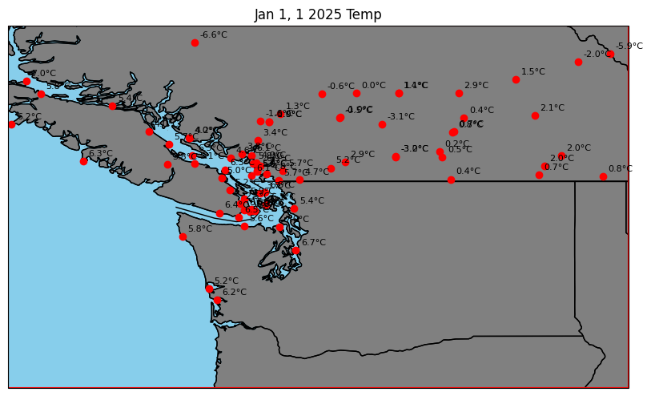

Animate Sieries Data

It's great to see the data on our map. Remember, our data type is a Sieries datatype. This means that we can animate the data and change the station pins based on temperature. Because we have the time stamps we can create an animation using Matplotlib and save it to a gif file type with the pillow package.
# Setup figure and map
fig, ax = plt.subplots(figsize=(10, 8), subplot_kw={'projection': ccrs.PlateCarree()})
geo_box = [-128, -116, 45, 52]
ax.set_extent(geo_box, crs=ccrs.PlateCarree())
ax.add_feature(cfeature.COASTLINE)
ax.add_feature(cfeature.BORDERS)
ax.add_feature(cfeature.STATES)
ax.add_feature(cfeature.LAND, color='gray')
ax.add_feature(cfeature.OCEAN, color="skyblue")
# Prepare plot objects
scatter_points = []
text_labels = []
# Get the sorted list of timestamps
timestamps = pnw_data['temp'].index # Shared across all stations
# Initialize the plot
def init():
return scatter_points + text_labels
# Animation update function
def update(frame_idx):
global scatter_points, text_labels
for p in scatter_points + text_labels:
p.remove()
scatter_points.clear()
text_labels.clear()
current_time = timestamps[frame_idx]
for info in station_data.values():
lon, lat = info['location'].x, info['location'].y
if not (geo_box[0] <= lon <= geo_box[1] and geo_box[2] <= lat <= geo_box[3]):
continue
temp_series = info['temp_series']
temp = temp_series.iloc[frame_idx]
if pd.notna(temp):
color = plt.cm.coolwarm((temp + 10) / 40) # Normalize temp
pt = ax.plot(lon, lat, marker='o', color=color, markersize=6, transform=ccrs.PlateCarree())[0]
txt = ax.text(lon + 0.1, lat + 0.1, f"{temp:.1f}°C", fontsize=7, transform=ccrs.PlateCarree())
scatter_points.append(pt)
text_labels.append(txt)
ax.set_title(f"Temperature on {current_time:%Y-%m-%d %H:%M}")
return scatter_points + text_labels
# Create animation
ani = animation.FuncAnimation(fig, update, frames=len(timestamps), init_func=init, blit=False, interval=1000)
ani.save("temperature_animation.gif", writer="pillow", fps=5)
print('animation saved as temerature_animation.gif')
animation saved as temerature_animation.gif
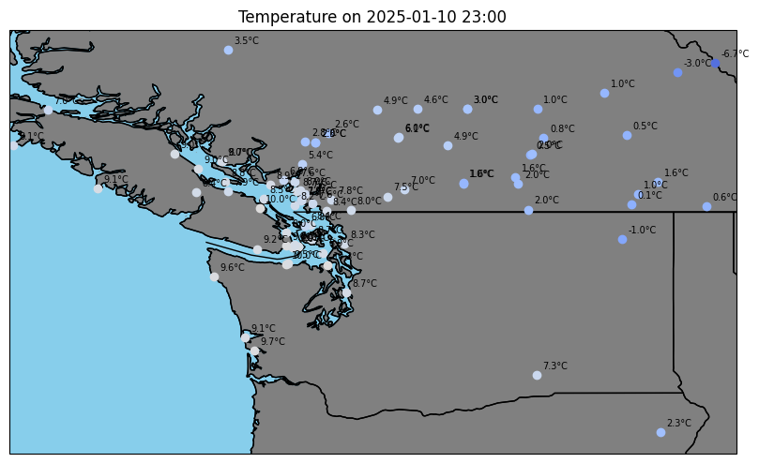

What We've Have Done so Far

That was pretty cool—we were able to take temperature data from a Pandas DataFrame, extract a Pandas Series for each station, and animate that data on a map! You could repeat the same process to visualize any of the other available weather fields (like wind speed, pressure, or precipitation).
You might have noticed that some weather stations flicker during the animation. This happens because the dataset has missing (NaN) values at certain time steps. Next, we'll address gaps in the data and take a few other cleanup steps to make the dataset more reliable and easier to work with.
Now, we are ready to begin processing our data to prepare it for use with machine learning. This involves organizing it into a consistent format, handling missing or incomplete values, and ensuring that all features are encoded as numerical values that machine learning algorithms can understand and learn from effectively.
# store all unique time stamps
time_indexes = set()
# itterate the pnd_data keys to add all
for key in pnw_data.keys():
indexes = pnw_data[key].index
time_indexes.update(indexes)
time_indexes = sorted(time_indexes)

Process Data

In the code block above, we retrieved all the unique indexes—in our case, timestamps—and sorted them. Our goal is to create a record (eventually a pandas DataFrame) for each observation in our dataset.
Next, we iterate through each unique timestamp and build a record that captures all the observations at that specific time. This gives us one complete record for each unique timestamp and weather station ID combination. At this stage, we're using plain Python objects (like dictionaries) because these operations are more efficient without the additional computational overhead of working with pandas DataFrames.
You can see that we also added metadata to each record object. This ensures we have rich, contextual data—including the station's location and elevation—which can enhance future analysis or improve the performance of machine learning models that rely on spatial or environmental factors.

Indexes
We use indexes in the second two lines of the code below to make our data access more efficient. In the metadata DataFrame, the "USAF" column holds the station IDs we frequently need to reference. Accessing these values repeatedly through filtering can be computationally expensive. To improve performance, we first remove duplicates to ensure each station ID is unique, then set "USAF" as the index. This allows us to quickly access records using dictionary-style lookups. Pandas indexes are a powerful feature that enables fast and readable access to specific records in a DataFrame.
flat_data = []
# make the look up to dict for faster look up, dorp dups
metadata_unique = metadata.drop_duplicates(subset="USAF", keep='first')
meta_lookup = metadata_unique.set_index("USAF").to_dict("index")
for index in time_indexes:
# diffrent datframse
# columns are station id
for station_id in pnw_data[key].columns:
meta = meta_lookup.get(station_id)
record = {
'timestamps': index,
'station_id': station_id,
'elivation' : meta['ELEV(M)'],
'x': meta['x'],
'y': meta['y'],
'geometry': meta['geometry']
}
for key in pnw_data.keys():
record[key] = pnw_data[key].at[index, station_id]
flat_data.append(record)
df = pd.DataFrame(flat_data)
df.info()
<class 'pandas.core.frame.DataFrame'>
RangeIndex: 1147200 entries, 0 to 1147199
Data columns (total 14 columns):
# Column Non-Null Count Dtype
--- ------ -------------- -----
0 timestamps 1147200 non-null datetime64[ns]
1 station_id 1147200 non-null object
2 elivation 1146720 non-null float64
3 x 1147200 non-null float64
4 y 1147200 non-null float64
5 geometry 1147200 non-null object
6 temp 781064 non-null float64
7 dewtemp 726491 non-null float64
8 pressure 510921 non-null float64
9 winddirection 753926 non-null float64
10 windspeed 772386 non-null float64
11 skycoverage 214667 non-null float64
12 precipitation-1h 72667 non-null float64
13 precipitation-6h 33638 non-null float64
dtypes: datetime64[ns](1), float64(11), object(2)
memory usage: 122.5+ MB
df
timestamps station_id elivation x y \
0 2025-01-01 00:00:00 892570 40.0 -59.150 -75.867
1 2025-01-01 00:00:00 889630 24.0 -56.983 -63.400
2 2025-01-01 00:00:00 890550 208.0 -56.717 -64.233
3 2025-01-01 00:00:00 890590 10.0 -56.683 -63.317
4 2025-01-01 00:00:00 892660 115.0 -60.167 -72.200
... ... ... ... ... ...
1147195 2025-01-10 23:00:00 718080 36.9 -57.183 51.450
1147196 2025-01-10 23:00:00 715580 29.0 -56.100 51.383
1147197 2025-01-10 23:00:00 713130 37.8 -63.600 50.283
1147198 2025-01-10 23:00:00 714210 589.0 -63.283 51.867
1147199 2025-01-10 23:00:00 715120 11.0 -64.226 50.271
geometry temp dewtemp pressure winddirection \
0 POINT (-59.15 -75.867) -2.1 -3.2 988.6 40.0
1 POINT (-56.983 -63.4) 5.7 -3.5 1003.0 110.0
2 POINT (-56.717 -64.233) 4.3 -5.8 1000.9 310.0
3 POINT (-56.683 -63.317) 1.0 1.0 1008.1 260.0
4 POINT (-60.167 -72.2) -1.2 -1.4 990.5 350.0
... ... ... ... ... ...
1147195 POINT (-57.183 51.45) 1.0 -3.0 994.1 10.0
1147196 POINT (-56.1 51.383) NaN NaN NaN NaN
1147197 POINT (-63.6 50.283) -2.0 -7.0 1003.7 360.0
1147198 POINT (-63.283 51.867) -7.5 -10.1 1006.5 10.0
1147199 POINT (-64.226 50.271) -1.5 -7.1 1004.4 350.0
windspeed skycoverage precipitation-1h precipitation-6h
0 7.2 NaN NaN NaN
1 3.6 7.0 NaN NaN
2 6.7 7.0 NaN 0.0
3 14.9 7.0 NaN 0.0
4 8.2 NaN NaN NaN
... ... ... ... ...
1147195 7.2 NaN NaN NaN
1147196 NaN NaN NaN NaN
1147197 4.1 0.0 NaN NaN
1147198 5.7 NaN NaN NaN
1147199 2.6 NaN NaN NaN
[1147200 rows x 14 columns]

Closer Look
Sometimes, it can be helpful to Visualize our data so we can see how the missing values are distributed across the data set.
import seaborn as sns
import matplotlib.pyplot as plt
sns.set_theme(style="whitegrid")
tips = sns.load_dataset("tips")
sns.heatmap(df.isnull(), cmap="coolwarm", cbar=True)
plt.title("Missing Data Heatmap")
plt.show()
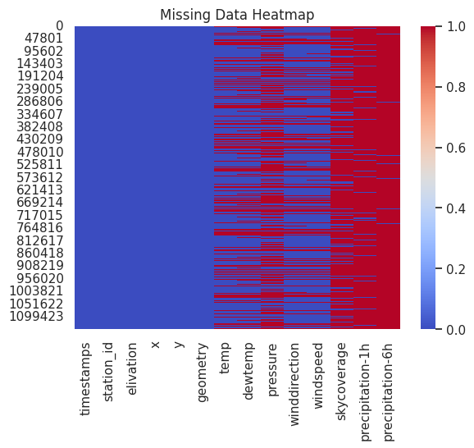

Dealing with missing Data

Let’s think through how we want to handle missing values in our weather dataset.
First, we’ll visualize the data to better understand the missing values. Keep in mind that this dataset currently only covers 10 days, so the sample size is limited. Also remember: this is weather data, so we can make domain-specific assumptions to fill in the gaps.
- Here are our assumptions and strategies for dealing with missing (NaN) values:
- Windspeed and Wind Direction: If these are missing, we’ll assume the wind was not blowing, so we’ll set missing values to 0.
- Sky Coverage and Precipitation: If NaN, we’ll assume clear skies and no rain, so we’ll also set these to 0.
- Dew Temperature and Air Temperature: For these, setting to 0 would distort the data. Instead, we’ll fill missing values using the median of each column, which helps preserve the overall distribution without being affected by outliers.
# Replace missing values
df.fillna({
'windspeed': 0,
'winddirection': 0,
'skycoverage' : 0,
'precipitation-1h' : 0,
'precipitation-6h' : 0,
}, inplace=True)
# Fill temperature columns with median values
df.fillna({
'temp' : df['temp'].median(),
'dewtemp' : df['dewtemp'].median(),
'pressure' : df['pressure'].median(),
}, inplace=True)
df.info()
<class 'pandas.core.frame.DataFrame'>
RangeIndex: 1147200 entries, 0 to 1147199
Data columns (total 14 columns):
# Column Non-Null Count Dtype
--- ------ -------------- -----
0 timestamps 1147200 non-null datetime64[ns]
1 station_id 1147200 non-null object
2 elivation 1146720 non-null float64
3 x 1147200 non-null float64
4 y 1147200 non-null float64
5 geometry 1147200 non-null object
6 temp 1147200 non-null float64
7 dewtemp 1147200 non-null float64
8 pressure 1147200 non-null float64
9 winddirection 1147200 non-null float64
10 windspeed 1147200 non-null float64
11 skycoverage 1147200 non-null float64
12 precipitation-1h 1147200 non-null float64
13 precipitation-6h 1147200 non-null float64
dtypes: datetime64[ns](1), float64(11), object(2)
memory usage: 122.5+ MB
We can see that we have 1147200 records and 1147200 non-null values for all rows. We are ready. To be sure, we can see it in our heat map.
sns.set_theme(style="whitegrid")
tips = sns.load_dataset("tips")
sns.heatmap(df.isnull(), cmap="coolwarm", cbar=True)
plt.title("Missing Data Heatmap")
plt.show()
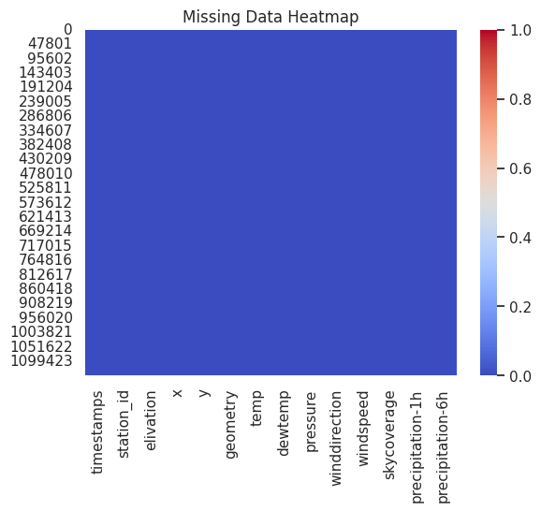

Recap

We've covered a lot and successfully completed a real-world data-cleaning and preparation project for weather analysis. Here's what we accomplished:
- Downloaded weather data from the NOAA database.
- Displayed the data on a map to visualize station locations.
- Created a time series and even animated weather conditions over time.
- Transformed the data from a wide format into individual observations (long format) for analysis.
Handled missing values by:
- Filling in values for windspeed, direction, sky coverage, and precipitation where appropriate.
- Using median values for temperature and dew point when data was missing.
- Dropping records only when filling wasn't reasonable or meaningful.

Reverences

- Global Hourly—Integrated Surface Database (ISD). (2021, March 17). National Centers for Environmental Information (NCEI). https://www.ncei.noaa.gov/products/land-based-station/integrated-surface-database
- How to Set Up a Virtual Environment in Python – And Why It’s Useful. (2022, April 11). freeCodeCamp.Org. https://www.freecodecamp.org/news/how-to-setup-virtual-environments-in-python/
- Introduction—Cartopy 0.24.1 documentation. (n.d.). Retrieved May 1, 2025, from https://scitools.org.uk/cartopy/docs/latest/
- Isd-fetch/README.md at main · CyrilJl/isd-fetch. (n.d.). GitHub. Retrieved April 29, 2025, from https://github.com/CyrilJl/isd-fetch/blob/main/README.md
- pandas—Python Data Analysis Library. (n.d.). Retrieved April 29, 2025, from https://pandas.pydata.org/
- seaborn.lineplot—Seaborn 0.13.2 documentation. (n.d.). Retrieved April 29, 2025, from https://seaborn.pydata.org/generated/seaborn.lineplot.html
- The Ultimate Guide to the Pandas Library for Data Science in Python. (2020, July 8). freeCodeCamp.Org. https://www.freecodecamp.org/news/the-ultimate-guide-to-the-pandas-library-for-data-science-in-python/

