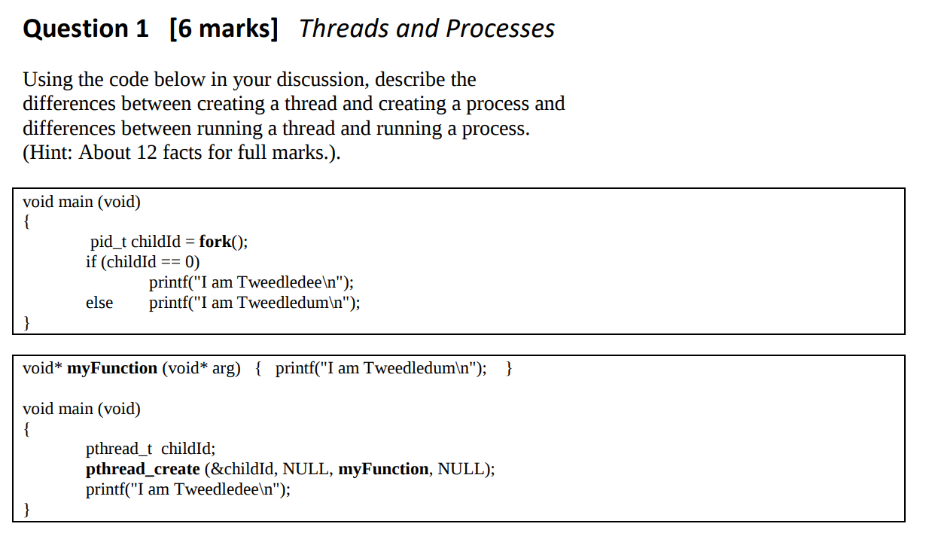
2018

Sample Answer:
After fork(), there are now two processes with one thread each, both continue
executing the same line of code after fork().

Whereas after pthread_create() (which has a parameter which is a pointer to a
function), there is still only one process but now with two threads, where the new
thread begins executing code in a call-back function (i.e. program counter
pointing to first line in this function, not continuing from pthread_create).

Specifically, fork() creates a separate child process, after which the program counter
points to the “if” in both processes. Processes are independent so that if one
process ends the other continues. But if the main thread ends, all other threads may
terminate.

Both threads share the same global address space but since each thread has its own
stack, changing a local variable will not affect other threads. Whereas the child
process has its own address space initialised with the parents data at the time of
the fork() (except the childId value which returns 0 to the child and the child PID
to the parent). Unlike threads, processes cannot directly modify each other’s data
without using “clever” communication mechanisms such as files, pipes or sockets.

Main points:

...
...
...
...

User handing over their authentication credentials to another user. e.g (Disk controller)

(b) Locality of reference
A computer program accesses an instruction from the location that contains that address (shortest distance)

(c) Snoopy caching
Bus sniffing

- They do not carry any information
- Participating processes must know each other’s process IDs
- The number of signals is limited (examples)
- Cooperating processes must agree on the meaning of each signal
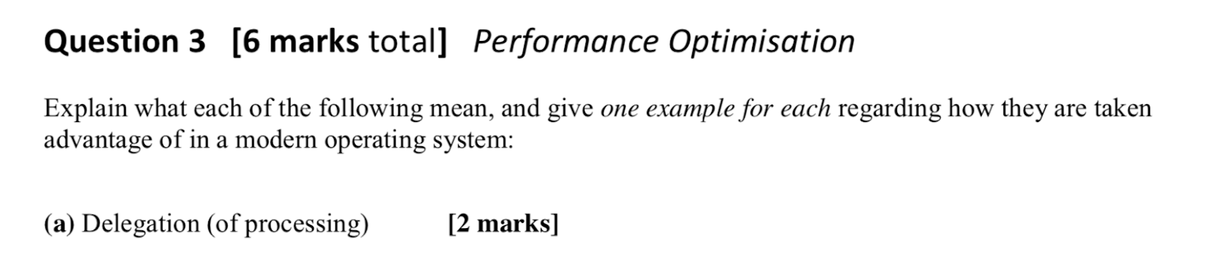
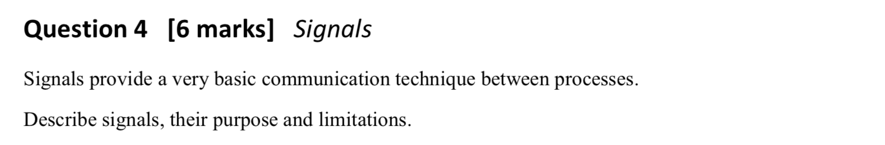
- No easy way for sending process to know if its signal was received
- Most signals terminate the process
- A signal handling routine can catch a signal instead of terminating the process - except SIGKILL, SIGSTOP
- if signal is not reset in signal handling routine, it cannot process more signals
- may come from hardware (/0), OS (file limit), user (ctrl-C), or other process
- only two user defined signals, SIGUSR1, SIGUSR2

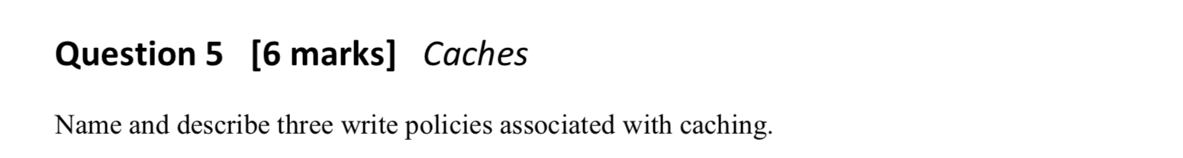
Write-through always write to disk
Write-back write to disk only when evicting (even if unchanged)
Write-deferred Mark cache entry as “dirty” (if changed) Write out dirty entry on eviction
Write allocation bring missed entry into cache
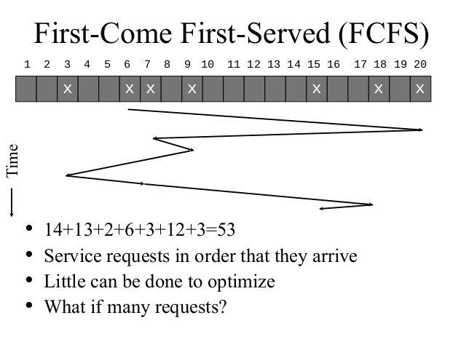
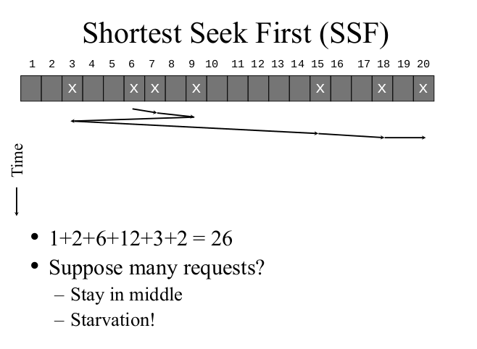
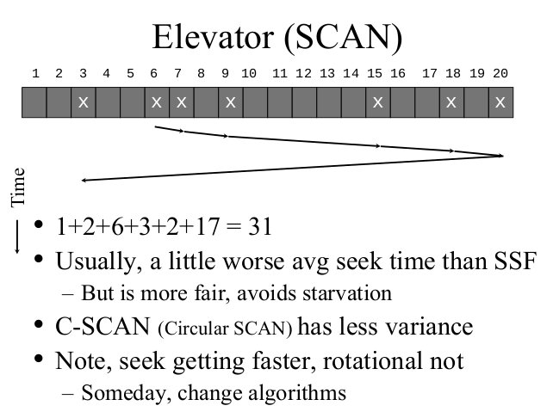

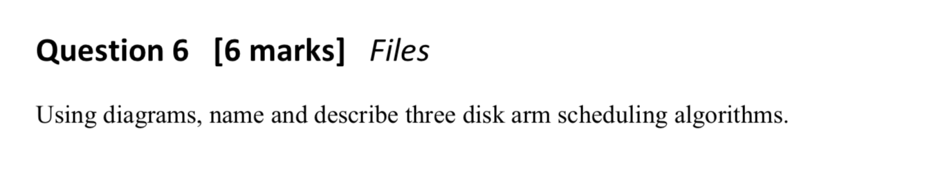
Main points:
...
...
...

