Hardware Throttle Configuration
C* A321neo

Configuring CLB and MCT/FLEX detents
The configuration of hardware throttle is entirely performed by using the standard X-Plane menu.

- Go to Settings → Joystick, select your device and find the corresponding axis for throttle 1 and throttle 2 (or a single axis)
- For each axis, calibrate it, set “Reverse Axis” if needed, and then press Add Response Curve:
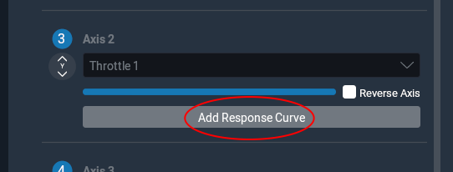
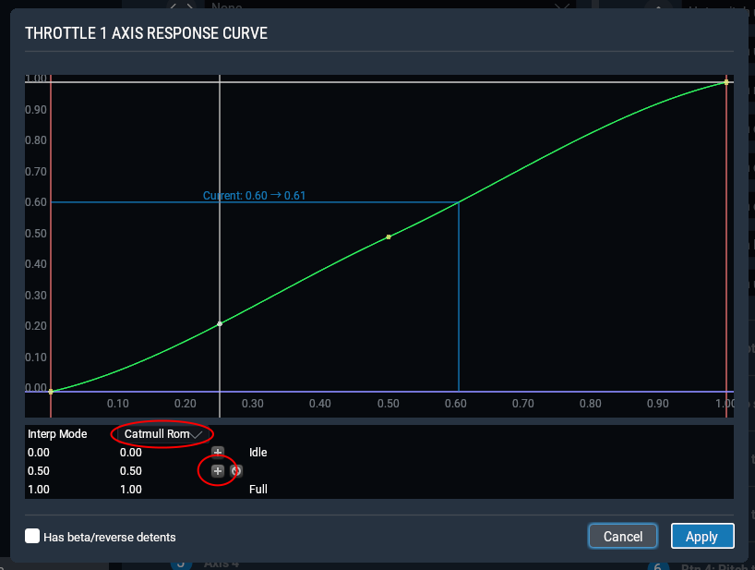
- In the new window select the interpolation mode you like (usually Linear is sufficient in most of the cases) and add a new point in the plot:

- You should now have four points: Idle and Full at the extremes and two free points in the middle (for CLB and MCT/FLEX)

- Move your throttle to the CLB position and copy the value showed near “Current” into the number of the left of the first free point:
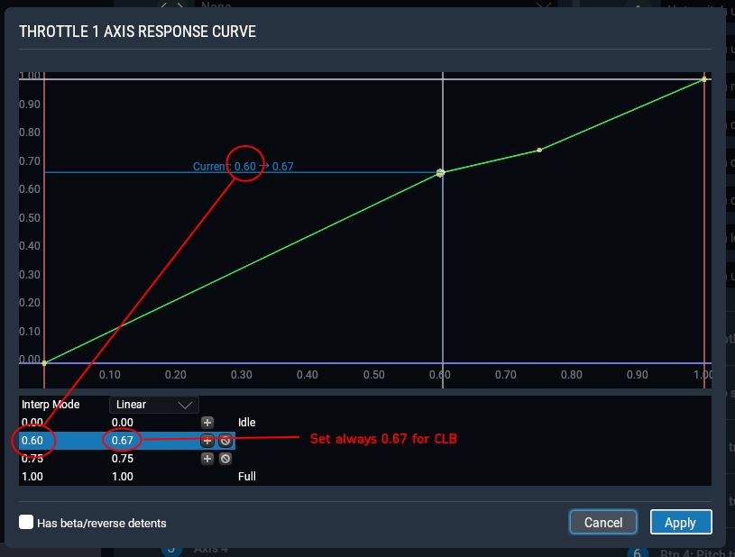

- Set the number on the right to 0.67

- Move your throttle to the MCT/FLEX position and copy the value showed near “Current” into the number of the left of the second free point:
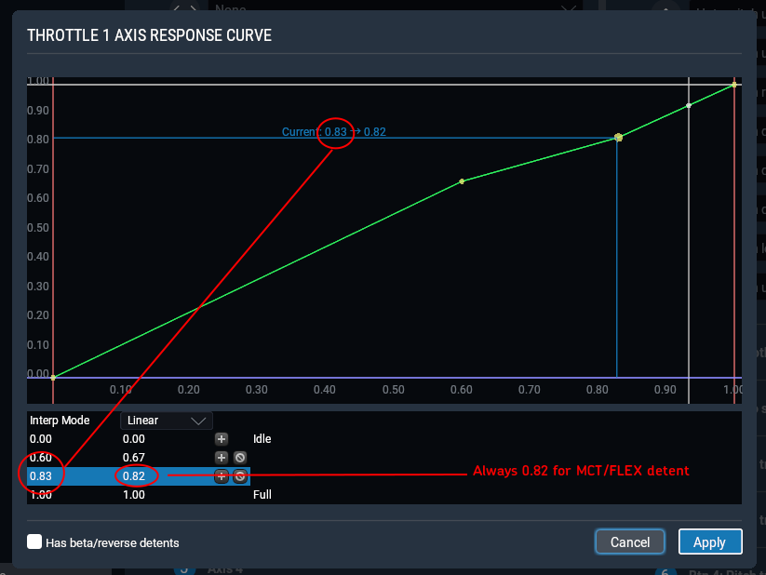

- Set the number on the right to 0.82

You have successfully configured the CLB and MCT/FLEX detents.

Configuring Reverse
To configure the reverse, it depends on your joystick configuration:

A. Your axis integrates the reverse. For example the first 10% of your axis is dedicated to reverse and the remaining 90% to the throttle → go to the next section

B. Hold at maximum reverse → Assign the commands “Hold thrust reverse at max #1” or “Hold thrust reverse at max #2” or the engine-independent “Hold thrust reverse at max.” to the button you like

C. Toggle reverse → Assign the command “Toggle thrust reversers” to the button you like. Once you trigger that, your throttle axis controls the reverse throttle. You need to press again the button to restore forward thrust. DO NOT use single-engine commands (e.g., “Toggle thrust reversers #1”), they are not supported.

D. Separate axis for reverse Not supported

Configuring Reverse – Reverse integrated in throttle axis

After configuring the CLB and MCT/FLEX detents, perform the following operations in the curve response window:
- Enable “Has beta/reverse detents”
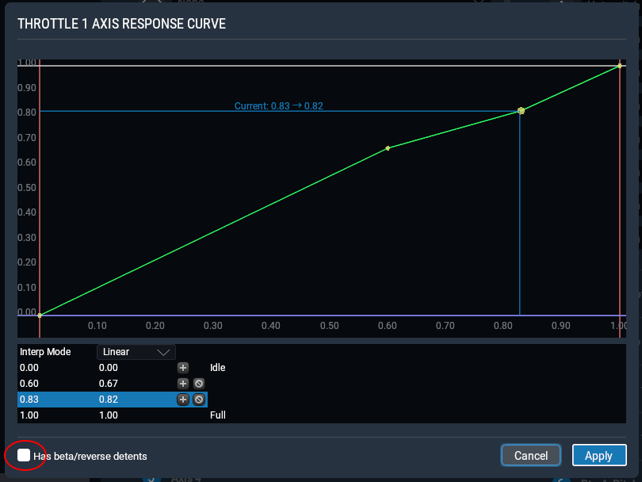

- Move your throttle to the idle position and copy the current value to the first number of the left of the “Beta/reverse crossover point”. Leave the right number as it is, its value is not relevant.
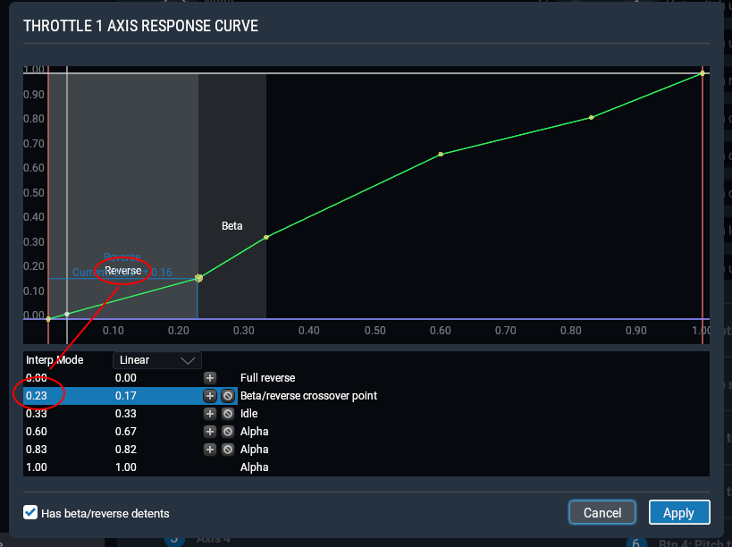

- Change the left number of “idle” by setting the same number of the “Beta/reverse crossover point”
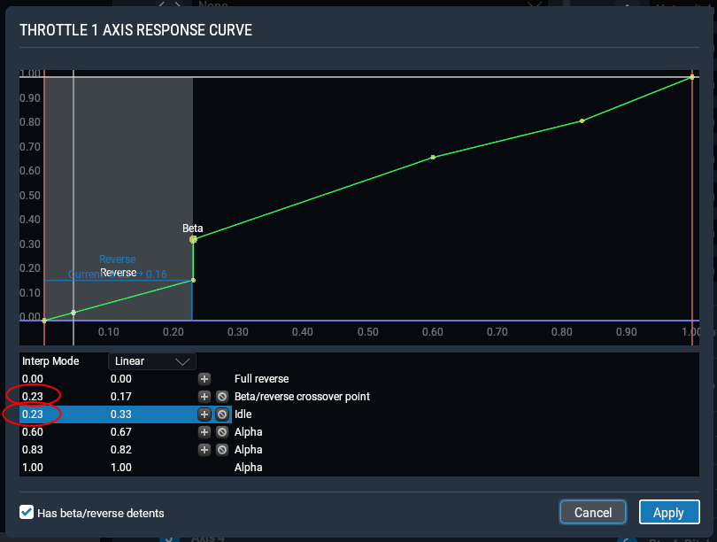

The configuration is now complete.

NOTE: Do not mix different solutions. For example, do not map both “hold reverse” and “toggle reverse” commands and do not map any command if you are using the integrated throttle/reverse axis. Otherwise, unpredictable behaviors may occur.

