Live Coding Oct 16.2015

Please pair with someone & collaborate. Please share unit-test cases to make sure that the code is solid. Each section lists points earned(100 means superb). We're going to making “Ascii/Unicode” animations today.

A. Grayscale2Unicode – Code 10 pts, Unit Tests 15 pts

a. Create a function that takes in a positive number N between 0-84 inclusive and returns a single unicode character in a string according to the following table: Goto: https://github.com/JonathanRitchey03/GrayscaleUnicodeArt and use the string in the readme file there.
Make 3 unit tests to verify it works properly. See appendix at end on how to add unit tests.
0 → \u2588 █
1 → \u2589 ▉
2 → \u258A ▊
3 → \u258B ▋
4 → \u2593 ▓
5 → \u25A9 ▩
6 → \u25A6 ▦
7 → \u25A4 ▤
8 → \u25A7 ▧
9 → \u25A8 ▨
10 → \u25C9 ◉
11 → \u25A3 ▣
12 → \u25C8 ◈
13 → \u2592 ▒
14 → \u2591 ░
15 → $
16 → @
17 → B
18 → %
19 → 8
20 → &
21 → W
22 → M
23 → #
24 → *
25 → o
26 → a
27 → h
28 → k
29 → b
30 → d
31 → p
32 → q
33 → w
34 → m
35 → Z
36 → O
37 → 0
38 → Q
39 → L
40 → C
41 → J
42 → U
43 → Y
44 → X
45 → z
46 → c
47 → v
48 → u
49 → n
50 → x
51 → r
52 → j
53 → f
54 → t
55 → /
56 → \
57 → |
58 → (
59 → )
60 → 1
61 → {
62 → }
63 → [
64 → ]
65 → ?
66 → -
67 → _
68 → +
69 → ~
70 → <
71 → >
72 → I
73 → !
74 → l
75 → I
76 → ;
77 → :
78 → ,
79 → "
80 → ^
81 → `
82 → '
83 → .
84 →

B. GrayscaleUnicodeCanvas – Code 20 pts, Unit Tests 35 pts

a. Create a class that will represent a 2D array of grayscale values from 0..255(uint8) and render to unicode values. Write the render function using grayScale2Unicode(uint8 gsvalue) method made in problem A.

Note: The backing array is one-dimensional. That is intentional. Math is done to map from 2D to 1D. Please let me know if there are any questions about how that works. Here's the basic skeleton:

public class GSCanvas {
short mArray[];
int mWidth,mHeight;
// constructor
public GSCanvas(int width,int height) {
// assert 0<width<MAX_WIDTH,0<height<MAX_HEIGHT,
// else default to width=height=DEFAULT_DIM
mArray = new short[width * height];
mWidth = width;
mHeight = height;
}
public void set(int x, int y, short grayscaleValue) {
// assert 0<x<mWidth, 0<y<mHeight, else do nothing
mArray[y*width + x] = grayscaleValue;
}
public void fillRect(int x0,int y0,int w,int y,short value) {
for(int y = y0; y < y0+h; y++)
for(int x = x0; x < x0+w; x++)
set(x,y,value);
}
public short get(int x, int y) {
// assert 0<x<mWidth, 0<y<mHeight, else do nothing
return mArray[y*width + x];
}
public String render() {
// map 0..255 to 0..84 and use grayScale2Unicode function
// write code for this
}
}

Make unit tests to verify each method works properly. Please see me for help if there's difficulties.

C. AverageMethod – Code 20 pts, Unit Test 25 pts

a. Add an average method to the class, that creates a new empty array. Now for each cell of the new array, take the sum of all the cells around it. Specifically for a new cell at x,y:

int sum = get(x-1,y-1) + get(x,y-1) + get(x+1,y-1) +
get(x-1,y) + get(x+1,y) +
get(x-1,y+1) + get(x,y+1) + get(x+1,y+1);

Now let the new cell's value equal the average of all the neighbors above.
After that, copy the newArray over mArray. So now mArray has the averaged array.

public class GSCanvas {
…
public void average() {
short newArray[] = new short[mWidth * mHeight];
for ( int y = 0; y < mHeight; y++ ) {
for ( int x = 0; x < mWidth; x++ ) {
int sum = get(x-1,y-1) + get(x,y-1) + get(x+1,y-1) +
get(x-1,y) + get(x+1,y) +
get(x-1,y+1) + get(x,y+1) + get(x+1,y+1);
…

// please complete
}

D. Beautiful Animation – Code 30 pts

a. Now in the main class add code that randomly draws a fill rect with a random value into the array then averages it using the average method. Render to the screen. Put this in a loop, clear the screen, then pause for 1/10th of a second. Keep repeating. Show me your animation when finished. Try different ideas...
Here's my implementation for reference...

import java.util.Random;
public class Main {
public static void main(String[] args) {
GSCanvas canvas = new GSCanvas(128,28);
Random random = new Random();
for ( int k = 0; k < 10; k++ ) {
for (int i = 0; i < 20; i++) {
if ( random.nextInt(2) == 0 ) {
canvas.fillRect(random.nextInt(127),
random.nextInt(40),
random.nextInt(30),
random.nextInt(30),
(short) random.nextInt(127));
}
for (int j = 0; j < 2; j++) {
canvas.average();
}
System.out.print(canvas.render());
//pressAnyKeyToContinue();
try { Thread.sleep(200); } catch(InterruptedException e) {}
clearScr();
}
}
}
private static void pressAnyKeyToContinue()
{
System.out.println("Press any key to continue...");
try {
System.in.read();
} catch(Exception e)
{}
}
public static void clearScr() {
final String ANSI_CLS = "\u001b[2J";
final String ANSI_HOME = "\u001b[H";
System.out.print(ANSI_CLS + ANSI_HOME);
System.out.flush();
}
}
E. If you get really stuck I've placed my IntelliJ project for reference up at:

a. Find the github repo at: https://github.com/JonathanRitchey03/GrayscaleUnicodeArt

b. The source code for Main and GSCanvas are at:
https://github.com/JonathanRitchey03/GrayscaleUnicodeArt/tree/master/src/com/company

Please let me know if I can help...

F. Bonus challenge

If you'd like an additional challenge. Try putting random values into the array and animate a quicksort on those values using the same visualization technique as in challenge E! Wikipedia has an excellent page with the pseudocode for Quicksort... It'll probably look really interesting...
https://en.wikipedia.org/wiki/Quicksort

quicksort(A, lo, hi)
if lo < hi
p = partition(A, lo, hi)
quicksort(A, lo, p - 1)
quicksort(A, p + 1, hi)

partition(A, lo, hi)
pivot = A[hi]
i = lo //place for swapping
for j = lo to hi - 1
if A[j] <= pivot
swap A[i] with A[j]
i = i + 1
swap A[i] with A[hi]
return i

Appendix – How to add Unit Tests to IntelliJ

1. In IntelliJ select the file you want to add tests to and press Command-Shift-T. (⌘ + shift + T)
2. Select “Create New Test”.
3. On the pop that comes up, select JUnit 4. Now click on the “Fix” button so it includes the JUnit 4 package.
4. Click on all the methods. (see screenshot)

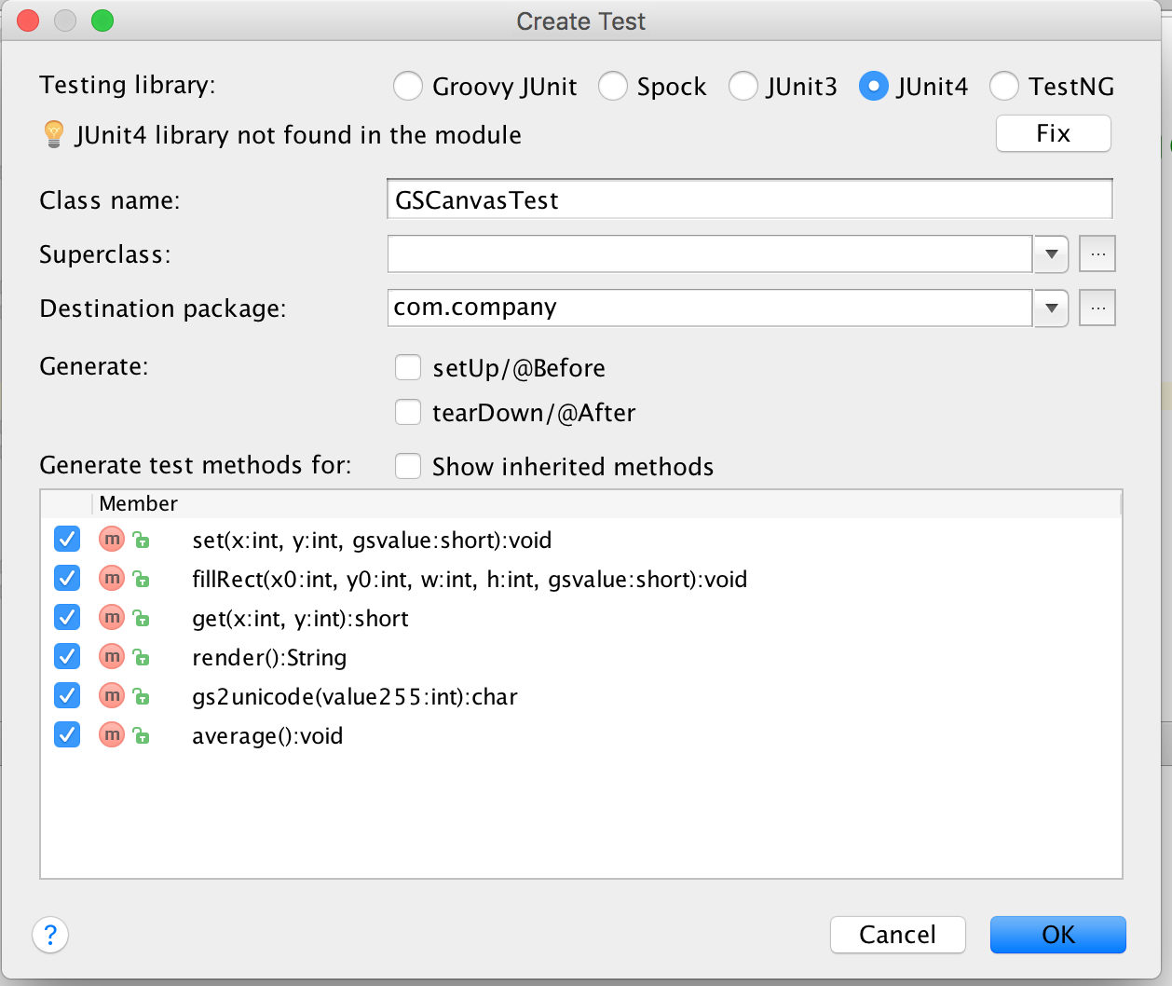

Here are some example unit tests:

@Test
public void testingCrunchifyAddition() {
assertEquals("Here is test for Addition Result: ", 30, addition(27, 3));
}

@Test
public void testingHelloWorld() {
assertEquals("Here is test for Hello World String: ", "Hello + World", helloWorld());
}

Appendix – How to add Unit Tests in PyCharm

https://confluence.jetbrains.com/display/PYH/Creating+and+running+a+Python+unit+test

1. In IntelliJ select the file you want to add tests to and press Command-Shift-T. (⌘ + shift + T)
2. Click on the check mark on all the method then press “OK”. See screenshot:

Here are some example test cases:

def test_get_team_and_score_from_string(self):

self.assertEqual(rank_teams.get_team_and_score_from_string("My Team 5"), ("My Team", '5'))
self.assertEqual(rank_teams.get_team_and_score_from_string("My Team 5 "), ("My Team", '5'))

def test_update_rank_dict_for_team_by_points(self):

rank_dict = {"teamA": 1}
rank_teams.update_rank_dict_for_team_by_points(rank_dict, "teamA", 1)
self.assertEquals(rank_dict, {"teamA": 2})
rank_teams.update_rank_dict_for_team_by_points(rank_dict, "teamA", 0)
self.assertEquals(rank_dict, {"teamA": 2})
rank_teams.update_rank_dict_for_team_by_points(rank_dict, "teamB", 0)
self.assertEquals(rank_dict, {"teamA": 2, "teamB": 0})
rank_teams.update_rank_dict_for_team_by_points(rank_dict, "teamB", 3)
self.assertEquals(rank_dict, {"teamA": 2, "teamB": 3})
Appendix – How to add Unit Tests in Visual C#

Check online. One link I found was:

http://www.codeproject.com/Articles/391465/Creating-Unit-tests-for-your-csharp-code

Appendix – How to add Unit Tests in JavaScript

If using WebStorm, JetBrains has support for this.

http://www.codeproject.com/Articles/391465/Creating-Unit-tests-for-your-csharp-code

