ASEP

Warm-up exercise evidence

This is all there was before

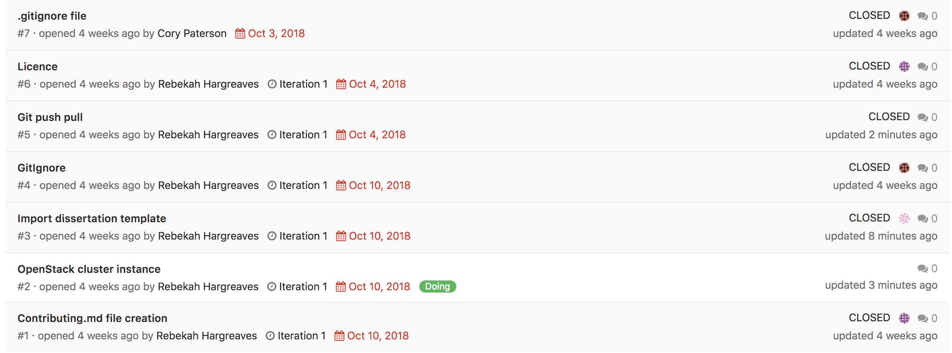

Literally 20mins after telling them to look at their error tracking and start tracking everything

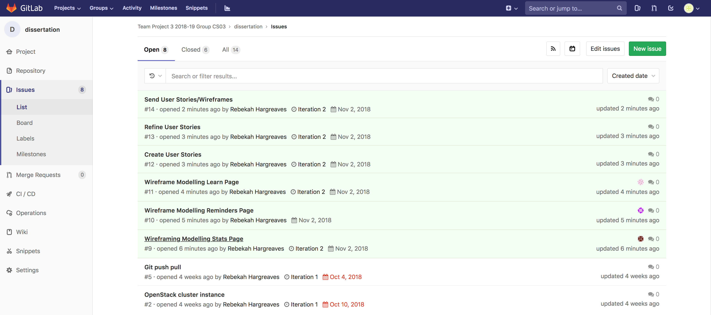

We should look into how to track and what to do after they have finished

Also currently no branching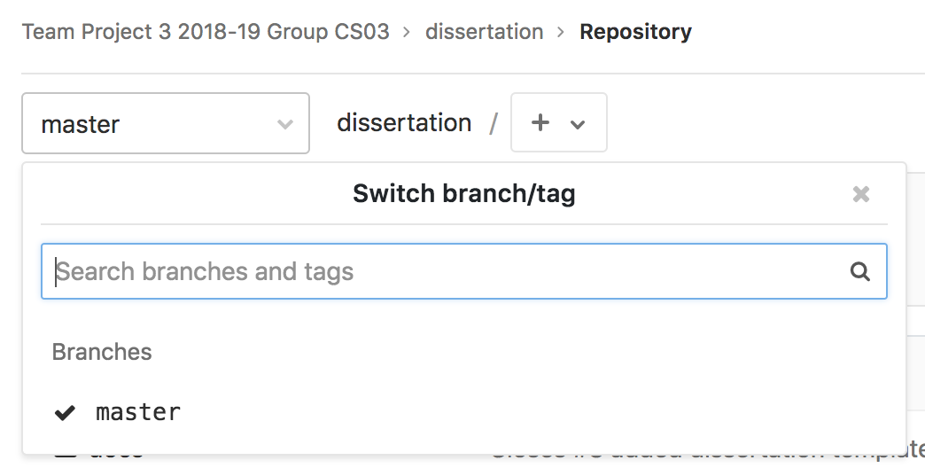

Also limited wiki

