

CE0951a – Applied Mathematics 3

Examination Solutions

2010/11

A1. | (a) | The auxiliary equation is 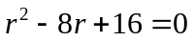. Thus the solutions of the auxiliary equations are 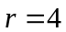 (repeated solution).  Hence the complimentary function has form 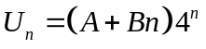.  The particular solution has the same form as the RHS of the DE. That is, 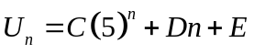. Substituting this into the original DE gives  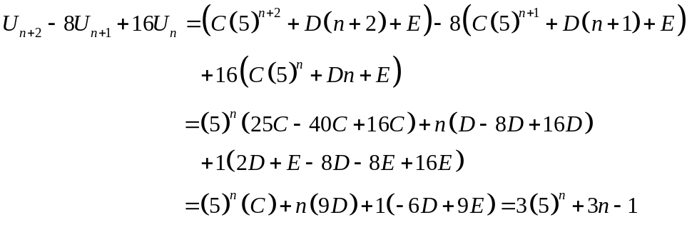  Comparing coefficients:  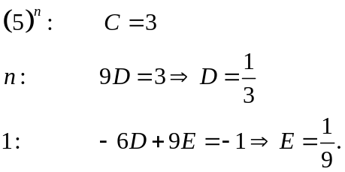  Thus the general solution is  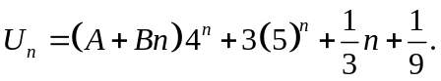  Now consider the initial conditions:  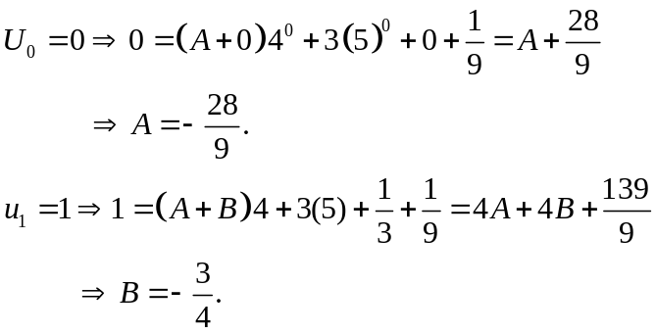  Hence our complete solution is  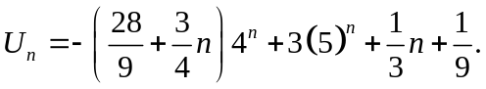 | [2]  [1]  [3]  [2]  [1]  [1]  [1]  [1]

 | (b) | (i) Sketch of the region R:  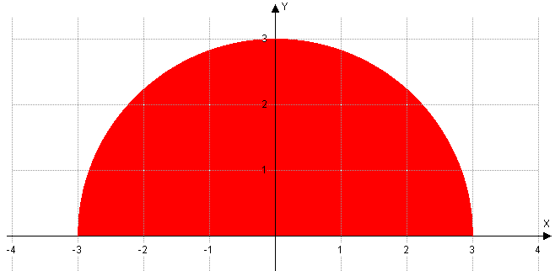  (ii) For the limits, we have 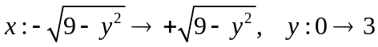.  Then performing the integral gives  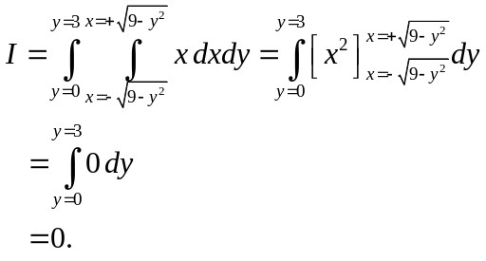 | [2]  [2]  [3]

 | (c) | Projecting a slice of the cylinder down to the x-y plane, we have the unit circle . We only take the first quadrant, thus multiplying the result by 4.  Hence the limits are 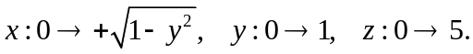  We have  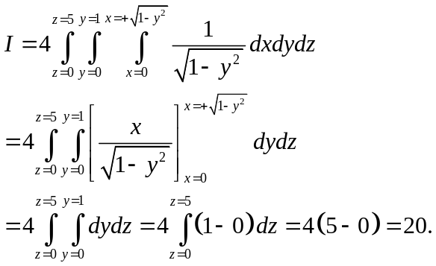 | [1]  [2]  [3]

A2. | (a) | (i) 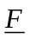 is conservative if 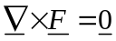. Calculating the LHS, we have  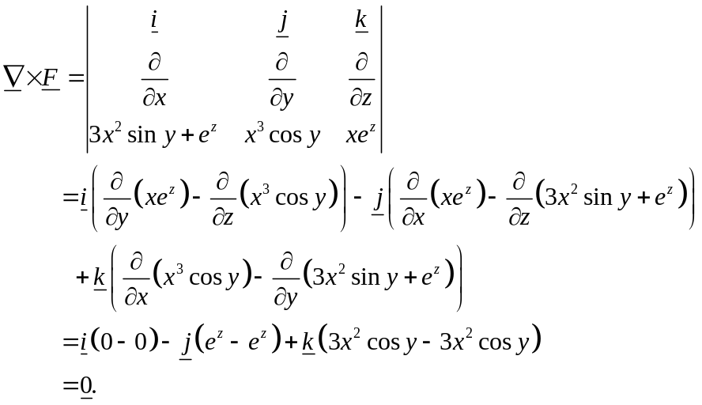  Hence is conservative.  (ii) As is conservative, we know that 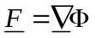, where our scalar potential is . Hence we see that  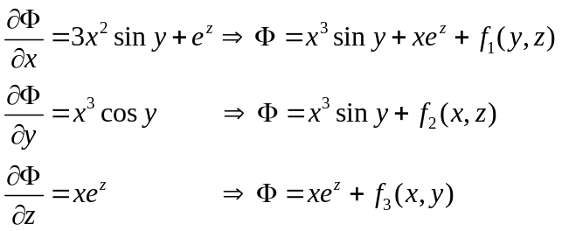  From the value 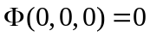, we see that 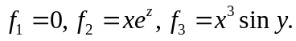 Hence  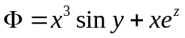. | [1]  [6]  [3]  [1]

 | (b) | We have that  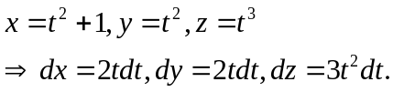  Substituting into the integral, we have  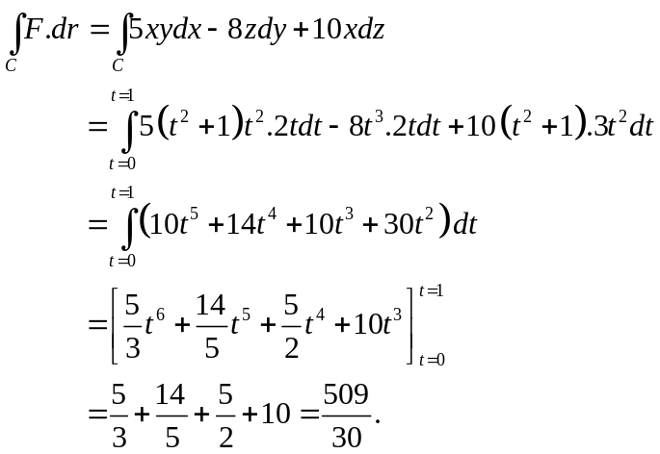 | [2]  [4]

 | (c) | We take R to be the positive quadrant, and then multiply the result by 4. Hence our limits are 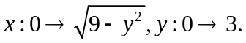  We also have  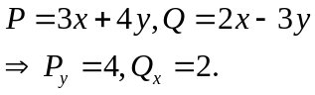  By Green’s Theorem,  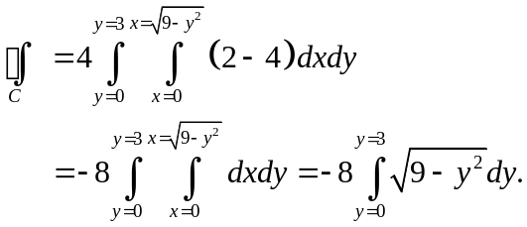  For the substitute, we let 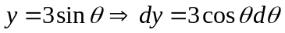 and we have the integration limits 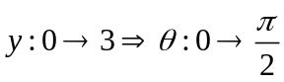. Then the integral above is  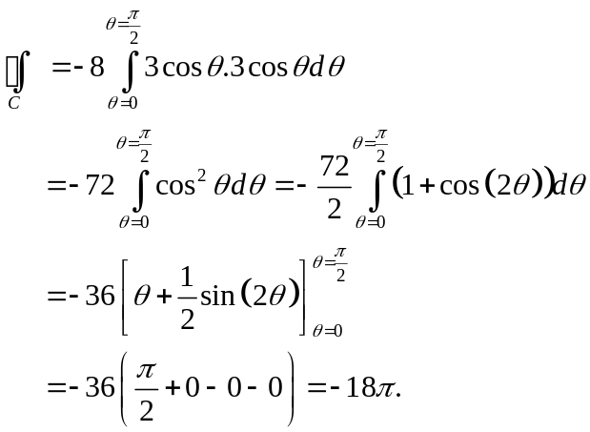 | [1]  [1]  [1]  [2]  [1]  [2]

A3. | (a) | This PDE has constant coefficients and has only one differentiation variable. We consider the equivalent ODE  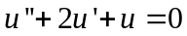.  The auxiliary equation is 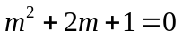. Solving the equation gives the repeated solution 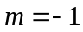 of multiplicity two.  Hence the general solution of the ODE is 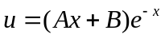.  Lifting the arbitrary constants A and B to the arbitrary functions 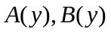, we have the general solution to the PDE as  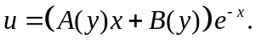 | [1]  [2]  [1]  [1]
 | (b) | The characteristics are  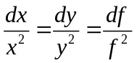.  Choosing characteristics 1 and 2, putting them equal and solving gives  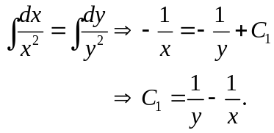  Choosing characteristics 2 and 3, putting them equal and solving gives  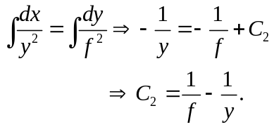  The general solution is then of the form  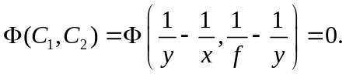 | [1]  [2]  [2]  [1]

 | (b)  cont | That is,  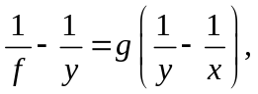  for some arbitrary function g. In turn, this means  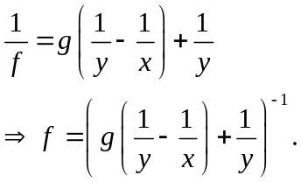  Applying the boundary condition,  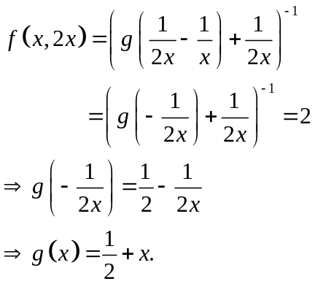  Hence the particular solution is  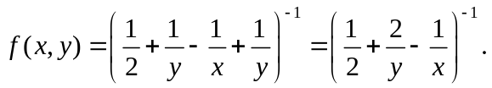  At the point 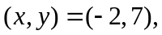 we have  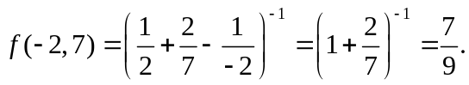 | [1]  [2]  [1]  [1]

 | (c) | We have the mesh  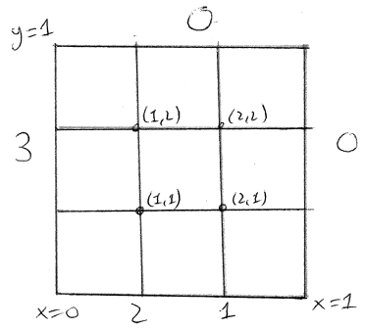  Scheme:  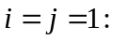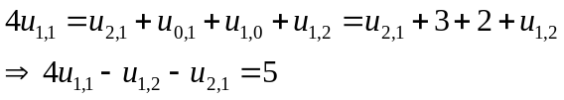  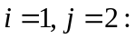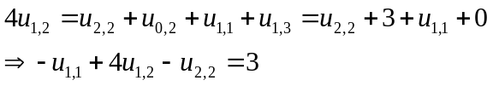  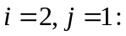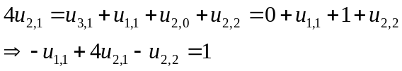  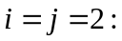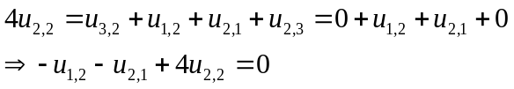  Hence the matrix equation is  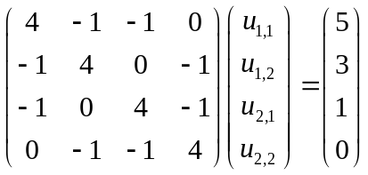. | [2]  [2]  [2]  [2]  [1]

B1. (a)
v
u
Let u, v be velocity components of A along and perp. to AB. Let w be speed of B along BA’. I is the impulsive tension set up in string.
A’

[2]
30°
w
I
6 Nm
A(2 kg)
B (4 kg)

Momentum eqn. along AB direction (Impulse = change in momentum):
[2]
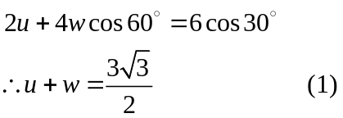
Momentum eqn. perpendicular to AB:
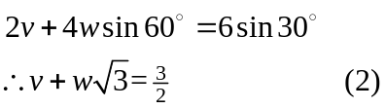
[2]
Equating velocities along BA’:
(3)
Using (1) and (2) in (3) 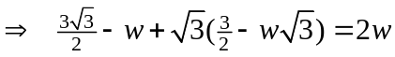
[3]
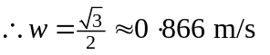= speed of B.
(1) 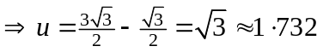m/s.
and (2) gives 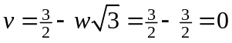m/s.
Hence speed of A’ =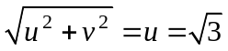m/s.
[3]
[1]
Also, the impulsive tension is I = 4w 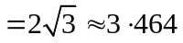Ns.

(b)

A = accel. of pulley
a = accel of 4 and 6 kg masses relative to moving pulley
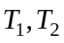 are tensions in strings
A
A
[2]
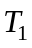

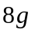

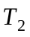
a
a
2g
4g
6g
Equations of motion:

8 kg mass - 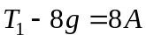 (1)
Pulley - 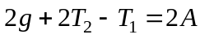 (2)
[4]
6 kg mass - 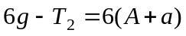 (3)
4 kg mass - 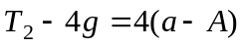 (4)

(1) + (4)  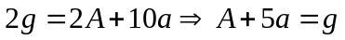 (5)
(1) and (2) give 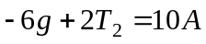 and then using (4) gives
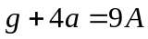 (6)

Solving (5) and (6) gives 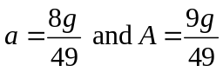 m/s².
[4]
[2]
Hence acceleration of 6 kg mass is 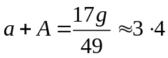 m/s².

B2. (a)
Y
X
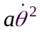
P
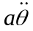
a
X and Y are the components of thrust at axis as shown along and perp. to diameter. Accel. of centre of mass has components as shown.

[2]
a

mg

Radial eqn. of motion: 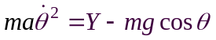 (1)
[2]
[2]
Transverse eqn. of motion: 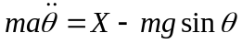 (2)

Rotational eqn. of motion: 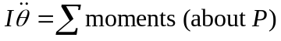
[2]
(3)
Integrating (3) gives 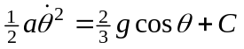 and 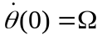 gives
[3]
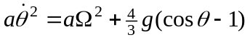 (4)
(2) and (3)
and (1) and (4) give
[2]
as required.

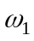
u
v
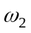
B
C
I
u, v are speeds of centres of rods after impulse as shown, I is the reaction impulse at hinge B (must be vertical as impulse is); , are the angular velocities of rods.
(b)
[2]
2 kg
1 kg
0⋅25 m
A
B
I
6 Ns
(1/2 m long)
(1 m long)

Linear momentum equations of rods:
[2]
AB - 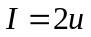 (1)
BC - 6 + I = v (2)

Angular momentum equations 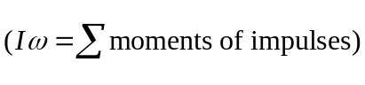:
(moments about centres of rods)
[2]
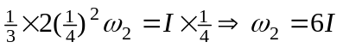 (3)
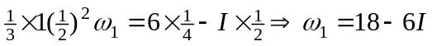 (4)

Velocity of B is the same for both rods, i.e.
[2]
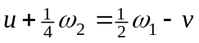 (5)

Using (1) to (4) in (5) gives
[2]
Ns.
This gives 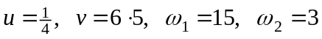
and velocity of A = 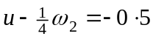 m/s,
[2]
velocity of C = 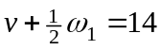 m/s.

B3. (a)
R
No initial spin so F acts as shown. Notice that 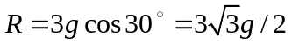and so the frictional force is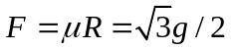.

3g
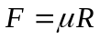
[2]

30°

(i) Linear equation of motion is:
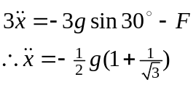
[3]
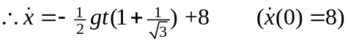 (1)

Rotational eqn. of motion (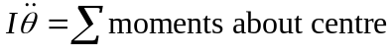):
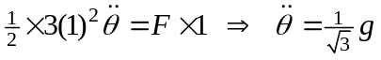.
[2]
Integrating, 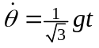 (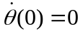) (2)

Cylinder starts to roll when 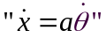, i.e. when 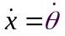, and so from (1) and (2)
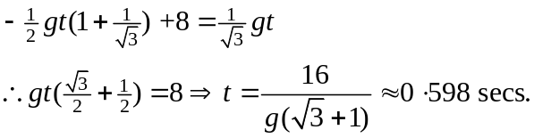
[2]
(ii) When rolling, energy is conserved, hence use KE lost = PE gained at highest point on plane (distant X from point of start of rolling), i.e.
[2]
“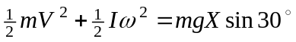”
where, from (1) or (2), when 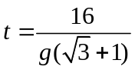, 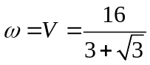.
The energy equation is then
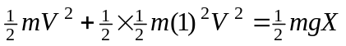
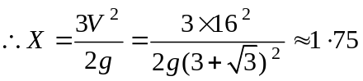 m.
[3]

I
v
u and v are components of velocity of centre after impact; I and J are the impulses set up at impact as shown; is the initial angular velocity.
(b) No slipping at impact gives 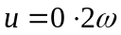 (1)
6 m/s
J
u
30°
0⋅2
2 kg
[2]
Vertically, Newton’s experimental rule gives
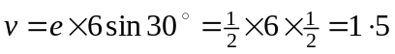 m/s (2)
Horizontally, momentum equation is
[4]
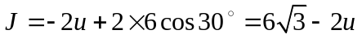 (3)
Angular momentum equation is (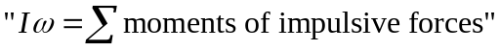)
(from (1)) (4)
[2]

(3) and (4) give
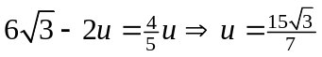 m/s
Hence speed of centre is
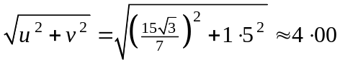 m/s.

Direction velocity makes with horizontal is
[3]


