
School of Computing & Engineering Systems
Subject Group: Mathematics
CE0951a : Applied Mathematics 3
2010/11
Term 2 - Terminal Examination
2 hours duration plus five minutes reading time

The paper contains 3 questions in Section A and 3 questions in Section B
Answer 2 questions from each section (4 in total)
Calculators with no remote external connection and no computer algebra/programming facility may be used in this examination. The removal of a calculator from any candidate must be approved by the Examiner or, if not available, by any member of the Mathematics staff.

Additional Materials
Mathematical Formulae Booklets
Examination Date |  | April 2011 |  | - |  | (reading time)
 |  |  |  | - |  | (examination time)
Examiner(s) | T N Lucas/M J Craven
Moderator(s) | M J Craven/T N Lucas
Section A – Answer any TWO questions from this section

A1. | (a) | Determine the solution of the second order difference equation  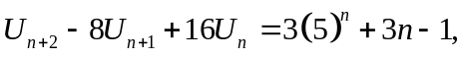  given that 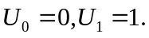 | [12]

 | (b) | Let R be the region of the plan bounded by the circle 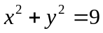 and the line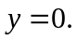

 |  | (i) | Sketch the region R. | [2]

 |  | (ii) | Evaluate the integral 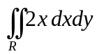 over the region R. | [5]

 | (c) | Evaluate the integral  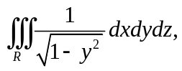  where R is the region bounded by the cylinder  between  to 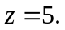 | [6]

A2. | (a) | Let 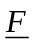 be the vector field given by  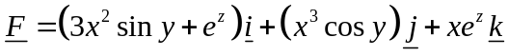.

 |  | (i) | Show that is conservative. | [7]

 |  | (ii) | Hence determine the scalar potential , given that 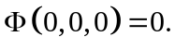 | [4]

 | (b) | Let 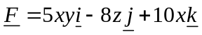. Compute the total work done 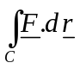 by moving a particle through the force field along the curve  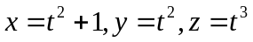  from  to 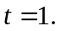 | [6]

 | (c) | Use Green’s Theorem to evaluate the integral  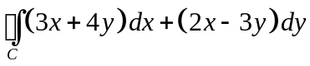,  where C is the boundary of the circle taken anti-clockwise. | [8]

A3. | (a) | Solve the second order partial differential equation  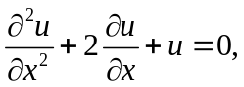  where 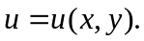 | [5]

 | (b) | Use the method of characteristics to solve the first order partial differential equation  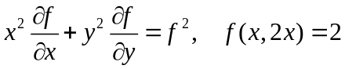.  Determine the value of the solution at the point 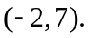 | [11]

 | (c) | Consider Laplace’s equation  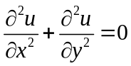  on the unit square 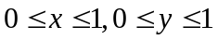 subject to the boundary conditions  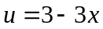 on 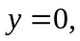 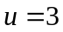 on , 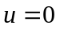 or  and 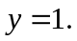  Using the mesh size 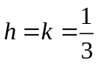 (so that there are four internal points), set up the discretised equations for 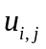 (for 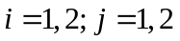) following the scheme  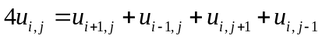.  Express this system of equations in matrix form 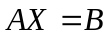, clearly identifying 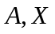 and B. [Do not attempt to solve the system] | [9]

Section B – Answer any TWO questions from this section
(Use g = 9⋅8 m/s² where necessary)

B1. | (a) | Two masses A and B of 2 kg and 4 kg respectively lie on a smooth horizontal table attached to the opposite ends of a light inelastic string. The string is initially taut when A is acted upon by an impulse of 6 Ns in the horizontal plane at 30° to AB. Determine the speeds of A and B immediately after the string becomes taut again and also the impulsive tension set up in the string. | (13)

 | (b) | A mass of 8 kg is attached to one end of a light inelastic string, which passes over a smooth fixed pulley in the vertical plane. The other end of the string is attached to a smooth moveable pulley of mass 2 kg (see diagram).

8 kg
2 kg

4 kg
6 kg

 |  | Masses of 4 kg and 6 kg are then connected by another light inelastic string passing over the moveable pulley and allowed to move freely. If the parts of the strings not in contact with the pulley are assumed vertical then calculate the acceleration of the 6 kg mass. | (12)

B2. | (a) | A uniform solid circular disc of mass m and radius a hangs vertically from a smooth hinge fixed to a point P on its circumference. An impulse at its lower end gives the disc an initial angular velocity of  in the vertical plane.  When the centre of the disc makes an angle of 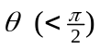with its original vertical position, show that the radial and transverse components of the thrust exerted on the hinge are given by  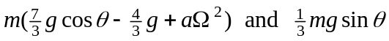  respectively. | (13)

 | (b) | A uniform straight rod AB of mass 2 kg and length 0⋅5 metres is freely jointed at B to a second uniform straight rod BC of mass 1 kg and length 1 metre. The rods lie on a smooth horizontal plane such that ABC is a straight line. An impulse of 6 Ns is then applied horizontally at a point on BC distant 0⋅25 metres from C, perpendicular to BC. Calculate the initial velocities of the ends A and C. | (12)

B3. | (a) | A uniform solid circular cylinder of mass 3 kg and radius 1 metre is projected with speed 8 m/s and no initial angular velocity up the line of greatest slope of a plane, coefficient of friction 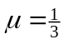, inclined at 30° to the horizontal. Calculate:

 |  | (i) | the time that elapses from this point until the cylinder stops slipping on the plane; | (9)
 |  | (ii) | the distance that the cylinder rolls up the plane. | (5)

 | (b) | A uniform solid sphere of mass 2 kg and radius 0⋅2 metres moves in the vertical plane just before it bounces on a horizontal rough floor. At the instant before impact, the centre of the sphere has velocity 6 m/s at an angle of 30° to the horizontal and no rotation.  If the floor is rough enough to prevent slipping, calculate the speed and direction of the centre of the sphere immediately after impact, given that the coefficient of restitution between the sphere and the floor is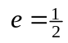. | (11)

END OF QUESTION PAPER

