
School of Computing & Creative Technologies
Subject Group: Mathematics
AR0970a : Applied Mathematics 3
Terminal Examination 2004/05
2 hours duration plus five minutes reading time

The paper contains 6 questions – 3 in Section A and 3 in Section B

Answer 2 questions from Section A and 2 questions from Section B (4 in total)

Put your solutions for questions in Section A and Section B in different answer booklets.
Additional Materials
Mathematical Formulae Booklets
Formula Sheet
Monday 9 May 2005 |  |  | 9.25 am | - | 9.30 am | (reading time)
 |  |  | 9.30 am | - | 11.30 am | (examination time)
Examiner(s) | T N Lucas
 | R B Paris
Moderator(s) | R B Paris
 | T N Lucas

 |  |  | Section A – Answer any TWO questions from this Section and put your solutions in a separate answer booklet to those of Section B
A1. | (a) |  | Use the integrating factor to solve the first-order differential equation  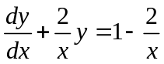  subject to the initial condition 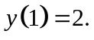 | (30%)

 | (b) |  | Find the general solution of the differential equation  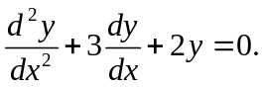 | (15%)

 | (c) |  | Find the solution of the differential equation  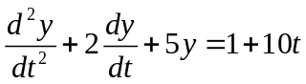  subject to the initial conditions 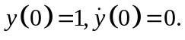 | (55%)

A2. | (a) |  | Find the solution of the difference equation  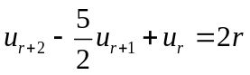  subject to the conditions 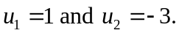  What is the dominant behaviour of 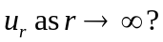 | (60%)

 | (b) |  | By changing the order of integration evaluate the repeated integral  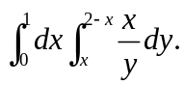 | (40%)

A3. | (a) |  | Show that the vector field F given by  is conservative. Determine the scalar potential 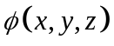 such that 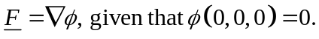  Hence evaluate the integral  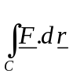  along any path C joining the points 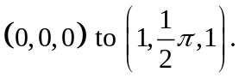 | (45%)
 | (b) |  | Use Green’s theorem to evaluate the integral  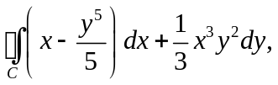  where C is the circle 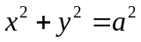 described in the positive sense. | (30%)
 | (c) |  | Use Gauss' theorem to evaluate the surface integral  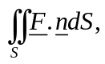  where  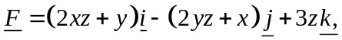  n is the outward-pointing unit normal to S and S is the entire surface of the sphere 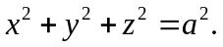 | (25%)

Section B – Answer any TWO questions from this Section and put your solutions in a separate answer booklet to those of Section A

(Use g = 9⋅8 m/s² where necessary)

B1. | (a) |  | Three masses A, B and C of 2, 1 and 3 kg respectively lie on a smooth horizontal table with angle ABC = 30°. Light inextensible strings connect A to B and B to C, with the strings just taut. A horizontal impulse of 5 Ns is applied to B in the direction of AB (see diagram).

u m/s
A (2 kg)

Velocity components of B
v m/s
30°

5 Ns
C (3 kg)
B (1 kg)

 |  |  | Set up the equations to find the initial speeds of the masses. Hence verify (by substitution, or otherwise) that these speeds are:  m/s for A, 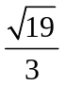 m/s for B and 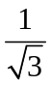m/s for C.  (50%) | (50%)

 | (b) |  | A wedge of mass 6 kg and triangular cross-section, with angles of 30°, 60° and 90°, is at rest on a smooth horizontal plane with its inclined face at 30° to the plane. A mass of 3 kg is placed gently onto the rough inclined face of the wedge and allowed to move freely down a line of greatest slope of the face. The coefficient of friction between the wedge and the mass is 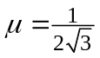.

 |  |  | By considering the horizontal equation of motion of the wedge and that of the mass perpendicular to the face of the wedge only, show that the acceleration of the wedge is approximately 1 m/s². | (50%)

B2. | (a) |  | A uniform circular disc of mass m and radius a can rotate freely in the vertical plane of the disc about an axis through a point P on its circumference. Initially, the disc is held so that the centre O is at the same height as P and it is then released from rest.

P
O
a

a
mg

 |  |  | Calculate the magnitude of the reaction force on the axis of rotation when OP makes an angle of 45° with its original horizontal direction. | (50%)

 | (b) |  | A uniform solid sphere of mass m and radius a is projected horizontally along the surface of a rough horizontal plane. The initial velocity of its centre is V and the angular velocity is zero.  If the coefficient of friction between the sphere and plane is 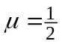, then show that the sphere will slip on the plane for a time of 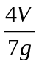 before starting to roll. Hence calculate its rolling velocity.  (50%) | (50%)

B3. | (a) |  | Two uniform rods AB and BC are smoothly hinged at B. Rod AB is of mass 2 kg and 2 metres long, whereas BC is of mass 4 kg and 4 metres long. Initially, the rods lie in a straight line and are at rest on a smooth horizontal plane. A horizontal impulse of 10 Ns is then applied to AB at the end A in a direction perpendicular to its length.

 |  |  | Write down the linear and angular momentum equations of the rods and use them in the common velocity equation at B to determine the impulsive reaction force that is set up at the hinge. Hence show that the initial speed of the end point C of BC is m/s. | (60%)

 | (b) |  | A uniform disc, of mass m and radius a, moves without rotation in its own vertical plane. It is about to strike a rough fixed plane, inclined at an angle 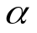 to the horizontal, along a line of greatest slope in the downward direction (see diagram).

V
30°

 |  |  | The velocity of the centre of the disc just before impact is V at 30° to the downward surface of the plane and the disc slips down the plane during collision. The coefficients of friction and restitution between the disc and plane are 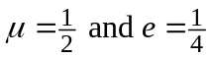 respectively.  Show that the angular velocity of the disc after this first impact with the plane is 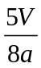.  (40%) | (40%)

END OF QUESTION PAPER

