
School of Computing & Creative Technologies
Subject Group: Mathematics
CS0980a : Applied Mathematics 3
2005/06
Term 2 - Terminal Examination
2 hours duration plus five minutes reading time

The paper contains 3 questions in Section A and 3 questions in Section B
Answer 2 questions from each section (4 in total)
Calculators with no remote external connection and no computer algebra/programming facility may be used in this examination. The removal of a calculator from any candidate must be approved by the Examiner or, if not available, by any member of the Mathematics staff.

Additional Materials
Mathematical Formulae Booklets
Examination Date |  | May 2006 |  | - |  | (reading time)
 |  |  |  | - |  | (examination time)
Examiner(s) | T N Lucas/R B Paris
Moderator(s) | R B Paris/T N Lucas
Section A – Answer any TWO questions from this section

A1. | (a)  (b)  (c) |  | Obtain the continuous solution of the differential equation  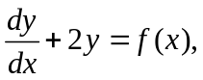 where 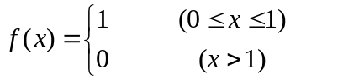  on the interval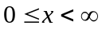 subject to the initial condition 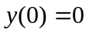.  Find the general solution of the differential equation  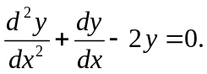  Solve the differential equation  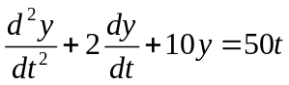  subject to the initial conditions 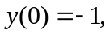 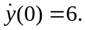 | (40%)  (15%)  (45%)

A2. | (a)  (b) |  | Solve the difference equation  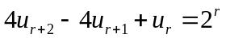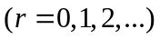  subject to the conditions 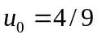 and 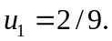  By changing the order of integration evaluate the repeated integral  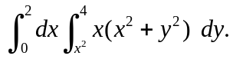 | (60%)  (40%)

A3. | (a) |  | Show that the vector field  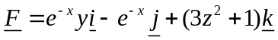  is conservative. Determine the scalar potential 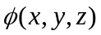 such that  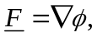 given that 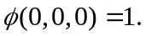  Hence evaluate the integral  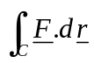  along any path  joining the points 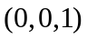 and 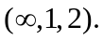 | (45%)

 | (b) |  | Use Green’s theorem to evaluate the integral  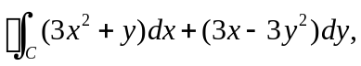  where is the rectangle with vertices at , 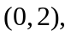 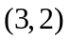 and 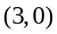 in that order. | (25%)

 | (c) |  | Use Stokes’ theorem to evaluate the surface integral  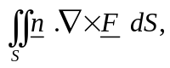  where  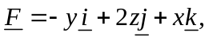  is the curved surface of the hemisphere 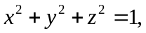 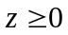 and is the outward-pointing unit normal vector to . | (30%)

Section B – Answer any TWO questions from this section
(Use g = 9⋅8 m/s² where necessary)

B1. | (a) |  | Two masses A and B of 2 kg and 4 kg respectively lie on a smooth horizontal table attached to the opposite ends of a light inelastic string. The string is initially taut when A is acted upon by an impulse of 5 Ns in the horizontal plane at 30° to AB. Determine the speed of B immediately after the string becomes taut again. | (50%)

 | (b) |  | A mass of 6 kg lies on a smooth horizontal table and is attached to a light inelastic string, which passes over the edge of the table to a smooth pulley of mass 2 kg attached to its other end (see diagram).

6 kg

2 kg

3 kg
5 kg

 |  |  | Masses of 3 kg and 5 kg are then connected by another light inelastic string passing over the pulley and allowed to move freely. If the parts of the latter string not in contact with the pulley are assumed vertical then calculate the acceleration of the 3 kg mass. | (50%)

B2. | (a) |  | A uniform straight rod of mass m and length 2a hangs vertically from a smooth hinge fixed to one of its ends. An impulse at its lower end gives the rod an initial angular velocity of  in the vertical plane.  When the rod makes an angle with its original vertical position, show that the radial and transverse components of the thrust exerted on the hinge are given respectively by  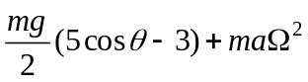 and 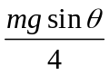. | (60%)

 | (b) |  | A truck is modelled by a rectangular block of mass M and four identical uniform solid discs (the wheels) each of mass m and radius a. The discs can rotate freely about the light connecting axles.  The truck is placed on a rough horizontal surface and is pushed without slipping by a constant horizontal force F applied in a direction along its length. Use the work-energy relationship to show that the speed of the truck after travelling a distance of x along the surface is given by  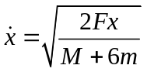.  Hence derive its acceleration. | (40%)

B3. | (a) |  | A uniform solid disc of mass 2 kg and radius ½ metres is projected with speed 5 m/s and no initial angular velocity up the line of greatest slope of a plane, coefficient of friction 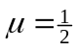, inclined at 30° to the horizontal. Calculate the time that elapses from this point until the disc stops slipping on the plane. | (60%)

 | (b) |  | A uniform straight rod of mass m and length 2a lies at rest on a smooth horizontal surface. A horizontal impulse J is applied to a point C on the rod at a distance of a/2 from one end (see the diagram) and making an angle with the rod.

C
a
a/2
a/2
m

J

 |  |  | Use the momentum component equations along and perpendicular to the rod to show that the speed of the point C immediately after the impulse is applied is given by  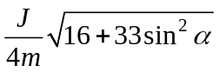. | (40%)

END OF QUESTION PAPER

