
School of Computing & Creative Technologies
Subject Group: Mathematics
CS0980a : Applied Mathematics 3
2006/07
Term 3 - Terminal Examination
2 hours duration plus five minutes reading time
Use g = 9⋅8 m/s² where necessary

The paper contains 6 questions – 3 in each of Sections A and B
Answer 2 questions from each section
Calculators with no remote external connection and no computer algebra/programming facility may be used in this examination. The removal of a calculator from any candidate must be approved by the Examiner or, if not available, by any member of the Mathematics staff.

Additional Materials
Mathematical Formulae Booklets
Examination Date |  | May 2007 |  | - |  | (reading time)
 |  |  |  | - |  | (examination time)
Examiner(s) | T N Lucas/R B Paris
Moderator(s) | R B Paris/T N Lucas
Section A – Answer any TWO questions

A1. | (a)  (b) | Use the integrating factor to solve the first-order differential equation  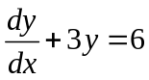  subject to the initial condition 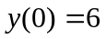.  Determine the general solution of the differential equation  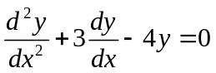. | (30%)  (15%)

 | (c) | Determine the solution of the inhomogeneous differential equation  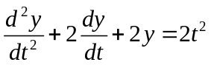  subject to the initial conditions 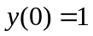, 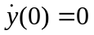. | (55%)

A2 | (a) | Determine the solution of the difference equation  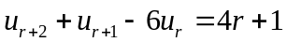  subject to the conditions 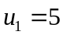 and 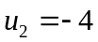. | (60%)

 | (b)  (c) | Sketch the region of integration over which the double integral  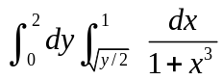  is to be evaluated. Evaluate this integral by reversing the order of integration.  Express the area bounded by 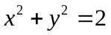,  and the -axis in the first quadrant as a single repeated integral. [Do not attempt to evaluate this integral.] | (30%)  (15%)

A3 | (a) | Show that the vector field 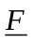 given by  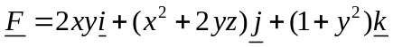  is conservative. Determine the scalar potential 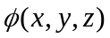 such that 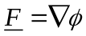,  given that 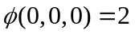.  Hence evaluate the line integral  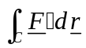  along any path joining (0,0,0) to (1,1,1). | (45%)

 | (b) | Use Green’s theorem to evaluate the integral  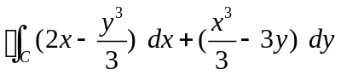,  where  is the circle 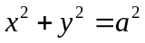 described in the positive sense. | (30%)

 | (c) | Use Gauss’ theorem to evaluate the integral  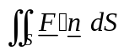,  where  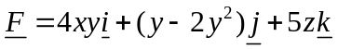,  is the outward-pointing unit normal to and is the surface of the sphere 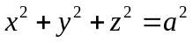. | (25%)

Section B – Answer any TWO questions

B1. | (a) | Three particles A, B and C of masses 4m, 2m and m respectively lie on a smooth horizontal plane with A attached to B and C by light threads. Initially, the threads are taut and AB is at right angles to AC when an impulse I is applied to A in a direction of 30° to BA such that the threads remain taut.  Show that the respective initial speeds of A, B and C after the impulse are  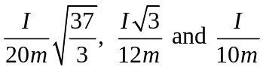. | (40%)

 | (b) | Two equal uniform rods AB and BC, each of mass 1 kg and length 2 metres, are freely hinged at B. Initially, ABC is a straight line with the rods resting on a smooth horizontal plane. A horizontal impulse of 6 Ns is then applied to the rod AB at A in a direction perpendicular to its length.  Calculate the velocities of the points B and C immediately after the impulse is applied. | (60%)

B2. | (a) | A uniform rod AB of length 2a and mass m rests in the vertical plane with B vertically below A, which is fixed to a smooth hinge. The rod is given an initial angular velocity  such that it rotates freely about A.  Show that the respective radial and transverse components of the reaction force at A, when the rod is horizontal, are  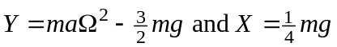. | (50%)

 | (b) | A thin uniform hoop of radius 1 metre and mass 2 kg rolls in the vertical plane, without slipping, along a horizontal plane at a uniform speed of 4 m/s. It then strikes a vertical step of height ¼ metres.  Assuming that no slipping occurs when the hoop mounts the step, calculate its speed at the top of the step. | (50%)

B3. | (a) | A uniform solid circular cylinder of mass 4 kg and radius ½ metres is projected with linear velocity 2 m/s and forward spin 3 radians/sec. along a rough horizontal plane with coefficient of friction 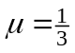.  Describe briefly the two main phases of the motion - in particular, calculate the initial velocity of the point of contact between the cylinder and plane to see how this affects the motion.  Determine the time taken for the cylinder to start rolling without slipping on the plane and hence calculate its rolling speed after this time. | (55%)

 | (b) | A uniform sphere of mass m and radius a moving without spin in the vertical plane hits a rough horizontal plane with speed V at an angle to the horizontal, as shown in the diagram.  V  

 |  | If no slipping occurs upon impact, show that the sphere’s angular velocity immediately after impact is 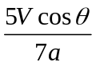. | (45%)

END OF QUESTION PAPER

