

CS0980a

Solutions to Applied Maths 3

Examination 2006/07
A1. (a) 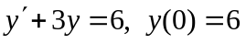 use integrating factor 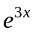, to get [1]
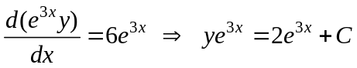. [2]
Hence, 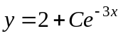 and using the initial condition 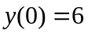 gives [1]
6 = 2 + C  C = 4
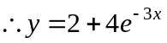. [1]

(b) 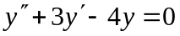 gives the auxiliary equation 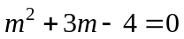 [1]
i.e. 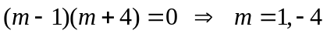, giving the general solution
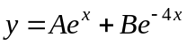. [2]

(c)
Auxiliary equation is 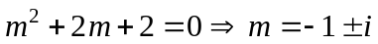, giving the CF as
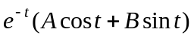 [3]
For the PI, try 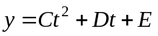 in the DE to give [1]
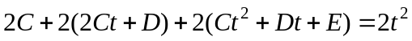
.
Hence, equating coefficients of powers of t gives
C = 1, 4C + 2D = 0 and 2C +2D + 2E = 0, which solve to give D = −2 and E = 1. [4]
the general solution is

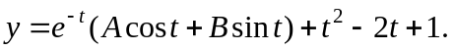 [1]

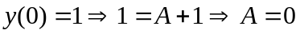
giving the particular solution as 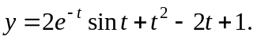 [3]

A2. (a) .
Auxiliary equation is 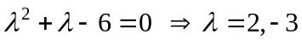 giving the CF as
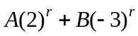 [2]
For the inhomogeneous equation, try 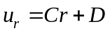 to get [1]
or, (by equating powers of r), i.e. C = D = −1. [4]
The general solution is then 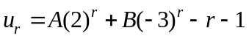. [1]

Using the initial conditions give 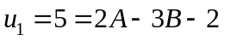 and 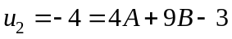, which solve to give A = 2 and B = −1. The complete solution is then

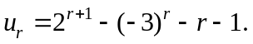 [3]
y
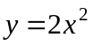
(b)
2
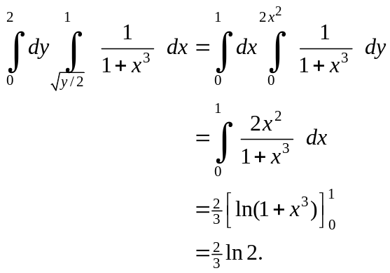

[4]
x
0
1

[2]
y
(c)
y = x
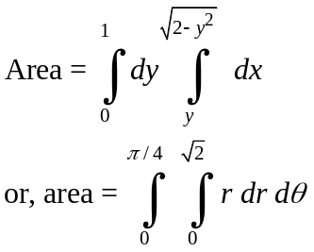

[3]
x
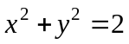

A3. (a) 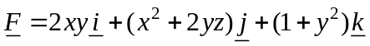
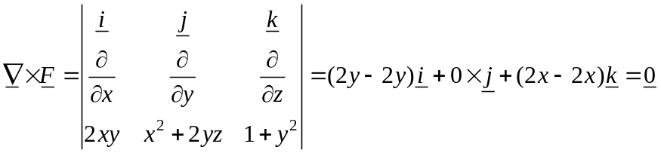
showing that 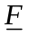 is conservative, so that 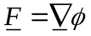. [2]

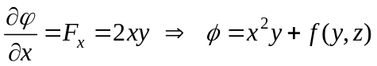
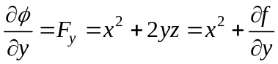 (using above) 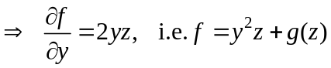
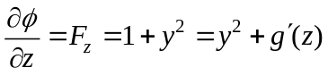 (from above results), giving 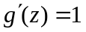 and
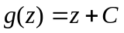.
Hence, 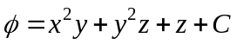 where C = 2 from initial condition 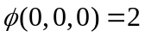. [5]
Then, 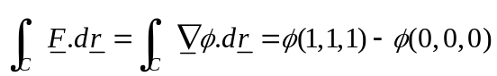
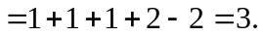 [2]

(b) 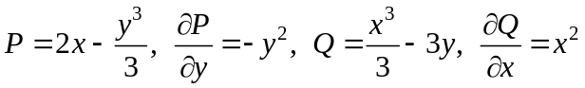
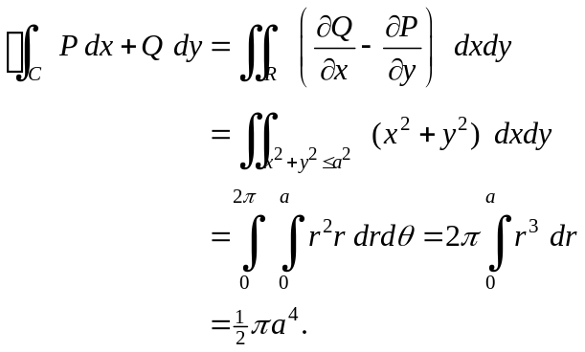 [6]

(c) [2]

By Gauss’s theorem

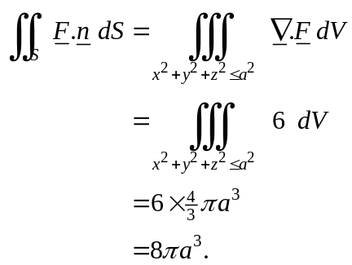 [3]

B1. (a)
[2]
A
C
B
m
2m
4m
u
v
v
u
30°
I
u and v are the speeds of B and C as shown after impulse applied and also the components of A.
Forming the momentum equations:

Along BA direction - 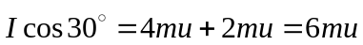
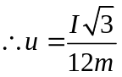 (speed of B). [2]
Along CA direction - 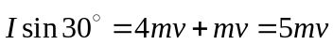
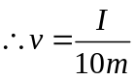 (speed of C). [2]
Speed of A after impulse is then given by 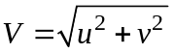, i.e.,
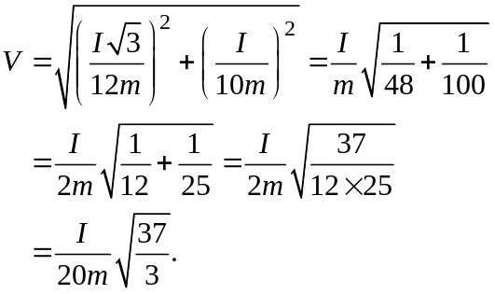
[2]

(b)
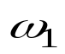
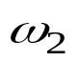
[2]
6 Ns
v
I
I
u
m = 1
m = 1
1
1
1
1
A
B
C
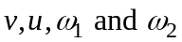 are linear and angular velocities of rods as shown and I is the impulsive reaction set up at the joint at B.
Linear momentum equations for the rods:

AB - 6 − I = v (1)
[2]
BC - I = u (2)

Angular momentum equations (moments about centres):

AB - 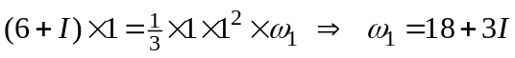 (3)
BC - 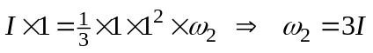 (4)
[2]

Common velocity equation at B is:

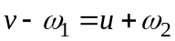 (5)
[2]

Substituting (1) – (4) into (5) gives

6 − I − (18 + 3I) = 3I + I I = −1⋅5 Ns

which in turn gives, u = −1⋅5, v = 7⋅5, 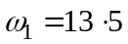, 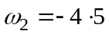.

Hence, velocity of B = 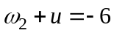 m/s
[4]
velocity of C = 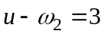 m/s.

X
B2. (a)
Eqn of motion along rod:
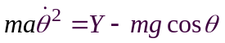 (1)
Eqn of motion perp. to rod:
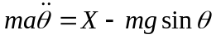 (2)
Rotational eqn of motion:
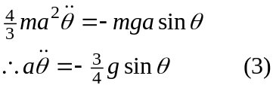
Y
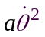
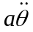
A
a

a

mg
B
[4]

Integrating (3) gives, 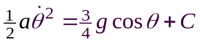, but 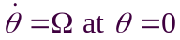 and so
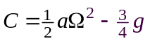, giving
[3]
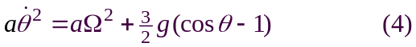

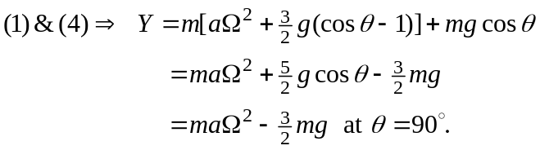
[2]

[1]

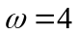
(b)
v = 4
1

m = 2

Angular momentum is conserved at the impulse with step.
AM before impact = 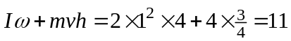

AM after impact = 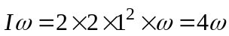, where is angular velocity of hoop immediately after impact and I is the moment of inertia of hoop about the top of the step.
Equating these gives 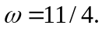
[3]

Now use energy conservation, with v = rolling velocity of hoop at top of step.
KE at bottom of step (after impulse) = 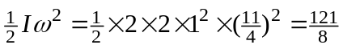.
KE at top of step = 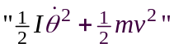 (rolling and translation)
= 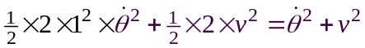
[5]
but 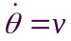 (radius 1) when rolling, so KE at top = 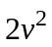.
PE at top of step = mgh = 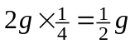.
Equating energies then gives
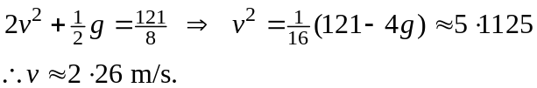
[2]

B3. (a) Cylinder first slides on the plane if “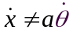” before rolling with a constant velocity when “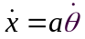”.
[2]
R

½
4g

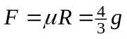

Velocity of point of contact between plane and cylinder = 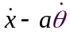 = 2 − ½ 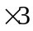 = 0⋅5 m/s initially and so slipping occurs to the right (in figure), hence frictional force opposes this as shown.
[2]

Eqn of motion of the c of g of cylinder: 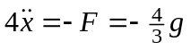
and integration gives, 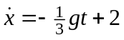 (1)
Rotational eqn of motion: 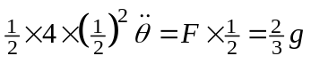
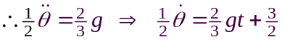 (2)
[4]
Cylinder stops sliding when 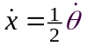 and so (1) and (2) give
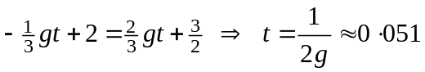 secs.
Speed v after this time is then given by (1) as
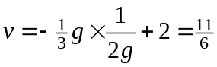 m/s.
[3]

(b)

V
w
u
J
a
u and w are components of velocity of sphere after impact, is its angular velocity and J is the horizontal frictional impulse component at impact.

[2]

[2]
No slipping upon impact 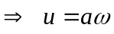, so no need to find w.
Momentum eqn along plane:
[2]
Angular momentum eqn:
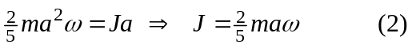
[2]
(1) and (2) with then give,
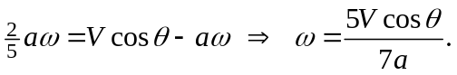
[1]

