
School of Computing & Creative Technologies
Subject Group: Mathematics
CS0980a : Applied Mathematics 3
2007/08
Term 3 - Terminal Examination
2 hours duration plus five minutes reading time
Use g = 9⋅8 m/s² where necessary

The paper contains 6 questions – 3 in each of Sections A and B
Answer 2 questions from each section
Calculators with no remote external connection and no computer algebra/programming facility may be used in this examination. The removal of a calculator from any candidate must be approved by the Examiner or, if not available, by any member of the Mathematics staff.

Additional Materials
Mathematical Formulae Booklets
Thursday 8 May 2008 |  |  | 1.55 pm | - | 2.00 pm | (reading time)
 |  |  | 2.00 pm | - | 4.00 pm | (examination time)
Examiner(s) | T N Lucas/R B Paris
Moderator(s) | R B Paris/T N Lucas
Section A – Answer any TWO questions

A1. | (a)  (b)  (c) | Use the integrating factor to solve the first-order differential equation  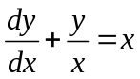  subject to the initial condition 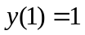.  Determine the general solution of the differential equation  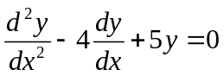.  Determine the solution of the inhomogeneous differential equation  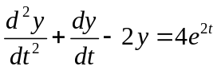  subject to the initial conditions 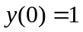, 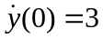. | (28%)  (20%)  (52%)

A2. | (a) | Determine the solution of the difference equation  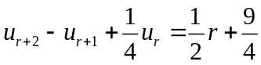  subject to the conditions 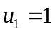, 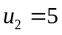. | (52%)

 | (b) | Sketch the region of integration over which the double integral  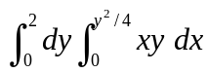  is to be evaluated. Evaluate this integral by reversing the order of integration. | (28%)

 | (c) | By evaluating an appropriate double integral, determine the mass of a disc of radius when the density per unit area 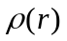 varies with radius according to the law  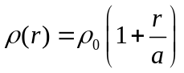,  where 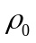 is a constant | (20%)

A3 | (a) | Show that the vector field 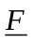 given by  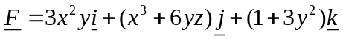  is conservative. Determine the scalar potential 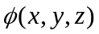 such that 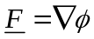, given that 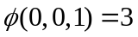.  Hence evaluate the line integral  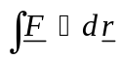  along any path joining 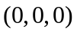 to 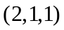. | (48%)

 | (b) | Use Green’s theorem to evaluate the integral  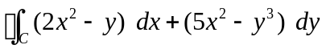,  where  is the square with vertices at , , 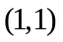 and 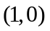 in that order. | (28%)

 | (c) | Use Gauss’ theorem to evaluate the integral  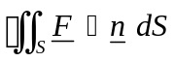,  where  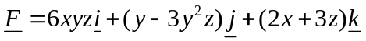,  is the outward-pointing unit normal to and is the surface of the sphere 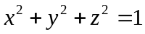. | (24%)

Section B – Answer any TWO questions

B1. | (a) | Two masses, A and B, of m and 2m respectively are placed on a smooth horizontal table and connected by a light inelastic string, which is just taut. If A is projected with velocity u at 30° to the direction of AB, determine the speeds of A and B just after the string becomes taut again. | (44%)

 | (b) | One end of a light inextensible string is attached to the base of a 5 kg mass on a smooth horizontal table. The string runs along the table and passes over its edge where a smooth pulley of mass 1 kg is attached to the other end of the string. Over this pulley passes another light inextensible string, with masses of 3 kg and 1 kg attached to its ends. If the system is allowed to move from rest freely, with the parts of the strings not in contact with the surfaces hanging vertically, calculate the acceleration of the 5 kg mass along the table. | (56%)

B2. | (a) | A uniform circular disc of mass m can rotate freely in the vertical plane about an axis through a point P on the circumference of the disc. Initially, the disc is held such that its centre O is on the same horizontal level as P. The disc is then released from rest. Calculate the magnitude and direction of the thrust on the axis through P when OP makes an angle of 30° with the downward vertical. | (48%)

 | (b) | A uniform straight rod AB of mass 3 kg and length 2a is freely jointed at B to a second rod BC of mass 1 kg and length 2a also. The rods lie on a smooth horizontal plane such that ABC is a straight line. An impulse of 10 Ns is then applied horizontally at a point on AB distant a/2 from A, perpendicular to AB. Calculate the impulsive reaction at the joint B and the initial velocities of the ends A and C. | (52%)

B3. | (a) | A uniform solid circular cylinder of mass 2 kg and radius ½ metres is projected with linear velocity 6 m/s and no initial angular velocity up the line of greatest slope of a plane, coefficient of friction 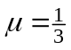, inclined at 30° to the horizontal.  Determine the time taken for the cylinder to start rolling without slipping on the plane and hence calculate how far it slips up the plane. | (56%)

 | (b) | A uniform solid sphere of mass 2 kg and radius 0⋅2 metres moves in the vertical plane just before it bounces on a horizontal rough floor. At the instant before impact, the centre of the sphere has horizontal and vertical components of velocity 4 and 2 m/s respectively and it has a backspin of 50 radians/second.  If the floor is rough enough to prevent slipping, show that the sphere rises vertically without spin after impact. | (44%)

